OKayMaps: From Truth Tables to Multiplexers
A Complete Visual Logic Suite

Institution: | Vishwakarma Institute of Technology, Pune
Department: | Department of Information Technology
Guide: | Prof. Riddhi Mirajkar
Course & Group: | DEAM | DIV: IT-E | Group No: 11 | Mid-Semester Review
Date: | 08/10/2026

Project Team Members:
- 1. Prem Prakash Salunke (Roll No. 23)
- 2. Mohammed Abdullah Qureshi (Roll No. 25)
- 3. Soham Vijay Randive (Roll No. 27)
- 4. Akhilesh Durgadas Rannaware Patil (Roll No. 29)

Table of Contents / Overview
- 1. Problem Statement
- 2. Introduction
- 3. Literature Review
- 4. Research Gaps Identified
- 5. Objectives
- 6. Proposed Methodology
- 7. Tools & Technologies Used
- 8. Project Flow Diagram & Workflow
- 9. Algorithms
- 10. Results and Discussion
- 11. References
1. Problem Statement
Students learning digital logic often need to convert the same Boolean function among a truth table, Boolean equation, Karnaugh map, and multiplexer implementation. Existing workflows usually require manual steps or multiple separate tools, which increases repeated work, makes equivalence difficult to verify, and gives limited step-by-step support/explanation. Therefore, there is a need for one interactive solver that accepts any of these representations and automatically produces the equivalent remaining representations.
2. Introduction
OKayMaps is an interactive, full-stack Boolean logic toolkit. The application seamlessly bridges the gap between algebraic expressions, truth tables, spatial grid minimizations, and multiplexer implementations. By supporting 2, 3, and 4-variable logic functions, OKayMaps allows users to input Boolean functions in four distinct modes—including raw folded and unfolded MUX line configurations—and instantly yields simplified Sum-of-Products (SOP), Product-of-Sums (POS), factored algebraic forms, XOR/XNOR parity forms, and dynamically drawn SVG multiplexer schematics.
3. Literature Review
Paper / Reference | Main Relevance | Difference from OKayMaps
“WWW-Based Boolean Function Minimization”  — S. P. Tomaszewski, I. U. Celik and G. E. Antoniou, 2003 | Accepts a Boolean expression, truth table or K-map and performs Boolean minimization using a modified Quine–McCluskey method. | Does not report bidirectional MUX conversion.
“KARMA: A Didactic Tool for Two-Level Logic Synthesis”  — C. E. Klock et al., IEEE MSE, 2007 | Works with equations, truth tables, K-maps, minterms, SOP/POS and step-by-step minimization. | MUX is not included as an equivalent input/output representation.
“Kmap Solver: A Free Mobile Application to Teach Karnaugh Map Simplifications”  — A. M. Moutinho et al., 2021 | Solves Boolean expressions of up to five variables and visually presents K-map solutions. | Primarily a K-map solver rather than a four-way interconverter.
“Implementation of the Quine-McCluskey Boolean Simplification Algorithm in an Interactive Smartphone Game”  — O. Levkovskyi and K. Lopez, 2016 | Implements automated Boolean minimization and generates optimal K-map solutions. | Focuses on solving and teaching K-map minimization, not MUX interconversion.
“Development of an Interactive Karnaugh Mapping Tool for Improving Digital Logic Education”  — M. L. George and M. Sampson, 2018 | Supports 2–4 variable K-maps, step-by-step solutions, prime implicants and minimum covers. | Does not present MUX as a bidirectional representation.
4. Research Gaps Identified
Previous research has produced Boolean minimizers and educational K-map solvers that connect expressions, truth tables, Karnaugh maps, SOP/POS forms, and implicant-based solutions. However, in the reviewed literature and online tools, MUX representation (as input or output) is absent. This leaves a gap for a unified four-way interconverter linking truth table, Boolean equation, K-map, and MUX representations.
5. Objectives
Implement Bidirectional MUX Processing: Develop an engine capable of accepting multiplexer line inputs (2^(n-1):1 folded or 2^n:1 unfolded) to solve functions, while simultaneously creating complete MUX derivation tables and SVG circuit diagrams.
Provide 4-Way Universal Mode Conversion: Enable cross-conversion among Truth Tables, Boolean Equations, Karnaugh Maps, MUX, and Logic Diagram for 2, 3, and 4-variable functions.
Deliver Dual SOP & POS Visualization: Compute and display side-by-side Karnaugh Maps for 1s grouping (Sum-of-Products) and 0s grouping (Product-of-Sums), complete with animated prime implicant overlays handling toroidal/cyclic wraparound.
Automate Advanced Simplification & Parity Recognition: Integrate pairwise SOP identity reduction (XY + X'Y = Y), algebraic factoring, and truth-table-based decomposition to automatically recognize global and partial XOR and XNOR parity structures.
6. Proposed Methodology
1. Input: User enters a 2–4 variable function via Truth Table, Equation, K-map, or MUX, with outputs 0, 1, or X.
2. Normalisation: FastAPI validates the input and converts every mode into common minterms, don’t-cares, and truth table data.
3. K-map: Minterms are placed on a Gray-code K-map (2×2, 2×4, or 4×4).
4. Minimisation: Finds valid groups, selects essential primes, generates SOP/POS, then performs algebraic simplification, factoring, and XOR/XNOR detection.
5. MUX: Generates folded 2^(n-1):1 and unfolded 2^n:1 MUX implementations and verifies them against the truth table.
6. Visualisation: Displays animated K-maps, group overlays, explanations, and MUX diagrams.
7. Validation: Invalid inputs return HTTP 400; error message shown to user.
7. Tools & Technologies Used
• Backend: FastAPI (Python)
• Frontend: Web Interface / JavaScript / SVG Rendering
• Algorithm Suite: Custom Gray-code K-map, Quine-McCluskey / Prime Implicant Solver, Boolean Parity Engine
8. Project Flow Diagram & Workflow
The system architecture follows an end-to-end multi-tiered workflow:
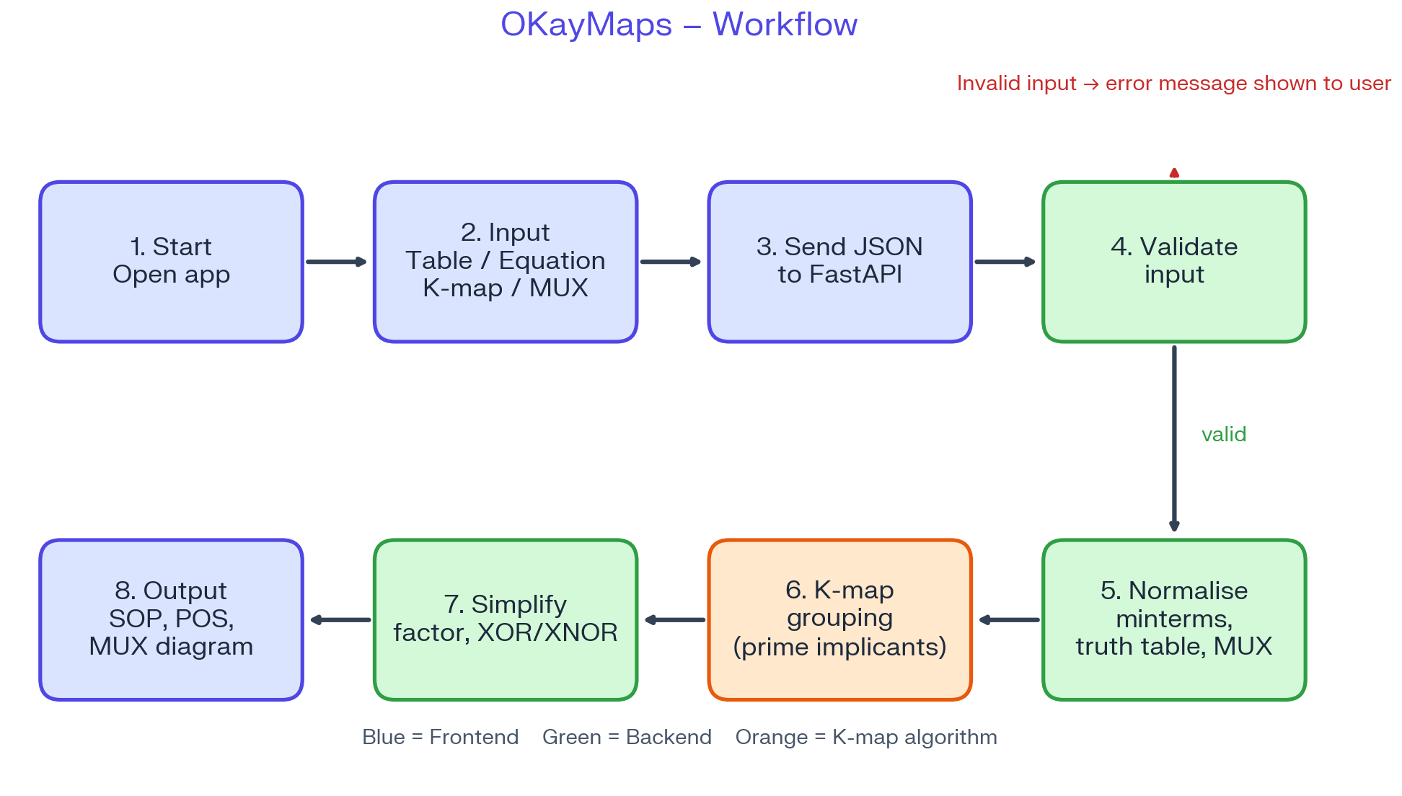
9. Algorithms
1. K-Map Placement: Map minterms on the Gray-coded K-map with wrap-around support.
2. Group Generation: Generate groups of sizes 16, 8, 4, 2, and 1; keep groups containing no 0 and ≥ 1 real 1.
3. Prime Implicant Identification: Find prime implicants by removing groups strictly contained within larger groups.
4. Group Selection: Add essential primes first, then cover remaining 1s using the largest available groups with maximum new coverage and minimal overlap.
5. Term Conversion: Convert groups to algebraic terms: constant variables stay as literals; changing variables are eliminated.
6. SOP Derivation: OR all selected product terms together.
7. POS Derivation: Repeat grouping process on 0s (don't cares ignored); convert each group to a sum term and AND them together.
8. SOP Simplification & Parity: Merge terms → factor common literals → detect XOR/XNOR using truth-table decomposition.
9. MUX Implementation & Verification:
- Folded MUX: [(F|v=0, F|v=1) → 0, 1, v, v']
- Unfolded MUX: [I_k = F[k], resolve X → 0]
- Verify MUX output against every defined truth table cell.
10. Output Generation: Yield simplified SOP, POS, factored form, XOR/XNOR parity form, and dynamic SVG MUX schematics.
10. Results and Discussion
Key Results
• Full Bidirectional MUX Workflow: Successfully processes MUX data to generate simplified Boolean expressions, while simultaneously generating folded/unfolded MUX derivation tables and SVG circuit schematics for any Boolean function.
• Unified Multi-Modal Functionality: Seamlessly converts logic functions across Equations, Truth Tables, K-Maps, and MUX.
• Interactive Visualization: Provides dynamic dual-map visualization (SOP and POS) with wrapped cyclic prime implicant step-by-step overlays and animated cell population timelines.
• Automated Logic Optimizations: Successfully reduces literals through algebraic factoring and automatically identifies XOR and XNOR parity structures.
Improvements / Future Work
• Export the results as PDF or PNG documents.
• Maintain a history of up to 3 previously generated solutions for quick reference and comparison.
11. References
[1] S. P. Tomaszewski, I. U. Celik, and G. E. Antoniou, “WWW-based Boolean function minimization,” International Journal of Applied Mathematics and Computer Science, vol. 13, no. 4, pp. 577–583, 2003.
[2] C. E. Klock, F. R. Schneider, M. V. N. Gomes, D. S. Moura, R. P. Ribas, and A. I. Reis, “KARMA: A didactic tool for two-level logic synthesis,” in Proc. 2007 IEEE International Conference on Microelectronic Systems Education (MSE ’07), San Diego, CA, USA, 2007, pp. 59–60, doi: 10.1109/MSE.2007.60.
[3] A. M. Moutinho, J. C. C. Andrades, J. F. Pereira, J. A. F. C. Rodrigues, and L. M. K. Camillo, “Kmap Solver: Um aplicativo móvel gratuito para o ensino de simplificações pelo mapa de Karnaugh,” Revista Brasileira de Ensino de Ciência e Tecnologia, vol. 14, no. 1, pp. 58–78, Jan.–Apr. 2021, doi: 10.3895/rbect.v14n1.11585.
[4] O. Levkovskyi and K. Lopez, “Implementation of the Quine–McCluskey Boolean simplification algorithm in an interactive smartphone game,” in Proc. 14th LACCEI International Multi-Conference for Engineering, Education, and Technology: Engineering Innovations for Global Sustainability, San José, Costa Rica, Jul. 20–22, 2016.
[5] M. L. George and M. Sampson, “Development of an interactive Karnaugh mapping tool for improving digital logic education,” International Journal of Recent Engineering Research and Development, vol. 3, no. 8, pp. 63–70, Aug. 2018.

