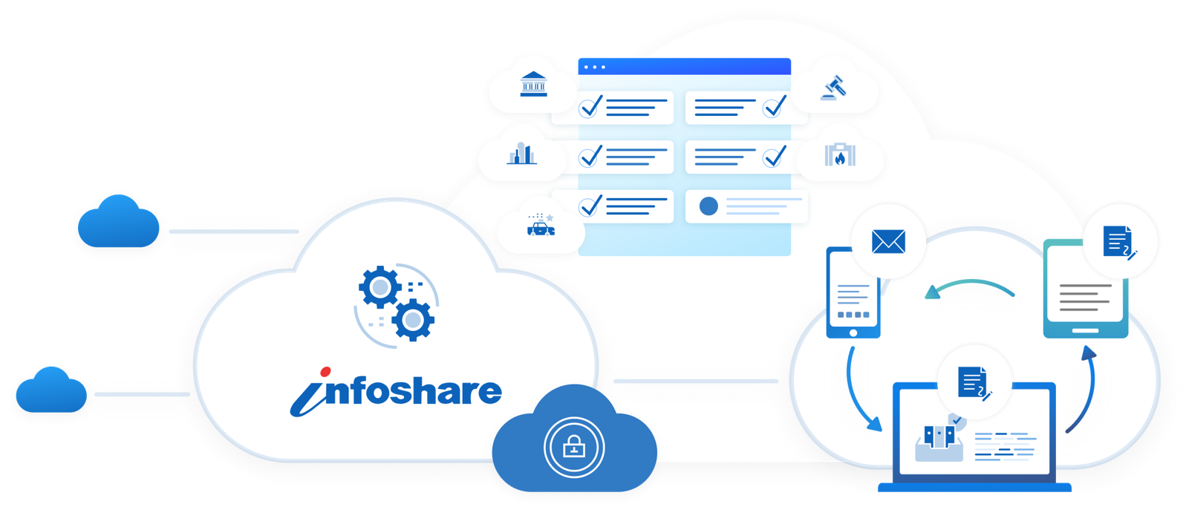

InfoShare® Global Search and the Next Generation of Law Enforcement Data Sharing

Why Data Sharing Matters in Modern Policing
Criminal activity does not respect municipal, county, or state boundaries. Yet many law enforcement agencies still rely primarily on information contained within their own records systems.
Secure data sharing helps agencies gain a broader view of criminal activity occurring across neighboring jurisdictions. Access to this information strengthens officer safety, improves investigations, supports crime analysis, and allows agencies to respond more proactively to emerging public safety concerns.
- Improved Officer Safety – In a non-sharing environment, agencies are limited to the information within their own system. An individual may be new to one jurisdiction, but shared data can reveal a recent history of criminal activity in surrounding jurisdictions, giving officers critical context before and during an encounter.
- More Effective Investigations – Shared reports help investigators identify patterns, connect related crimes, and link individuals to multiple cases across agencies.
- Better Crime Analysis – Access to a broader data set enables agencies to identify crime trends more accurately, recognize emerging patterns, and make more informed operational decisions.
Data sharing also saves valuable time by reducing the need for officers, investigators, and records personnel to make separate calls, send emails, or submit formal requests to determine whether another agency has relevant information. With appropriate access controls in place, users can quickly discover related incidents, associated individuals, vehicles, property, and agency contact information from one search location. This allows personnel to spend less time tracking down records and more time acting on information, following leads, preparing cases, and supporting day-to-day public safety operations.

CSI Takes Data Sharing to the Next Level
To support multi-jurisdictional investigations and enhance situational awareness, CSI Technology Group developed Global Search within InfoShare® RMS.
Global Search allows authorized users to search participating CSI cloud-based systems through a single, intuitive interface. Instead of limiting investigations to one jurisdiction, users can quickly identify related incidents, people, vehicles, property, and agency contacts across participating agencies, helping uncover critical connections that might otherwise go unnoticed or require additional tedious hours.
Because Global Search is built directly into InfoShare® RMS, agencies benefit from seamless access without the need for additional applications, user accounts, or administrative overhead. Access permissions remain fully under agency control, ensuring a secure and efficient user experience.
Designed with agency ownership in mind, Global Search respects local data governance policies. Sensitive investigations, restricted records, and protected cases can be excluded from shared search results until agencies determine that information is appropriate for release.
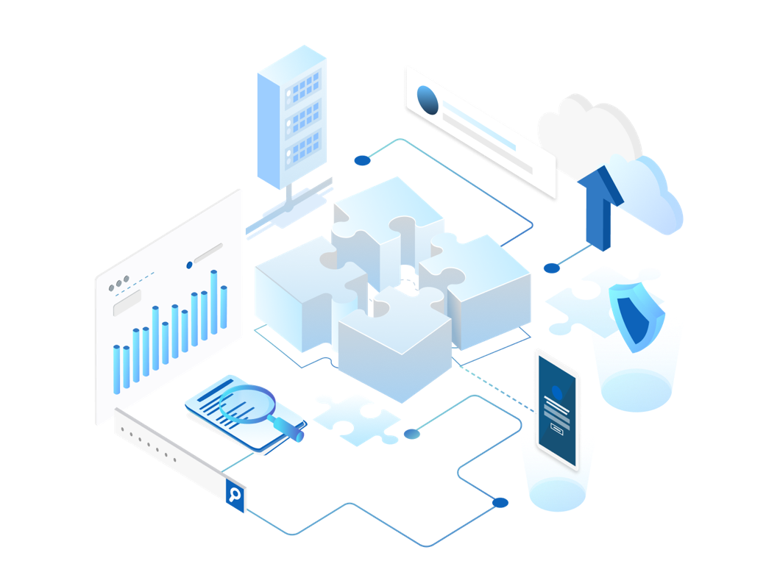
The platform can also incorporate approved external data sources to further expand investigative visibility. In Pennsylvania, planned integration with LEJIS and RISS will provide agencies with broader access to information and strengthen their ability to identify cross-jurisdictional relationships.
By breaking down information silos and connecting relevant data across agencies, Global Search helps investigators identify patterns, develop leads faster, and improve regional collaboration. The result is a secure, controlled approach to information sharing that enhances decision-making, improves operational efficiency, and empowers agencies to better serve and protect their communities.
Delivering More Value At No Additional Cost
Many data-sharing solutions require additional licensing, software, and maintenance costs. Global Search is included with InfoShare® RMS at no additional cost to participating agencies. Agencies can immediately access a broader network of information, strengthen investigative capabilities, and enhance situational awareness through a seamless, secure user experience. By extending the value of existing technology investments, Global Search helps agencies uncover critical connections faster, improve collaboration across jurisdictions, and make more informed decisions without adding complexity or cost.
Ready to learn more? Contact CSI Technology Group at sales@csitech.com to schedule a demonstration and see how Global Search can help your agency expand investigative visibility, strengthen regional collaboration, and maximize the value of your InfoShare® RMS solution.

