PRQLite
A Relational Database Built From Scratch in C++
How It Works — An End-to-End Guide
A plain-language tour of every component: from typing a SQL query to reading and writing bytes on disk — with diagrams and worked examples.
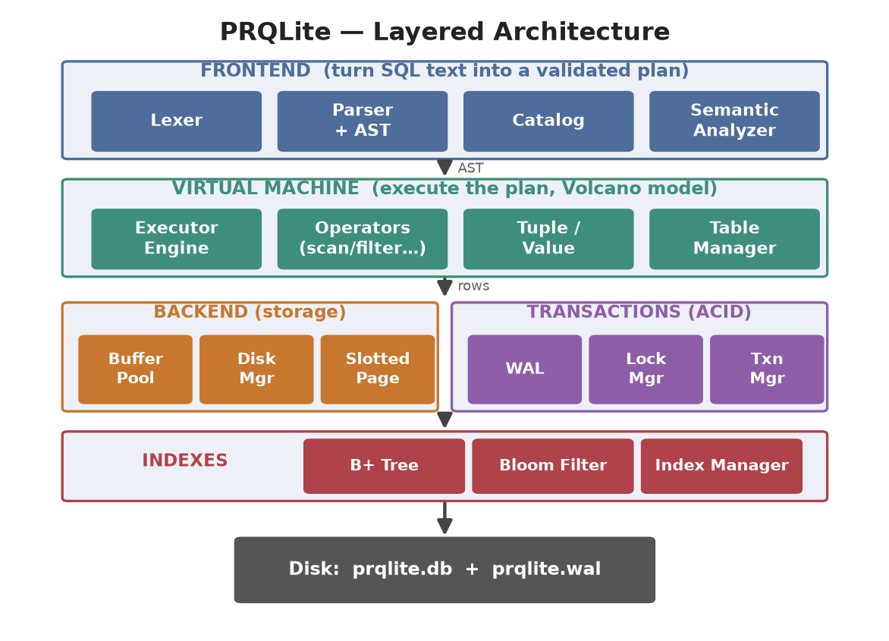

Contents
1. What Is PRQLite?
2. The Big Picture — Five Layers
3. The Journey of One SQL Statement
4. Frontend — Understanding the Query
4.1 Lexer (the scanner)
4.2 Parser & the AST
4.3 Catalog (the table registry)
4.4 Semantic Analyzer (the validator)
5. Virtual Machine — Running the Query
5.1 Values & Tuples (rows as bytes)
5.2 Operators & the Volcano Model
5.3 The Executor Engine
6. Backend — Storing the Data
6.1 The Slotted Page
6.2 Disk Manager
6.3 Buffer Pool
6.4 Page Guards (safe access)
7. Transactions — Keeping Data Safe (ACID)
7.1 Write-Ahead Log (WAL)
7.2 Lock Manager
7.3 Transaction Manager
8. Indexes — Finding Rows Fast
8.1 B+ Tree
8.2 Bloom Filter
8.3 Index Manager
9. Full Worked Example (start to finish)
10. SQL Features Supported
11. How to Build & Run
12. Glossary

1. What Is PRQLite?
PRQLite is a small but real relational database, written from scratch in modern C++ (C++20). "Relational" means it stores data in tables made of rows and columns — the same idea behind PostgreSQL, MySQL, and SQLite — and you talk to it using SQL, the standard query language.
You start it, get a prompt, and type SQL commands ending with a semicolon:
PRQLite 0.1.0 - a relational database from scratch.
prqlite=# CREATE TABLE users (id INT, name TEXT, age INT);
CREATE TABLE
prqlite=# INSERT INTO users VALUES (1, 'Ada', 36);
INSERT 0 1
prqlite=# SELECT name FROM users WHERE age > 30;
name
----
Ada
(1 row)
What makes it a "real" database and not just a file of text is everything happening behind that prompt. It has to:
- Understand your query — break the text apart, check it makes sense, and reject typos.
- Execute it efficiently — read only the rows it needs, using indexes when possible.
- Store data on disk — in a compact binary format, cached in memory for speed.
- Stay correct under failure — so a crash or a mistake never leaves half-written data.
This document walks through how each of those jobs is done, one component at a time, in simple language.
Naming: PRQLite is inspired by the article "How I built a Relational Database from scratch in C++" and the reference project of the same family. The code is organised into five namespaces that map to the five layers you'll see next: db::parser, db::semantic, db::vm, db::backend, and db::txn.

2. The Big Picture — Five Layers
PRQLite is organised as a stack of five layers. Each layer only talks to the one directly below it, which keeps the design tidy: you can understand one box at a time.

Figure 1 — The five layers and where data ends up on disk.
Layer | Job (in one line) | Key parts
Frontend | Turn SQL text into a checked, structured plan | Lexer, Parser, AST, Catalog, Semantic Analyzer
Virtual Machine | Run the plan and produce result rows | Executor Engine, Operators, Tuple, Value, Table Manager
Backend | Store rows as bytes on disk, cached in RAM | Slotted Page, Disk Manager, Buffer Pool, Page Guard
Transactions | Guarantee correctness (ACID) | Write-Ahead Log, Lock Manager, Transaction Manager
Indexes | Find rows without scanning the whole table | B+ Tree, Bloom Filter, Index Manager

A helpful way to think about it: the top two layers are about logic (what does the query mean, and how do I run it), while the bottom three are about mechanics (where do the bytes live, how do I keep them safe, and how do I find them quickly).

3. The Journey of One SQL Statement
Before diving into each component, here is the whole trip a single query takes. Keep this picture in mind — every later section is just a zoom-in on one of these steps.
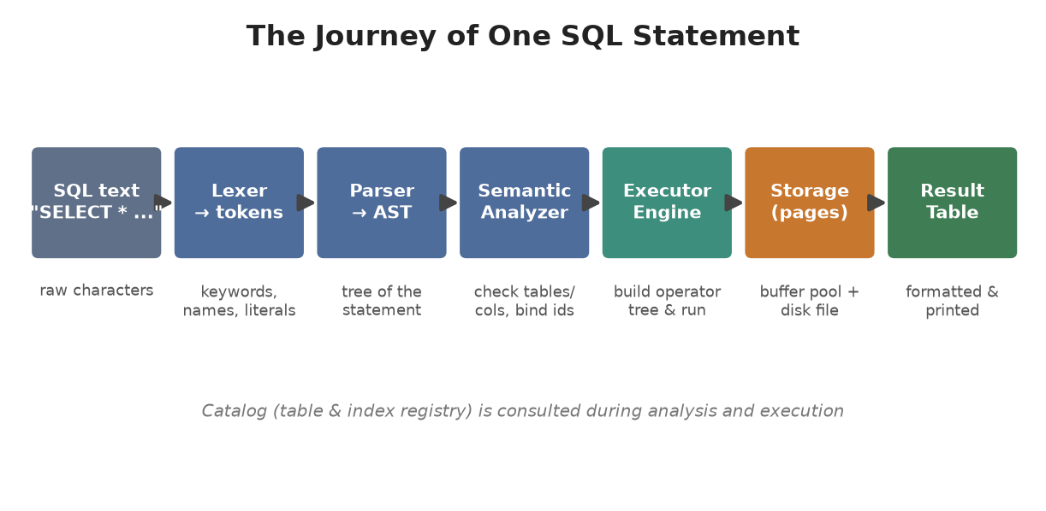
Figure 2 — One statement flows left to right through the pipeline.
Step by step, for SELECT name FROM users WHERE age > 30;
# | Stage | What happens | Example output
1 | Lexer | Splits text into tokens (words the DB understands) | SELECT, name, FROM, users, WHERE, age, >, 30
2 | Parser | Builds a tree (AST) showing the statement's structure | SelectStatement{ cols=[name], where=(age>30) }
3 | Semantic | Checks the table & columns exist; binds ids/types | users → tableId 0; age → column 2 (INT)
4 | Engine | Builds an operator tree and pulls rows through it | Scan → Filter → Projection
5 | Storage | Reads pages from the buffer pool / disk | page 0, slot 0 → bytes → row
6 | Result | Formats matching rows into a text table | name / ---- / Ada

Where does this live in code? The orchestration is DB::connect() in src/frontend/db.cpp. It runs lex → parse → analyze → execute and catches errors at each stage, returning a friendly message instead of crashing.

4. Frontend — Understanding the Query
The frontend's whole job is to take a string of SQL and turn it into something the rest of the engine can trust: a validated, structured plan. It does this in four moves.

4.1 Lexer (the scanner)
The lexer (also called a tokenizer or scanner) reads the raw text one character at a time and groups characters into tokens — the smallest meaningful pieces. Think of it like splitting an English sentence into words and punctuation before you can understand grammar.
It recognises keywords (SELECT, FROM, WHERE…), identifiers (table and column names), literals (numbers like 30, strings like 'Ada'), operators (=, !=, <, >=…), and punctuation ( ( ) , ; * ). It also tracks line and column numbers so error messages can point at the mistake. It is hand-written — no regular expressions or external libraries.
Input: SELECT name FROM users WHERE age > 30;
Tokens: [SELECT] [IDENTIFIER "name"] [FROM] [IDENTIFIER "users"]
[WHERE] [IDENTIFIER "age"] [GT ">"] [INTEGER_LITERAL 30]
[SEMICOLON] [END_OF_FILE]
The lexer always ends the stream with an END_OF_FILE token.

4.2 Parser & the AST
The parser takes the flat list of tokens and builds a tree that captures the structure of the statement. This tree is called the AST — Abstract Syntax Tree. If the tokens don't fit the grammar (for example FROM is missing), the parser raises a clear syntax error.
PRQLite uses recursive-descent parsing: one small function per grammar rule. Expressions inside WHERE are handled by precedence climbing, so the usual rules apply automatically — NOT binds tighter than AND, which binds tighter than OR, just like in maths a×b comes before a+b.
Each kind of statement becomes its own node type: SelectStatement, InsertStatement, CreateStatement, DeleteStatement, UpdateStatement, and so on. A WHERE clause becomes a small expression tree of its own.
SELECT name FROM users WHERE age > 30;
SelectStatement
/ | \
columns table where
[name] users |
BinaryExpr(>)
/ \
ColumnRef(age) Literal(30)
The AST makes the query's shape explicit and easy to walk over.
Design pattern: The AST uses the Visitor pattern. Every node has an accept(visitor) method, so different passes (validation now, execution later) can walk the same tree without the node types needing to know about them. This is why the semantic analyzer and the executor engine are both "visitors".

4.3 Catalog (the table registry)
The Catalog is the database's memory of what exists: every table, its columns and their types, its indexes, and its foreign keys. It hands out a unique numeric tableId to each table. It is a single shared registry (a singleton) that both CREATE statements write to and every other statement reads from.
- CREATE TABLE / CREATE INDEX add entries to the catalog.
- DROP / ALTER change or remove them.
- SELECT / INSERT / UPDATE / DELETE look up schemas to validate and run.

4.4 Semantic Analyzer (the validator)
A query can be perfectly spelled yet still be nonsense — for example selecting from a table that doesn't exist, or comparing a number to text. The semantic analyzer catches these. It walks the AST and checks it against the Catalog.
Along the way it also binds information back into the tree so execution is fast and unambiguous: it fills in the tableId, converts each column name into a numeric column index, and records each expression's data type.
It checks… | Example error it prevents
Table exists | SELECT … FROM ghosts → unknown table
Columns exist | SELECT height FROM users → no such column
Types are compatible | WHERE age = 'hello' → type mismatch
Right number of values | INSERT … VALUES (1) into a 3-column table
No duplicate names | CREATE TABLE users … when it already exists

Only after this stage passes does the query reach the execution engine. By then, every table id, column index, and type is already resolved.

5. Virtual Machine — Running the Query
The frontend produced a clean, validated plan. The virtual machine (VM) layer actually runs it and produces rows.

5.1 Values & Tuples (rows as bytes)
A Value is a single cell: an integer, a boolean, some text, or SQL NULL (meaning "no value"). A Tuple is one full row — an ordered list of Values.
To store a row on disk it must become a compact sequence of bytes. That is serialization. Reading it back is deserialization. The tuple knows the table's schema (the column types in order), so it can pack and unpack itself precisely:
Row: (id=1, name='Ada', age=36)
On disk:
[ null bitmap ] 1 bit per column: is it NULL?
INT id -> 8 bytes -> 01 00 00 00 00 00 00 00
TEXT name -> 4-byte length + bytes -> 03 00 00 00 'A' 'd' 'a'
INT age -> 8 bytes -> 24 00 00 00 00 00 00 00
A leading null bitmap records which columns are NULL, so NULLs cost almost nothing.
Comparisons follow SQL's three-valued logic: comparing anything with NULL gives "unknown", not true or false. This matters for WHERE clauses and is handled centrally in the Value code.

5.2 Operators & the Volcano Model
PRQLite runs queries using the Volcano (iterator) model — the same idea used by many production databases. Each step of a query becomes an operator, and operators are stacked into a tree. Every operator offers the same tiny interface:
- init() — get ready to produce rows.
- next() — produce the next row, or say "I'm done".
The top operator asks its child for a row; that child asks its child; and so on down to the table scan at the bottom. Rows are pulled up one at a time. Nothing loads the whole table into memory at once, so even large tables use little RAM.
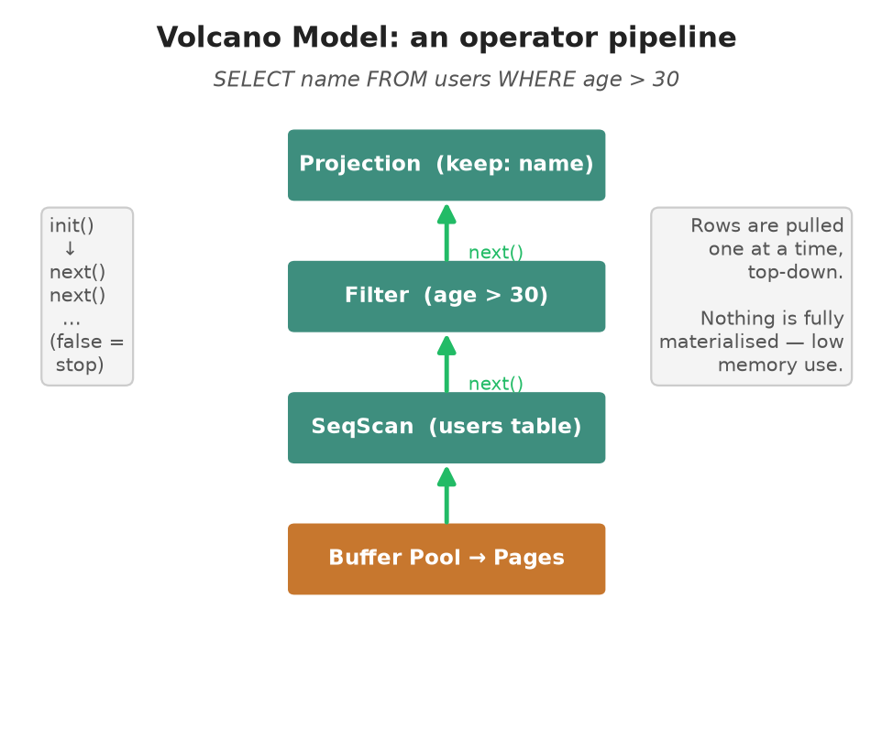
Figure 3 — Operators pull rows one at a time, top to bottom.
Operator | What it does
SeqScan | Reads every live row of a table, in order
Filter | Passes through only rows where the WHERE predicate is TRUE
Projection | Keeps only the requested columns
Insert / Delete / Update | Write, tombstone, or modify rows
Join / Aggregate / Sort / Limit | Combine, summarise, order, or cap rows

For our example, SELECT name FROM users WHERE age > 30 becomes: SeqScan(users) → Filter(age > 30) → Projection(name). The Filter throws away Bob (age 25); the Projection drops every column except name.

5.3 The Executor Engine
The executor engine is the visitor that reads the validated AST and builds the right operator tree for each statement type, then runs it and collects the output into a ResultSet (column headers + rows, or a status message like "INSERT 0 1").
It is also where the layers meet. When it runs an INSERT it:
- serializes the row and asks the Table Manager to store it,
- updates every index defined on that table,
- checks foreign-key constraints,
- and, if a transaction is open, writes a WAL record and registers an undo action.
Smart shortcut: Before doing a full scan, the engine checks whether the WHERE clause is a simple "column = value" on an indexed column. If so, it asks the index for a direct point lookup instead of reading every row — turning an O(n) scan into an O(log n) search.

6. Backend — Storing the Data
Everything above deals in rows and Values. The backend deals in bytes: how rows are packed into fixed-size pages, cached in memory, and read from or written to a single file on disk.

6.1 The Slotted Page
Disks and databases work in fixed-size blocks called pages — here, 4 KB each. A table is simply a list of pages. But rows have different sizes (text can be long or short), so how do you fit variable rows into a fixed page neatly? The answer is the slotted page.
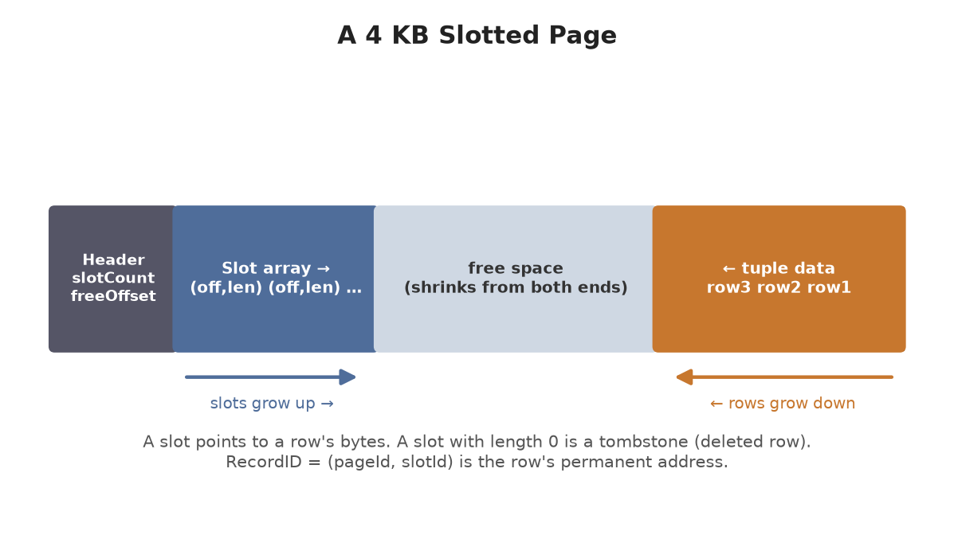
Figure 4 — Slots grow from the front; row data grows from the back.
A slot is a tiny pointer (offset + length) that says where a row's bytes live inside the page. Slots grow from the front; the actual row bytes grow from the back; free space is in the middle. To delete a row, its slot's length is set to 0 — a tombstone. The slot id is never reused, so a row's address stays stable forever.
That address is the RecordID = (pageId, slotId). It is how indexes and transactions refer to a specific row.

6.2 Disk Manager
The disk manager is the only part that touches the actual file (prqlite.db). It reads and writes whole pages by their id: page N lives at byte offset N × 4096. It can also grow the file by one blank page when the table needs more room. Everything above it thinks in terms of page ids, never file offsets.

6.3 Buffer Pool
Reading from disk is slow; reading from RAM is fast. The buffer pool is a fixed set of in-memory slots (frames) that cache recently used pages, so the same page isn't fetched from disk over and over.
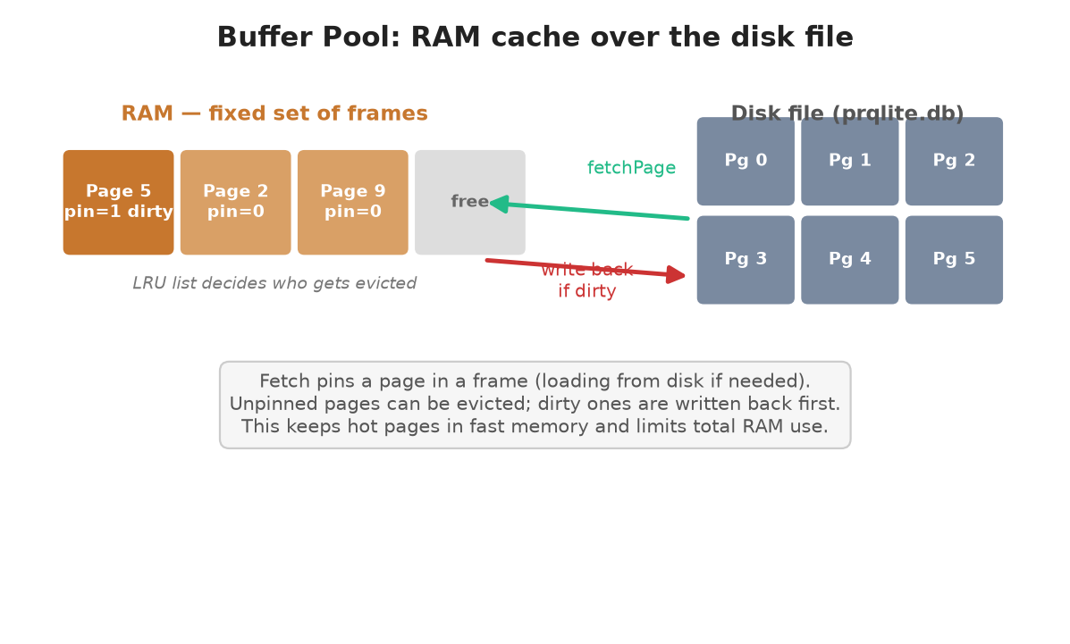
Figure 5 — Hot pages stay in RAM; cold, unpinned pages are evicted.
- Pinning — while a page is in use it is "pinned" so it can't be thrown out.
- Eviction — when RAM is full, an unpinned page is chosen to leave, using Least-Recently-Used (LRU) — the page untouched longest goes first.
- Dirty write-back — if an evicted page was changed ("dirty"), it is written back to disk before its frame is reused, so no change is lost.
This gives the speed of memory with the capacity and durability of disk, while capping how much RAM the database uses.

6.4 Page Guards (safe access)
Forgetting to "unpin" a page would slowly leak the buffer pool. A PageGuard prevents that using C++ RAII: when you take a guard it pins the page, and the moment the guard goes out of scope it automatically unpins it (and flags it dirty if you changed it). Safe access with no manual bookkeeping.

7. Transactions — Keeping Data Safe (ACID)
A transaction groups several changes so they succeed or fail together. Databases promise ACID: Atomicity (all-or-nothing), Consistency, Isolation (concurrent transactions don't corrupt each other), and Durability (committed data survives crashes). Three components deliver this.
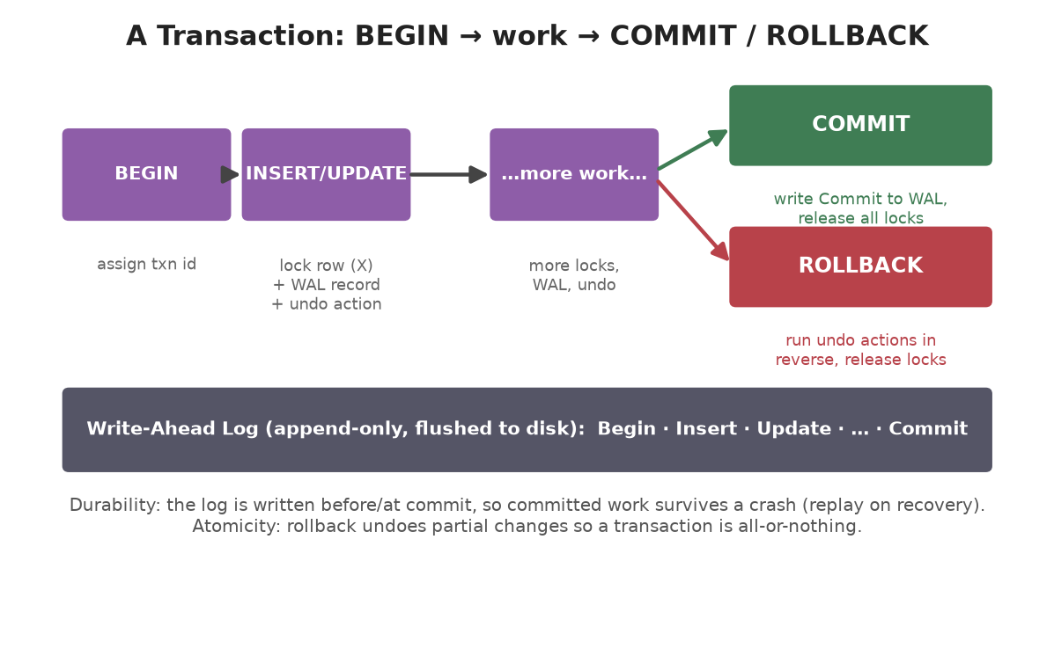
Figure 6 — BEGIN starts a transaction; COMMIT keeps changes, ROLLBACK undoes them.

7.1 Write-Ahead Log (WAL)
The golden rule: write down what you're about to do before you do it. The WAL is an append-only file that records each change (Begin, Insert, Delete, Update, Commit, Abort) with enough information — the row's before and after bytes — to redo or undo it. Each record gets an increasing number (LSN).
Because the log is flushed to disk, a committed transaction is safe even if the machine crashes a moment later: on restart, the log can be replayed to recover. This is what gives the D in ACID — Durability.

7.2 Lock Manager
When two transactions touch the same row at once, one must wait, or the data could be corrupted. The lock manager hands out row-level locks:
- Shared (read) lock — many transactions can hold it at once.
- Exclusive (write) lock — only one holder; nobody else may read or write that row.
A transaction that only reads a row can share it; a transaction that writes must have it exclusively. lock() waits until the row is available; a transaction may upgrade a shared lock to exclusive once it's the only holder. This gives the I in ACID — Isolation.

7.3 Transaction Manager
The transaction manager ties the WAL and lock manager together. It assigns each transaction an id and, for every change, remembers an undo action — a small function that reverses that change.
Command | What the manager does
BEGIN | Assign a new transaction id; start collecting undo actions
INSERT / UPDATE / DELETE | Lock the row, write a WAL record, register an undo
COMMIT | Write a Commit record to the WAL; release all locks — changes are permanent
ROLLBACK | Run the undo actions in reverse order; release all locks — as if nothing happened

Atomicity (the A in ACID) falls right out of this: on rollback, every partial change is undone, so the transaction is truly all-or-nothing.

8. Indexes — Finding Rows Fast
Without an index, finding rows means scanning the whole table — fine for ten rows, painful for ten million. An index is a side structure that lets the database jump straight to the rows it wants. PRQLite pairs two structures for each index.

8.1 B+ Tree
A B+ tree keeps keys in sorted order in a shallow, wide tree. Looking up a key walks from the root down to a leaf in just a few hops — O(log n) — no matter how big the table grows. Each key maps to the RecordIDs of the rows that carry it (duplicates are allowed).
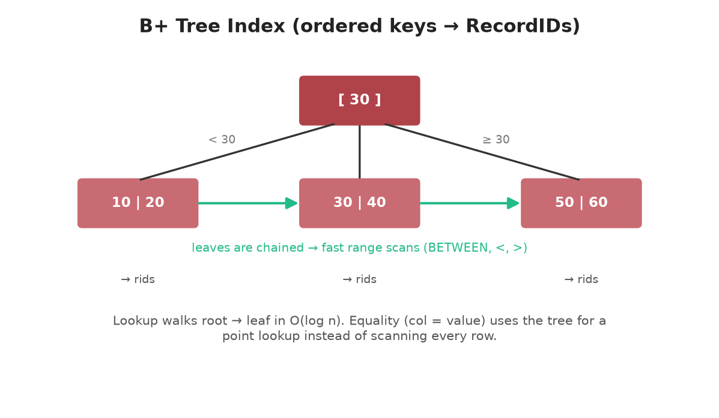
Figure 7 — Sorted keys in a shallow tree; leaves are chained for ranges.
Because the leaves are linked together in order, the B+ tree is also great for range queries — BETWEEN, <, >, and ORDER BY can walk the chain instead of sorting from scratch. This is why CREATE INDEX makes equality and range lookups dramatically faster.

8.2 Bloom Filter
Sometimes the fastest lookup is proving a key isn't there at all. A bloom filter is a compact bit array that answers one question very cheaply: "could this key possibly exist?"
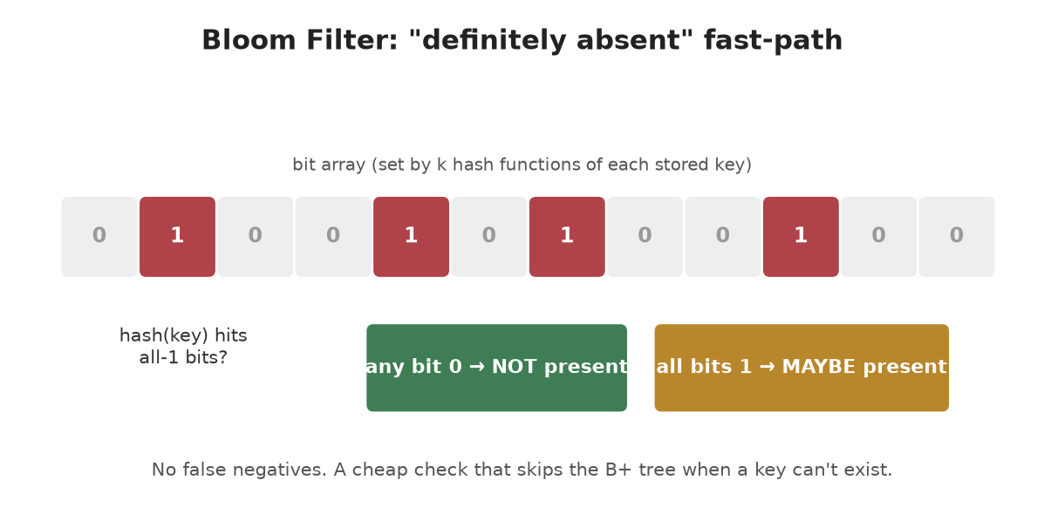
Figure 8 — If any checked bit is 0, the key is definitely absent.
Each stored key flips a few bits (chosen by hash functions) to 1. To test a key, check those same bits: if any is 0, the key is definitely absent, so you can skip the B+ tree entirely. If all are 1, the key is probably present (a rare false positive is possible), so you do the real lookup. It never gives a false negative, which is what makes the shortcut safe.

8.3 Index Manager
The index manager is the registry of all indexes, keyed by name. It bundles a B+ tree and a bloom filter into each index, and offers the engine simple operations: create an index, drop it, find the index on a given (table, column), and list a table's indexes so they can be kept in sync whenever rows are inserted or deleted.

9. Full Worked Example (start to finish)
Let's connect everything with one short session and trace what each layer does. Imagine typing these commands at the prompt.
Step 1 — Create a table.
prqlite=# CREATE TABLE users (id INT, name TEXT, age INT);
CREATE TABLE
Frontend: lexer + parser build a CreateStatement; the semantic analyzer registers the table in the Catalog and assigns it tableId 0 with columns id(0, INT), name(1, TEXT), age(2, INT).
Step 2 — Add an index on age.
prqlite=# CREATE INDEX age_idx ON users (age);
CREATE INDEX
The Index Manager creates age_idx: a B+ tree + bloom filter on column 2 of table 0. It starts empty and will be updated on every insert.
Step 3 — Insert rows.
prqlite=# INSERT INTO users VALUES (1, 'Ada', 36);
INSERT 0 1
prqlite=# INSERT INTO users VALUES (2, 'Bob', 25);
INSERT 0 1
prqlite=# INSERT INTO users VALUES (3, 'Cleo', 41);
INSERT 0 1
For each row the engine: serializes it to bytes → Table Manager finds a page with room and stores it, returning a RecordID like (0, 0) → the value of age is added to age_idx. So the index now maps 36→(0,0), 25→(0,1), 41→(0,2).
Step 4 — Query with a filter.
prqlite=# SELECT name FROM users WHERE age > 30;
name
----
Ada
Cleo
(2 rows)
Because age > 30 is a range (not equality), the engine runs SeqScan → Filter(age > 30) → Projection(name). The buffer pool serves the page from RAM. Bob (25) fails the filter; Ada and Cleo pass, and only their name column is returned.
Step 5 — A transaction that rolls back.
prqlite=# BEGIN;
BEGIN
prqlite=# INSERT INTO users VALUES (4, 'Dan', 50);
INSERT 0 1
prqlite=# ROLLBACK;
ROLLBACK
prqlite=# SELECT COUNT(*) FROM users;
COUNT(*)
--------
3
(1 row)
BEGIN opens a transaction. The INSERT locks the new row, writes a WAL record, and registers an undo action. ROLLBACK runs that undo — removing Dan from the table and from age_idx — and releases the lock. The final count is 3: it's as if Dan was never inserted. That is atomicity in action.
The point: Every one of these one-line commands quietly exercised all five layers — parsing, validation, execution, storage, indexing, and (in step 5) transactions — exactly as the earlier sections described.

10. SQL Features Supported
PRQLite implements a practical subset of SQL, built up in phases.
Category | Supported
Data types | INT, BOOL, TEXT / VARCHAR(n), plus NULL
Define data (DDL) | CREATE / DROP TABLE, CREATE / DROP INDEX, ALTER TABLE (ADD/DROP COLUMN)
Change data (DML) | INSERT, UPDATE, DELETE
Query (SELECT) | column projection or *, WHERE, INNER JOIN … ON
WHERE operators | =, !=, <, <=, >, >=, AND / OR / NOT, IS [NOT] NULL, [NOT] IN, BETWEEN, LIKE
Grouping & order | GROUP BY, HAVING, COUNT/SUM/AVG/MIN/MAX, ORDER BY, LIMIT
Subqueries | scalar, IN, EXISTS (uncorrelated)
Constraints | FOREIGN KEY … REFERENCES (checked on insert/update/delete)
Transactions | BEGIN, COMMIT, ROLLBACK

11. How to Build & Run
PRQLite uses CMake and C++20, with a self-contained test suite (no external framework needed).
# Configure and build
cmake -S . -B build
cmake --build build
# Run the interactive REPL
./build/prqlite # (Windows: .\build\prqlite.exe)
# Run all tests
ctest --test-dir build
Ten test suites cover the lexer, parser, storage, transactions, indexes, and more.
At the prompt, type SQL ending in a semicolon. Use \h for help and \q to quit. Data is kept in prqlite.db, with the write-ahead log in prqlite.wal.

12. Glossary
ACID — The four guarantees of safe transactions: Atomicity, Consistency, Isolation, Durability.
AST — Abstract Syntax Tree — the parser's tree representation of a statement.
Buffer pool — In-memory cache of disk pages, to avoid slow repeated disk reads.
Bloom filter — Compact bit array that quickly proves a key is absent (no false negatives).
B+ tree — Sorted, shallow tree giving fast O(log n) lookups and range scans.
Catalog — The registry of tables, columns, indexes, and foreign keys.
Dirty page — A cached page that was modified and must be written back before eviction.
Index — A side structure that finds rows without scanning the whole table.
Lexer — Turns raw SQL text into tokens (the scanner/tokenizer).
LSN — Log Sequence Number — the increasing id of each WAL record.
Page — A fixed-size (4 KB) block of storage; a table is a list of pages.
Pin — Marking a cached page as in-use so it can't be evicted.
RecordID — A row's permanent address: (pageId, slotId).
Serialize — Convert a row into a compact sequence of bytes (and back = deserialize).
Slotted page — Page layout with a slot directory pointing to variable-size rows.
Tombstone — A slot marked deleted (length 0); its id is never reused.
Tuple — One row — an ordered list of Values.
Volcano model — Execution style where operators pull rows one at a time via next().
WAL — Write-Ahead Log — record changes before applying them, for crash recovery.

— End of guide —

