Celonis Services Consultant Challenge

Hi! **Congratulations** on making it to the Challenge Phase of the interview process! Over the next several days, you will have the opportunity to play the role of a Celonis Services Consultant and deliver a miniature Celonis implementation for a mock customer. Attached in this email is a mock Order-to-Cash dataset from the SAP Enterprise Resource Planning (ERP) system. The dataset is spread across multiple .CSV files.

Your **ultimate task** is to analyze the dataset using Celonis and deliver a 30-45 minute presentation (including a slideshow) to a group of Celonis employees playing the mock role of customer executives. The **key deliverables** you need to complete this task are as follows:

* **Integrate** (upload) the provided data into the Celonis Platform.
* **Figure out** which data is needed for the “**Remove Delivery Block**” process activity, **write the SQL** to fetch this data from the dataset, and **insert this data** into the Celonis Activity table, which is included in the .CSV files.
* **Create** a **Process Data Model**, according to the schema diagram on page 5.
* **Generate business insights** in a Celonis Analysis**.** The questions provided on page 3 can serve as guidance.
* **Build**, at a minimum, the following components in a Celonis Analysis:

1. Process Explorer
2. Variant Explorer
3. Case Explorer
4. Analysis dashboard(s) which allows a user to “drill down” into the data

Your presentation **must** include the following topics:

1. An **Introduction** to Celonis and the Celonis Platform.
2. A 15-minute **technical demonstration** of how to arrive at business insights and/or highlight value opportunities using Celonis.
3. A **Summary** of the insights obtained from Celonis.
4. The **financial impact** each business insight and/or value opportunity has on the customer’s business. Make sure to clearly quantify the value identified, as a dollar amount, in your analysis, and be prepared to explain how you calculated it.
5. **Recommendations** for how to address each business insight and/or value opportunity *using the Celonis Platform*.
6. List the **assumptions** you made to provide a comprehensive analysis; however, make sure that you **document** and **explain** your reasoning.

You will be asked questions throughout the presentation, so plan for approximately 30 minutes of presentation and 15 minutes of Q&A. Please assume that your audience has minimal-to-no prior knowledge or experience with Celonis, and construct your presentation accordingly.

*It is very important to note that this challenge is very much a “challenge”*. You may run into technical issues while uploading the data, transforming the data using SQL, creating the data model, or building the analyses. **These issues are expected, and part of the challenge is to find ways through them;** please refrain from reaching out to our support team or Academy team for assistance. Technical challenges are encountered daily with customers. Consultants are expected to be creative and “think outside of the box” in addressing these challenges.

The resources and online training tracks linked below will be useful in completing the challenge. Please consult them as needed. Note: you can “click through” each training to find the information most relevant to you. Should you have any questions, please contact your recruiter.

* [Celonis for Order Management](https://www.celonis.com/solutions/order-management/) - how we position our platform to improve the Order Management process.
* [Review and Interpret Analyses](https://academy.celonis.com/learning-paths/review-and-interpret-analyses) - overview on how to navigate and interpret data within the Celonis Analysis UI. (you should have taken this prior to this challenge)
* [Upload Files](https://docs.celonis.com/en/uploading-files.html) - how to upload CSVs / Excels into the Celonis Platform.
* [Get Data Into Celonis](https://academy.celonis.com/learning-paths/get-data-into-the-ems-1) - a primer on how to integrate data into the Celonis platform and connect processes via SQL.
* [LeanX](https://www.leanx.eu/en/sap/table/search) - searchable data dictionaries for the SAP ERP tables provided
* [Build Analyses](https://academy.celonis.com/learning-paths/build-analyses-basics) - an overview of how to create Celonis Analyses by yourself.
* [Write PQL Queries](https://academy.celonis.com/learning-paths/build-analyses-advanced) - a deep dive into the Celonis-proprietary query language, PQL, and how to use it to create your own dimensions and KPIs within an Analysis.
* [Celonis Docs](https://docs.celonis.com/?lang=en) - our publicly-facing, searchable technical documentation

**Good Luck, and have fun!**

Functional Requirements Document

1. Questions which should guide your presentation

* What deviations affect our Sales Order Line Items most often?
* Build components which can explain why activities like “Remove Delivery Block”, “Approve Credit Check” or “Change Price” are impacting our business.
* How often do they occur, and can you quantify the monetary impact (estimate)?
* How much time do these deviations add to the process, on average?
* Do customers have significantly different behavior if these deviations happen?
* How much more manual effort and rework is needed in the overall process?
* What are the root causes of these deviations? Do we have a specific focus on customers/plants/material …?
* What would you recommend as next steps to address each deviation?
* Which one(s) would you prioritize and why?
* What positive impact would be created by solving these issues?
* Are there other activities that lead to a negative impact on our business?

Should you be able to answer additional questions beyond those listed here, please do so. When making recommendations, please include your assumptions, approach, priorities, risks, mitigation strategies, requirements, and any other content that you consider relevant. Please draw on your domain-specific expertise as needed.

1. How would we like Celonis implemented?
2. The Data: We have provided you with CSV extracts of one (partially completed) table constructed by our analyst (_CEL_O2C_ACTIVITIES) plus seven key SAP tables.
   1. _CEL_O2C_ACTIVITIES: Celonis Activities table
      1. Primary Key = _CASE_KEY (Case Key = VBAP.MANDT + VBAP.VBELN + VBAP.POSNR) + ACTIVITY_EN (Activity Name in English - hardcoded by you) + EVENTTIME (Time at which the Activity Took Place) + _SORTING (Integer sort key used to sort events visually in the process explorer in the event of “ties”)
      2. Important Fields
         1. The user who performed the transaction: USER_NAME
   2. VBAP: Sales Order Line Item Table (***the “Case” Table***)
      1. Primary Key = MANDT (Client) + VBELN (Sales Order #) + POSNR (Sales Order Line Item #)
      2. Important Field = NETWR_CONVERTED (Order Value in USD)
   3. VBAK: Sales Order Header Table
      1. Primary Key = MANDT (Client) + VBELN (Sales Order #)
   4. KNA1: Customer Master Table
      1. Primary Key = MANDT (Client) + KUNNR (Customer #)
   5. CDHDR: Change Document Header = ***One row for each change transaction***
      1. Primary Key = MANDANT (Client) + OBJECTCLAS (Object Class) + OBJECTID (Object ID) + CHANGENR (Document Change Number)
      2. Important Timestamps:
         1. Change Date (UDATE)
         2. Change Time (UTIME)
   6. CDPOS: Change Document Items = ***One row for each column that was changed within a transaction***
      1. Primary Key = MANDANT (Client) + OBJECTCLAS (Object Class) + OBJECTID (Object ID) + CHANGENR (Document Change Number) + TABNAME (Table Name) + TABKEY (Primary Key of the Changed Row in the Changed Table) + FNAME (Field Name) + Change Type [Update, Insert, Delete] (CHNGIND)
   7. DD02T: Name Mapping Tables
   8. DD03M: Name Mapping Columns

1. Overview on the final Data Model including table relationships

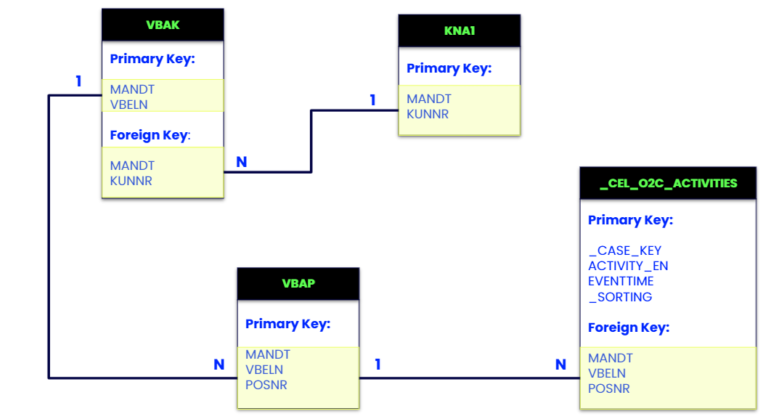

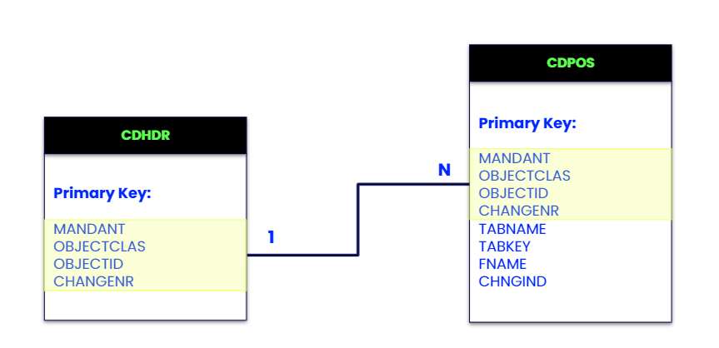

1. Your To-Do’s
   1. Upload each of the provided CSVs into Celonis. Make sure to configure the upload and initially cast all columns as strings to prevent errors. (That said, make to use SQL to cast _CEL_O2C_ACTIVITES’ EVENTTIME column back to a timestamp, _SORTING back to an integer, and any numeric columns used for calculations as floats)
   2. Create a data job in Data Integration which inserts the following activity into _CEL_O2C_ACTIVITIES.

| Activity | Description | Additional Description | Activity Event Time | Sorting Value | User Name |
| --- | --- | --- | --- | --- | --- |
| Remove Delivery Block | The Delivery Block flag on the Sales Order has been set to NULL | VBAK.LIFSK changed from ‘ZA’ to ‘nan’ | Date and time of the change document (CDHDR.UDATE concatenated with  CDHDR.UTIME, cast as a TIMESTAMP) | 285 | CDHDR.USERNAME |

* 1. Recreate the data model shown in (b) as a Process Data Model in Celonis. Update the name mapping as indicated in the screenshot below.   
     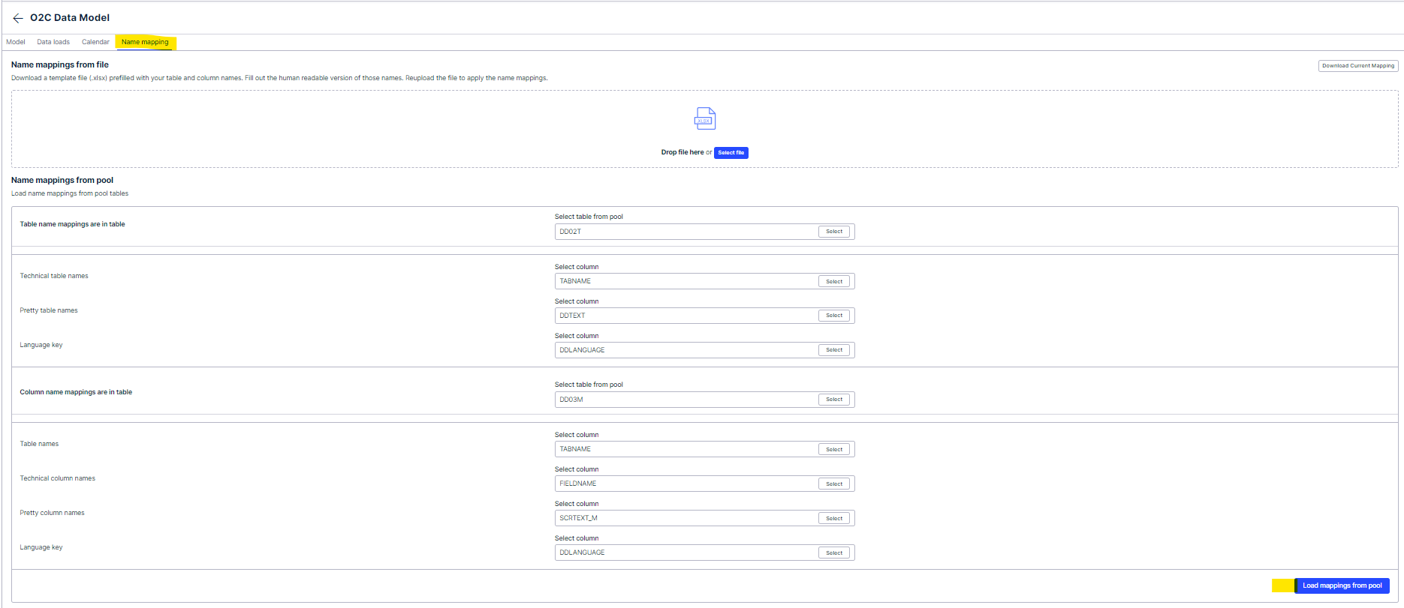
  2. Reload the Process Data Model.
  3. Create a package and an analysis in Studio.
  4. Add in a Variant Explorer, Process Explorer, Case Explorer, and additional dashboard(s) to the analysis.
  5. Build components within the analysis which are able to explain why the “Remove Delivery Block” and “Approve Credit Check” activities are impacting our business.