Chapter11
Phase Change
Melting 熔化freezing 凝固vaporization 气化condensation 冷凝sublimation升华 deposition 沉积
Heat of phase change q1+q2 = q3
Q3>q2>q1
Supercritical fluids
The temp beyond which a gas cannot be compressed to form liquid phase is called its critical temp
The pressure needed to compress the liquid at critical temp is called critical temperature
Critical 此处可以翻译为临界
The state beyond this temperature and pressure is called a supercritical fluid
The greater the IF the higher the critical temperature
Vapor Pressure
From p = 0 理解这个概念
The ending position is the vapor pressure
Temp increase the fraction of m to escape increases, thus the vapor pressure increases
Normal b.p.
The temp. of a liquid which its v.p. = atmospheric pressure
Normal b.p.
Phase diagram
Liquid crystals

Chapter13 Properties of Solutions
In a solution, the solute (溶质) is dispersed (分散) uniformly throughout the solvent (溶剂)
对于非极性物质，色散力占主导 对于离子物质，离子-偶极作用占主导
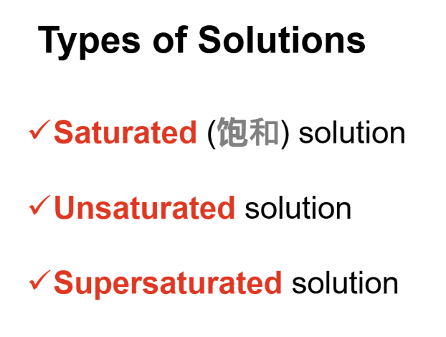
crystallization
In general, the solubility of gases in water increases with increasing mass.
the solubility of a gas in a liquid is directly proportional to its pressure.
Sg = kPg
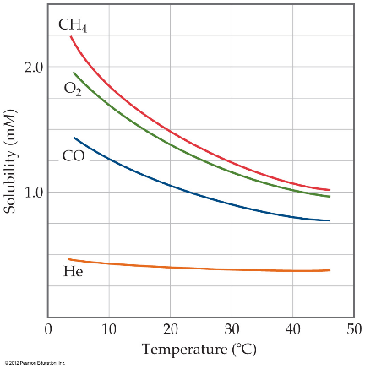
Mass Percentage
Mole Fraction (X)
Molarity (M)
Molality (m，molal)
当涉及温度变化时，常用质量摩尔浓度
Colligative Properties (依数性)
Including:
- Lowering of v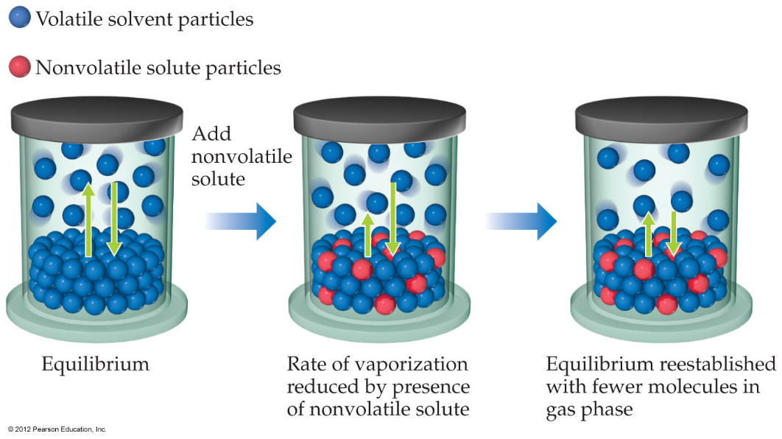
Therefore, the vapor pressure of a solution is lower than that of the pure solvent.
- apor-pressure
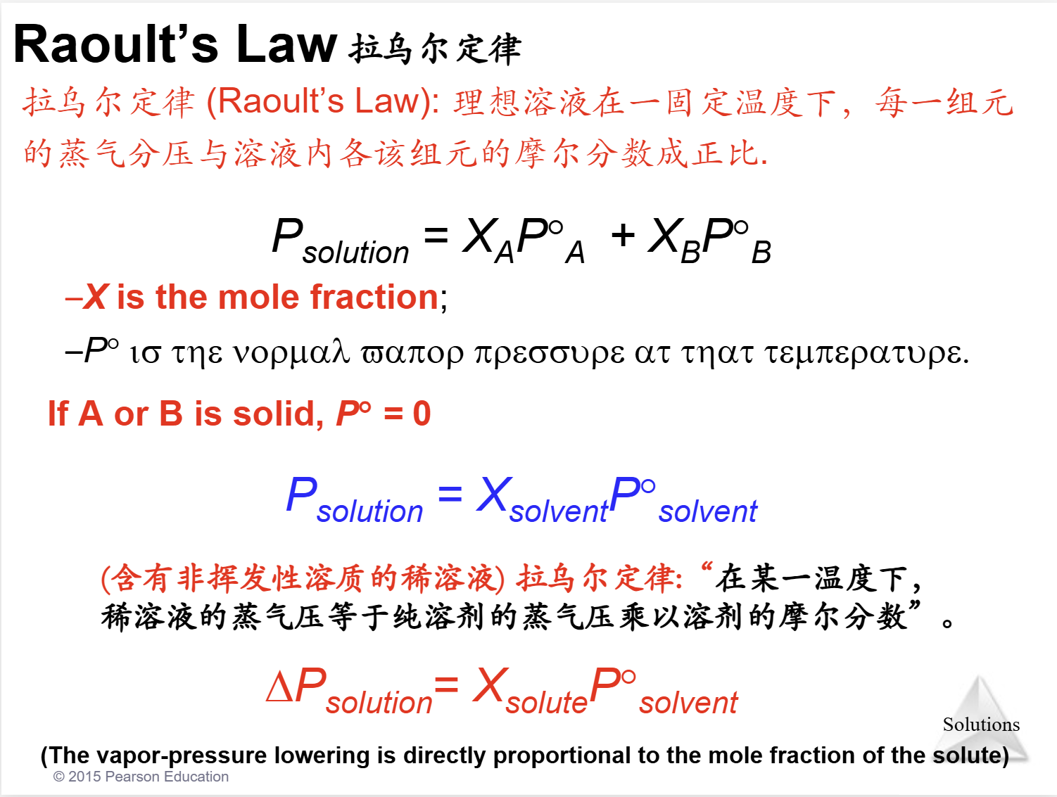

- Raising of boiling-point
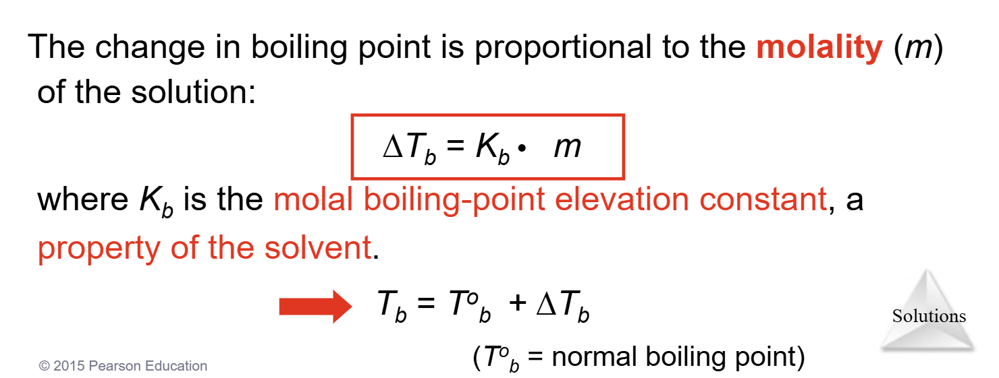
- Lowering of melting-point
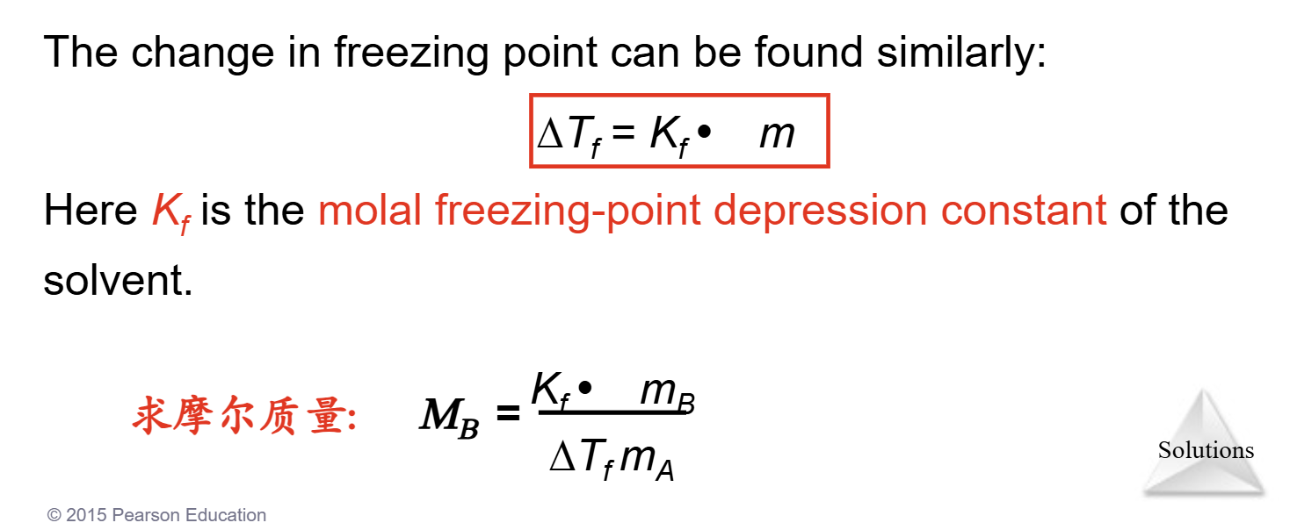
Colligative Properties of Electrolytes
Some Na+ and Cl− re-associate for a short time, so the true concentration of particles is somewhat less than two times the concentration of NaCl.

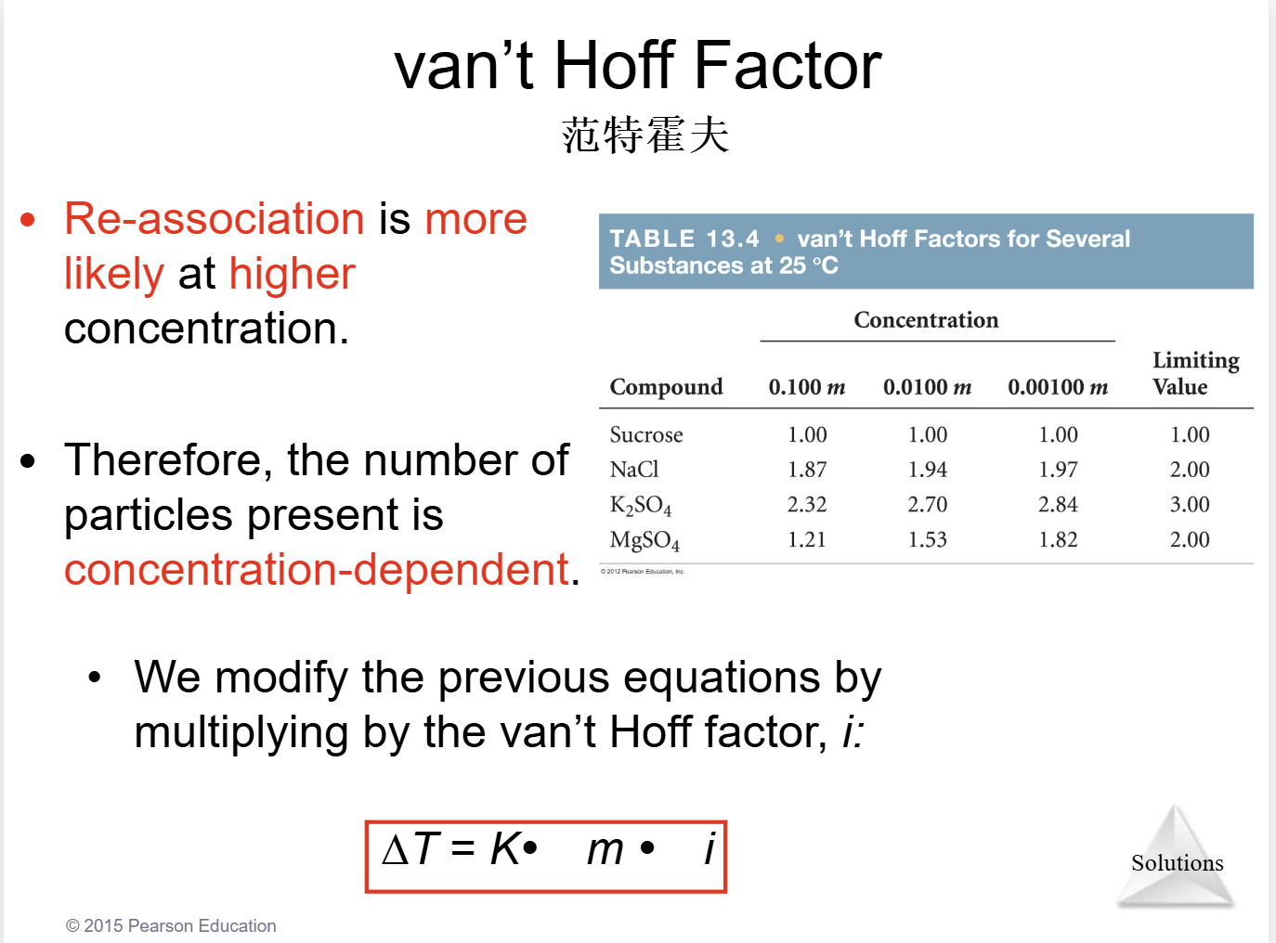
- Osmotic pressure
hypertonic (高渗的).
hypotonic (低渗的).
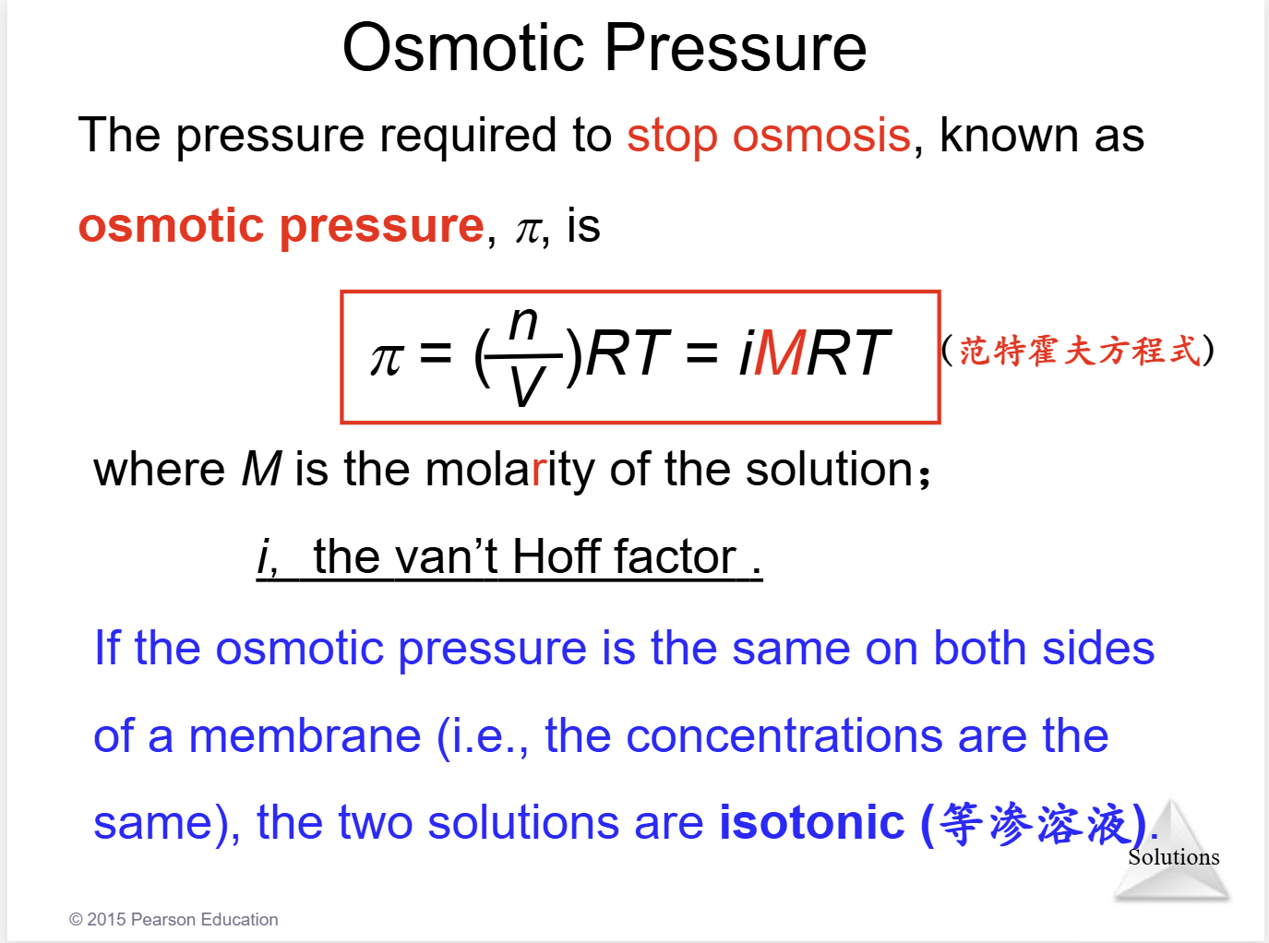
Colloids (胶体)
Colloid particles range in diameter from 5 to 1000 nm
These colloids may be hydrophilic (water loving) or hydrophobic (water fearing).
Emulsifying agents:
[ɪˈmʌlsɪfaɪ]乳化剂
乳化是一种将两种原本互不相溶的液体（通常是油和水）混合在一起，形成一种看起来均匀、稳定的混合液的过程。这个过程得到的最终产物被称为乳状液

Chapter14 Chemical Kinetics
we study the rate
Reaction rate
Relative Rates
Based on the experiments, we got the rate law (速率定律), which shows the relationship between rate and concentration for all reactants:

First Order Reactions
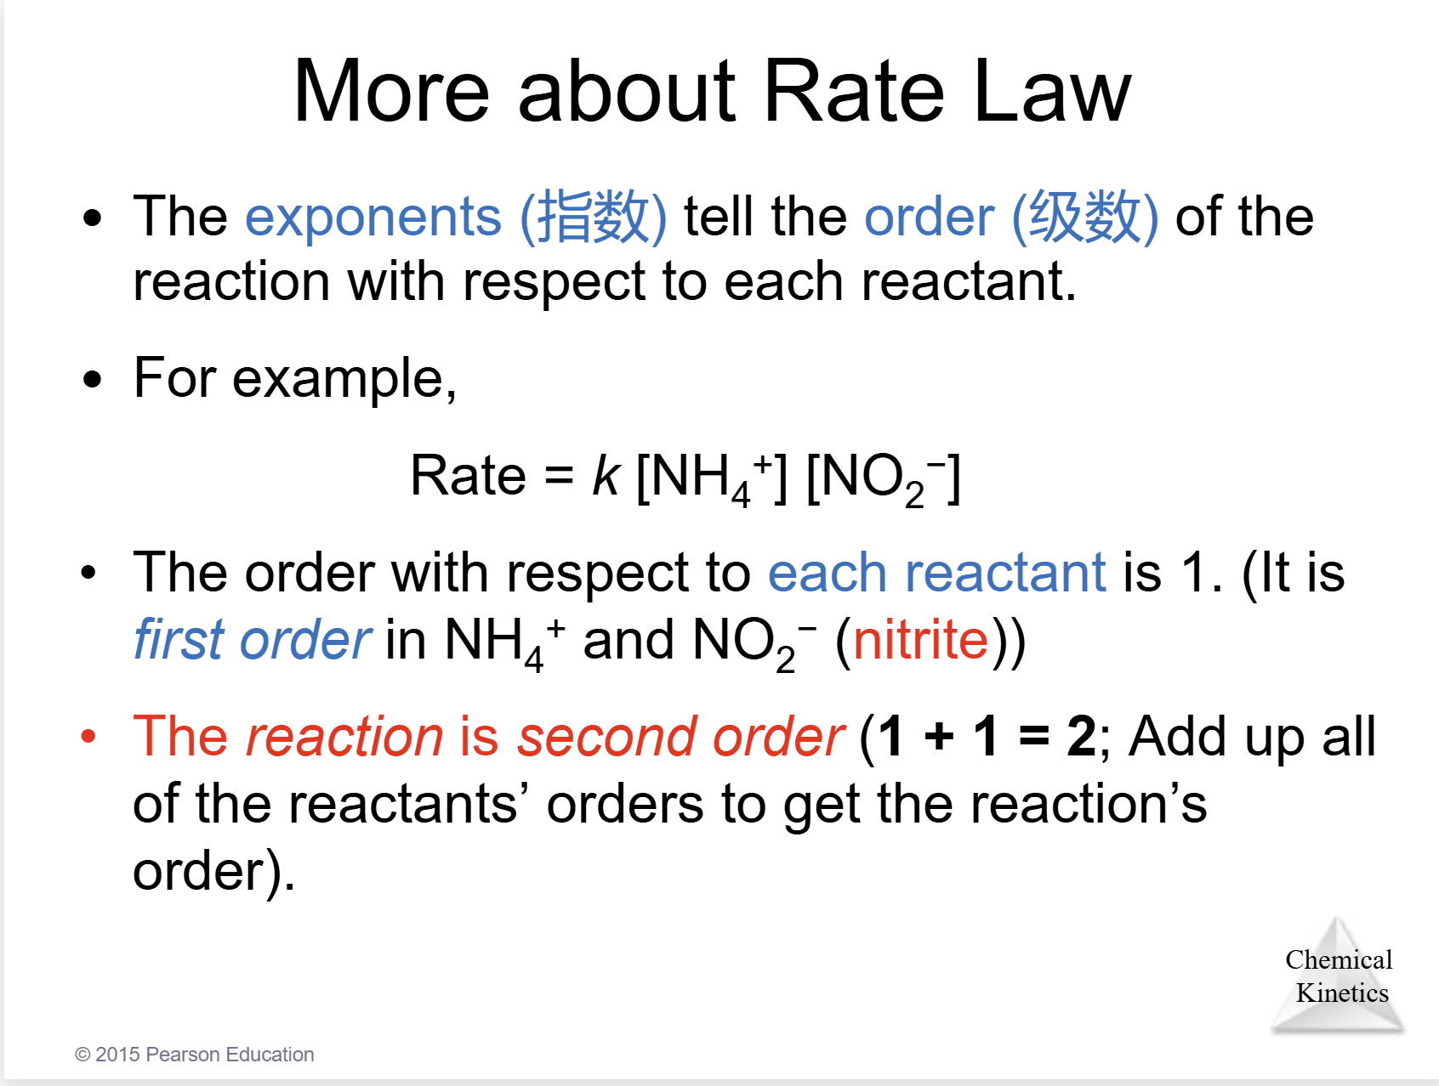
要注意 一个反应的order分为 reactant 的和 reaction的
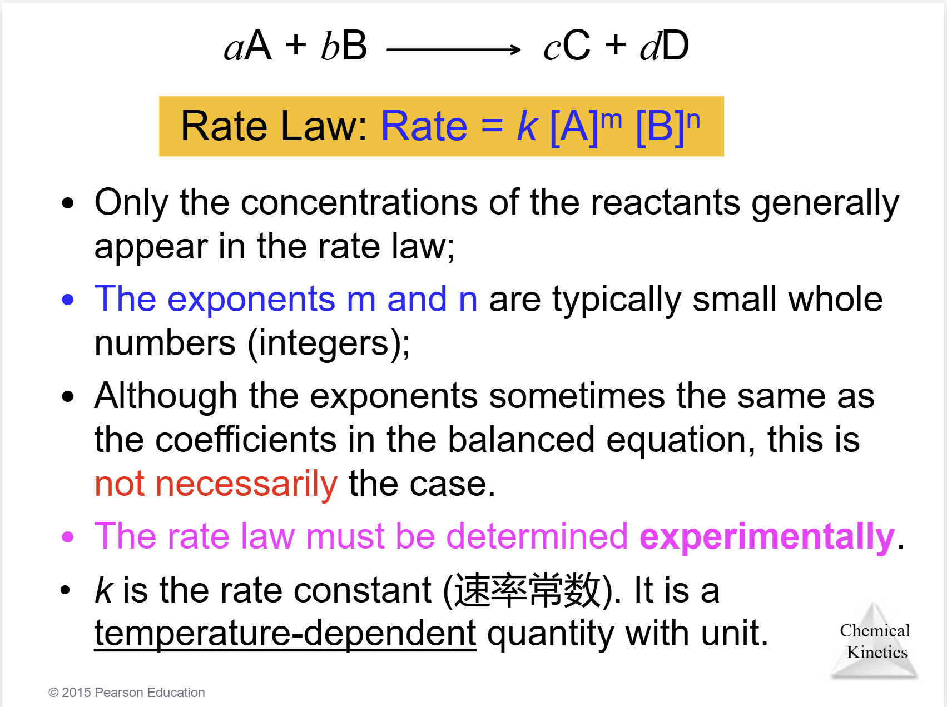
Frist Order
Ln [at] = -kt + ln[ai]
Ln 2 = k t0.5
T0.5 = 0.693/k
Second Order (Rate Law = k*[a]^2)
1/[at] = kt + 1/[ai]
T0.5 = 1/k[ai]

1/[A]t = k t + 1/[A]o This formula can be used to compute the final concentration

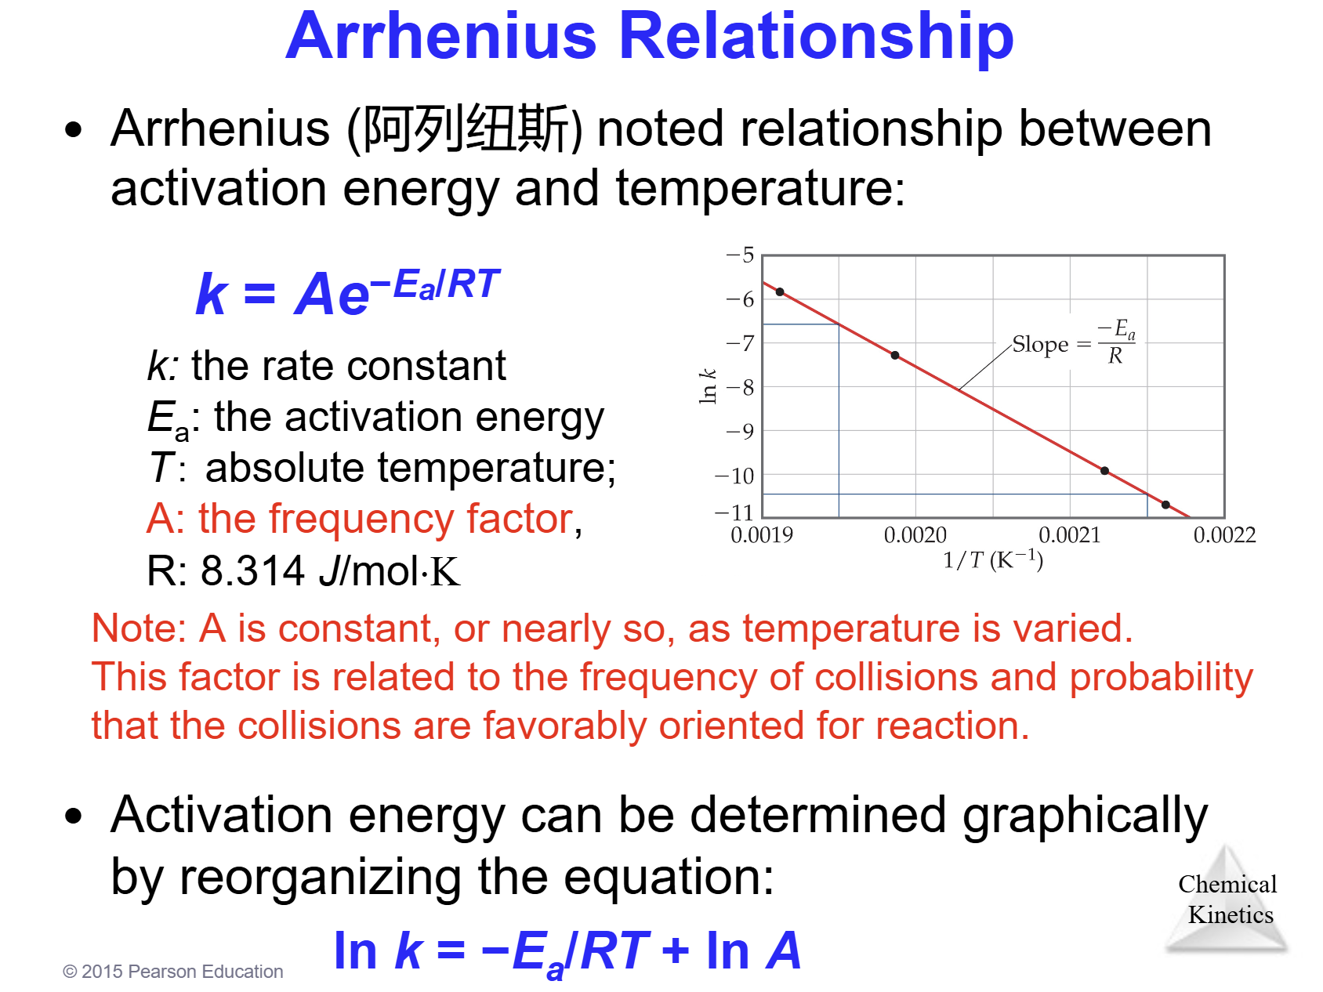

Reaction Mechanisms
elementary reaction (基元反应)
Nearly all mechanisms use only unimolecular or bimolecular reactions.
If a reaction is elementary, its rate law is based directly on its molecularity.
正常情况下，我们会了解哪一步是决速步，会有若干种决速步的情况，而后使用rate law 去决定是哪一种情况是决速步。
即If the first step is the rate-determining step, the coefficients on the reactants side are the same as the order in the rate law!
对于快速步而言，用可逆符号表示正向的反应速率等于反向的反应速率。
利用r+ = r- 来完成消元可以将决速步式子换成想要的物质。
Plausible means possible and make sense
molecularity
uni-/bi-/ter-

Chapter15 Chemical Equilibrium
Equilibrium Constant Kc
通过正反向的rate平衡时相等推出来的结论 => Kc is a constant
➢ The equilibrium-constant expression depends only on the stoichiometry of the reaction, not on its mechanism.*
➢ Equilibrium constants are reported without units.*
主要原因是平衡常数本质上是通过活度activity来计算的，而活度不带单位

Chapter16 Acid–Base Equilibria
Arrhenius (阿列纽斯)
Brønsted–Lowry （BL酸碱）
– An acid is a proton donor. HCL
– A base is a proton acceptor. NaOH
Lewis Acid/Base
Lewis acids are electron pair acceptors.
Lewis bases are electron pair donors.
amphiprotic (两性的).
A substance capable of acting as either an acid or a base is called amphiprotic.
Conjugate Acids and Bases 共轭酸碱对
Reactions between acids and bases always yield their conjugate bases and acids.
通过加减H 完成变换
Acidic, Basic, or Neutral
Hydrolysis

Chapter 17 Additional Aspects of Aqueous Equilibria
Buffers
Henderson Hasselbalch equation：pH = pKa + lg([A–]/[HA])
This applies only to buffers.
the pH range of a buffer is usually ±1 pH unit from pKa.
Titration 滴定
Titration of a Strong Acid with a Strong Base
With 谁就是加入谁
Using the Henderson Hasselbalch equation, we can see that half way to each equivalence point gives us the pKa for that step.

Chapter 19 Chemical Thermodynamics
Enthalpy vs Entropy
Spontaneous
Reversible process Irreversible processes
Translational
Vibrational
Rotational
Standard Molar Entropies (So)
ΔS°= ΣnS°products – ΣmS°reactants
so we call −T*ΔSuniv the free-energy change (ΔG)
Standard Free Energy Changes
Analogous to standard enthalpies of formation are standard free energies of formation 标准生成 自由能, ΔGf°:
ΔG°= ∑𝑛ΔGf°𝑝𝑟𝑜𝑑𝑢𝑐𝑡𝑠 −∑𝑚ΔGf°(𝑟𝑒𝑎𝑐𝑡𝑎𝑛𝑡𝑠)

Solution 1 M concentration
Element Gf0 = 0 for element in standard state
ΔG = ΔG°+ RT ln Q
ΔG° = −RT ln K

Chapter 20 Electric
cell potential (电池电位) Ecell.
standard hydrogen electrode (SHE)
the reduction potential for hydrogen is 0 V
Standard Reduction Potentials 标准还原电位
The cell potential at standard conditions can be found through this equation:
= Ered(cathode) – Ered(anode) (always positive)
an intensive property
谁ΔE大谁就是阴极（得电子）
对于任意自发得氧化还原反应E° = E°red (reduction) – E°red (oxidation)
ΔG= –nFE (F is the Faraday constant, 96,485 C/mol, n is the number of moles of electrons)
E = E° – (0.0592V/n) lg Q
E = E° – (2.303 ) lgQ
Cathode
Anode
Electrolysis
Q = It = nF n是一段时间内通过导线的电子数

