 University of Asia Pacific

Department of Computer Science and Engineering
CSE 438: Robotics Lab

LAB REPORT
Experiment Number: 01
Experiment Title: Designing of a Line Following Robot with IR Sensors

Submitted by:
Name: Joynove Binta Mim
Student ID: 23101179
Section: D1

Submitted to:
Md. Rasheduzzaman
Lecturer
CSE,UAP

1. Experiment Name :
Mini Project 1: Designing of a Line Following Robot with IR Sensors

2. Objective

This project is to develop a line-following robot using IR sensors and a microcontroller. The robot will be able to sense the contrast between the line and the surrounding surface, process the sensor signals, and control its motors to move along the designated path accurately and autonomously.

3. Apparatus / Hardware & Software Requirements
Hardware:
- Arduino Uno
- IR Sensor Module (2)
- DC Gear Motors (2)
- L298N Motor Driver Module
- Robot Chassis
- Robot Wheels (2)
- Caster Wheel
- Breadboard
- Jumper Wires
- Battery / Power Source
Software:
- Arduino IDE
- Tinkercad

4. Circuit Diagram / Schematic

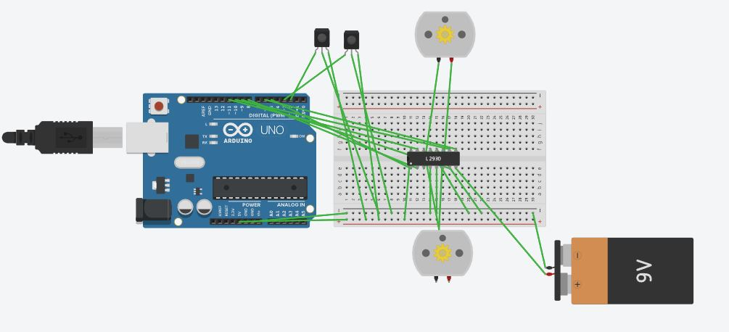

5. Code / Assembly Program

// Line Following Robot

// Arduino UNO + 2 IR Sensors + L293D + 2 Motors

int leftIR = 2;

int rightIR = 3;

// Left Motor

int IN1 = 8;

int IN2 = 9;

// Right Motor

int IN3 = 10;

int IN4 = 11;

void setup() {

pinMode(leftIR, INPUT);

pinMode(rightIR, INPUT);

pinMode(IN1, OUTPUT);

pinMode(IN2, OUTPUT);

pinMode(IN3, OUTPUT);

pinMode(IN4, OUTPUT);

}

void loop() {

int left = digitalRead(leftIR);

int right = digitalRead(rightIR);

// Both sensors on white

if (left == HIGH && right == HIGH) {

forward();

}

// Left sensor on black

else if (left == LOW && right == HIGH) {

leftTurn();

}

// Right sensor on black

else if (left == HIGH && right == LOW) {

rightTurn();

}

// Both sensors on black

else {

stopRobot();

}

}

// Move Forward

void forward() {

digitalWrite(IN1, HIGH);

digitalWrite(IN2, LOW);

digitalWrite(IN3, HIGH);

digitalWrite(IN4, LOW);

}

// Turn Left

void leftTurn() {

digitalWrite(IN1, LOW);

digitalWrite(IN2, LOW);

digitalWrite(IN3, HIGH);

digitalWrite(IN4, LOW);

}

// Turn Right

void rightTurn() {

digitalWrite(IN1, HIGH);

digitalWrite(IN2, LOW);

digitalWrite(IN3, LOW);

digitalWrite(IN4, LOW);

}

// Stop

void stopRobot() {

digitalWrite(IN1, LOW);

digitalWrite(IN2, LOW);

digitalWrite(IN3, LOW);

digitalWrite(IN4, LOW);

}

7. Result

The line-following robot was successfully designed and simulated using Tinkercad. The robot detected the line through IR sensors and moved according to the path. Thus, the main objective of the project was successfully completed.

8. Conclusion
The project was successfully completed by using Arduino, IR sensors, and DC motors. The robot could sense the path and change its direction automatically based on the sensor readings. Through this project, we learned how sensors and motors work together to make a robot move automatically. The required performance of the line-following robot was achieved successfully.

