Ephys Inc. Master Analysis Protocol
Last updated: 2025_12_22 by Christian Althaus and Rachel Callaghan

****Things to add
-Work flow protocol with abf saving and storage
-roughly which abf files correspond to which traces and measures
-
-Metadata workflow and input
-Tips and tricks

-“updated” for each section

Resting Membrane Potential (RMP)
- Drag and drop file into clampfit
- Set Cursor 1 and 2 at 0.0s and .200s, respectively
- Hit Statistics
- Select Baseline as “Fixed at: 0”
- Select search region to 1
- Range: Cursor 1…2
- “From” and “To” should reflect 0.0 and 0.200s
- Measurements Select mean (mV)
- Destination option: append results to sheet
- Hit ok
- Mean values will be displayed in the Results page under R1S1 mean (mV)
- Repeat for all RMP files across groups
- TIP: if you drag and drop the next file onto the one you just analyzed, it will place the cursors at 0.0 to .200s instead of their default starting points
- Copy Results table into excel or analysis software to compile and average
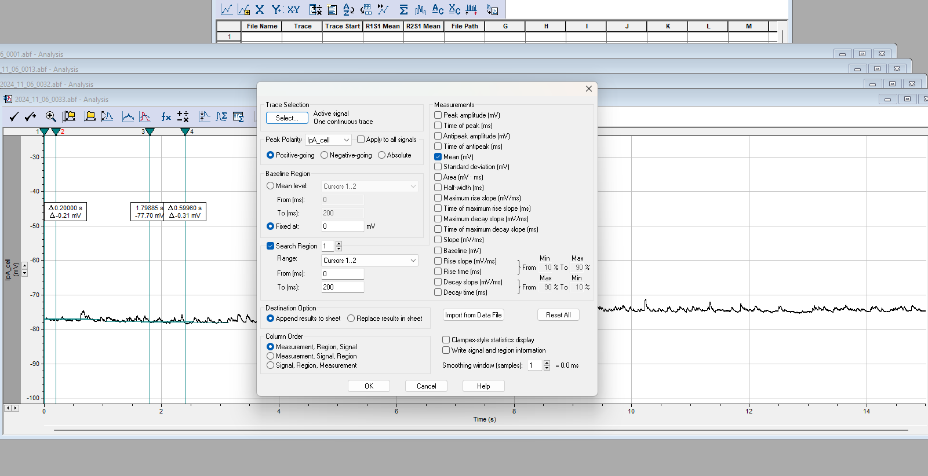

Input Resistance and Sag Ratio
- Drag and drop abf file onto clampfit
- Cursor Positions
  - Double click on analysis window and under “cursor options” add another pair of cursors for a total of 3 sets
  - double click on cursor 1 and type in Time the seconds below – can scroll to next one by hitting “next”
- 0.0 s
- 0.2 s

- 0.3 s
- 0.5 s

- 1.0 s
- 1.2 s

- Note*** if one of the traces has an action potential in the baseline region (cursors 1 and 2) or the steady state region (cursors 5 and 6), remove that trace prior to running the statistics below.
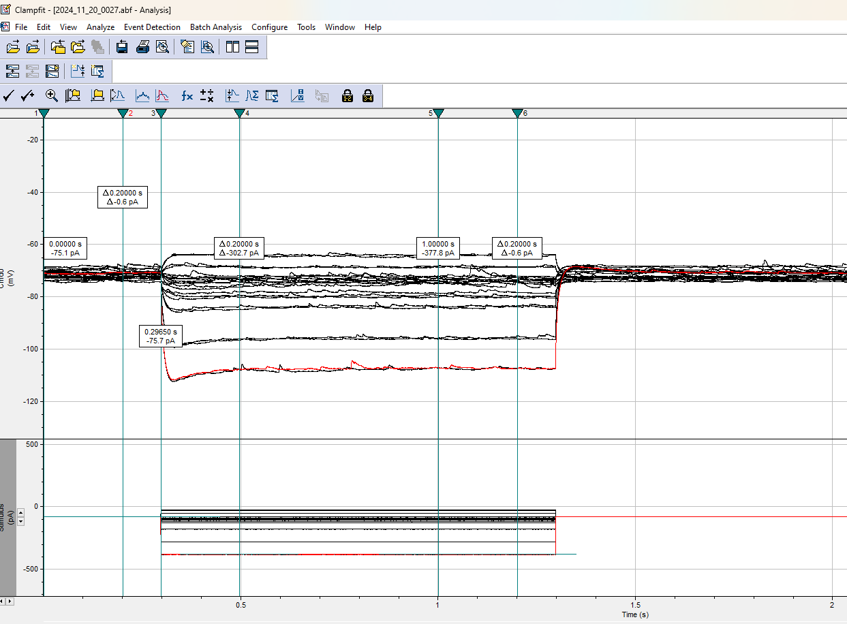

- Click the “Statistics” symbol at top of window
- Setup Measurements (see figures below):
  - Under “Trace Selection”
    - Select “All visible signals” and “All visible traces”
  - Under “Peak Polarity”
    - Check “Apply to all Signals”
    - Select “Positive-going”
  - Under “Baseline region”
    - Select “fixed at:” and enter 0mV
  - Search region 1
    - Range: Cursors 1 and 2
    - Location should self populate
    - Measurements: Check “MEAN”
  - Search region 2
    - Range: Cursors 3 and 4
    - Measurements: Check “Antipeak amplitude” AND “Time of Antipeak”
  - Search region 3
    - Cursors 5 and 6
    - Measurement: Check “MEAN”
  - Under “Destination Option” Choose to append or replace results in sheet (can keep track of previous recording’s measurements or just replace the old ones – your decision)
  - Column order: Measurement, Region, Signal
  - See figures below

Search Region 1:
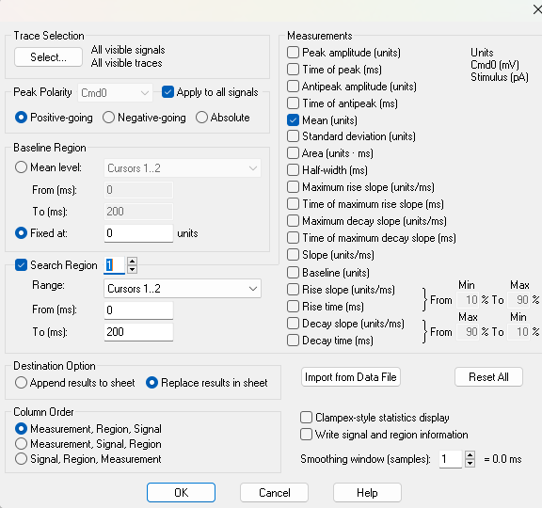

Search region 2: Search region 3:
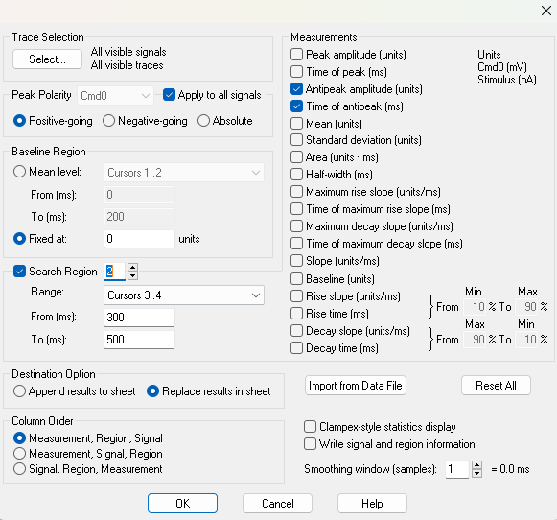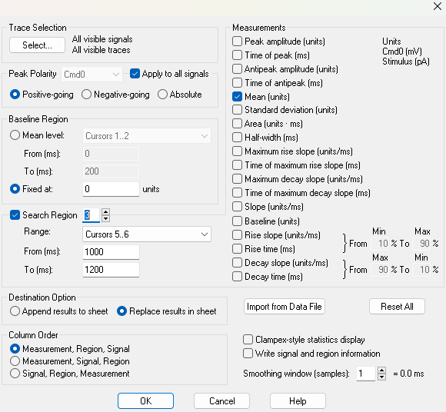

- Click “OK”
- Measurements will appear in the Results window under the Statistics tab
- Copy and paste this table into excel to analyze

- Columns of interest are (see figure below):
  - Note: Region refers to area between cursors. Signal refers to mV vs pA (stimulus)
  - R2S1 (Region2, Signal 1) Antipeak Amp (mV)
    - This is your peak negative mV for each trace between cursors 3 and 4
    - Subtract this value from R1S1 Mean (baseline) to get the change, or delta, in mV
  - You can largely ignore the next 3 columns, but time of anti peak could be interesting to see at what point in time the peak Sag is reached
  - R1S1 Mean (mV)
    - This is your baseline mV between cursors 1 and 2
    - Subtract this value FROM your Antipeak and R3S1 Mean (steady state) to get the delta mV
  - R1S2 Mean (pA)
    - Baseline pA from your stimulus signal
    - Subtract this value FROM your R3S2 Mean to get the delta pA, or in other words, how much current was injected for that stimulus
  - File path
    - Can ignore or save. Up to you

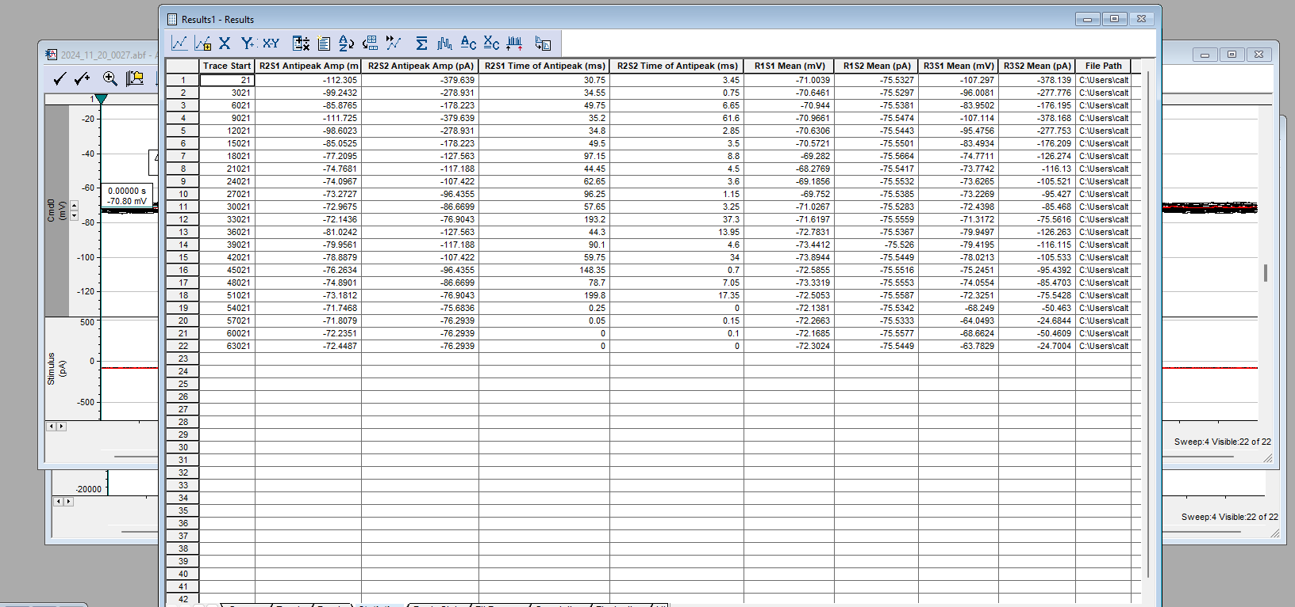
Calculate Input Resistance
- Subtract the Baseline mV and pA values (Region 1) from the corresponding Steady State values (Region 3)
- Graph the resulting columns on an I/V scatter plot
  - pA on the x-axis
  - mV on the y-axis
- Add a best fit line to the graph
  - Only graph sweeps between -50 and +50 pA
- The slope of the line will be your Input Resistance in Ohms!
- Multiply by 1000 to get the units to MOhms
- (note: graph below is different example from clampfit values above)
Copied over from Clampfit into Input Resistance Analysis Template (excel)
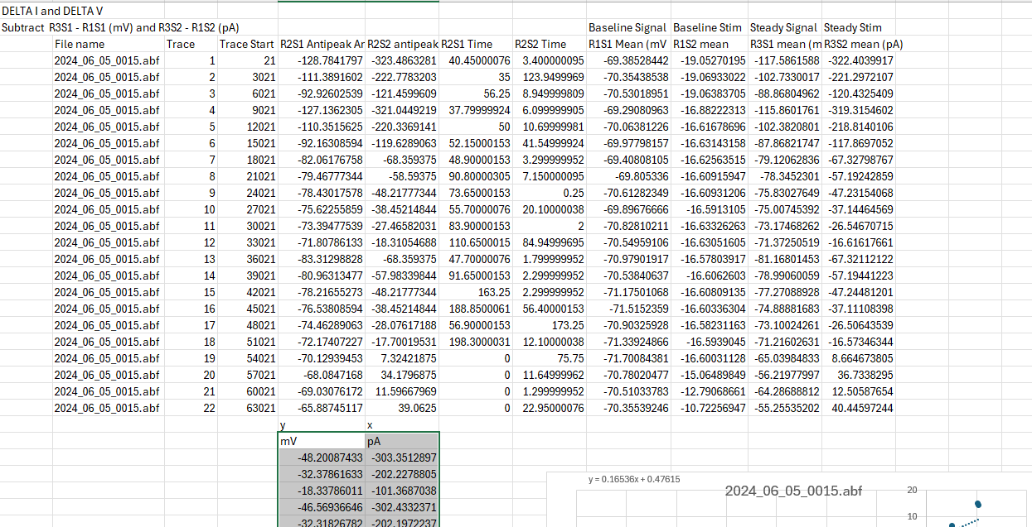
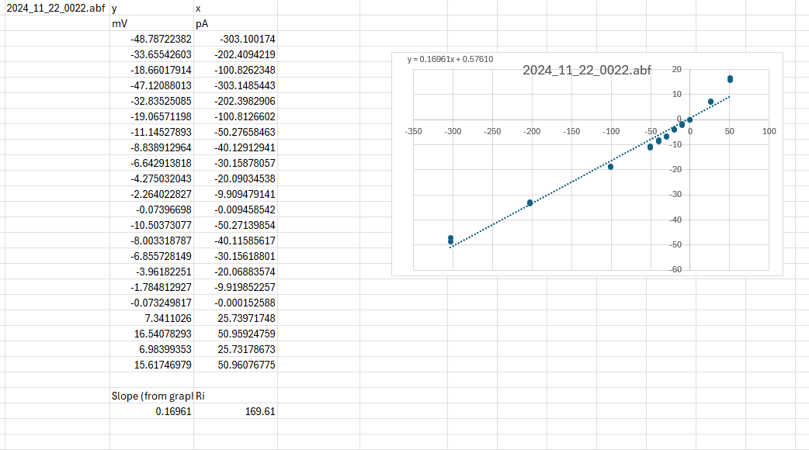

Calculate the Sag Ratio
- Subtract the Baseline mV value (R1S1 Mean) from the Antipeak Amp (R2S1) to get the delta peak mV (Sag or hump Amplitude)
- This Sag or hump amplitude could also be worth measuring and graphing
- Sag Ratio = (Steady State delta mV) / (Antipeak delta mV)
- Divide the mV column calculated from the input resistance by the antipeak column just calculated to get the Sag Ratio
- We’re only really interested in the two most negative current injections (-300 pA and -200 pA) – which are each performed twice (traces 1, 2, 4, 5)
- Average the two for each injection and that is your Sag ratio for that cell (see example below)

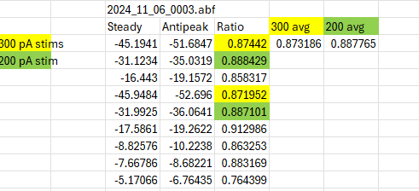

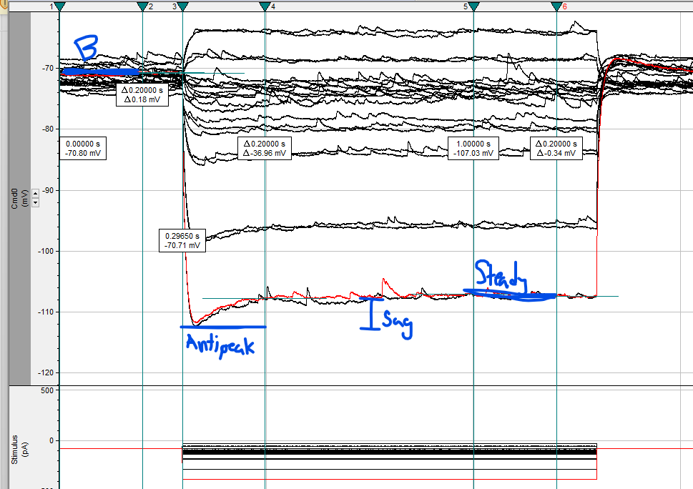

- Note: the smaller the Sag Ratio, the larger the Sag. The more negative current injections will likely result in a smaller sag ratio (larger Sag) due to more Ih channels being activated

5 Spike AHP

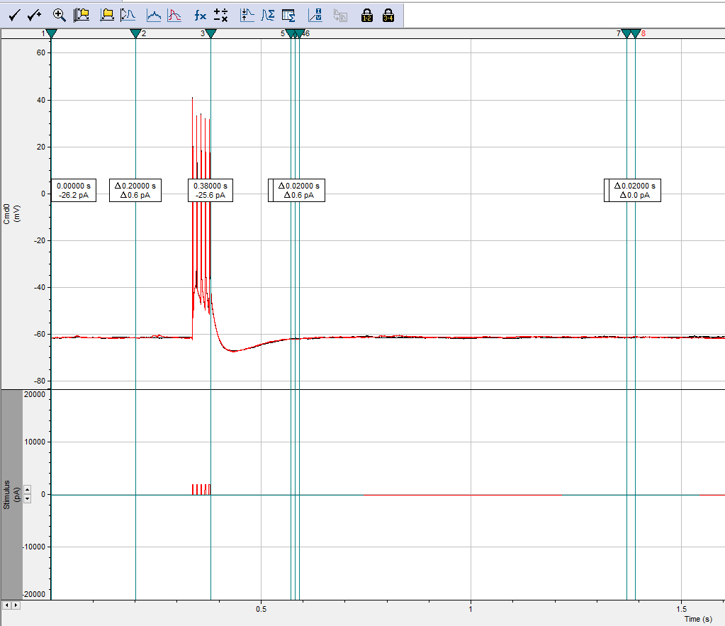

Spike AHP
- Drag and drop .abf file into Clampfit
- Adjust Cursor Positions
  - In analysis window, right click and select “properties”
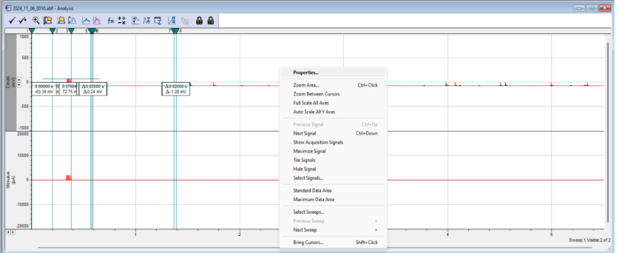
  - Under “Cursor Options” increase the number of cursor pairs to 4
  - Double click cursor 1 and change “Time (s)” to the value listed below – move through all cursors adjusting their value by selecting “next”
Cursors (newly updated 2025_03_17 for fewer decimal places)
Baseline
- 0.0
- 0.2
Medium (peak)
- 0.38
- 0.58
200ms AHP
- 0.57
- 0.59
slowAHP (sAHP)
- 1.37
- 1.39

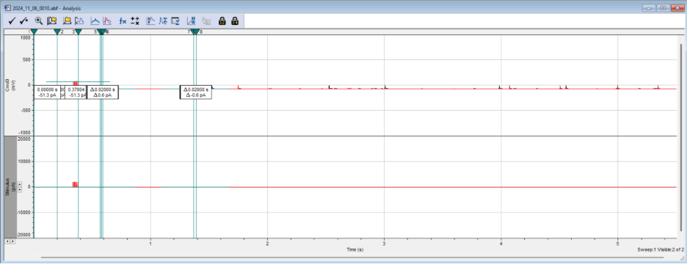
- Click the “Statistics” symbol at the top of the window
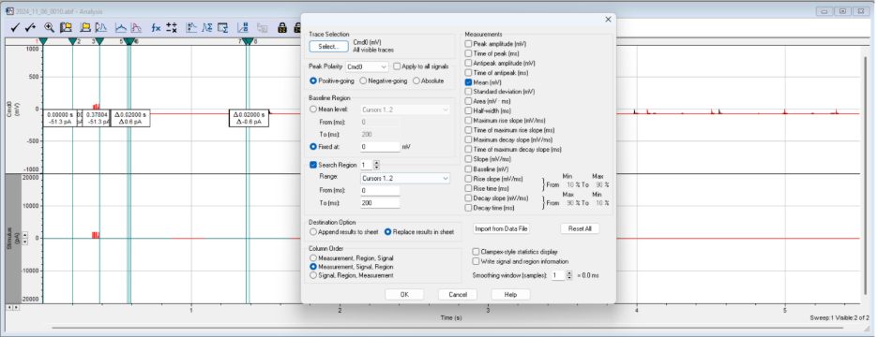
- Set up measurements
  - Under “Trace Selection”
    - Select “Cmd0” and “All visible traces”
  - Under “Peak Polarity”
    - Uncheck “Apply to all signals” and just select “Cmd0”
    - Select “Positive-going”
  - Under “Baseline region”
    - Select “fixed at:” and enter 0mV
  - Search region 1
    - Range: Cursors 1 and 2
    - Location should self populate
    - Measurements: Check “MEAN”
  - Search region 2
    - Range: Cursors 3 and 4
    - Measurements: Check “Antipeak amplitude”
  - Search region 3
    - Cursors 5 and 6
    - Measurement: Check “MEAN”
  - Search region 4
    - Cursors 7 and 8
    - Measurement: Check “MEAN”
  - Under “Destination Option” Select either append or replace results in sheet, matter of personal preference
  - Under “Column Order” Select “Measurement, Signal, Region)
- Click “Ok”
- Measurements will be printed in the “Results” window
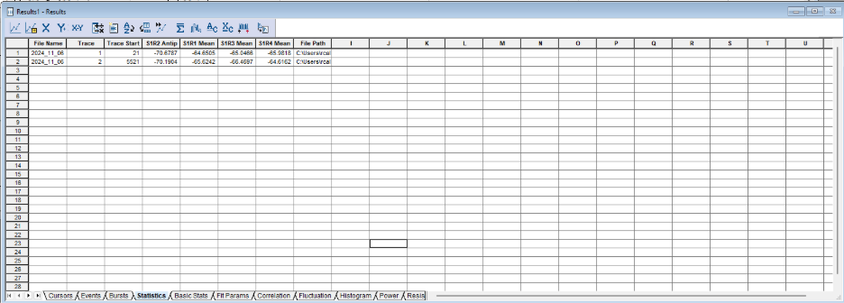
- Copy and paste data into an excel spreadsheet for further analysis
- An Explanation of each column of the produced results
  - Column 1: The file name, this can be especially useful if you are compiling the results of multiple recordings
  - Column 2: The Trace/Sweep that the results were produced from
  - Column 3: The time at which the Trace/Sweep began (ms)
  - Column 4: S1R2 Antipeak Amp, the magnitude of the signal’s antipeak (negative peak)
  - Column 5: S1R1 Mean, is the average of the cell’s BASELINE, which is used to normalize the other readings for AHP calculation
  - Column 6: S1R3 Mean, is the average unnormalized value of the mAHP
  - Column 7: S1R4 Mean, is the averaged unnormalized value of the sAHP
  - Column 8: File Path, is the file path used to find the origin of the .abf file used to produce these results

Calculate AHP
- The purpose of the data calculations is to normalize the values present in column 4, 6, and 7 as well as averaging the values of the two traces
  - Subtract the S1R1 mean from S1R2 the Antipeak value to calculate peakAHP
  - Subtract the S1R1 mean from the S1R3 mean to calculate the mAHP
  - Subtract the S1R1 mean from S1R4 mean to calculate the sAHP
  - After these calculations are done for both traces, calculate the average of the baseline, peakAHP, mAHP, and sAHP for each recording from the two traces

25 Spike AHP

25 spike peak/m/sAHP cursor placement
 |  | seconds | rounded update
baseline | 1 | 0.00000 | 0
 | 2 | 0.20000 | 0.2
Medium (peak) | 3 | 0.66394 | 0.66
 | 4 | 0.86394 | 0.86
200ms (old medium) | 5 | 0.85394 | 0.85
 | 6 | 0.87394 | 0.87
slow | 7 | 1.65394 | 1.65
 | 8 | 1.67394 | 1.67

50 Spike AHP
Cursors (DMG_1/2/26):
Baseline
- 0.0
- 0.2
Medium (peak)
- 1.41
- 1.61
200ms AHP
- 1.60
- 1.62
slowAHP (sAHP)
- 2.40
- 2.42

1s AP Firing
Cursors
- 0s and 0.2s
- 0.290s and1.5s

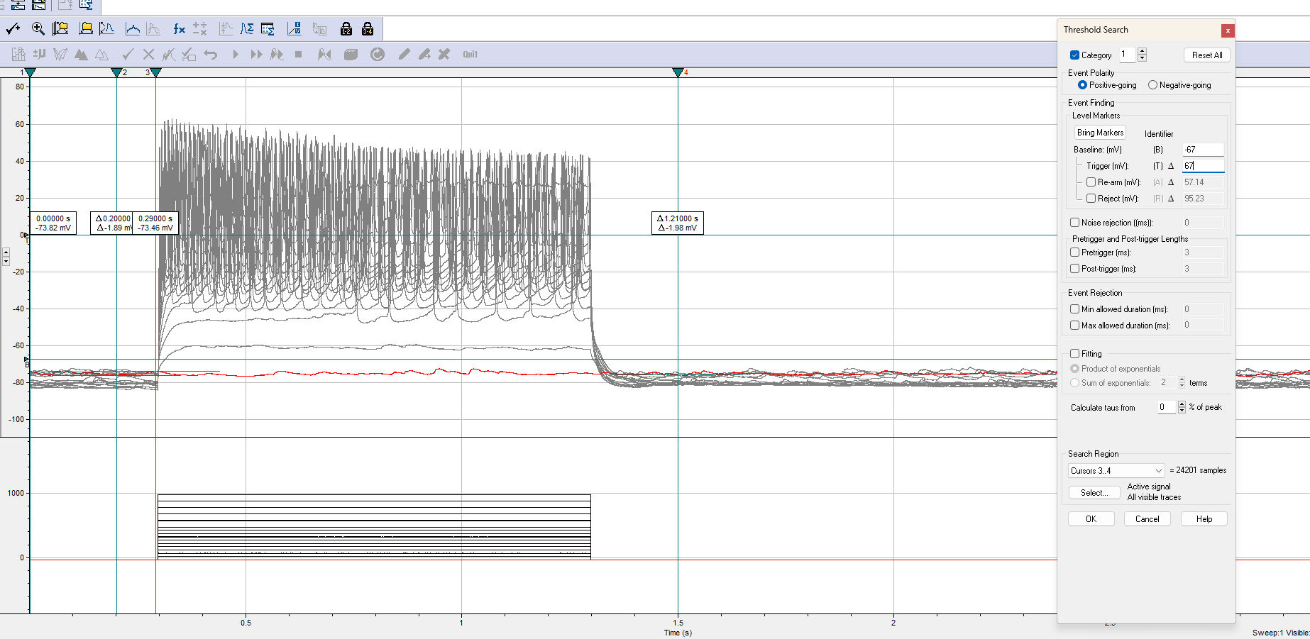

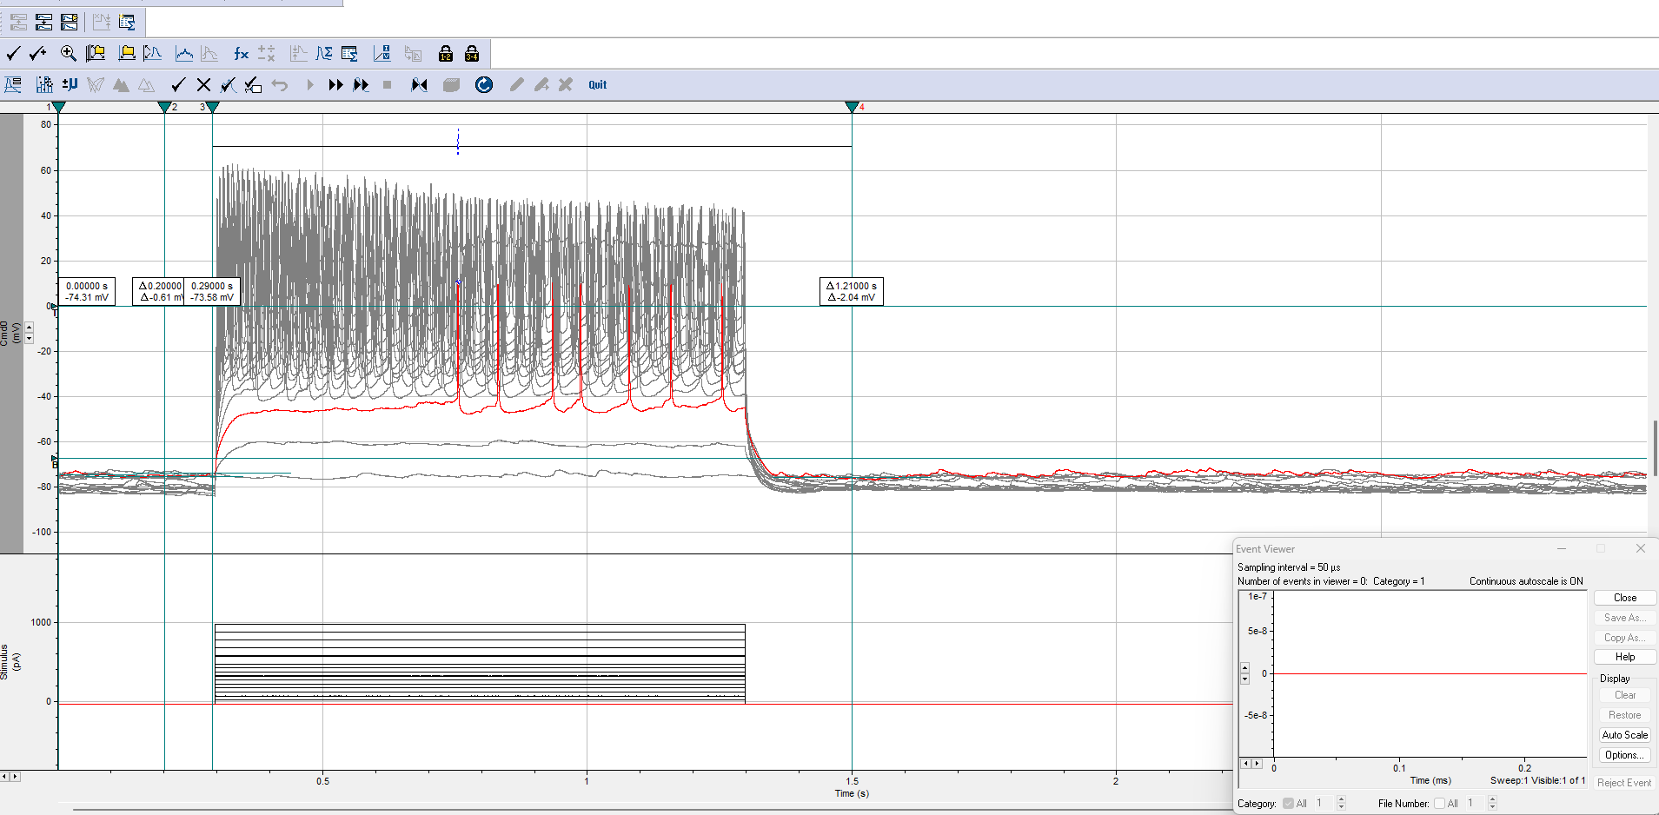

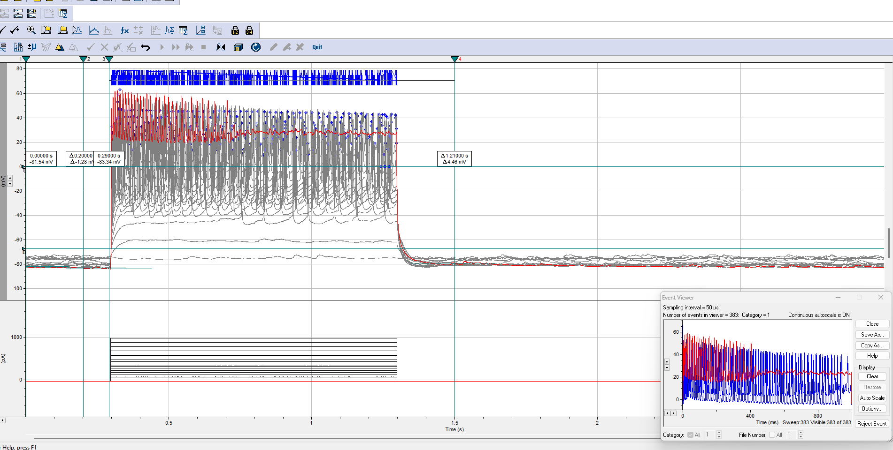

OBSOLETE ANALYSIS PROTOCOL IMAGES

