Rheobase Protocol

- Drag and drop abf file into clampfit
- Set cursor 1 to 0s
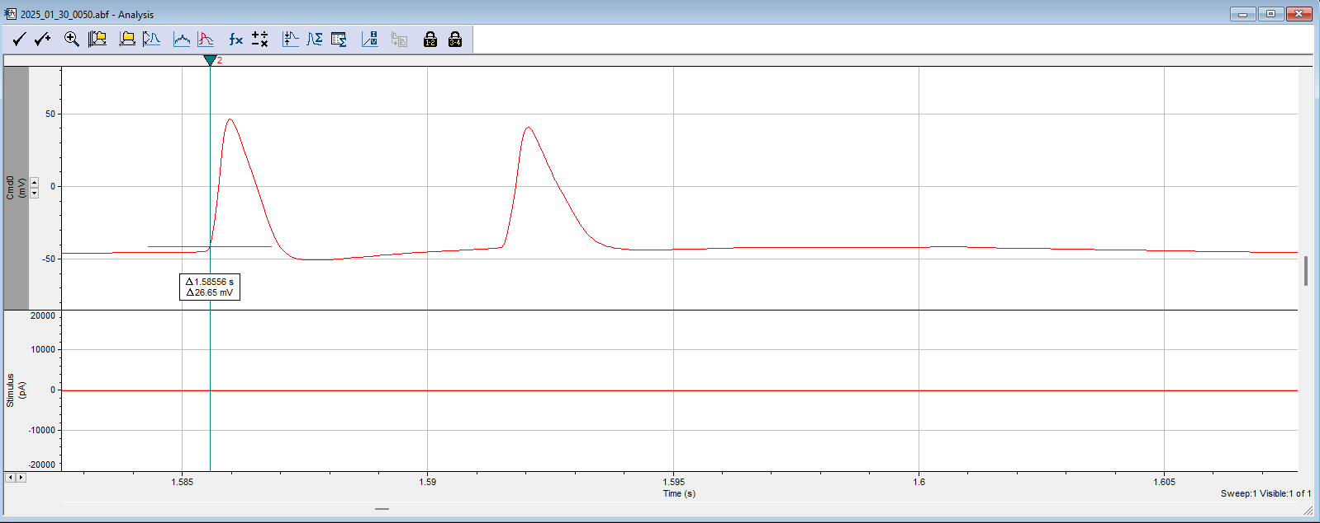
- Manually place cursor 2 where the FIRST action potential threshold takes place
- Click statistics
- Select search to region 1
- Range: Cursor 1…2
- From (ms) should always reflect 0.
- To(ms) will always be different depending on where Cursor 2 was manually set
- Destination Option
  - Append results to sheet
- Column Order: Measurement, Region, Signal
- Measurements:
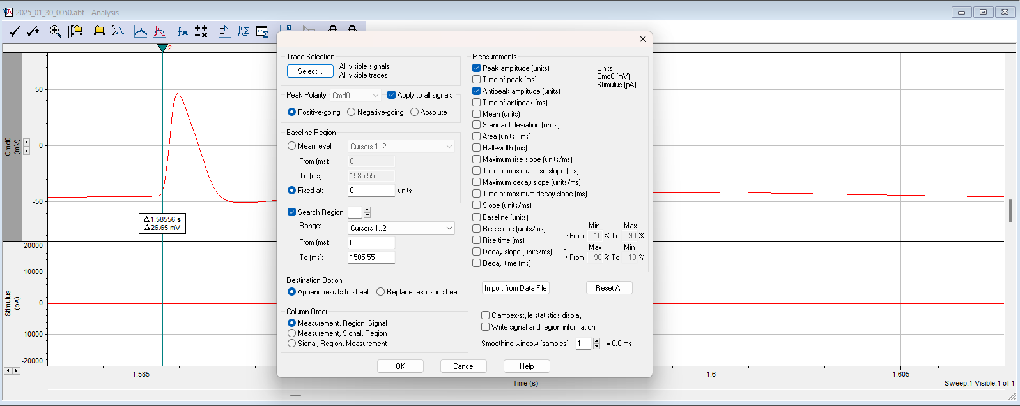
  - Check Peak Amplitude and Antipeak amplitude

- Results will be added to Results Sheet
- Continue to do this for all Rheobase Files
- When all files are complete, proceed to next step
- Copy and paste results from clampfit to Rheobase Template excel under the “Clampfit Export” section within the excel template
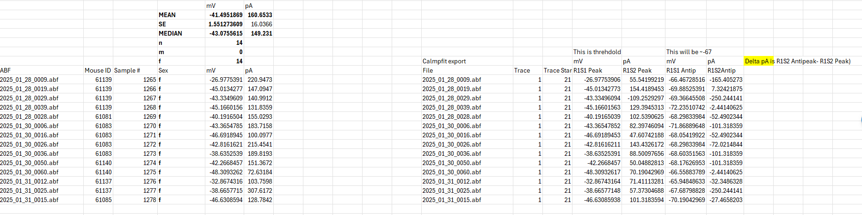
  - It will automatically do the calculations

Calculations defined:
- R1S1 Peak: The Action Potential Threshold mV
- R1S2 peak- R1S2 antipeak: Δ pA

