**SRS**

**TOPIC** – Books renting and management.

**CATEGORY-** Dynamic Web based application.

**Layers** --

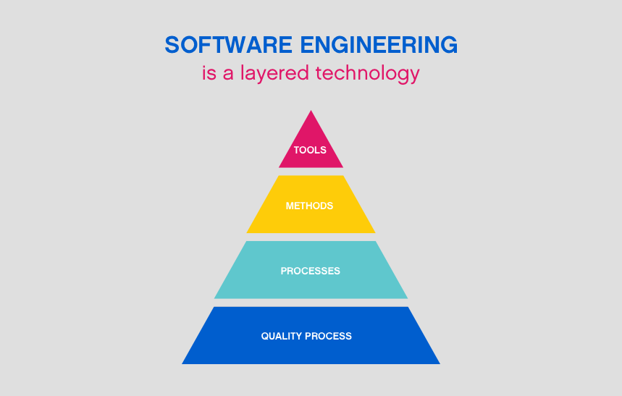

***Tools--***

Operating Systems – Windows

Programming Language – JAVA

Web designing – HTML, DHTML(CSS), Java script

Web technologies – Servelet, JSP

Database – MySQL

Server—Apache tomcat / Glassfish server

IDE – Net beans, Bootstrap

***Method****—*

This application works on a dynamic web based system which manages different libraries which are linked with this application, through which a user can access the libraries and can rent any book online.

***Model***— 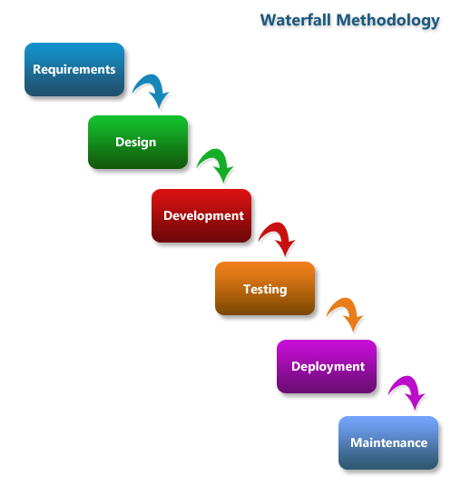

In this application we will use **Water fall Model**.

The waterfall model is a breakdown of project activities into linear sequential phases where each phase depends on the deliverables of the previous ones and corresponds to a specializations of tasks.