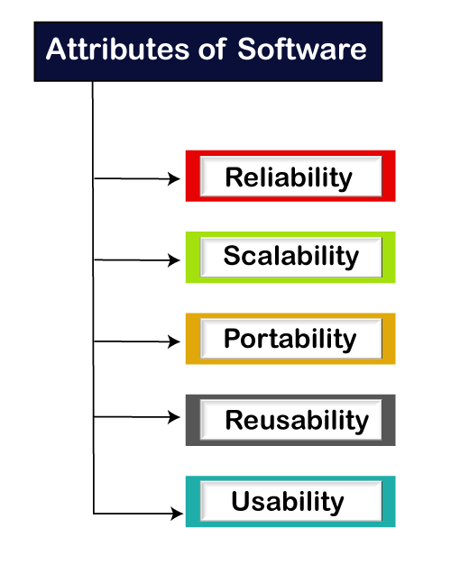**What is Software Testing**

* Software testing is a process of identifying the correctness of software by considering its all attributes.
* evaluating the execution of software components to find the software bugs or errors or defects**.**

**IEEE defines testing as**

The process of a system by manual or automated means to that it satisfies specified requirements or to identify differences between expected and actual results.

Software testing is closely related to the terms Verification and Validation.

Verification refers to the process of ensuring that the software is developed according to its specifications.

For verification, techniques like reviews, analysis, inspections and walkthroughs are commonly used.

Validation refers to the process of checking that the developed software meets the requirements specified by the user.

# **Bug, Error, Fault & Failure’**

* Bug is defined as a logical mistake, which is caused by a software developer while writing the software code.
* a [bug](https://www.javatpoint.com/bug-in-software-testing) is the informal name of defects,
  + which means that software or application is not working as per the requirement.
  + When we have some coding error, it leads a program to its breakdown, which is known as **a bug**.
  + The **test engineers** use the terminology **Bug**.

## Defect

When the application is not working as per the requirement is knows as **defects**. It is specified as the aberration from the **actual and expected result** of the application or software.

In other words, we can say that the bug announced by the **programmer** and inside the code is called a [**Defect**](https://www.javatpoint.com/defect-or-bug-tracking-tool)**.**

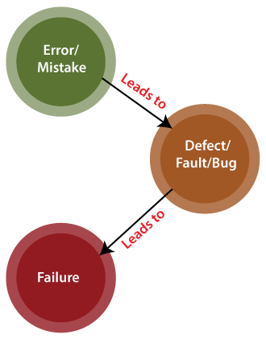

**Error**

* Error is defined as the measure of deviation of the outputs given by the software from the outputs expected by the user.
* The Problem in code leads to errors, which means that a mistake can occur due to the developer's coding error as the developer misunderstood the requirement or the requirement was not defined correctly.
* The **developers** use the term **error**.

**Fault**

* Fault is defined as the condition that leads to malfunctioning of the software.
* The fault may occur in software because it has not added the code for fault tolerance, making an application act up.

A fault may happen in a program because of the following reasons:

* Lack of resources
* An invalid step
* Inappropriate data definition

**Failure**

* + Defect that causes error in operation or negative impact is called failure.
  + Failure is defined as that state of software under which it is unable to perform functions according to user requirements.
* Many defects lead to the **software's failure**, which means that a loss specifies a fatal issue in software/ application or in its module, which makes the system unresponsive or broken.
* In other words, we can say that if an end-user detects an issue in the product, then that particular issue is called a **failure**.

**Testability**

Testability refers to **the degree that any module, requirements, subsystem or other component of your architecture can be verified as satisfactory or not.**

* The ease with which a program is tested is known as Testability.
* Testability is required so as to detect errors with minimum efforts.

