Game Design Document

“Rusty Defender”

Răzvanț Alexandru

**CONTENTS**

1. ***Concept***
   1. ***Player Model***
   2. ***Enemy Model***
2. ***Gameplay***
   1. ***Goal***
   2. ***User Skills***
   3. ***Game Mechanics***
   4. ***Progression and Losing***
3. ***Art style***
4. ***Music & Sounds***
5. ***Technical description* and Future Ideas**
6. ***Bibliography***

**1. Concept**

*A simple arcade game that imitates a classic space shooter where the player controls a space ship flying through cosmos. The idea is to survive the enemy asteroid waves that come towards the player, by either shooting or avoiding them.*

*The game does not consider boss concepts, it is a sort of infinite runner type of game.*

* 1. **Player Model**

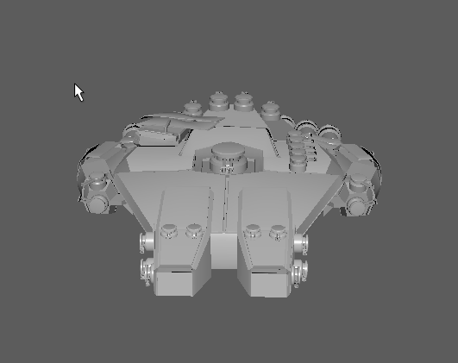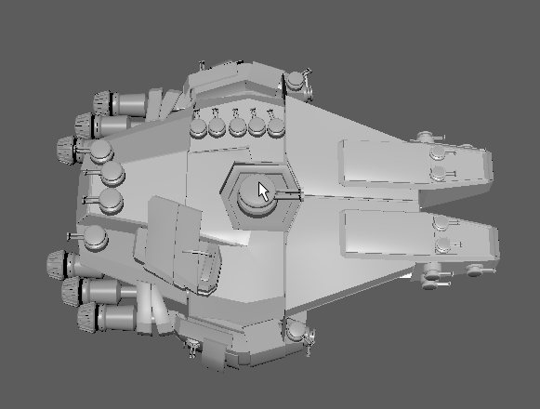

* 1. **Enemy Model**

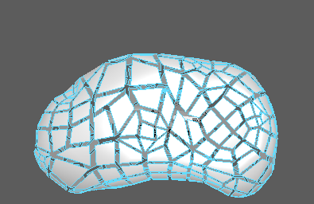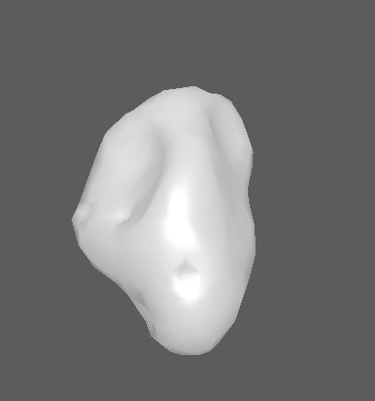

**2. Game Play**

“*The game begins with an idea.” - Jesse Schell, Book of Lenses*

*The Gameplay is simple, similar to classic arcade games. The player must either destroy or avoid colliding with the asteroids in order to gain score points and continue the game. If the asteroid hits the player, the game is over.*

**2.1. Goal**

*This is a challenging game where the player controlling the space ship must destroy enemy waves in order to survive. The goal is to destroy as many asteroids as you can.*

*Overall(long term) : Survive enemy waves*

*Gameplay(short term) : Shoot asteroids to gain score*

**2.2 User Skills**

1. *Hoover & Tilt*
2. *Shooting*
3. *Moving up/down/up/down*

**2.3 Game Mechanics**

* **Movement System** : The player can move left/right , up and down while enemies are moving strictly forward the player with no AI path-finding involved.

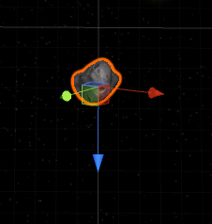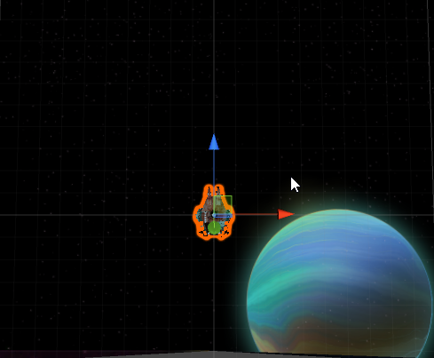

*The player can move by the red & blue axis.  
The enemy asteroid can move only on the blue axis.*

* **Shooting System** *: In the game only player can shoot projectiles, from the front turrets(2).Enemies cannot shoot.*

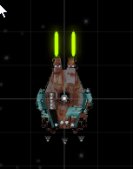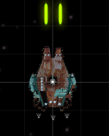

* **Rotation System :** 
  + *The rotation is randomly added to the enemy asteroids at their spawn time,to reflect the gravity in space.*
  + *When the player shoots the asteroid but doesn’t destroy it, the asteroid gains velocity from the projectile thus rotating faster while coming towards the player.*

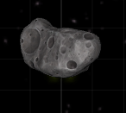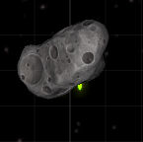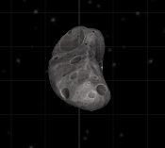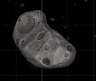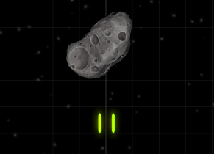

*2*

*1*

*Before collision.*

3

4

*After Collision.*

* **Particle system :**
  + 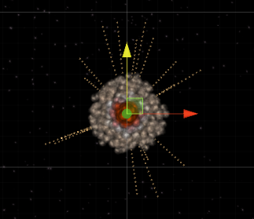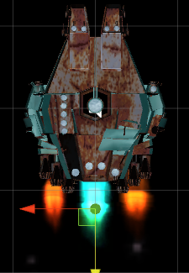The particle generator is used both on player’s movement animation, as jet fuel, and also at the explosion effect.
* **Game Controller:**
  + *The game is based on infinite gameplay rule, the waves keep coming faster and faster until the player gets hit and destroyed.*
  + *When the player is destroyed, a flashing text appears asking R for restart or Q for quitting the game.*
  + *Player gets 100 score points per destroyed enemy.*

**2.4 Progression and Losing**

*Difficulty will advance by spawning enemy waves faster as the game goes on.*

*Losing: When the player is destroyed, the game will be restarted by pressing ‘R’ key, or it will quit if the ‘Q’ was pressed.*

**3. Art style**

*This is a 2.5D game with high quality 2D sprites and 3D objects.*

*I don’t have copyrights on the objects used in the game.  
The 3D spaceship model was downloaded from free3d.com [Open Source]*

*The 2D sprites used for the background were downloaded from opengameart.org*

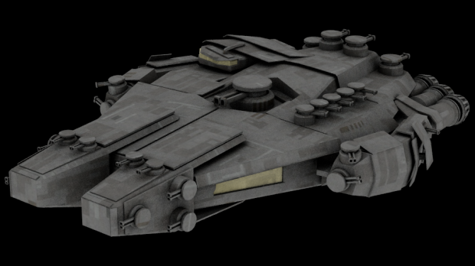

*Spaceship :*

*The 2D sprites were designed in Adobe Photoshop and Adobe Illustrator, using free Sprites from opengameart.org*

C:\Users\Joywalker\AppData\Local\Microsoft\Windows\INetCache\Content.Word\Background-Middle2.tifC:\Users\Joywalker\AppData\Local\Microsoft\Windows\INetCache\Content.Word\Background-Face.tifC:\Users\Joywalker\AppData\Local\Microsoft\Windows\INetCache\Content.Word\BackgroundUp.tifC:\Users\Joywalker\AppData\Local\Microsoft\Windows\INetCache\Content.Word\Background-Middle1.tif

**4. Music and Sounds**

*“Music is the language of the soul, and as such, it speaks to players on a deep level.” – Jesse Schell, Book of Lenses*

*The Main Menu music is horror/scary-like, involving some curiosity and challenge of what’s in the gameplay, and how to handle it.*

*This idea will help me develop the story of the game later on.*

*More on chapter 5.*

*The music background of the game, represents a track with fast notes and high pitches that insists on increasing the player’s adrenaline, while playing the game.*

**5. Technical description and Future Ideas**

*Initially, the game is developed for Windows x64-x86.*

*In the future I’m planning to also extend the game for the Android.*

*For the future directions of the gameplay, I’m planning to :*

* *Add Levels*
* *More enemies*
* *Add items and power/ups to the player*
* *Bosses*
* *Multiplayer - 2 Players*
* *Work on the quality of the text in Main Menu screen, and also replace some images with hi-res ones. For example the textures on the player ship.*
* *Add a story where the personage (the pilot) will find himself in a nightmare, flying the spaceship to escape all the obstacles, and after defeating the boss, he wakes up.*

# [BIBLIOGRAPHY]

1. Coding
   1. [**https://unity3d.com/ru/learn/tutorials**](https://unity3d.com/ru/learn/tutorials)
   2. [**https://www.tutorialspoint.com/csharp**](https://www.tutorialspoint.com/csharp)
   3. [**https://docs.unity3d.com/ScriptReference/**](https://docs.unity3d.com/ScriptReference/)
   4. [**http://ricardogeek.com/docs/clean_code.pdf**](http://ricardogeek.com/docs/clean_code.pdf)
2. 3D Desing
   1. [**https://www.youtube.com/watch?v=T-fFpmBYP_Q**](https://www.youtube.com/watch?v=T-fFpmBYP_Q)
3. 2D Textures Design
   1. [**https://www.youtube.com/watch?v=4gzJlHaSj5k**](https://www.youtube.com/watch?v=4gzJlHaSj5k)
4. Game Mechanics
   1. [**https://www.youtube.com/watch?v=szyDLSmhFbg**](https://www.youtube.com/watch?v=szyDLSmhFbg)
   2. [**https://www.youtube.com/watch?v=HrDxnMI7pCc&t=106s**](https://www.youtube.com/watch?v=HrDxnMI7pCc&t=106s)