FML_Assignment4

Jay Oza

2022-11-02

#install.packages("factoextra")  
library(factoextra) # Clustering algorithms & visualization

## Loading required package: ggplot2

## Welcome! Want to learn more? See two factoextra-related books at https://goo.gl/ve3WBa

library(ISLR)  
library(caret)

## Loading required package: lattice

#Importing our dataset

Pharmaceuticals <- read.csv("/Users/Jay/Downloads/Pharmaceuticals.csv")  
summary(Pharmaceuticals)

## Symbol Name Market_Cap Beta   
## Length:21 Length:21 Min. : 0.41 Min. :0.1800   
## Class :character Class :character 1st Qu.: 6.30 1st Qu.:0.3500   
## Mode :character Mode :character Median : 48.19 Median :0.4600   
## Mean : 57.65 Mean :0.5257   
## 3rd Qu.: 73.84 3rd Qu.:0.6500   
## Max. :199.47 Max. :1.1100   
## PE_Ratio ROE ROA Asset_Turnover Leverage   
## Min. : 3.60 Min. : 3.9 Min. : 1.40 Min. :0.3 Min. :0.0000   
## 1st Qu.:18.90 1st Qu.:14.9 1st Qu.: 5.70 1st Qu.:0.6 1st Qu.:0.1600   
## Median :21.50 Median :22.6 Median :11.20 Median :0.6 Median :0.3400   
## Mean :25.46 Mean :25.8 Mean :10.51 Mean :0.7 Mean :0.5857   
## 3rd Qu.:27.90 3rd Qu.:31.0 3rd Qu.:15.00 3rd Qu.:0.9 3rd Qu.:0.6000   
## Max. :82.50 Max. :62.9 Max. :20.30 Max. :1.1 Max. :3.5100   
## Rev_Growth Net_Profit_Margin Median_Recommendation Location   
## Min. :-3.17 Min. : 2.6 Length:21 Length:21   
## 1st Qu.: 6.38 1st Qu.:11.2 Class :character Class :character   
## Median : 9.37 Median :16.1 Mode :character Mode :character   
## Mean :13.37 Mean :15.7   
## 3rd Qu.:21.87 3rd Qu.:21.1   
## Max. :34.21 Max. :25.5   
## Exchange   
## Length:21   
## Class :character   
## Mode :character   
##   
##   
##

# a. Use only the numerical variables (1 to 9) to cluster the 21 firms. Justify the various choices made in creating the cluster analysis, such as weights for different variables, the specific clustering algorithm used, the number of clusters formed, and so on.

# Remove missing data and rescale variables for comparability before clustering data.

Pharma<- na.omit(Pharmaceuticals) #provides data after removing the missing values.  
Pharma

## Symbol Name Market_Cap Beta PE_Ratio ROE ROA  
## 1 ABT Abbott Laboratories 68.44 0.32 24.7 26.4 11.8  
## 2 AGN Allergan, Inc. 7.58 0.41 82.5 12.9 5.5  
## 3 AHM Amersham plc 6.30 0.46 20.7 14.9 7.8  
## 4 AZN AstraZeneca PLC 67.63 0.52 21.5 27.4 15.4  
## 5 AVE Aventis 47.16 0.32 20.1 21.8 7.5  
## 6 BAY Bayer AG 16.90 1.11 27.9 3.9 1.4  
## 7 BMY Bristol-Myers Squibb Company 51.33 0.50 13.9 34.8 15.1  
## 8 CHTT Chattem, Inc 0.41 0.85 26.0 24.1 4.3  
## 9 ELN Elan Corporation, plc 0.78 1.08 3.6 15.1 5.1  
## 10 LLY Eli Lilly and Company 73.84 0.18 27.9 31.0 13.5  
## 11 GSK GlaxoSmithKline plc 122.11 0.35 18.0 62.9 20.3  
## 12 IVX IVAX Corporation 2.60 0.65 19.9 21.4 6.8  
## 13 JNJ Johnson & Johnson 173.93 0.46 28.4 28.6 16.3  
## 14 MRX Medicis Pharmaceutical Corporation 1.20 0.75 28.6 11.2 5.4  
## 15 MRK Merck & Co., Inc. 132.56 0.46 18.9 40.6 15.0  
## 16 NVS Novartis AG 96.65 0.19 21.6 17.9 11.2  
## 17 PFE Pfizer Inc 199.47 0.65 23.6 45.6 19.2  
## 18 PHA Pharmacia Corporation 56.24 0.40 56.5 13.5 5.7  
## 19 SGP Schering-Plough Corporation 34.10 0.51 18.9 22.6 13.3  
## 20 WPI Watson Pharmaceuticals, Inc. 3.26 0.24 18.4 10.2 6.8  
## 21 WYE Wyeth 48.19 0.63 13.1 54.9 13.4  
## Asset_Turnover Leverage Rev_Growth Net_Profit_Margin Median_Recommendation  
## 1 0.7 0.42 7.54 16.1 Moderate Buy  
## 2 0.9 0.60 9.16 5.5 Moderate Buy  
## 3 0.9 0.27 7.05 11.2 Strong Buy  
## 4 0.9 0.00 15.00 18.0 Moderate Sell  
## 5 0.6 0.34 26.81 12.9 Moderate Buy  
## 6 0.6 0.00 -3.17 2.6 Hold  
## 7 0.9 0.57 2.70 20.6 Moderate Sell  
## 8 0.6 3.51 6.38 7.5 Moderate Buy  
## 9 0.3 1.07 34.21 13.3 Moderate Sell  
## 10 0.6 0.53 6.21 23.4 Hold  
## 11 1.0 0.34 21.87 21.1 Hold  
## 12 0.6 1.45 13.99 11.0 Hold  
## 13 0.9 0.10 9.37 17.9 Moderate Buy  
## 14 0.3 0.93 30.37 21.3 Moderate Buy  
## 15 1.1 0.28 17.35 14.1 Hold  
## 16 0.5 0.06 -2.69 22.4 Hold  
## 17 0.8 0.16 25.54 25.2 Moderate Buy  
## 18 0.6 0.35 15.00 7.3 Hold  
## 19 0.8 0.00 8.56 17.6 Hold  
## 20 0.5 0.20 29.18 15.1 Moderate Sell  
## 21 0.6 1.12 0.36 25.5 Hold  
## Location Exchange  
## 1 US NYSE  
## 2 CANADA NYSE  
## 3 UK NYSE  
## 4 UK NYSE  
## 5 FRANCE NYSE  
## 6 GERMANY NYSE  
## 7 US NYSE  
## 8 US NASDAQ  
## 9 IRELAND NYSE  
## 10 US NYSE  
## 11 UK NYSE  
## 12 US AMEX  
## 13 US NYSE  
## 14 US NYSE  
## 15 US NYSE  
## 16 SWITZERLAND NYSE  
## 17 US NYSE  
## 18 US NYSE  
## 19 US NYSE  
## 20 US NYSE  
## 21 US NYSE

#To cluster the 21 firms, just quantitative variables (1-9) needs to be collected.

row.names(Pharma)<- Pharma[,1]  
Pharma_1<- Pharma[,3:11]  
head(Pharma_1)

## Market_Cap Beta PE_Ratio ROE ROA Asset_Turnover Leverage Rev_Growth  
## ABT 68.44 0.32 24.7 26.4 11.8 0.7 0.42 7.54  
## AGN 7.58 0.41 82.5 12.9 5.5 0.9 0.60 9.16  
## AHM 6.30 0.46 20.7 14.9 7.8 0.9 0.27 7.05  
## AZN 67.63 0.52 21.5 27.4 15.4 0.9 0.00 15.00  
## AVE 47.16 0.32 20.1 21.8 7.5 0.6 0.34 26.81  
## BAY 16.90 1.11 27.9 3.9 1.4 0.6 0.00 -3.17  
## Net_Profit_Margin  
## ABT 16.1  
## AGN 5.5  
## AHM 11.2  
## AZN 18.0  
## AVE 12.9  
## BAY 2.6

#Scale all the dataframe’s quantitative variables

Pharma_2<-scale(Pharma_1)  
head(Pharma_2)

## Market_Cap Beta PE_Ratio ROE ROA Asset_Turnover  
## ABT 0.1840960 -0.80125356 -0.04671323 0.04009035 0.2416121 -5.121077e-16  
## AGN -0.8544181 -0.45070513 3.49706911 -0.85483986 -0.9422871 9.225312e-01  
## AHM -0.8762600 -0.25595600 -0.29195768 -0.72225761 -0.5100700 9.225312e-01  
## AZN 0.1702742 -0.02225704 -0.24290879 0.10638147 0.9181259 9.225312e-01  
## AVE -0.1790256 -0.80125356 -0.32874435 -0.26484883 -0.5664461 -4.612656e-01  
## BAY -0.6953818 2.27578267 0.14948233 -1.45146000 -1.7127612 -4.612656e-01  
## Leverage Rev_Growth Net_Profit_Margin  
## ABT -0.2120979 -0.5277675 0.06168225  
## AGN 0.0182843 -0.3811391 -1.55366706  
## AHM -0.4040831 -0.5721181 -0.68503583  
## AZN -0.7496565 0.1474473 0.35122600  
## AVE -0.3144900 1.2163867 -0.42597037  
## BAY -0.7496565 -1.4971443 -1.99560225

#Determining the no. of clusters to do the cluster analysis by utilising Elbow Method

fviz_nbclust(Pharma_2, kmeans, method = "wss") + labs(subtitle = "Elbow Method")

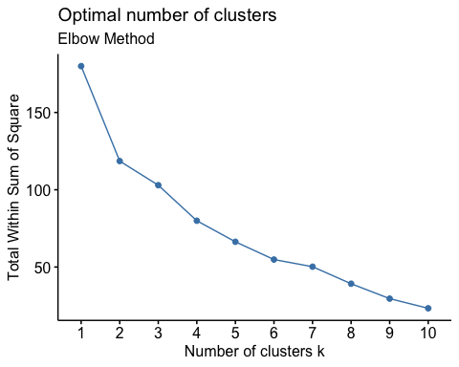

##Using Silhouette method for determining no of clusters

fviz_nbclust(Pharma_2, kmeans, method = "silhouette")+ labs(subtitle = "Silhouette Method")

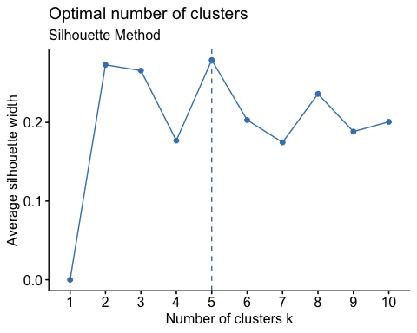

The number of clusters is 5 in the above plots, which is sufficient to display the data variations.

set.seed(64060)  
k5<- kmeans(Pharma_2,centers=5,nstart = 25)

#Visualizing the output

k5$centers #for centroids

## Market_Cap Beta PE_Ratio ROE ROA Asset_Turnover  
## 1 -0.87051511 1.3409869 -0.05284434 -0.6184015 -1.1928478 -0.4612656  
## 2 -0.43925134 -0.4701800 2.70002464 -0.8349525 -0.9234951 0.2306328  
## 3 -0.76022489 0.2796041 -0.47742380 -0.7438022 -0.8107428 -1.2684804  
## 4 -0.03142211 -0.4360989 -0.31724852 0.1950459 0.4083915 0.1729746  
## 5 1.69558112 -0.1780563 -0.19845823 1.2349879 1.3503431 1.1531640  
## Leverage Rev_Growth Net_Profit_Margin  
## 1 1.36644699 -0.6912914 -1.320000179  
## 2 -0.14170336 -0.1168459 -1.416514761  
## 3 0.06308085 1.5180158 -0.006893899  
## 4 -0.27449312 -0.7041516 0.556954446  
## 5 -0.46807818 0.4671788 0.591242521

fviz_cluster(k5,data = Pharma_2) # to Visualize the clusters

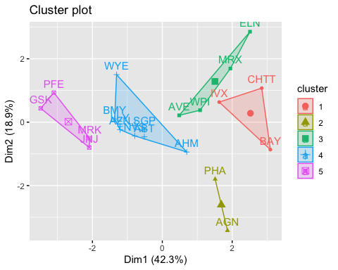

k5

## K-means clustering with 5 clusters of sizes 3, 2, 4, 8, 4  
##   
## Cluster means:  
## Market_Cap Beta PE_Ratio ROE ROA Asset_Turnover  
## 1 -0.87051511 1.3409869 -0.05284434 -0.6184015 -1.1928478 -0.4612656  
## 2 -0.43925134 -0.4701800 2.70002464 -0.8349525 -0.9234951 0.2306328  
## 3 -0.76022489 0.2796041 -0.47742380 -0.7438022 -0.8107428 -1.2684804  
## 4 -0.03142211 -0.4360989 -0.31724852 0.1950459 0.4083915 0.1729746  
## 5 1.69558112 -0.1780563 -0.19845823 1.2349879 1.3503431 1.1531640  
## Leverage Rev_Growth Net_Profit_Margin  
## 1 1.36644699 -0.6912914 -1.320000179  
## 2 -0.14170336 -0.1168459 -1.416514761  
## 3 0.06308085 1.5180158 -0.006893899  
## 4 -0.27449312 -0.7041516 0.556954446  
## 5 -0.46807818 0.4671788 0.591242521  
##   
## Clustering vector:  
## ABT AGN AHM AZN AVE BAY BMY CHTT ELN LLY GSK IVX JNJ MRX MRK NVS   
## 4 2 4 4 3 1 4 1 3 4 5 1 5 3 5 4   
## PFE PHA SGP WPI WYE   
## 5 2 4 3 4   
##   
## Within cluster sum of squares by cluster:  
## [1] 15.595925 2.803505 12.791257 21.879320 9.284424  
## (between_SS / total_SS = 65.4 %)  
##   
## Available components:  
##   
## [1] "cluster" "centers" "totss" "withinss" "tot.withinss"  
## [6] "betweenss" "size" "iter" "ifault"

distance<- dist(Pharma_2, method = "euclidean")  
fviz_dist(distance)

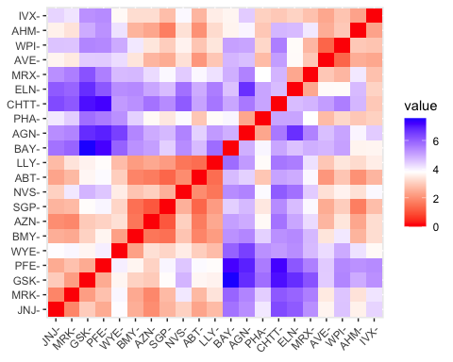 #Using K-Means Cluster Analysis- to Fit the data with 5 clusters

fit<-kmeans(Pharma_2,5)

#calculating the mean of all quantitative variables in each cluster

aggregate(Pharma_2,by=list(fit$cluster),FUN=mean)

## Group.1 Market_Cap Beta PE_Ratio ROE ROA  
## 1 1 1.69558112 -0.1780563 -0.1984582 1.2349879 1.3503431  
## 2 2 -0.66114002 -0.7233539 -0.3512251 -0.6736441 -0.5915022  
## 3 3 -0.96247577 1.1949250 -0.3639982 -0.5200697 -0.9610792  
## 4 4 -0.52462814 0.4451409 1.8498439 -1.0404550 -1.1865838  
## 5 5 0.08926902 -0.4618336 -0.3208615 0.3260892 0.5396003  
## Asset_Turnover Leverage Rev_Growth Net_Profit_Margin  
## 1 1.153164e+00 -0.4680782 0.4671788 0.5912425  
## 2 -1.537552e-01 -0.4040831 0.6917224 -0.4005718  
## 3 -1.153164e+00 1.4773718 0.7120120 -0.3688236  
## 4 -3.330669e-16 -0.3443544 -0.5769454 -1.6095439  
## 5 6.589509e-02 -0.2559803 -0.7230135 0.7343816

Pharma_3<-data.frame(Pharma_2,fit$cluster)  
Pharma_3

## Market_Cap Beta PE_Ratio ROE ROA Asset_Turnover  
## ABT 0.1840960 -0.80125356 -0.04671323 0.04009035 0.2416121 -5.121077e-16  
## AGN -0.8544181 -0.45070513 3.49706911 -0.85483986 -0.9422871 9.225312e-01  
## AHM -0.8762600 -0.25595600 -0.29195768 -0.72225761 -0.5100700 9.225312e-01  
## AZN 0.1702742 -0.02225704 -0.24290879 0.10638147 0.9181259 9.225312e-01  
## AVE -0.1790256 -0.80125356 -0.32874435 -0.26484883 -0.5664461 -4.612656e-01  
## BAY -0.6953818 2.27578267 0.14948233 -1.45146000 -1.7127612 -4.612656e-01  
## BMY -0.1078688 -0.10015669 -0.70887325 0.59693581 0.8617498 9.225312e-01  
## CHTT -0.9767669 1.26308721 0.03299122 -0.11237924 -1.1677918 -4.612656e-01  
## ELN -0.9704532 2.15893320 -1.34037772 -0.70899938 -1.0174553 -1.845062e+00  
## LLY 0.2762415 -1.34655112 0.14948233 0.34502953 0.5610770 -4.612656e-01  
## GSK 1.0999201 -0.68440408 -0.45749769 2.45971647 1.8389364 1.383797e+00  
## IVX -0.9393967 0.48409069 -0.34100657 -0.29136529 -0.6979905 -4.612656e-01  
## JNJ 1.9841758 -0.25595600 0.18013789 0.18593083 1.0872544 9.225312e-01  
## MRX -0.9632863 0.87358895 0.19240011 -0.96753478 -0.9610792 -1.845062e+00  
## MRK 1.2782387 -0.25595600 -0.40231769 0.98142435 0.8429577 1.845062e+00  
## NVS 0.6654710 -1.30760129 -0.23677768 -0.52338423 0.1288598 -9.225312e-01  
## PFE 2.4199899 0.48409069 -0.11415545 1.31287998 1.6322239 4.612656e-01  
## PHA -0.0240846 -0.48965495 1.90298017 -0.81506519 -0.9047030 -4.612656e-01  
## SGP -0.4018812 -0.06120687 -0.40231769 -0.21181593 0.5234929 4.612656e-01  
## WPI -0.9281345 -1.11285216 -0.43297324 -1.03382590 -0.6979905 -9.225312e-01  
## WYE -0.1614497 0.40619104 -0.75792214 1.92938746 0.5422849 -4.612656e-01  
## Leverage Rev_Growth Net_Profit_Margin fit.cluster  
## ABT -0.21209793 -0.52776752 0.06168225 5  
## AGN 0.01828430 -0.38113909 -1.55366706 4  
## AHM -0.40408312 -0.57211809 -0.68503583 2  
## AZN -0.74965647 0.14744734 0.35122600 5  
## AVE -0.31449003 1.21638667 -0.42597037 2  
## BAY -0.74965647 -1.49714434 -1.99560225 4  
## BMY -0.02011273 -0.96584257 0.74744375 5  
## CHTT 3.74279705 -0.63276071 -1.24888417 3  
## ELN 0.61983791 1.88617085 -0.36501379 3  
## LLY -0.07130879 -0.64814764 1.17413980 5  
## GSK -0.31449003 0.76926048 0.82363947 1  
## IVX 1.10620040 0.05603085 -0.71551412 3  
## JNJ -0.62166634 -0.36213170 0.33598685 1  
## MRX 0.44065173 1.53860717 0.85411776 3  
## MRK -0.39128411 0.36014907 -0.24310064 1  
## NVS -0.67286239 -1.45369888 1.02174835 5  
## PFE -0.54487226 1.10143723 1.44844440 1  
## PHA -0.30169102 0.14744734 -1.27936246 4  
## SGP -0.74965647 -0.43544591 0.29026942 5  
## WPI -0.49367621 1.43089863 -0.09070919 2  
## WYE 0.68383297 -1.17763919 1.49416183 5

#view of the cluster plot

library(cluster)  
clusplot(Pharma_2,fit$cluster,color = TRUE,shade = TRUE,labels = 2,lines = 0)

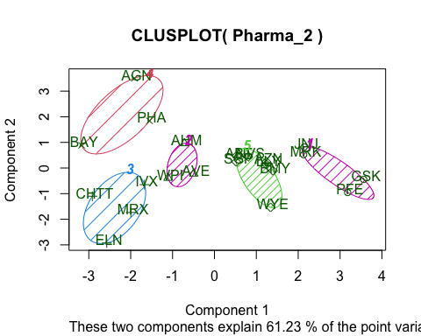

#b.Interpret the clusters with respect to the numerical variables used in forming the clusters. By looking at the mean values of all quantitative variables in each cluster.

Cluster 1 - JNJ, MRK, PFE, GSK ~ Cluster 1 has highest Market_cap,ROA,ROE,Asset_Turnover and lowest is Beta,PE_Ratio.

Cluster 2 - AHM,WPI,AVE ~ Cluster 2 has highest Rev_Growth and lowest PE_Ratio, Asset_Turnover

Cluster 3 - CHTT,ELN,MRX,IVX ~ Cluster 3 has highest Beta, Leverage and lowest Market_Cap, ROE, ROA, Leverage, Rev_Growth, Net_Profit_Margin.

Cluster 4 - BAY,PHA,AGN ~ Cluster 4 has highest PE_Ratio and lowest Leverage, Asset_Turnover.

Cluster 5 - AZN,ABT,NVS,BMY,WYE,SGP,LLY ~ Cluster 5 has highest Net_Profit_Margin and lowest leverage,Beta.

# c.s there a pattern in the clusters with respect to the numerical variables (10 to 12)? (those not used in forming the clusters)

With respect to the Media recommendation variable, there is a pattern in the clusters.

Cluster 1 with highest Market_Cap, highest ROE, highest ROA, highest Asset_Turnover has equal Hold and Moderate Buy Recommendation.

Cluster 2 with lowest PE_Ratio and lowest Asset_Turnover has Hold Recommendation.

Cluster-3 with highest Beta, highest Leverage has mostly Moderate Buy Recommendation.

Cluster 4 with highest PE_Ratio has Hold Recommendation.

Cluster 5 with highest Net_Profit_Margin has mostly Hold Recommendation.

In terms of variables, I have seen a pattern among the clusters (10 to 12)

Clusters 1,3 has mostly Moderate Buy Recommendation

Clusters 1,2,4,5 has Hold Recommendation

# d.Provide name for each cluster using any or all of the variables in the dataset.

Cluster-1 - Moderate Buy (or) Hold cluster.

Cluster-2 - Low PE_Ratio, Asset_Turnover cluster (or) Hold cluster.

Cluster-3 - High Beta, Leverage cluster (or) Buy Cluster.

Cluster-4 - High PE_Ratio cluster (or) High Hold cluster.

Cluster-5 - High Net_Profit_Margin cluster (or) High Hold cluster.