## **ASSIGNMENT-2**

1.You have given a string “I live in Cochin. I love pets” divide this strength in such a way that the two sentences in IT are separated and stored in different variables print them.

Code:

sentences = "I live in Cochin.I love pets."

my_list = sentences.split('.')

print("The two sentences are")

print(my_list[0])

print(my_list[1])

**Output:**

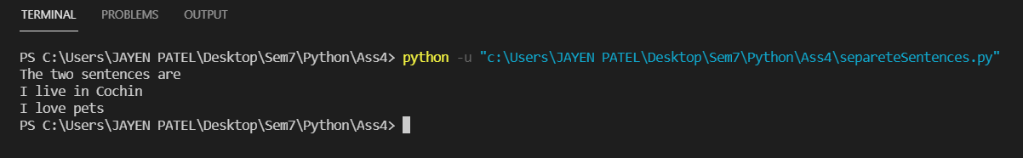

2.Write a program to find duplicate characters in a given string.

Code:

string = input("Enter string:")

d = {}

for char in string:

    if(char in d.keys()):

        d[char] += 1

    else:

        d[char] = 1

print("Duplicate characters are:")

for key, value in d.items():

    if(value > 1):

        print(key, end=" ")

**Output:**

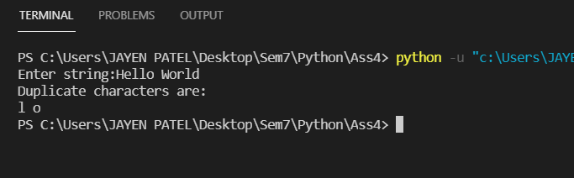

 3.Write a program to check whether a given string is palindrome or not.

Code:

string = input("Enter string:")

ans = True

for i in range(0, int(len(string)/2)):

    if(string[i] != string[int(len(string))-1-i]):

        ans = False

        break

    else:

        pass

if(ans):

    print("String entered is pallindrome")

else:

    print("String entered is not a pallindrome")

**Output:**

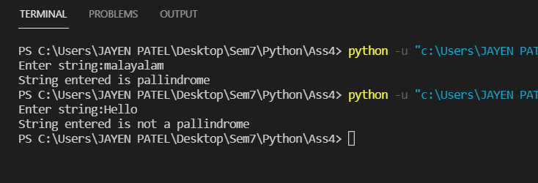

4.Write a program to remove punctuation from string.

Code:

string = input("Enter string:")

punctuations = '''!()-[]{};:'"\,<>./?@#$%^&*_~'''

for x in string:

    if x in punctuations:

        string = string.replace(x, "")

print(string)

**Output:**

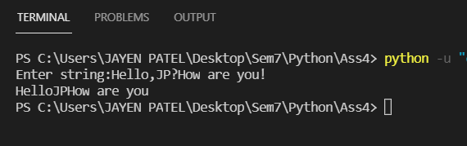

6.Write a program to add two Matrices.

Code:

m1 = [[1, 2, 3], [4, 5, 6], [7, 8, 9]]

m2 = [[1, 2, 3], [4, 5, 6], [7, 8, 9]]

ans = []

for i in m1:

    my_list = []

    print(i)

    for j in range(0, len(i)):

        my_list.append(i[j]+i[j])

    ans.append(my_list)

print(ans)

**Output:**

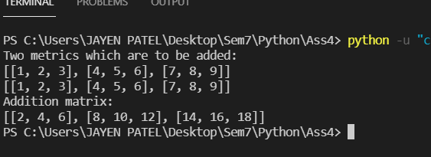

6.Write a program to transpose a matrix.

Code:

mat=[]

transMat=[]

row=int(input("Enter no of rows for matrix:"))

col=int(input("Enter no of cols for matrix:"))

for j in range(0, row):

    dataList = []

    for k in range(0, col):

        data = int(input("Enter value for Matrix[%i][%i]:" % (j, k)))

        dataList.append(data)

    mat.append(dataList)

print("Matrix before performing transpose operation:",mat)

for j in range(0, col):

    dataList = []

    for k in range(0, row):

        dataList.append(mat[k][j])

    transMat.append((dataList))

print("Matrix after performing transpose operation:",transMat)

**Output:**

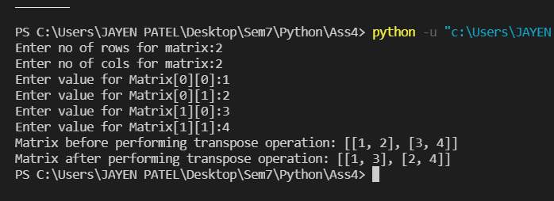

7.Write a Python program to demonstrate various string functions and operations

Code:

str = "Hello,how are you?"

# indexing,reverse indexing

print("2nd character:", str[3],   "Last character:", str[-1])

# slicing

print("Slicing:", str[0:18:2])

# concatination

str += 'Are you ok?'

print("After concatination:", str)

# Uppercase

str = str.upper()

print("Uppercase string:", str)

# Lowercase

str = str.lower()

print("Lowercase string:", str)

# replace

str = str.replace('?', '!')

print("After replacing ? by !:", str)

# length

print("Length:", len(str))

# split

my_list = str.split(' ')

print("Splitted List:", my_list)

# join

my_list = ['1', '2', '3', '4', '5']

ans = "->".join(my_list)

print("After Joining:", ans)

# first occurance of char

focc = str.index('l')

print("Firs occurance  of l:", focc)

# count freq of a char

freq = str.count('h')

print("Freq of h:", freq)

**Output:**

