**Name: Jayen Patel**

**PRN-2018033800122946**

**Batch - A**

**Assignment 6**

**1.) Write a program to implement ASCII addition**

**SOURCE CODE:**

.model small

.data

num1 db '1'

len db ($-num1)

num2 db '4'

ans db 4dup(0)

.code

main proc near

mov ax,@data

mov ds,ax

lea si,num1

lea di,num2

lea bx,ans

mov ax,0000h

mov cl,len

dec cl

again:

inc si

inc di

inc bx

loop again

inc bx

mov cl,len

x:

mov al,[si]

adc al,[di]

aaa

mov [bx],al

dec si

dec di

dec bx

loop x

adc [bx],00h

mov cl,len

inc cl

y:

add [bx],30h

inc bx

loop y

mov ax,4c00h

int 21h

endp

end

**OUTPUT:**

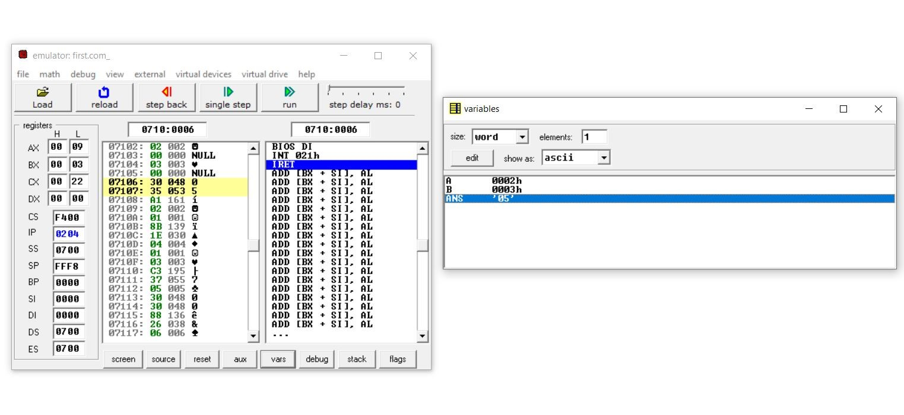

**2.) Write a program to implement ASCII subtraction string**

**SOURCE CODE:**

.model small

.data

num1 db '5'

len db ($-num1)

num2 db '3'

ans db 3dup(0)

.code

main proc near

mov ax,@data

mov ds,ax

lea si,num1

lea di,num2

lea bx,ans

mov ax,0000h

mov cl,len

dec cl

again:

inc si

inc di

inc bx

loop again

inc bx

mov cl,len

x:

mov al,[si]

sbb al,[di]

aas

mov [bx],al

dec si

dec di

dec bx

loop x

sbb [bx],00h

mov cl,len

inc cl

y:

add [bx],30h

inc bx

loop y

mov ax,4c00h

int 21h

endp

end

**OUTPUT:**

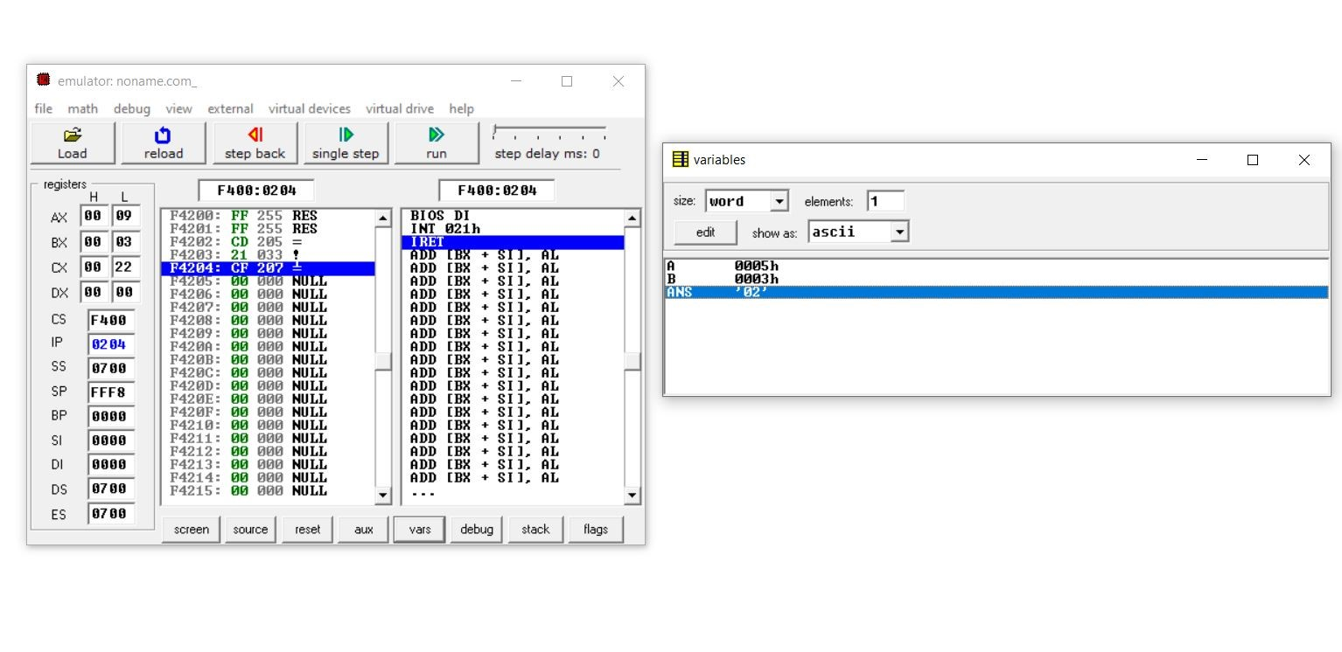

**3.) Write a program to implement ASCII multiplication**

**SOURCE CODE:**

.model small

.data

num1 db '1'

lendb ($-num1)

num2 db '5'

ansdb 4dup(0)

.code

main proc near

mov ax,@data

mov ds,ax

lea si,num1

lea bx,ans

mov ax,0000h

mov cl,len

dec cl

again:

incsi

incbx

loop again

incbx

mov cl,len

mov dx,00h

x:

mov al,[si]

and al,0fh

and num2,0fh

mul num2

aam

adcal,dl

mov dl,ah

aam

mov [bx],al

decsi

decbx

loop x

adc [bx],dl

mov cl,len

inc cl

y:

add [bx],30h

incbx

loop y

mov ax,4c00h

int 21h

endp

end

**OUTPUT:**

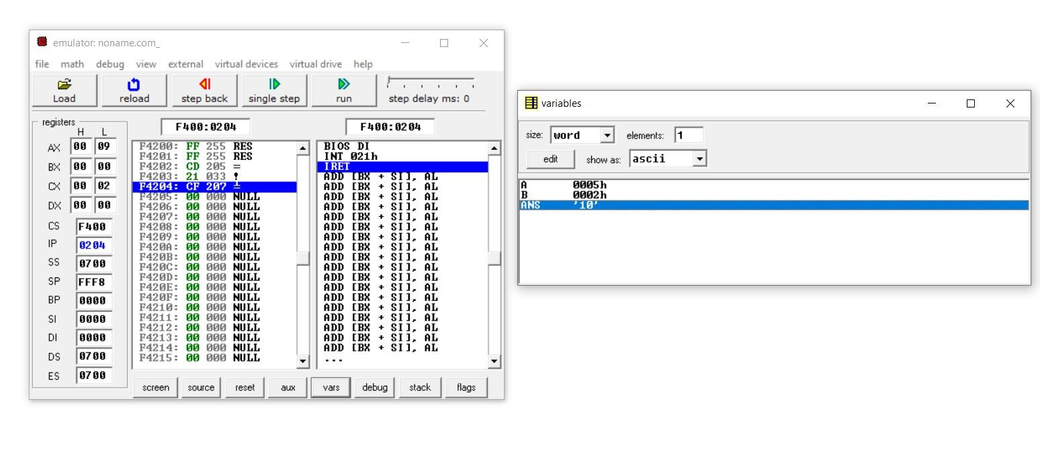

**4.) Write a program to implement ASCII division**

**SOURCE CODE:**

.model small

.data

num1 db '10'

lendb $-num1

num2 db '2'

ansdb 4dup(0)

.code

main proc near

mov ax,@data

mov ds,ax

lea si,num1

mov bl,num2

lea di,ans

and bl,0fh

mov cl,len

dec cl

again:

incsi

inc di

loop again

mov cl,len

l1: mov ah,00h

mov al,[si]

and al,0fh

aad

div bl

mov [di],al

decsi

dec di

loop l1

mov cl,len

lea di,ans

l2:add [di],30h

inc di

loop l2

mov ax,04ch

int 21h

endp

end

**OUTPUT:**

