Name: Jayen Patel

PRN-2018033800122946

Batch - A

# **Assignment 7**

**1.) Write a program to create a macro to take name and age as input from user and display the same on user screen**

**SOURCE CODE:**

org 100h

.data

inp1 db 0ah,0dh,"Name:- $"

inp2 db 0ah,0dh,"Age:- $"

msg1 db 0ah,0dh,"Your name is : $"

msg2 db 0ah,0dh,"Your age is : $"

namee db 20 dup('$')

age db 4 dup('$')

.code

name_age macro:

lea dx,inp1

mov ah,09h

int 21h

mov si,offset namee

input1:

mov ah,1

int 21h

cmp al,13

je name_done

mov [si],al

inc si

jmp input1

name_done:

lea dx,inp2

mov ah,09h

int 21h

mov si,offset age

input2:

mov ah,1

int 21h

cmp al,13

je display

mov [si],al

inc si

jmp input2

display:

lea dx,msg1

mov ah,09h

int 21h

lea dx,namee

mov ah,09h

int 21h

lea dx,msg2

mov ah,09h

int 21h

lea dx,age

mov ah,09h

int 21h

endm

name_age

end

**OUTPUT:**

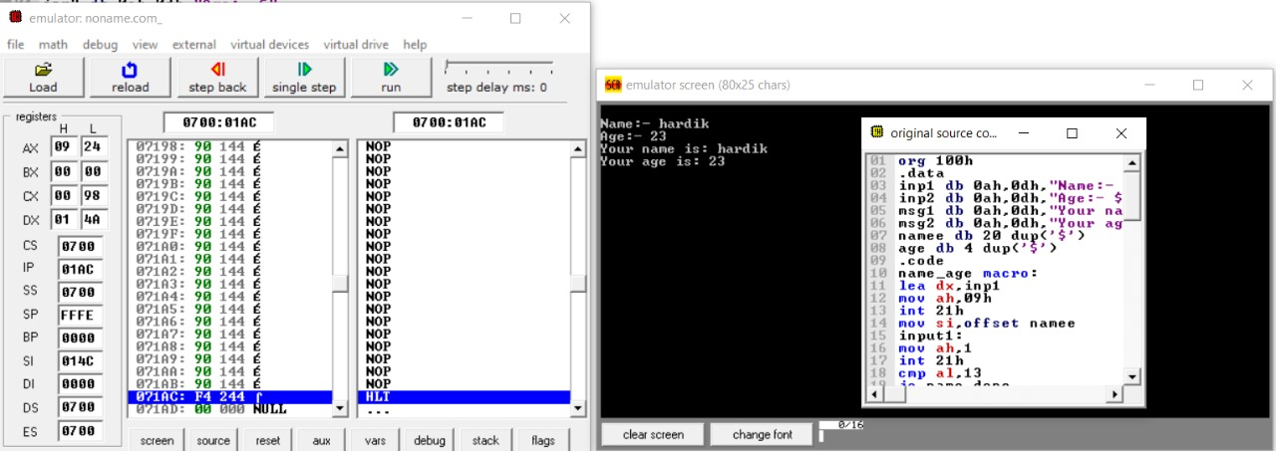

**2.) Write a program to check if the password entered by user is correct or not**

**SOURCE CODE:**

org 100h

.data

correct db "Correct$"

length db 7

password db 10 dup('$')

len db 0

inp db "Enter your password : $"

success db 0ah,0dh,"Login Successful!!$"

failed db 0ah,0dh,"Login Failed!!$"

.code

lea dx,inp

mov ah,09h

int 21h

lea si,password

input:

mov ah,1

int 21h

cmp al,13

je check

mov [si],al

inc len

inc si

jmp input

check:

mov dl,length

cmp dl,len

jne fail

mov cl,length

lea si,Correct

lea di,password

compare:

cmpsb

jnz fail

loop compare

lea dx,success

mov ah,09h

int 21h

jmp done

fail:

lea dx,failed

mov ah,09h

int 21h

done:

mov ah,4ch

int 21h

end

**OUTPUT:**

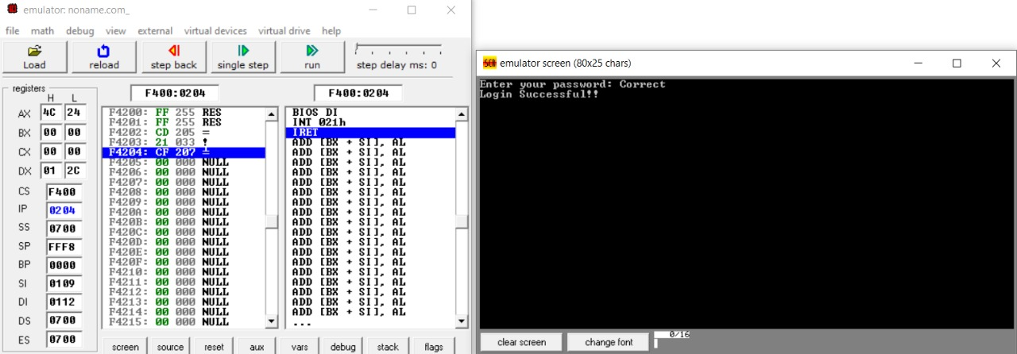

**3.) Write a program to check if a string entered by user is palindrome or not**

**SOURCE CODE:**

org 100h

.data

str db 10 dup('$')

len db 0

rev_str db 10 dup('$')

inp db "Enter a string : $"

yes db 0ah,0dh,"Entered String is Palindrome!$"

no db 0ah,0dh,"Entered String is Not Palindrome!$"

.code

lea dx,inp

mov ah,09h

int 21h

lea si,str

input:

mov ah,1

int 21h

cmp al,13

je check

mov [si],al

inc len

inc si

jmp input

check:

mov bx,0

mov bl,len

mov si,bx

mov bx,0

dec si

while:

cmp str[bx],'$'

je next

mov al,str[bx]

mov rev_str[si],al

inc bx

dec si

jmp while

next:

mov rev_str[bx],'$'

mov cl,len

lea si,str

lea di,rev_str

compare:

cmpsb

jnz fail

loop compare

lea dx,yes

mov ah,09h

int 21h

jmp done

fail:

lea dx,no

mov ah,09h

int 21h

done:

mov ah,4ch

int 21h

end

**OUTPUT:**

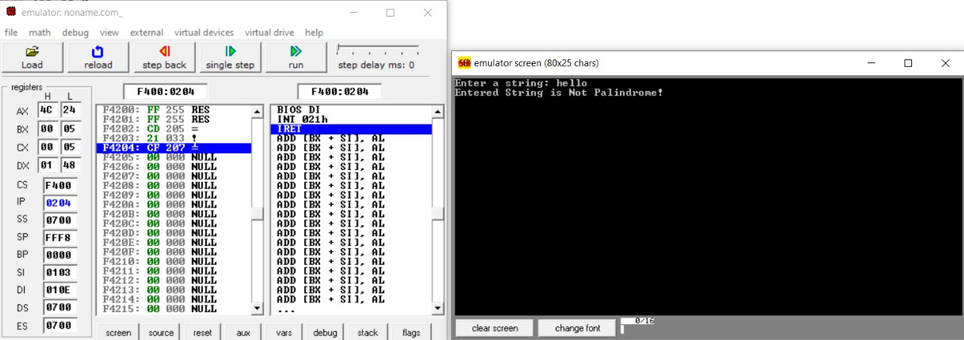

**4.) Write a program for addition of two numbers taken from user (ASCII addition)**

**SOURCE CODE:**

org 100h

.data

num1 db 0ah,0dh,"Enter number1 :- $"

num2 db 0ah,0dh,"Enter number2 :- $"

msg db 0ah,0dh,"Ans :- $"

.code

lea dx,num1

mov ah,09h

int 21h

mov ah,01

int 21h

mov bl,al

lea dx,num2

mov ah,09h

int 21h

mov ah,01

int 21h

mov bh,al

sub bh,30h

sub bl,30h

add bh,bl

add bh,30h

lea dx,msg

mov ah,09h

int 21h

mov dl,bh

mov ah,02h

int 21h

end

**OUTPUT:**

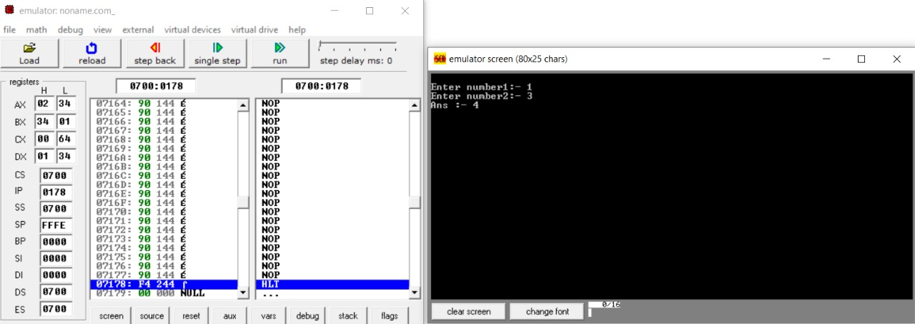

**5.) Write a program subtraction of two numbers taken from user (ASCII subtraction)**

**SOURCE CODE:**

org 100h

.data

num1 db 0ah,0dh,"Enter number1 :- $"

num2 db 0ah,0dh,"Enter number :- $"

msg db 0ah,0dh,"Ans :- $"

.code

lea dx,num1

mov ah,09h

int 21h

mov ah,01

int 21h

mov bh,al

lea dx,num2

mov ah,09h

int 21h

mov ah,01

int 21h

mov bl,al

sub bh,30h

sub bl,30h

sub bh,bl

add bh,30h

lea dx,msg

mov ah,09h

int 21h

mov dl,bh

mov ah,02h

int 21h

end

**OUTPUT:**

