**<>**

**Data Specification**

Version <>

# Revision History

|  |  |  |  |
| --- | --- | --- | --- |
| Date | Version | Description | Author |
| <MM/DD/YYYY> | <version> | <description> | <author> |
|  |  |  |  |
|  |  |  |  |

# Table of Contents

Revision History 2

Table of Contents 3

Introduction 4

Purpose 4

Scope 4

Definition, Acronyms and Abbreviations 4

References 4

Database Design 4

Data Dictionary 4

Appendices 4

# Introduction

<Introduction of this Data Specification. What will be covered in this document? What is the aim of this document? What are the main focuses? >

## Purpose

<Purpose of this document. Do you write this document to describe the current database? Do you write this document as a guide to develop a new database? Do you expect the end user will gain a better understanding of the data structure by reading this document? Do others like system designer and developer to gain understanding of the data structure by reading this document?>

## Scope

<Scope of this document. What parties or systems will be mentioned or focused? Will you talk about the stakeholders, the existing process and computer system in-use?>

## Definition, Acronyms and Abbreviations

<Collection of terms to be used in this document, with their definition. For example, you may want to describe the word ‘legacy’ that appears in your entity description>

|  |  |
| --- | --- |
| Term | Definition |
|  |  |

## References

<A list of reference material used by this document.>

# Database Design

## Diagrama de clases ViewGroup

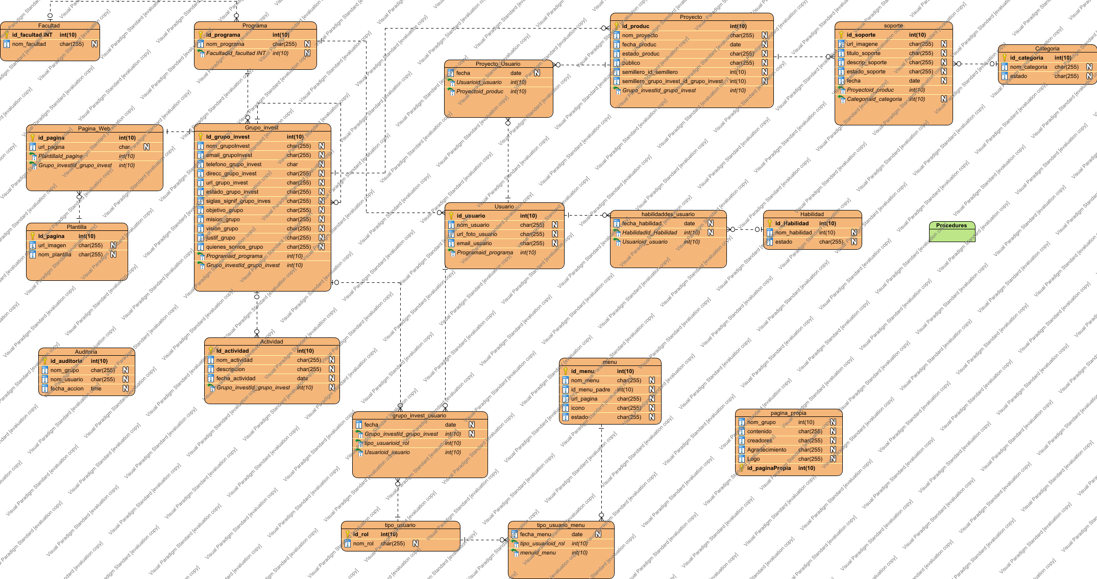

# Data Dictionary

## Data Dictionary

|  |  |  |  |  |  |  |  |  |  |
| --- | --- | --- | --- | --- | --- | --- | --- | --- | --- |
| Entity Name | Entity Description | |  |  |  |  |  |  |  | | --- | --- | --- | --- | --- | --- | --- | | Column Name | Column Description | Data Type | Length | Primary Key | Nullable | Unique | |
| Actividad |  | | descripcion |  | char | 255 | false | true | false | | --- | --- | --- | --- | --- | --- | --- | | fecha_actividad |  | date | 0 | false | true | false | | Grupo_investId_grupo_invest |  | int | 10 | false | true | false | | Id_actividad |  | int | 10 | true | false | false | | nom_actividad |  | char | 255 | false | true | false | |
| Auditoria |  | | fecha_accion |  | time | 7 | false | true | false | | --- | --- | --- | --- | --- | --- | --- | | id_auditoria |  | int | 10 | true | false | false | | nom_grupo |  | char | 255 | false | true | false | | nom_usuario |  | char | 255 | false | true | false | |
| Categoria |  | | estado |  | char | 255 | false | true | false | | --- | --- | --- | --- | --- | --- | --- | | id_categoria |  | int | 10 | true | false | false | | nom_categoria |  | char | 255 | false | true | false | |
| Facultad |  | | id_facultad INT |  | int | 10 | true | false | false | | --- | --- | --- | --- | --- | --- | --- | | nom_facultad |  | char | 255 | false | true | false | |
| Grupo_invest |  | | direcc_grupo_invest |  | char | 255 | false | true | false | | --- | --- | --- | --- | --- | --- | --- | | email_grupoInvest |  | char | 255 | false | true | false | | estado_grupo_invest |  | char | 255 | false | true | false | | Grupo_investId_grupo_invest |  | int | 10 | false | false | false | | Id_grupo_invest |  | int | 10 | true | false | false | | justif_grupo |  | char | 255 | false | true | false | | mision_grupo |  | char | 255 | false | true | false | | nom_grupoInvest |  | char | 255 | false | true | false | | objetivo_grupo |  | char | 255 | false | true | false | | Programaid_programa |  | int | 10 | false | false | false | | quienes_somos_grupo |  | char | 255 | false | true | false | | siglas_signif_grupo_inves |  | char | 255 | false | true | false | | telefono_grupo_invest |  | char | 0 | false | true | false | | url_grupo_invest |  | char | 255 | false | true | false | | vision_grupo |  | char | 255 | false | true | false | |
| grupo_invest_usuario |  | | fecha |  | date | 0 | false | true | false | | --- | --- | --- | --- | --- | --- | --- | | Grupo_investId_grupo_invest |  | int | 10 | false | true | false | | tipo_usuarioid_rol |  | int | 10 | false | false | false | | Usuarioid_usuario |  | int | 10 | false | false | false | |
| Habilidad |  | | estado |  | char | 255 | false | true | false | | --- | --- | --- | --- | --- | --- | --- | | Id_Habilidad |  | int | 10 | true | false | false | | nom_habilidad |  | int | 10 | false | true | false | |
| habilidaddes_usuario |  | | fecha_habilidad |  | date | 0 | false | true | false | | --- | --- | --- | --- | --- | --- | --- | | HabilidadId_Habilidad |  | int | 10 | false | true | false | | Usuarioid_usuario |  | int | 10 | false | false | false | |
| menu |  | | estado |  | char | 255 | false | true | false | | --- | --- | --- | --- | --- | --- | --- | | icono |  | char | 255 | false | true | false | | id_menu |  | int | 10 | true | false | false | | id_menu_padre |  | int | 10 | false | true | false | | nom_menu |  | char | 255 | false | true | false | | url_pagina |  | char | 255 | false | true | false | |
| pagina_propia |  | | Agradecimiento |  | char | 255 | false | true | false | | --- | --- | --- | --- | --- | --- | --- | | contenido |  | char | 255 | false | true | false | | creadores |  | char | 255 | false | true | false | | id_paginaPropia |  | int | 10 | true | false | false | | Logo |  | char | 255 | false | true | false | | nom_grupo |  | int | 10 | false | true | false | |
| Pagina_Web |  | | Grupo_investId_grupo_invest |  | int | 10 | false | false | false | | --- | --- | --- | --- | --- | --- | --- | | id_pagina |  | int | 10 | true | false | false | | PlantillaId_pagina |  | int | 10 | false | false | false | | url_pagina |  | char | 0 | false | true | false | |
| Plantilla |  | | Id_pagina |  | int | 10 | true | false | false | | --- | --- | --- | --- | --- | --- | --- | | nom_plantilla |  | char | 255 | false | true | false | | url_imagen |  | char | 255 | false | true | false | |
| Programa |  | | Facultadid_facultad INT |  | int | 10 | false | true | false | | --- | --- | --- | --- | --- | --- | --- | | id_programa |  | int | 10 | true | false | false | | nom_programa |  | char | 255 | false | true | false | |
| Proyecto |  | | estado_produc |  | char | 255 | false | true | false | | --- | --- | --- | --- | --- | --- | --- | | fecha_produc |  | date | 0 | false | true | false | | Grupo_investId_grupo_invest |  | int | 10 | false | false | false | | id_produc |  | int | 10 | true | false | false | | nom_proyecto |  | char | 255 | false | true | false | | publico |  | char | 255 | false | true | false | | semillero_grupo_invest_id_grupo_invest |  | int | 10 | false | true | false | | semillero_id_semillero |  | int | 10 | false | true | false | |
| Proyecto_Usuario |  | | fecha |  | date | 0 | false | true | false | | --- | --- | --- | --- | --- | --- | --- | | Proyectoid_produc |  | int | 10 | false | false | false | | Usuarioid_usuario |  | int | 10 | false | false | false | |
| soporte |  | | Categoriaid_categoria |  | int | 10 | false | true | false | | --- | --- | --- | --- | --- | --- | --- | | descrip_soporte |  | char | 255 | false | true | false | | estado_soporte |  | char | 255 | false | true | false | | fecha |  | date | 0 | false | true | false | | id_soporte |  | int | 10 | true | false | false | | Proyectoid_produc |  | int | 10 | false | false | false | | titulo_soporte |  | char | 255 | false | true | false | | url_imagene |  | char | 255 | false | true | false | |
| tipo_usuario |  | | id_rol |  | int | 10 | true | false | false | | --- | --- | --- | --- | --- | --- | --- | | nom_rol |  | char | 255 | false | true | false | |
| tipo_usuario_menu |  | | fecha_menu |  | date | 0 | false | true | false | | --- | --- | --- | --- | --- | --- | --- | | menuid_menu |  | int | 10 | false | false | false | | tipo_usuarioid_rol |  | int | 10 | false | false | false | |
| Usuario |  | | email_usuario |  | char | 255 | false | true | false | | --- | --- | --- | --- | --- | --- | --- | | id_usuario |  | int | 10 | true | false | false | | nom_usuario |  | char | 255 | false | true | false | | Programaid_programa |  | int | 10 | false | false | false | | url_foto_usuario |  | char | 255 | false | true | false | |

# Appendices