Juan Pablo
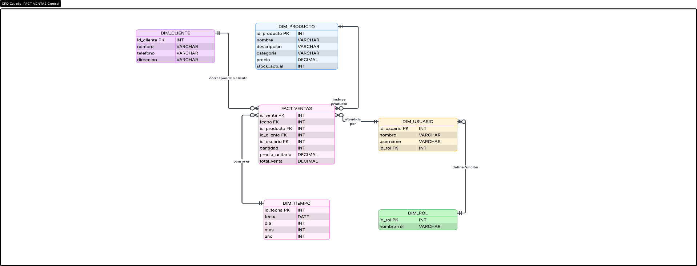

https://lucid.app/lucidchart/79359aae-fba9-4ec1-9899-5d61e69d5a92/edit?viewport_loc=-1218%2C-1817%2C4398%2C1669%2CTspQ8yZaS7P9&invitationId=inv_241e4756-c76e-4989-b95d-086b8dda1e6a

