CASE NO. 1: Without DB (Hard coded login)
Components Need:
- Vertical Arrangement
- 2 Text Boxes
- 1 Button
- Notifier
Code Blocks:
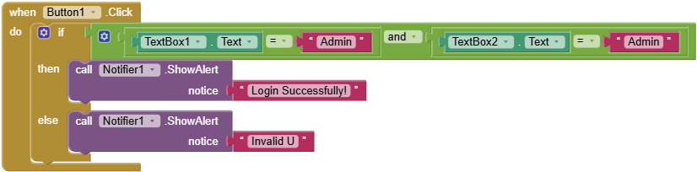

CASE NO. 2: With DB (TinyDB, Fixed Username/Password)
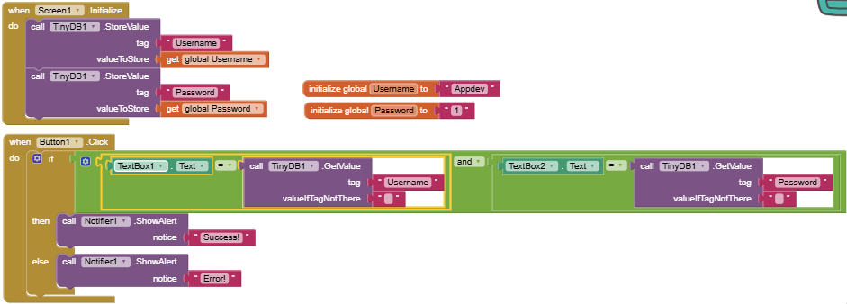
Components Need:
- Vertical Arrangement
- 2 Text Boxes
- 1 Button
- Notifier
- TinyDB
Code Blocks:

CASE NO. 3: With DB (TinyDB, User Registration)
Components Need:
- 2 Vertical Arrangement
- 4 Text Boxes (2 Each Vertical Arrangement)
- 3 Buttons (Login, Signup, and Register) (2 Buttons in Login Screen, 1 Button in Register Screen)
- Notifier
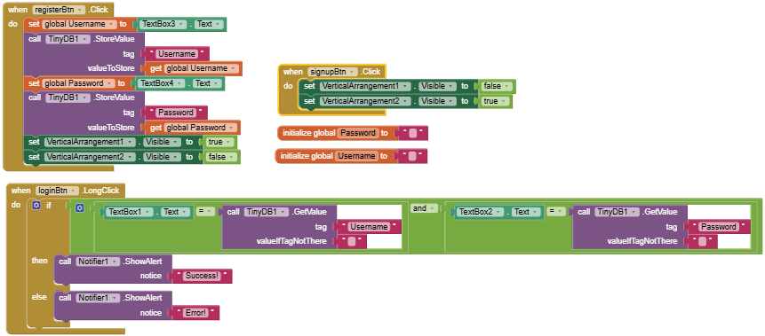
- TinyDB

