--
Change “Oldest” to “Longest”. Leader to Practitioner.
“The Philippines’ Longest Pile Testing Practitioner”

--

Change to “Get Support”

--

this is good for now.

--
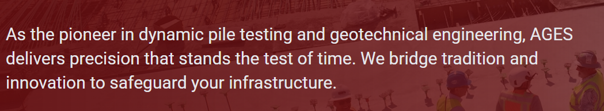
AGES Pile Testing Clients rely on our team to draw on pioneering years of experience. From planning stage documentation and discussion, field test execution, down to the Test Results Report, Clients can expect an attentive service with our timely support.

--

Get Support (phone icon) (email icon)


Who we are:
Philippines’ Oldest Pile Testing Group (1996)
Globally Certified Pile Testing Practitioners (2015)
1st in the Philippines by the only PDI / PDCA of USA
AGES has been bestowed with deep pile testing experience from different projects demands and challenges. The lessons have shaped the character and capabilities of our team today. Our nationwide Clients gain wholistic insights to pile testing as AGES is also a geotechnical company since 1986 at the time the company was founded.
--
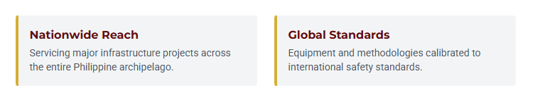
“Nationwide Reach”
Servicing in all of Philippines
“Global Standards”
Globally Certified Practitioners with Methodology
compliant to local and international standards.

---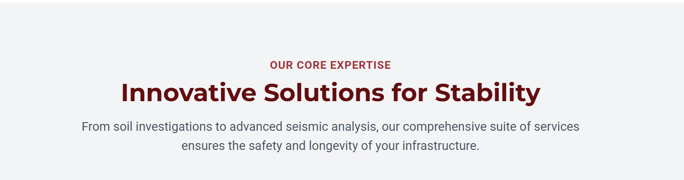

OUR CORE EXPERTISE
Timely and Reliable Pile Testing Services
PDA (Pile Dynamic Analysis, ASTM D4945), PIT (Pile Integrity test- Low Strain, ASTM D5882), Crosshole Sonic Logging (CSL ASTM, D6760) and other pile testing requirements involving micro-piles, bored piles, precast concrete driven pile, and steel piles among others.

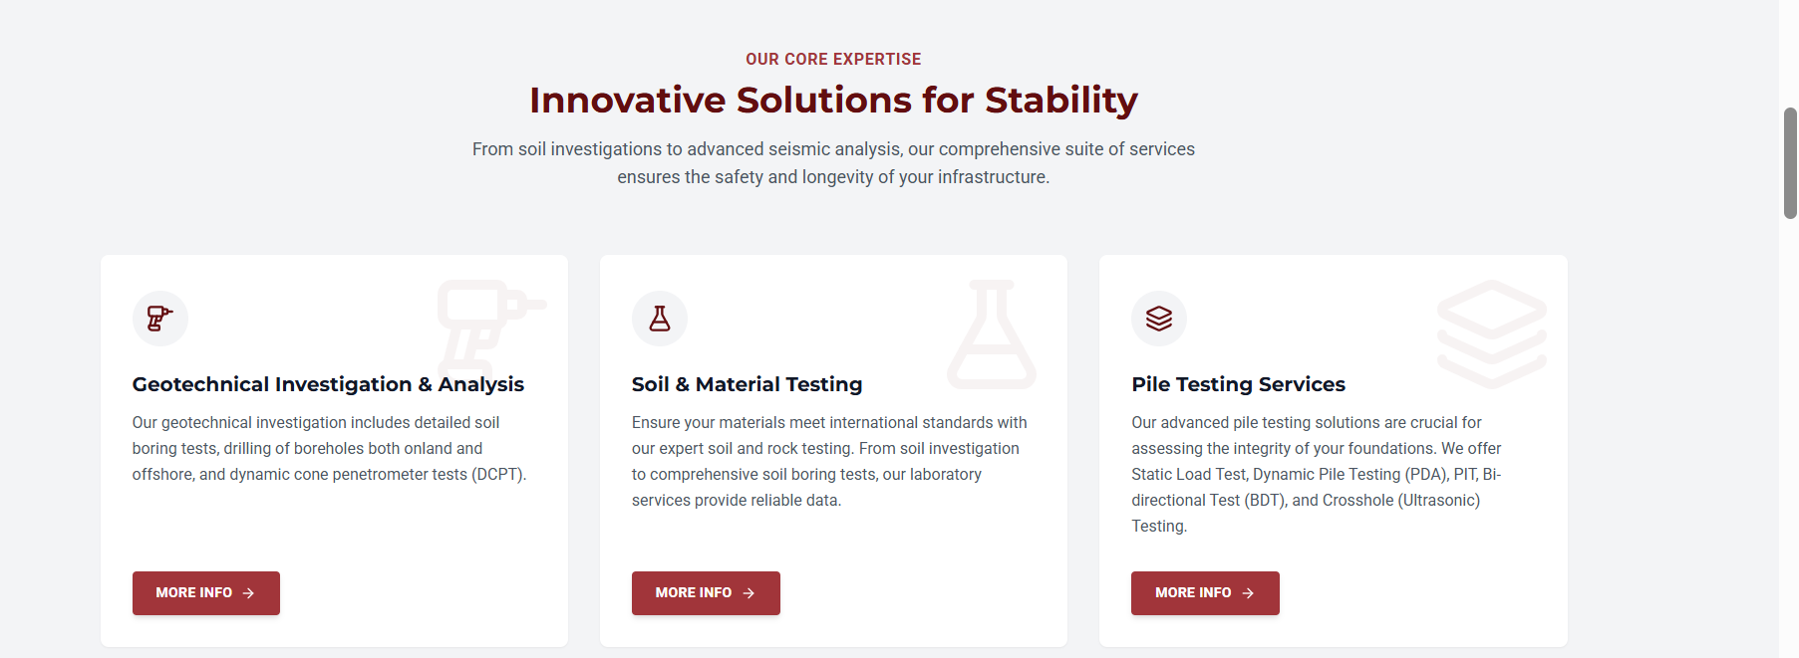
For the square tiles,
Pile Dynamic Analysis (PDA), ASTM D4945
High Strain Dynamic Test or normally called the PDA Test is conducted to determine the bearing capacity and integrity of the pile. Most conducted bearing capacity test on pre-cast concrete piles, steel piles, and bored piles. Appropriate preparation of materials and equipment is essential for a smooth and successful test.
Pile Integrity Test (PIT-Low Strain), ASTM D5882
Low Strain Integrity Testing that only uses a handheld hammer and sensor attached to the pile top to determine the pile integrity and check for major defects on the pile. Quick and minimal pile preparation may be necessary.

Crosshole Sonic Logging (CSL), ASTM D6760
Another integrity testing normally for bored piles that utilizes preinstalled steel tubes on the pile rebar that will later on be access to the ultrasonic probes during the test. Requires foresight and installation of steel tubes on rebar cage of bored piles prior to pile concreting.

Static Load Testing ASTM D1143, D3689, D3966
Gold standard to pile foundation testing. A direct load and settlement measurement on the pile to test the bearing capacity and observe the load-displacement curve of the pile. May be done in compression(D1143), tension or pullout (D3689), and lateral direction (D3966). Kentledge Method or Reaction Piles are the normal test setup which entails a detailed planning and discussion in order to prepare for a successful test.
Bi-Directional Testing (BDT) ASTM D8169
An alternative to conventional Static Load Testing. This method is advantageous for larger test loads that might be impractical for conventional SLT or perhaps area constraints where there is a limitation in the working environment. Normally the larger the test load the more economical and practical the BDT test becomes. However the BDT requires an advanced lead time and pre planning since each BDT equipment will be manufactured and tailor fitted to the pile design.
Plate Load Test ASTM D1195, D1196
One of the conventional ways to determine bearing capacity of the ground and its subgrade modulus. This test normally aids in the design of shallow foundations, roads, and pavements. Site ground and equipment preparation is normally necessary and coordinated with the guidance of AGES.
Length Inductive Test Equipment (LITE)
For determining lengths of existing piles, this test is effective to estimate the length of existing steel / metal piles. This may be applied in sheet piles, steel pipe piles, H-Piles whose length is unknown. Nearby access is required to create a borehole lined with a pvc pipe to be used as the access of the LITE probe during test. This may be used in any setting with steel pile lengths in question.
Parallel Seismic Test (PST) ASTM D8381
For determining lengths of existing piles, this test is effective to estimate the length of existing concrete piles. This may be applied in driven piles and bored piles whose length is unknown. Nearby access is required to create a borehole lined with a pvc pipe to be used as the access of the PST geophone during test. Normally applied in bridges, ports, whose foundation records and lengths can no longer be retrieved.
SHaft Area Profile Evaluator (SHAPE) / Borehole Imaging Tool
A recent development to become an alternative to the Koden Test, the SHAPE is the latest and most advanced borehole inclination and imaging tool. It provides the bored pile hole inclination / eccentricity from the vertical and also twice as many profiles than the Koden Test due to its increased number of sensors. Hence it may also produce a 3D image of the hole. Its biggest advantage lies in being lighter and thus easily transported by one person.
---

What our Clients get:
Attentive Support and Reliable Results
From planning stage documents such as Photo Guides, Work Methodology, Calibration Reports, etc. to efficient site preparation and smooth testing of piles, and finally the timely submission of Test Results, AGES Pile Testing shall provide comprehensive assistance and dependable output to its Clients.
(wala pa maisip sa checks-list. Maybe wala na muna)
-


M:+639204124450
M:+639178518280
L: (02) 79033965
email: ages@ages.ph

Other notes:
(make section for ages pile testing story)

Click box with “company origins”
In 1986, co-founded by Engr. Richard C. Tan,MSCE and Ms. Janet V. Tan,MBA/MIR who were both University of the Philippines Alumni and Masteral graduates….

