Assignment-4

Create Stored procedure in Northwind database to insert or update a record in a table

**1**.Create a stored procedure in the Northwind database that will calculate the average value of Freight for a specified customer.Then, a business rule will be added that will be triggered before every Update and Insert command in the Orders controller,and will use the stored procedure to verify that the Freight does not exceed the average freight. If it does, a message will be displayed and the command will be cancelled.

(a)

Create Proc spAvgFreightValueOfCustomer

AS

BEGIN

select CustomerID, Avg(Freight)

from Orders

group by CustomerID;

END

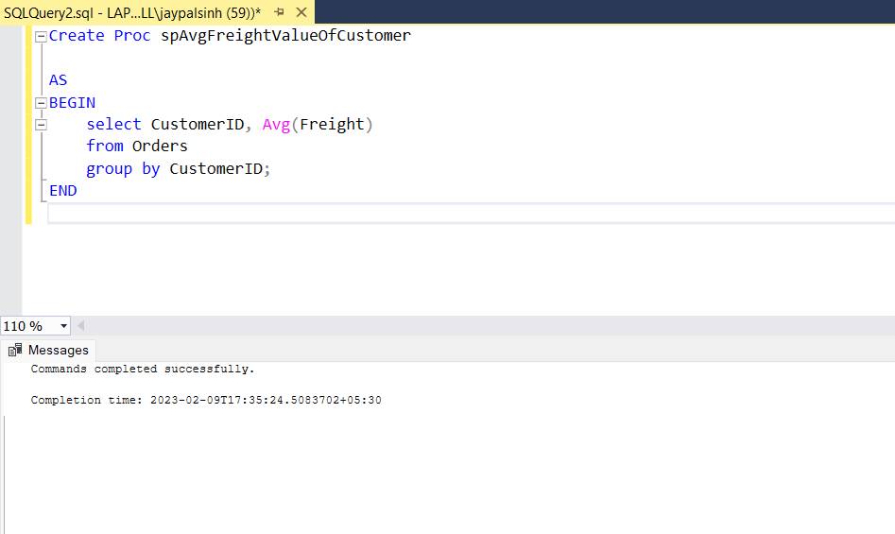

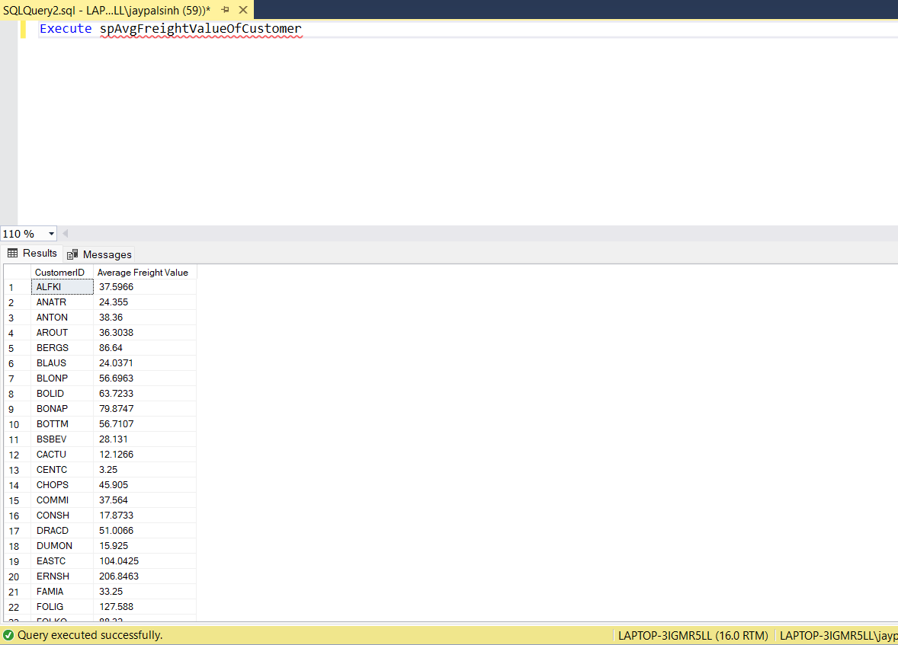

(b)

Create PROC smInsertUpdateOrders(@OrderID INT, @CustomerID NCHAR(5), @EmployeeID INT, @OrderDate DATETIME, @RequiredDate DATETIME, @ShippedDate DATETIME,

@ShipVia INT, @Freight MONEY, @ShipName NVARCHAR(40), @ShipAddress NVARCHAR(60), @ShipCity NVARCHAR(15), @ShipRegion NVARCHAR(15), @ShipPostalCode NVARCHAR(10),

@ShipCountry NVARCHAR(15),@type NVARCHAR(7)

AS

BEGIN

DECLARE @AvgFreight MONEY

SELECT @AvgFreight = AVG(Freight) FROM Orders

WHERE CustomerID = @CustomerID

GROUP BY CustomerID

IF(@AvgFreight < @Freight)

BEGIN

RAISERROR('Operation denied due to Average Freight Condition.',10,1)

END

ELSE

BEGIN

IF(@type = 'INSERT')

BEGIN

INSERT INTO Orders(OrderID, CustomerID, EmployeeID, OrderDate, RequiredDate, ShippedDate, ShipVia, Freight, ShipName, ShipAddress, ShipCity, ShipRegion, ShipPostalCode, ShipCountry)

VALUES (@OrderID, @CustomerID, @EmployeeID, @OrderDate, @RequiredDate, @ShippedDate, @ShipVia, @Freight, @ShipName, @ShipAddress, @ShipCity, @ShipRegion, @ShipPostalCode, @ShipCountry)

END

ELSE

BEGIN

UPDATE Orders SET

CustomerID = @CustomerID, EmployeeID = @EmployeeID,

OrderDate = @OrderDate, RequiredDate = @RequiredDate, ShippedDate = @ShippedDate,

ShipVia = @ShipVia, Freight = @Freight, ShipName = @ShipName,

ShipAddress = @ShipAddress, ShipCity = @ShipCity, ShipRegion = @ShipRegion,

ShipPostalCode = @ShipPostalCode, ShipCountry = @ShipCountry

WHERE OrderID = @OrderID

END

END

END

SET IDENTITY_INSERT Orders ON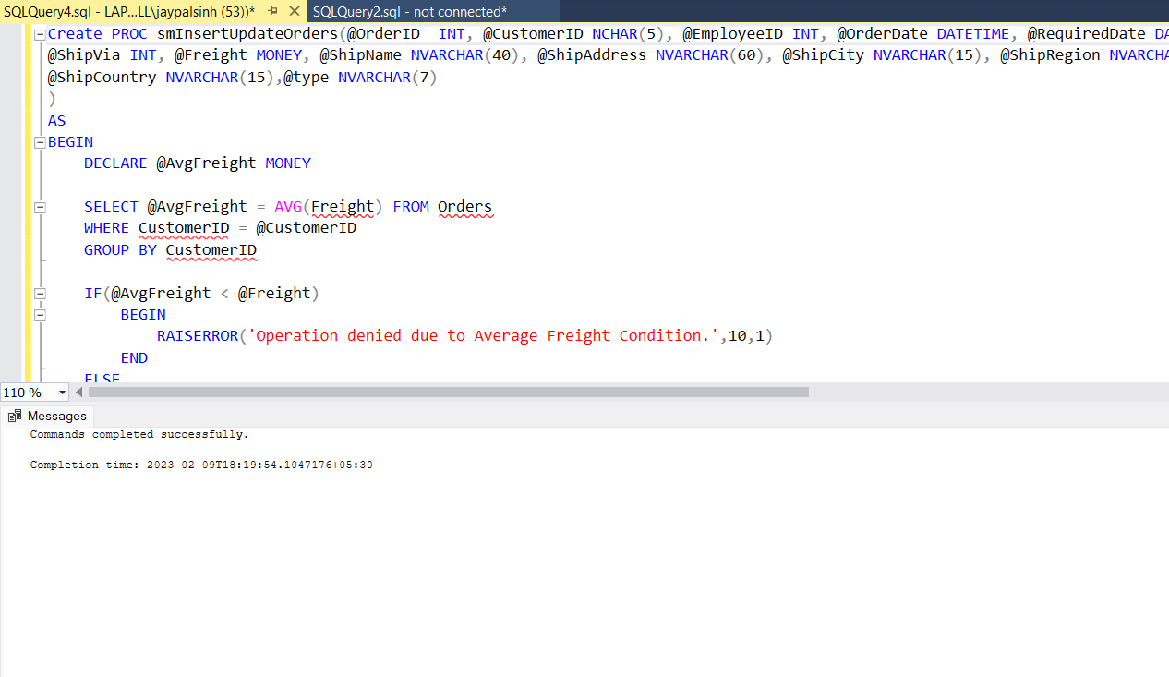

=>Inserting data into table

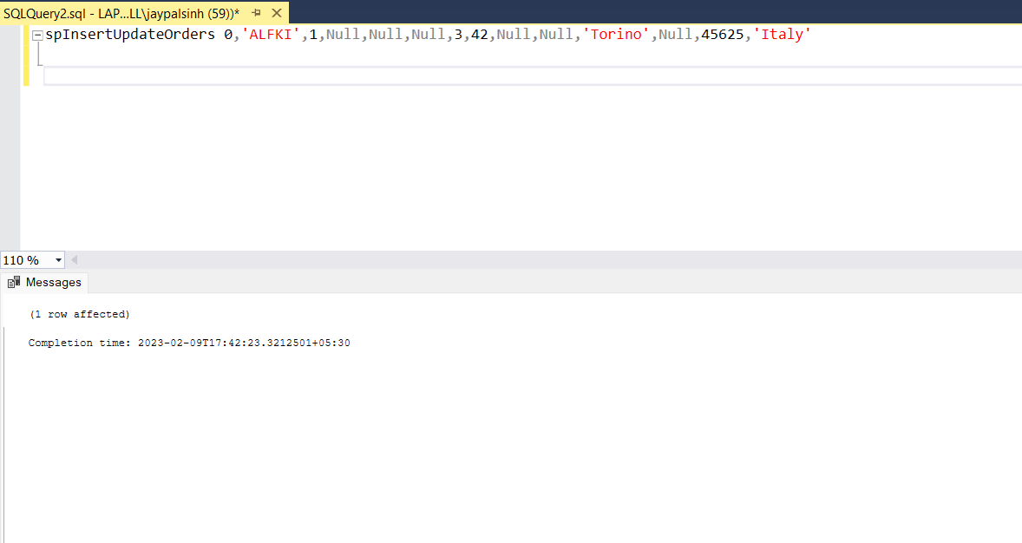

=>Updating data into table

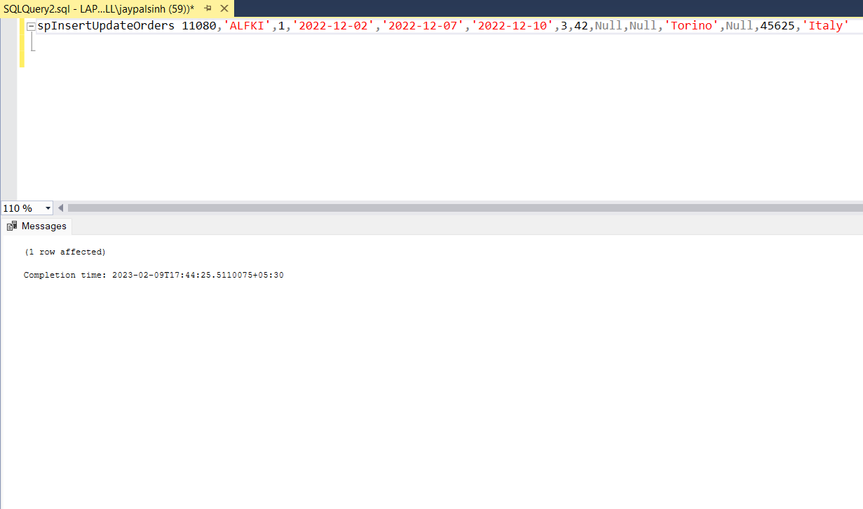

**2**. write a SQL query to Create Stored procedure in the Northwind database to retrieve Employee Sales by Country

Create Proc spEmployeesSalesByCountry

AS

BEGIN

select e.EmployeeID, e.FirstName, e.LastName, o.ShipCountry ,sum(Quantity) as [totalsales],ROUND(SUM(CONVERT(decimal(14,2), OD.Quantity * (1-OD.Discount) * OD.UnitPrice)), 0) as [Total Purchase]

from Employees e

join

(

Orders o

join [Order Details] od

on o.OrderID = od.OrderID

)

on e.EmployeeID = o.EmployeeID

group by e.EmployeeID,e.FirstName,e.LastName,o.ShipCountry

order by e.EmployeeID

END

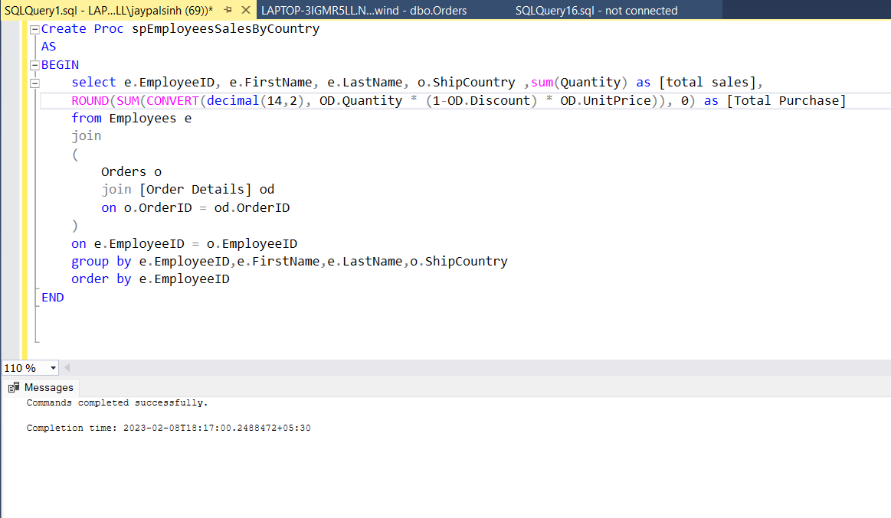

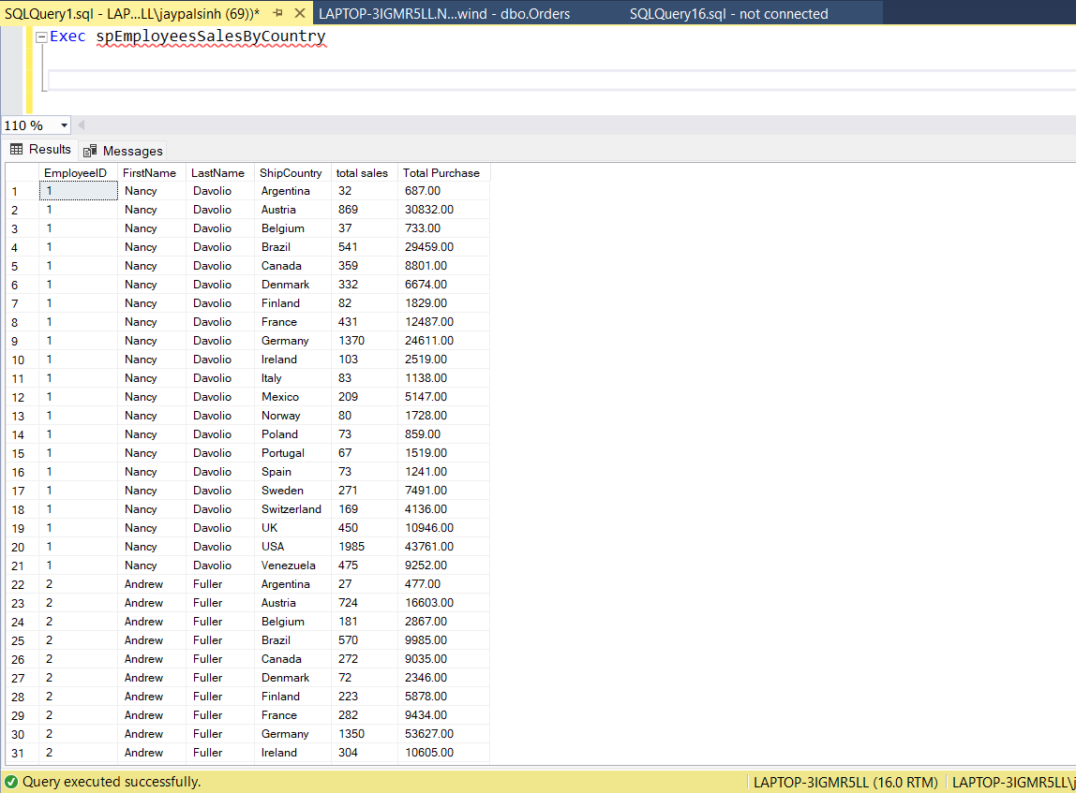

**3**. write a SQL query to Create Stored procedure in the Northwind database to retrieve Sales by Year

Create Proc spSalesByYear

AS

BEGIN

select year(o.OrderDate) as Year, sum(Quantity) as [Total sales],ROUND(SUM(CONVERT(decimal(14,2), OD.Quantity * (1-OD.Discount) * OD.UnitPrice)), 0) as [Total Purchase]

from Orders o

join [Order Details] od

on o.OrderID = od.OrderID

group by year(o.OrderDate)

END

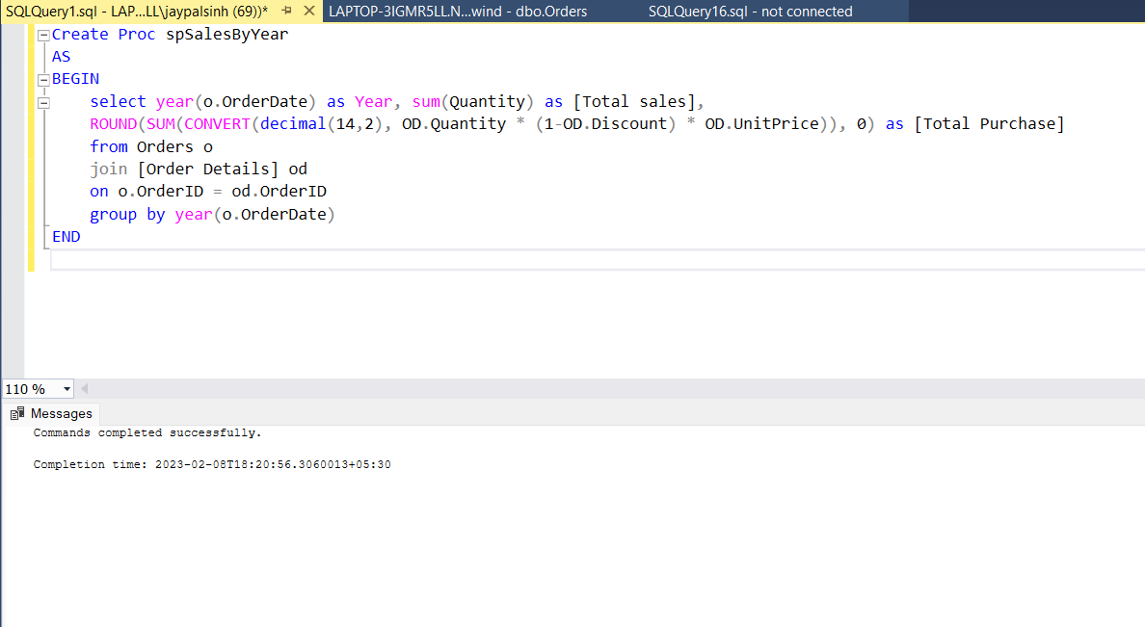

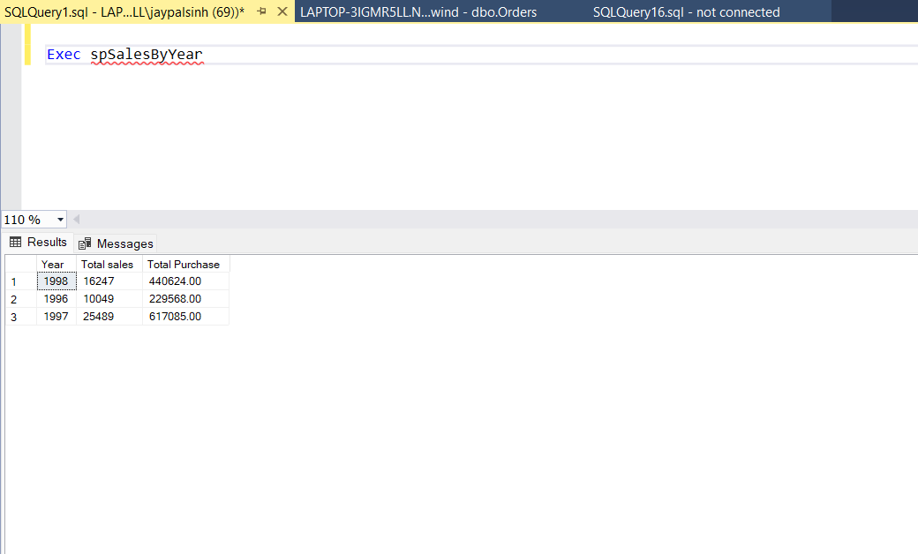

**4**. write a SQL query to Create Stored procedure in the Northwind database to retrieve Sales By Category

Create Proc spSalesByCategories

AS

BEGIN

select c.CategoryID, c.CategoryName, p.ProductName, sum(Quantity) as [Total Sales],ROUND(SUM(CONVERT(decimal(14,2), OD.Quantity * (1-OD.Discount) * OD.UnitPrice)), 0) as [Total Purchase]

from Categories c

left join Products p

on c.CategoryID = p.CategoryID

left join [Order Details] od

on p.ProductID = od.ProductID

group by c.CategoryID,c.CategoryName,p.ProductName

order by c.CategoryID

END

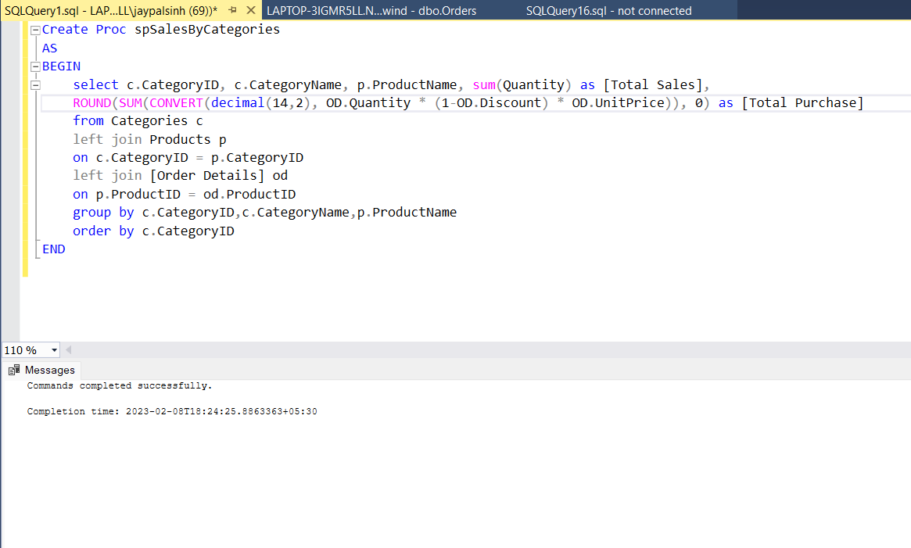

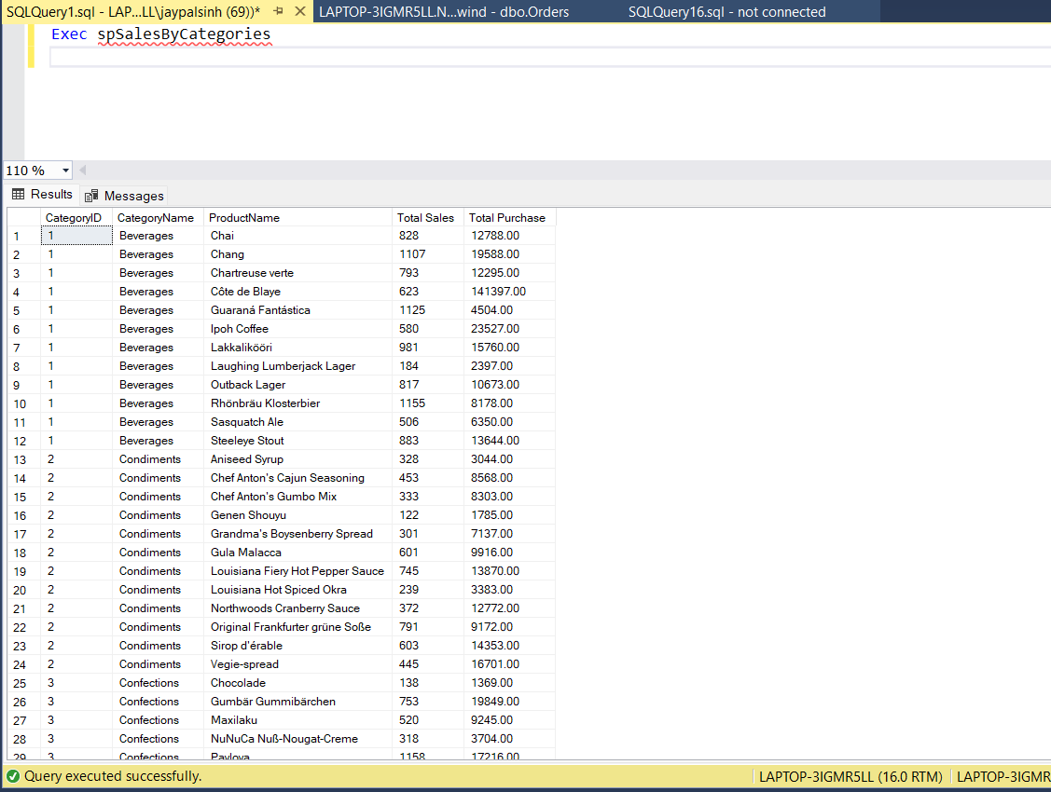

**5**. write a SQL query to Create Stored procedure in the Northwind database to retrieve Ten Most Expensive Products

Create Proc spTopTenExpensiveProducts

AS

BEGIN

select top 10 ProductID, ProductName, UnitPrice as Price

from Products

order by UnitPrice desc

END

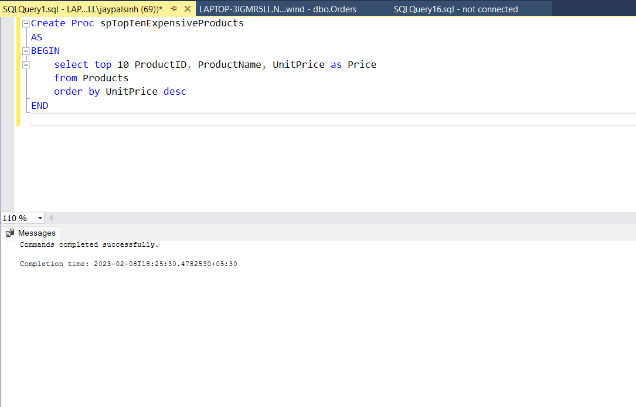

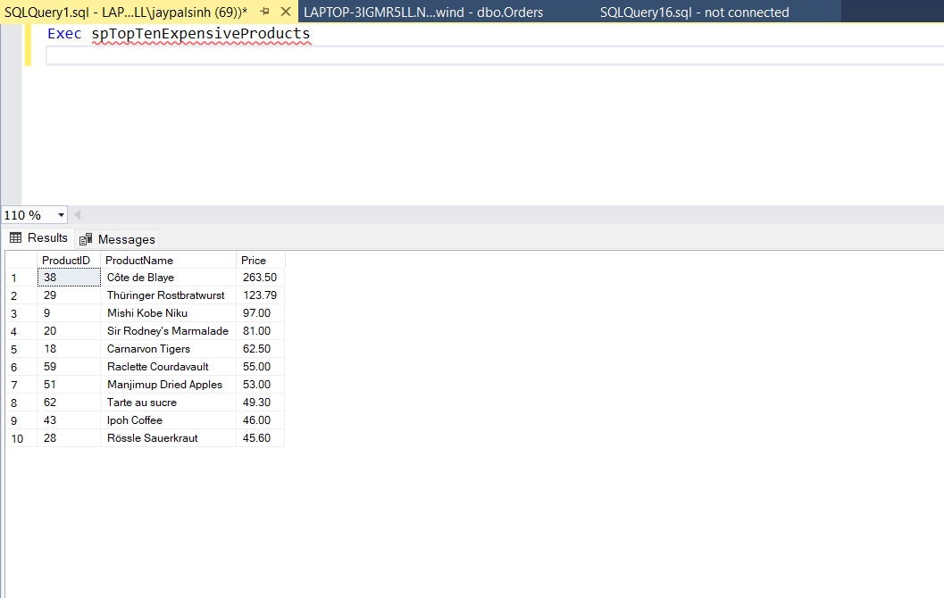

**6**. write a SQL query to Create Stored procedure in the Northwind database to insert Customer Order Details

Create Proc spInsertCustomerOrderDetails

(

@OrderID int,

@ProductID int,

@UnitPrice decimal(6,2),

@Quantity int,

@Discount decimal(2,2)

)

AS

BEGIN

Insert into [Order Details]

values (@OrderID, @ProductID, @UnitPrice, @Quantity, @Discount)

END

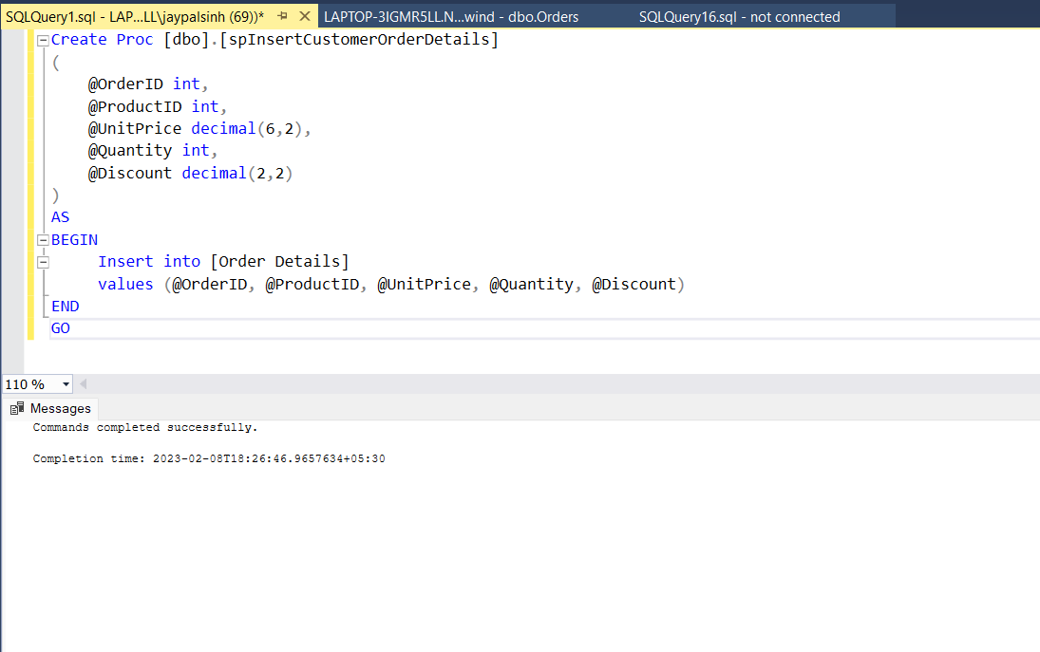

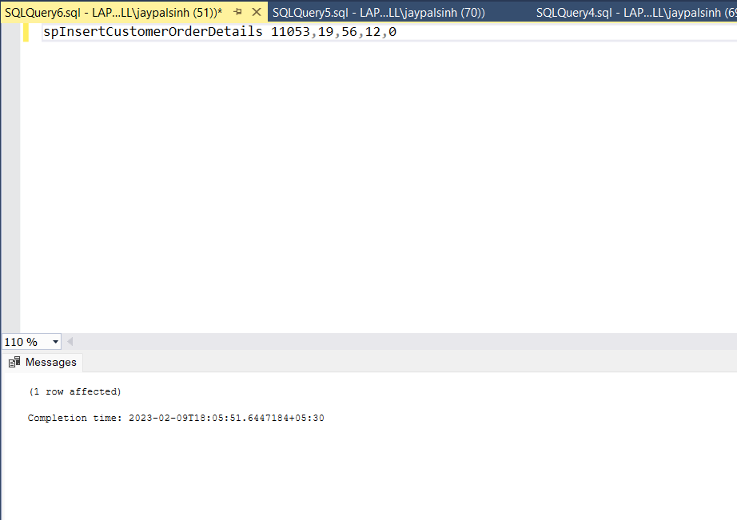

**7**. write a SQL query to Create Stored procedure in the Northwind database to update Customer Order Details

Create Proc spUpdateCustomerOrderDetails

(

@OrderID int,

@UnitPrice decimal(6,2),

@Quantity int,

@Discount decimal(2,2)

)

AS

BEGIN

Update [Order Details]

SET

UnitPrice = @UnitPrice,

Quantity = @Quantity,

Discount = @Discount

Where OrderID = @OrderID

END

