ECE 4180 Lab 1 – Basic I/O with mbed
(dates might change later based on final kit distribution dates)
Section A Due Date: Sept 13 odd groups – Sept 14 even groups
Section B Due Date: Sept 15 odd groups – Sept 16 even groups

Names:_________________________Sect:_____ _____________________________Sect:_____

Item | Lab Demo | Extra Credit | Max Extra Credit Pts.
4180 LAB 1
Basic Digital I/O |  | n/a | n/a
LED PWM dimming and interrupts |  |  | 1%
RGB LED color and PWM dimming |  | n/a | n/a
Navigation Switch (Digital Joystick) |  | n/a | n/a
USB Mouse using Nav Switch |  | n/a | n/a
Touch Keypad with I2C interface |  | n/a | n/a
Digital I/O with an SPI Port Expander |  |  | 1%
Analog Input from a Potentiometer |  | n/a | n/a
Analog Output of a Sine wave |  | n/a | n/a
DMA Sine wave demo |  | n/a
WatchDog Timer | n/a |  | 2%
ARM Assembly Language | n/a |  | 4%
Power Management | n/a |  | 4%
Two MCP23S17s on one Bus | n/a |  | 2%
USB Mouse Scroll Feature | n/a |  | 2%
USB MIDI input | n/a |  | 1%
Early Bird Checkoff | n/a |  | 2%

Even/Odd group names rule: Add the ASCII value of the first character of last names for each student in the lab team and do % 2 to determine even (0) or odd (1). Using the official last name found on the class roll. In the case of students in a lab group that are in different sections, the first due date applies.

Final TA Signoff: ________________________________ Total Points ____________________

Note: If you are working in the lab, bring your student breadboard to the lab and any jumper wires you may have. It will not be possible to leave your setup using the breadboards in the lab, if you don’t finish once you start with the large numbers of students in this class. Some parts not in kit (i.e., SPI I/O Port Expander IC, touch keypad and navigation switch) are required for a couple parts of the lab and they can be checked out from a TA once lab opens.

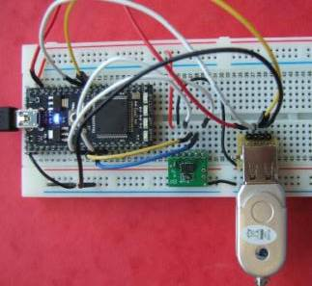

Prelab: The purpose of this lab and the next is to build and demo several types of widely used I/O devices using the standard interfaces found on microcontrollers in embedded devices. Since this lab uses several input and output devices in your kit, it would be helpful to read and/or review the wiki pages on common user input devices available at: https://developer.mbed.org/users/4180_1/notebook/user-input-devices/ and the wiki page on output devices at https://developer.mbed.org/users/4180_1/notebook/user-output-devices/

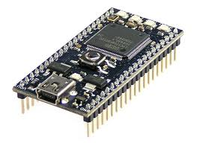

Getting Started with the mbed module
The easy to use mbed LPC1768 modules http://developer.mbed.org/ have an ARM processor, use a web-based C++ compiler, and work like a USB flash drive. To get started, first plug the mbed USB cable into the PC (the bed’s blue power LED should be turn on), and then click the MBED.HTM link on the new flash drive that appears on the PC. Make sure you plug in the mbed first, it must be attached to automatically configure the compiler for this model of mbed board for your account (there are over 100 with different compiler settings needed for each one!). In the web page that appears (seen below) Click signup, and create an new account (if you don’t already have one). You will also save your source files on the cloud server using this code. You will need to setup and logon this account to compile on the web. The signup page is something like the one seen below (might have some minor changes).

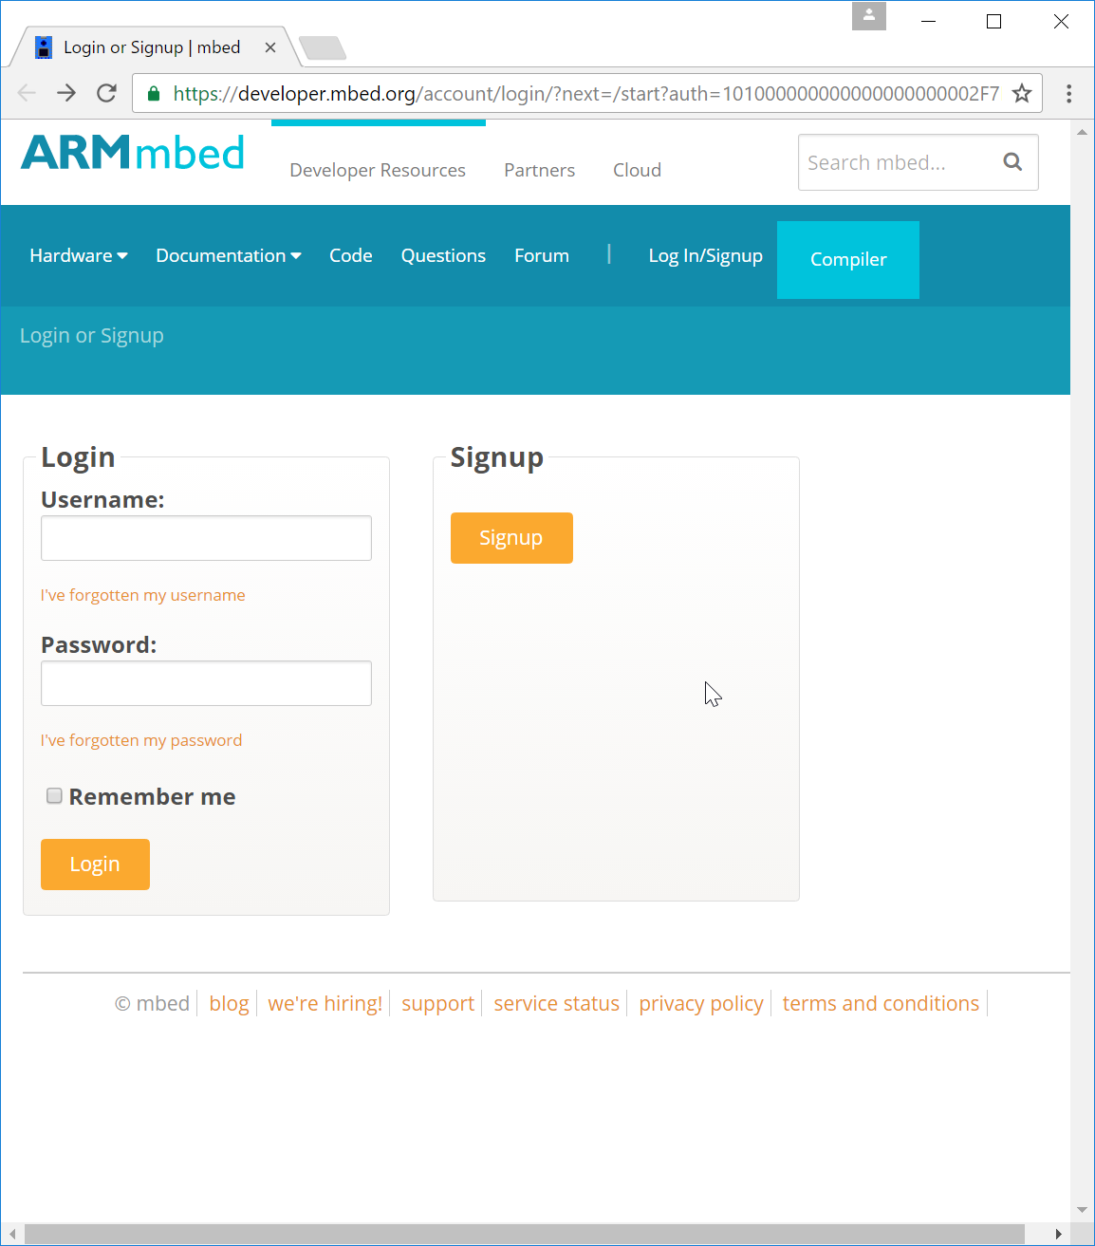

After you signup and create your account, a new web page should appear for the LPC1768. click the “import program” box in the “Helloword Example” program box and then click “import” in the new compiler window that appears. Next, Hit Compile to compile the HelloWorld example for the mbed board, save the program code it returns to mbed’s flash drive (during download, the blue power LED on the mbed board will flicker). After download completes, push the center black/blue button on the mbed board to reset the processor. This will start running the most recently downloaded program. The program will blink a blue LED once it runs.

When logging on again, click on “compiler” to switch to the compiler window to write code (for the compiler to work you must sign in with your account). Read through the HelloWorld C code and note the use of DigitalOut and LED1. If you cannot find HelloWorld in your Program Workspace in the online compiler, click on “New” and enter “HelloWorld” for the Program Name and click “OK” to create a new project with the demo code.

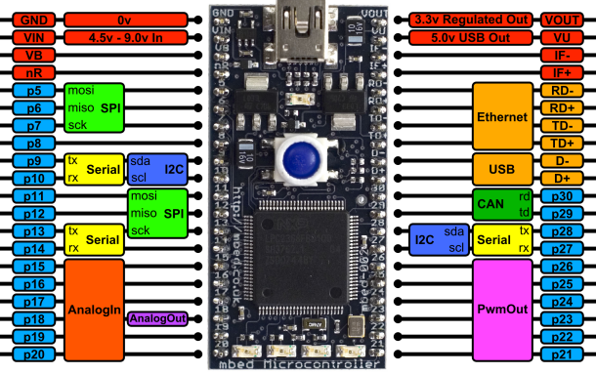

Here is a handy image and pin out of the mbed LPC1768 board. In C++ code, you can use the pin’s name to read or send a value to the pin. Note that power (3.3V and 5V up to 460MA) is available for the protoboard from the upper pins. On chip power circuits produce this voltage using power from the USB cable (500MA max). Vin is for an external power source like a battery – don’t connect anything to it while using the USB cable. VB is for a real-time clock battery backup, so skip it. There are four blue user LEDs at the bottom of the board (LED1 – LED4). They are handy for status displays. Over the USB cable, you can also set it up to send serial data to the PC using printf.
This mbed Microcontroller is based on an ARM Cortex-M3 Core running at 96MHz, with 512KB FLASH, 64KB RAM and a load of interfaces including Ethernet, USB Device, CAN, SPI, I2C and other I/O. RS232 serial, CAN, USB, and Ethernet outputs require a breakout board with a connector. Many of these are available from Sparkfun and Adafruit and there is an assortment available in the lab in addition to those found in your standard kit parts.

A schematic of the mbed LPC1768 is available at http://mbed.org/media/uploads/chris/mbed-005.1.pdf and the 32-bit NXP ARM Cortex-M3 LPC 1768 processor data sheet and a user manual is also available at https://developer.mbed.org/platforms/mbed-LPC1768/#schematics-and-data-sheets, but you will likely never need it. The various devices have I/O registers on the machine, but the handy built-in C++ API calls for I/O hide the nasty 780 pages of I/O register details with another layer of abstractions. The LEDs will flash on the bottom of the mbed board if you ever have a compiler run-time error (Blue LEDs of Death!). The most common way to get this is to try to setup a pin to do something that is not supported in hardware (that function is not on color coded mbed card!)
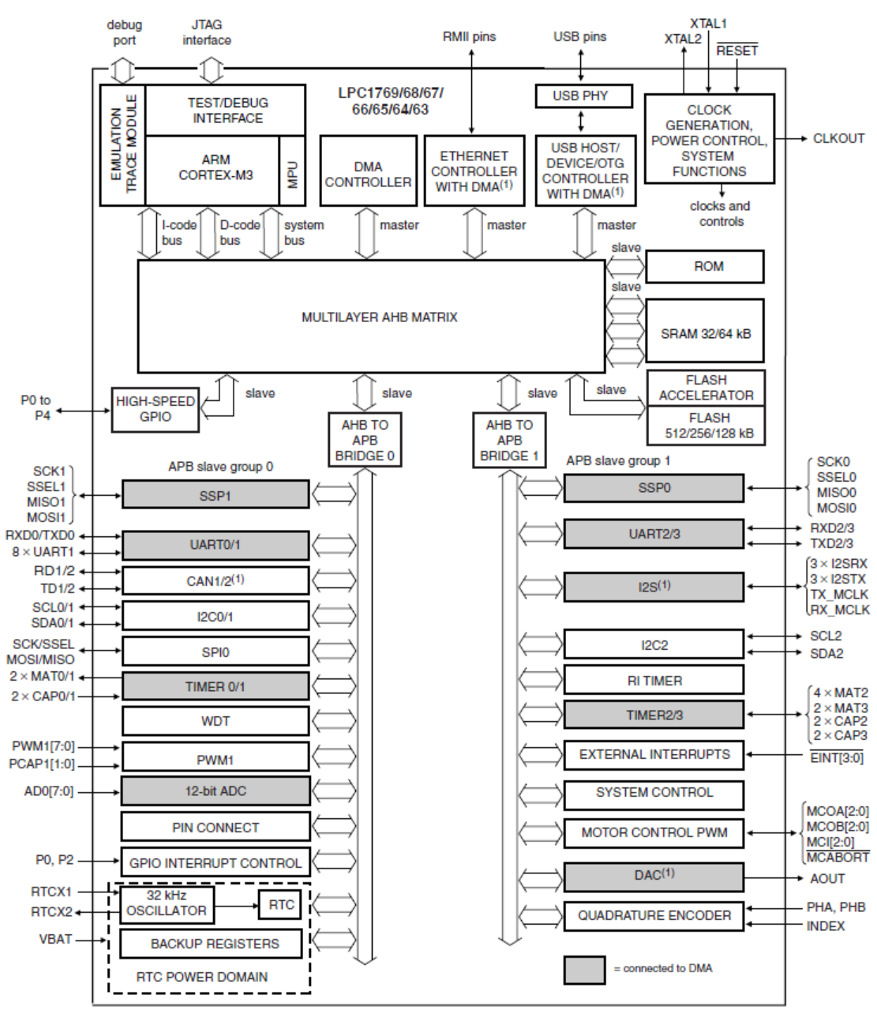

NXP LPC 1768 Block Diagram

Note the wide range of I/O features built into mbed’s ARM Cortex–M3 processor chip. They include GPIO, ADC, DAC, Serial (UART), SPI (SSP), I2C, PWM, USB, and Ethernet. We will be using all of these in the lab exercises that follow.

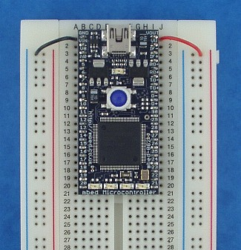

Inserting an mbed into a breadboard
Note: The mbed Microcontroller is fragile, and inserting it in to breadboard will require some force; ensure you line up the holes, then press evenly until it goes in to the board fully. Mess up and pins will break!

Removing an mbed from a breadboard – Use Caution!
Never try and remove the mbed Microcontroller by pulling on the USB lead or USB connector. You'll just pull off the USB connector itself! There are short instructional videos available on mbed insertion and mbed removal
It is best to leave the mbed Microcontroller in the board whenever possible; if you do need to remove it, be patient and do it carefully. Use a small jeweler’s screwdriver or similar, and lever it a bit at a time from each of the four corners in turn, ensuring you pull up with the screwdriver so you are pressing against the breadboard with the tip and the edge of the microcontroller with the shaft, rather than the tip touching the bottom of the microcontroller (which might damage the components on the underside).
So remember..
- Don't pull on the lead/connector (it will just pull off the connector; you should avoid there being force on the connector at all times)
- Don't pull it out from one side (you will bend and break the pins!)
- Don't lever the device where it touches the bottom of the microcontroller (there are lots of components there, and you will damage them!)

Turning Power Off
You can push the button on the mbed to reboot, but to turn power off on the mbed board disconnect the USB cable. The small USB connector on the mbed module is a bit fragile, so use the larger USB connector that plugs into the PC. If the blue LED is on, you have power to the mbed. Always Remove power when changing wiring on the breadboard or inserting or removing boards!
ECE 4180 Laboratory Assignment 1 - Basic I/O Devices
Part 1 - Basic Digital Input and Output (10%)
Read and review the following wiki pages to prepare for Parts 1-4:
http://mbed.org/users/4180_1/notebook/pushbuttons/ has info on using SPST pushbuttons with resistor pullups and how to debounce pushbuttons when needed.
https://developer.mbed.org/users/4180_1/notebook/rgb-leds/ has more info on LED polarity, RGB LEDs, series voltage dropping resistors and exactly how this value is calculated.
When short code examples are provided, read the code examples and make sure that you understand how it works. Refer to the mbed handbook, if you need additional details on mbed I/O APIs used.
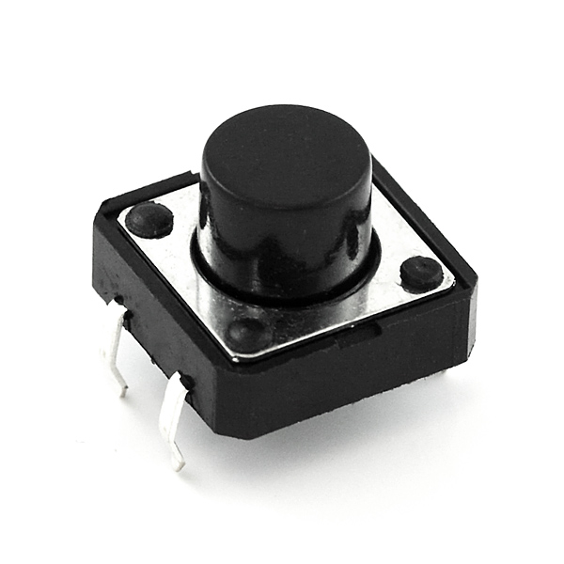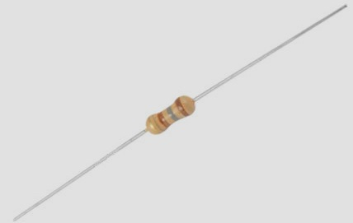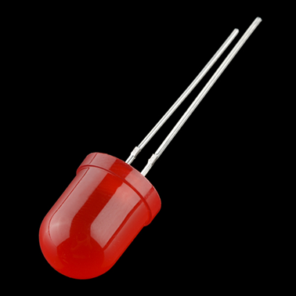
A small SPST Pushbutton, a resistor, and a red LED.

Lab Demo: Read a pushbutton input in a program loop using DigitalIn and use the input value to control an external LED with DigitalOut. This repeats forever in an infinite while loop. When the pushbutton is held down the LED should stay on, and turn off whenever it is released.

Additional Details: Any numbered pin, Px, can be used for general purpose digital I/O (GPIO) but try to stay clear of the analog, serial, SPI, networking, and I²C pins, they will be used later. Attach a pushbutton switch module with a 10K ohm pull-up resistor to Vout and an LED using a discrete LED. Use the external pullup for the switch this time to understand how it works, (later we will use the internal pullups with a software setting – not all devices can use internal pullups, so you need to understand how to hookup external ones at least once). Don’t forget the resistor in series with the 2.2V LED to drop the voltage a bit. The longer wire on an LED is goes to +V. Anything around 100-300 ohms works for mid-sized red LEDs. Note that the mbed takes power from USB and has power pins to power external devices. Use 3.3V power by default since the chips I/O pins use 3.3V and not 5V level logic. Write C++ code to read in the pushbutton (without debouncing) and output to the LED in a loop forever. http://mbed.org/handbook/Homepage has a handy list of built-in C I/O API calls. Check out DigitalIn and DigitalOut in the mbed handbook as they will be needed. Use the external switch pullup resistor for this first lab assignment, but there is a way to avoid it later. Don’t forget that an LED should have a voltage dropping (100-300 ohm) resistor in series with a digital logic output pin that controls it as they typically want to see only around 2 volts.

Part 2 - Using PWM to dim an LED with pushbuttons and interrupts (10%)

Lab Demo: Use two pushbuttons to dim one of mbed’s builtin LEDs using PWM

Additional Details: Add code to dim and brighten an LED using Pulse Width Modulation (PWM) using two pushbuttons for control. Check out the PwmOut API in the mbed handbook. Note that it is more energy efficient to control devices using PWM instead of an analog output. LEDs also emit light only in a very limited voltage range (2-3V depending on color) and PWM is typically used for dimming LEDs. Using analog out will dissipate more heat and not be as energy efficient in the transistor driver circuits than PWM since the transistors are not driven to saturation. As an example, if an analog driver circuit is turned on half way, this means that half of the power is dissipated as heat in the driver transistor (since it has the same voltage drop and current flow as the LED).

The dimmer program must work in the following manner:
One pushbutton switch makes the LED brighter and the other one makes it dimmer.
Each pushbutton click adjusts the PWM level (up or down) by 0.1,
but once the PWM value reaches 1.0 or 0.0, it stays at the limit until the other button is hit.
Pushbuttons must use internal pullups and must be debounced with PinDetect
Pushbuttons use interrupt callbacks setup using the PinDetect class (see pushbutton wiki last example).

Hint: Here is a simple demo program that dims LED1 on mbed using PWM

#include "mbed.h"
PwmOut led(LED1); //setup PWM output
int main() {
while(1) {
for(float p = 0.0f; p < 1.0f; p += 0.1f) {
led = p; //dim led using PWM
wait(0.1); //0.1 second time delay-so a human can see it
}
}
}

Extra Credit (1%) Monitor the PWM output and duty cycle using an oscilloscope in the lab or a MyDAQ. Capture the scope image show it to the TA or show a copy of a screen image at checkout.
Part 3 - Using PWM to control an RGB LED (10%)

Lab Demo: Use PWM with two pushbuttons and a DIP switch to control the color and brightness of an RGB LED

Additional Details: Add code to select the color and dim and an RGB LED using Pulse Width Modulation (PWM) using two pushbuttons and three dip switch inputs for control. The demo will display several basic colors and allow dimming of the RGB LEDs color, but custom color mixing of any possible color is not implemented. With PWM outputs, several million colors would be possible on an RGB LED. A SPST DIP switch connects the two pins on either side of the plastic slider/rocker arm when the switch is on. It can only switch a few milliamps of current and will burn out if used to switch higher current levels.

The RGB LED color and dimmer control program must work in the following manner:
Use three PWM outputs to control the RGB LED (see RGB LED wiki)
Three DIP switch inputs select one of seven basic colors by each turning on/off one of the red, green,
and blue LEDs. They must be digital inputs to the computer and not directly in the RGB LED circuit.
The DIP switches should use internal pullups and do not need to be debounced.
One pushbutton switch makes the RGB LED brighter and the other one makes it dimmer.
Each pushbutton click adjusts the PWM level (up or down) by 0.1 on the DIP switch selected LEDs,
but once the PWM value reaches 1.0 or 0.0, it stays at the limit until the other button is hit.
On LEDs not selected by DIP switch inputs, the PWM level should remain at 0.0 (off).
Pushbuttons must use internal pullups and must be debounced with PinDetect
Pushbuttons use interrupt callbacks setup using the PinDetect class (see pushbutton wiki last example).

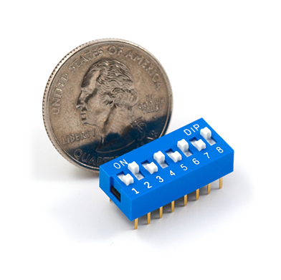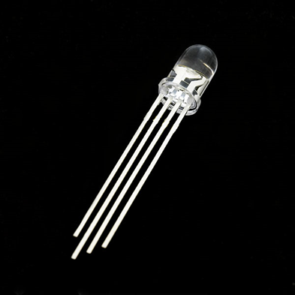
An 8 position SPST DIP switch and an RGB LED (note 4 leads)

Pickup Parts in Lab to continue parts 1-8. Parts 9 and 10 do not require extra parts.
For Lab 1, there are a some extra parts (not in your kit) you will need to pickup sometime in the lab once the TA lab schedule is setup to complete many of the remaining required parts of lab 1. Several of the extra credit options can be done without these parts. The SPI I/O expander chip, navigation switch, and touch switch keypad board are available for check out from a Lab TA. I left out the $1 I/O expander DIP IC since very few students used it again after lab 1. We found very low cost clones of the original Sparkfun navigation switch and touch keypad board designs from China and left them out of the new kits to reduce your kit cost around $20. Sparkfun does not want to sell imported boards in kits since they are worried about quality control and availability. Having you order them direct from China for the class was not an option since shipping can take over a month and for just one the shipping cost is several times the board price. Sparkfun even stopped making their own boards recently once they showed up for 1/10 of the cost from China. The boards look exactly the same and many even have a Sparkfun Logo on them. Once you finish your checkoffs, return them ASAP to a TA. They will not be needed again in future labs. If they are needed later in the design project, you can check them out again later as needed.
Part 4 – Using a Navigation Switch or Digital Joystick and BusIn (10%)
Lab Demo: Hookup and run the navigation switch demo program. The mbed’s built-in LEDs show which switches have been activated.
Additional Details: Wiring and code is provided on this mbed cookbook wiki page:
https://developer.mbed.org/users/4180_1/notebook/using-a-navigation-switch-digital-joystick/
In the code, note the use of BusIn. It is faster than multiple DigitalIns when several bits must be read. Leave the switch hooked up for the next part to save time. Plug in the navigation switch to the breadboard with the pins orientated to the right.
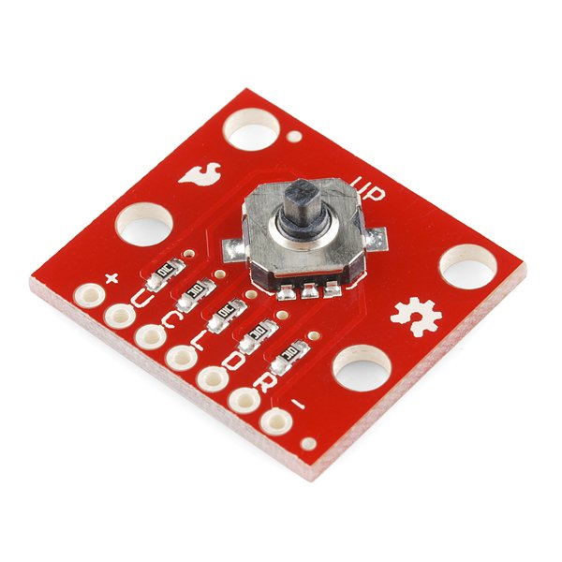
A Navigation switch has five SPST pushbuttons, up, down, left, right, and a center push.
Part 5 – A basic USB mouse function with the Navigation Switch (10%)
Lab Demo: Use the mbed as a USB mouse on a PC using the navigation switch for user input.
Additional Details: USB is a fast serial bus for PC I/O devices. The mbed LPC1768 has an internal USB controller interface and can function as a USB host or as a USB device. In addition to high speed bidirectional data transfers, a USB 2.0 cable also supplies up to 500MA of 5VDC power to the I/O device. Every USB device contains a microcontroller with USB firmware. USB will be examined later in class, but this quick USB demo will be done in the lab while the navigation switch is still on the breadboard from the previous part to save wiring time in lab. The complete details of a USB driver are a bit too involved to read through the code. At power on, USB devices report a code which enables the OS to automatically determine which driver is needed and the device is assigned an address on the USB bus when the OS loads the correct driver. After this somewhat complex initialization process (called USB enumeration), a USB mouse then sends periodic data packets to the PC containing X,Y movement and button status over the USB cable. The pushbuttons on the navigation switch are read to produce the data inside these packets (using the same switch code and wiring from the previous part).
The USB connector mounted on the mbed board can be used for downloading code and power only. To use mbed’s USB controller interface, add the USB connector breakout board as seen below. Ensure the navigation switch is still connected from the previous part. Import, compile, download and run the mbed USB mouse and navigation switch code example that is found on the wiki page at https://developer.mbed.org/users/4180_1/code/USBMouse_NavSwitch/. Plug in another mini USB cable from the USB breakout board to the PC. Hit reset on mbed, the PC should then recognize that a new USB mouse has been plugged in. The navigation switch should then function as a mouse on your PC. The switch will move the mouse cursor around the screen and the center pushbutton works like the left mouse button. Other mice do not need to be unplugged. Assuming the navigation switch was plugged into the breadboard with the pins on the right side, mouse up is towards the top of the breadboard to make it less confusing and to avoid needing to rotate the breadboard to use the mouse.

If you do not have a second mini USB cable available, use this procedure. Download the program to mbed and then unplug the regular USB cable from the mbed board. Add a jumper wire from the USB breakout board from its VCC pin (USB 5V power) to the Vin pin on the mbed. This will power mbed from the USB cable breakout in standalone mode. Plug in the USB cable to the USB breakout board and then to the PC. Mbed should power up, and the PC should recognize the new mouse device. Do not plug back in a second USB cable directly to mbed while mbed is getting external power from the Vin wire added to the USB breakout board. Of course, the regular USB cable will need to be moved back to download new code.
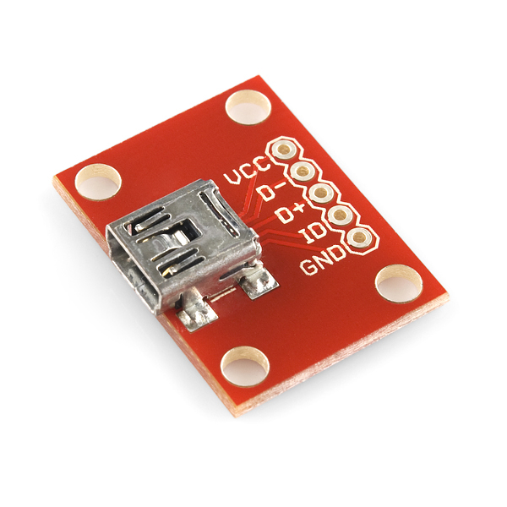
A mini USB breakout board must be added to use mbed’s USB controller interface.
Hookup D+, D-, and gnd pins to the mbed LPC1768 pins with the same name.
Part 6 – Touch Switch inputs using I2C and Interrupts (10%)
Lab Demo: Hookup and run the touch keypad demo program. The mbed’s built-in LEDs show a binary number for the key has been touched. Each key state change generates an interrupt.
Additional Details: Wiring and code is provided on this mbed cookbook wiki page:
https://developer.mbed.org/users/4180_1/notebook/mpr121-i2c-capacitive-touch-sensor/

There was a new problem with this demo in Fall 2020 that seems to be a function of which links you click with a mouse to import the program – the two different methods used to be exactly the same, but it appears one must update a project with new versions of the software automatically, and the other does not. Use the second level yellow link and not the blue link for import. So here is what not to do on a Wiki page now:
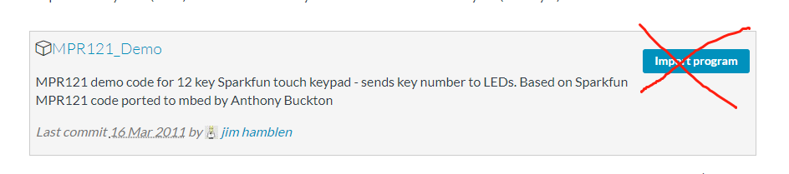
Instead two click import it this way (and this is likely safer in future labs):
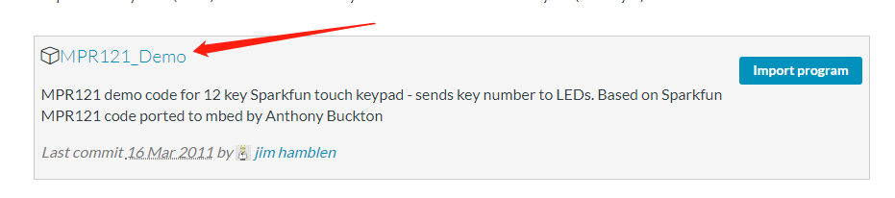
Which opens this page with a yellow link for import:

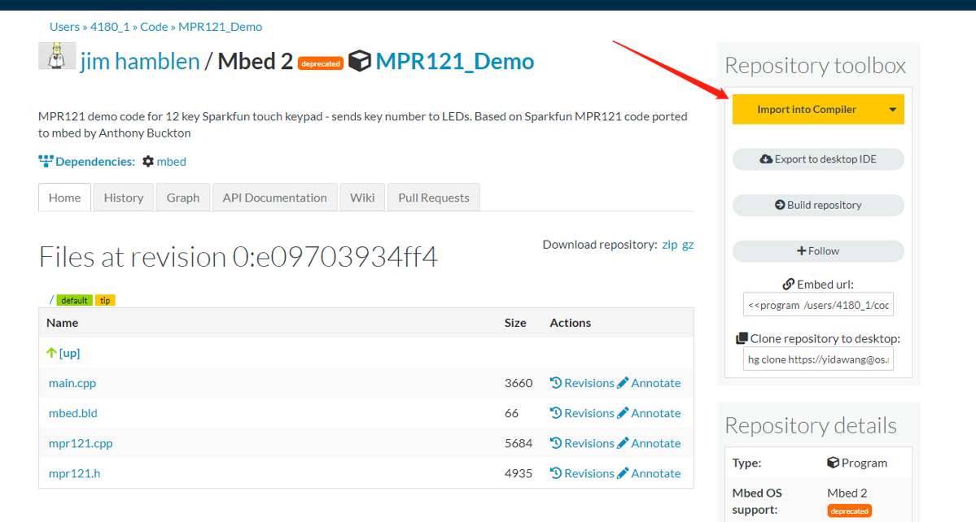

Don’t forget the two required I2C pullups (per instructions on wiki page)! It will not work without them. Internal pullups are not the correct value for the I2C bus. This MPR121 initialization code in this example is probably a bit too complex to read and understand completely at this point since the MPR121 IC requires a very complex setup procedure after power up. The details of how the I2C bus works will be described later. Some breakout boards have the pullups, but this one does not. In general, the schematic of the breakout board should be checked for pullups. The I2C bus supports multiple devices (with different addresses), but should have only one set pullups whenever multiple devices are used on the same I2C bus. I2C pins are open collector outputs and do not go high without an external pull up resistor.
Once the IC is initialized, 12-bits in two 8-bit registers indicate the status of each touch key. Whenever a key changes state, an interrupt is generated by the MPR121 touch controller IC. The interrupt routine reads the key state and updates the LEDs. Note the APIs used to setup the interrupt routine in the code provided.
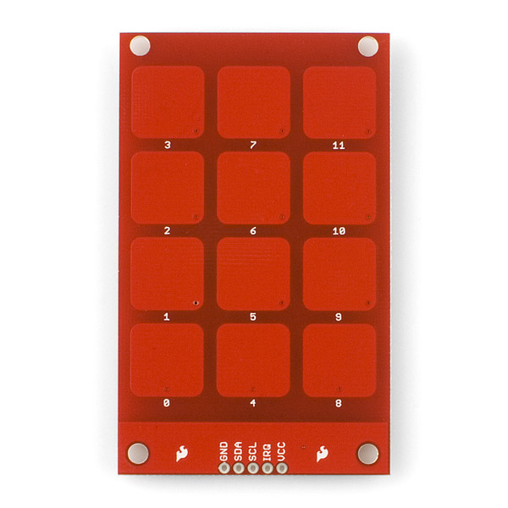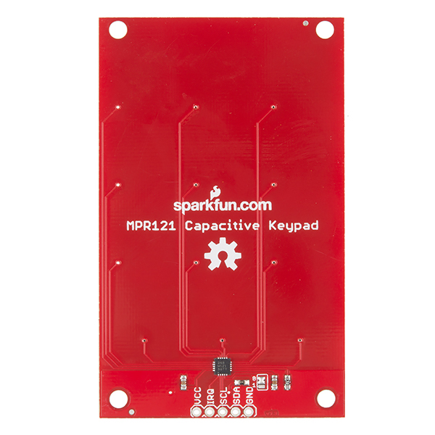
This 12-key touch keypad uses an I2C serial bus interface. The tiny MPR121 touch switch controller surface mount IC (black square) is on the back side of the PCB.
Part 7 - Expanding Digital I/O ports and SPI (15%)

Lab Demo: Read a switch input and control an LED using an SPI serial bus I/O port expander IC.

Additional Details: When extra digital I/O pins are needed in small microcontrollers, I/O expander chips are typically used. SPI is a low cost 1-bit serial bus with a clock that works just like a shift register. The MCP23SA17 as seen in the image below is available in a 28-pin DIP package that will plug directly into a protoboard. The mbed cookbook has a link for a MCP23S17 and a library code example using this chip at http://mbed.org/users/romilly/notebook/mcp23s17-addressable-16-bit-io-expander-with-spi/ with test demo code at http://mbed.org/users/4180_1/programs/MCP23S17_Basic_IO_Demo/llprau . The library code uses the mbed compiler’s SPI API function for low-level operations and adds a layer of functions to configure, read, and write the MCP23S17 chip using mbed’s built-in hardware SPI controller. A complete datasheet for the Microchip MCP23SA17 SPI I/O port expander chip can be found at http://ww1.microchip.com/downloads/en/DeviceDoc/20001952c.pdf . Be sure to correctly configure the reset pin on the MCP23S17 chip and note the wiring suggestions on this page. Reset cannot be just left floating high on this chip per the data sheet! Repeat Part 1 using the I/O expander IC by attaching an LED to a bit on an output port, a switch to a bit on an input port, and writing code to read the switch and output to the LED.
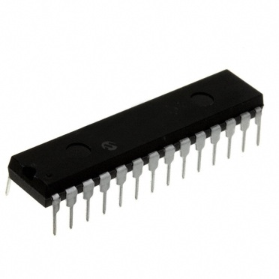
The MCP23S17 IC is an addressable 16-Bit I/O Expander with an SPI interface.

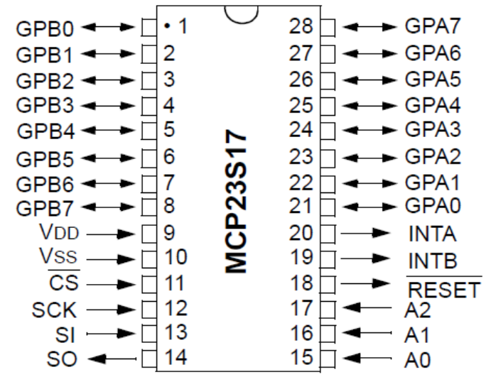
Mbed LPC1768 | MCP23S17
GND | A0, A1, A2
P20 | /CS
P14 | /RESET
P5, P6, P7 | SI, SO, SCK
3.3V | V_{DD}
GND | V_{SS}

Extra Credit (1%) Capture an input and output SPI bus cycle (both clock and data lines) using a logic analyzer or the mixed signal oscilloscope in the lab or a MyDAQ, if you have one. Be sure to demo it on the scope or LA to the GTA, or capture the image and hand it in later at checkout. If you need to review how to use a logic analyzer a tutorial is available.
Part 8: Reading an Analog Input from a Potentiometer with AnalogIn (10%)

Lab Demo: Read the analog voltage input from a potentiometer and use the input value to dim an LED with PWM

Additional Details: Many basic sensors provide an analog voltage output. Using an analog input pin, a microcontroller can read external analog voltage levels using an internal Analog to Digital converter (A/D or ADC). Potentiometers are another common user input device and they produce and analog output voltage using a voltage divider circuit. Wiring and example code for the small potentiometer can be found at: https://developer.mbed.org/components/Potentiometer/. The LED should get brighter as the pot knob rotates clockwise. The AnalogIn API returns a value from 0.0 to 1.0. A return value of 1.0 corresponds to an external analog voltage of 3.3V and 0.0 is 0.0V. Even though many sensors output an analog voltage, it still needs to be in the correct voltage range. If not, an analog circuit is needed to scale the analog voltage from 0-3.3V for the microcontroller’s analog input pin.

In some applications, a low pass filter may also be needed. A/D hardware can be a bit slow to convert (called conversion time) and accuracy depends on the number of bits in the A/D hardware, noise in the analog signal, and sampling rates. Faster and more accurate A/D hardware increases the cost. Many analog devices have high noise levels, a non-linear response, and limited bandwidth that might also limit accuracy and sample rates for the A/D. Selecting the appropriate sample rate and the number of bits needed varies in each application. Even small noise levels present on power supplies used for analog circuits can be an issue.
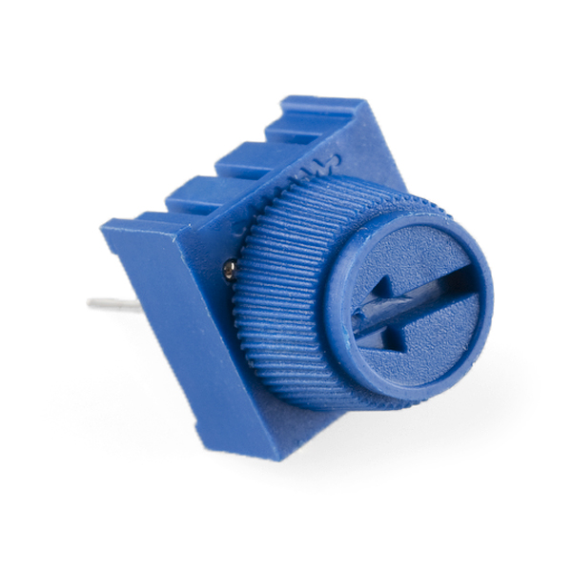
This small 10K potentiometer will plug into a breadboard and can be adjusted by hand without using any tools.

Many analog sensors have a non-linear voltage response curve. If accurate physical measurements are needed, numerical analysis curve fitting techniques or piecewise linear interpolation can be used to improve accuracy with some calculations after analog conversion. This is some variance between individual sensors on the response curves, but individual calibration procedures for sensors should be avoided whenever possible on mass produced consumer devices.
Part 9: Generate a Sine wave analog output with AnalogOut (10%)

Lab Demo: Send out a sine wave on the analog output pin using AnalogOut. Capture the sine wave scope image and hand it in at checkout or show it to the TA. Note the frequency of the sine wave.

Additional Details: Recall that the C/C++ sin() function has a range between +1.0 and -1.0. DC Bias and scale the analog output so that it uses the full analog output range (0 – 3.3V external on the pin, but 0.0 to 1.0 in the mbed AnalogOut API argument).

The analog sine wave output program must work in the following manner:
All output values and computations must be type float - no integer values allowed.
Use the C sin() function to compute each value and scale output values from 0.0 to 1.0 for AnalogOut
Use 20 samples per cycle and send out a complete cycle in a for loop.
It should output a complete cycle, and repeat forever in an infinite while loop.

Note the frequency of the resulting sine wave output. Is it faster or slower than you would have expected?

This lab computes sine values each time and is required to use only floating point arithmetic. It would be a bit faster to precompute the values and store them in an array. Integer values can be used with AnalogOut’s write_u16() function. Integer arithmetic is always a bit faster than floating point, but careful scaling is required. In general, the calculations may need to be run first in floating point to determine the correct scaling factors for integer only arithmetic. The waveplayer function that will be used later in the next lab uses integer values read from a file and stored in an array to achieve a higher rate on audio playback.

While the scope is available and hooked up to the DAC, it would save time to go ahead and do the next part with DMA.

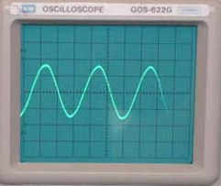

Part 10: DMA Controller to DAC Demo (5%)

Lab Demo: Send out a sine wave on the analog output pin using DMA to the DAC. Capture the sine wave scope image and hand it in at checkout or show it to the TA. Note the frequency of the sine wave and the high number of samples on the sine wave. Do you see the sample point where the DMA controller switches to another buffer with a small software delay?

Additional Details: Use a DMA controller on mbed to output a sine wave to the DAC. Run the mbed LPC1768 DMA controller to DAC demo program at https://os.mbed.com/users/4180_1/code/mbed_DMA_DAC_sine_demo/ . There is not a standard mbed API for DMA, this LPC1768 specific program uses the MODDMA library to setup the DMA controller to transfer a memory buffer containing 360 precomputed points on a sine wave to the DAC. DMA is a bit more complex than interrupts, but higher performance is possible when block transfers of data are needed since processor instruction execution clock cycles can be overlapped with I/O transfers.

Examine the demo program found in the project’s example4.h include file. Timer1 controls the DMA data rate to produce a 1 KHz sine wave output on the DAC (p18) with 360 samples per cycle (360KHz). After main computes one cycle of sine wave values to initialize the buffer and puts them in the format needed for the 32-bit DAC output register (i.e., it also includes a DAC speed/power bit and many bits are zero), it starts the DMA transfer by providing the DMA src and dest addresses along with number of values to transfer, and programs the Timer used by the DMA controller with the 360 KHz audio output sample rate.

The DMA uses double buffering ping/pong style. This is a common setup and while one buffer is doing a DMA transfer the other buffer can be loaded with new data or processed by other code. This allows for some overlap of I/O transfers in parallel with processor computations to speed things up. Main just blinks LED1 in a loop while the DMA controller does all the work outputting thousands of sine wave values to the DAC on p18. The other two LEDs show which buffer is being used for DMA. These are changed in the TC0, 1 DMA interrupt functions that are called when a DMA buffer transfer is complete (i.e., the hardware generates a DMA transfer done interrupt). For the demo, monitor p18 using an oscilloscope to verify the 1 KHz sine wave output, along with the blinking LEDs.

Additional Extra Credit Options for Lab 1

(2%) Add a WatchDog timer example to your Part 1 demo. Include a simulated fault that occurs after a few seconds. See http://mbed.org/cookbook/WatchDog-Timer for more info and examples. If the video does not play on the Wiki page, use this link: https://www.youtube.com/watch?v=7Xn2qKazxus
(4%) Do Part 1 by using only ARM assembly language. See http://mbed.org/cookbook/Assembly-Language for more info and examples. The relevant chapter on GPIO is now in chapter 9 of the LPC1768 reference manual (not 8 as per wiki).
(4%) Use Power Management to minimize the power consumption on your Part 1 demo. Hook up an external 5V power supply to V_{in} (with USB cable not connected!) and monitor the current saved. Some lab power supplies display current or a Voltmeter that measures current could be used. See http://mbed.org/cookbook/Power-Management for more info and examples. Some mbed modules support more power management features that are needed for extremely low power levels. If you run the C++ demo code on the wiki page, change the Peripheral_PowerDown(0xFFFF7FFF); , line to make bit 23 to a zero. For ticker to work now bit 23 must be a zero (i.e., oxFF7F7FF), since ticker uses timer 3 in the mbed library code. See powerdown register table after code example on the wiki page. If the videos do not play on the Wiki page, use these links: https://www.youtube.com/watch?v=rWedQLStHQ8 and https://www.youtube.com/watch?v=JTMmyM5gjIs
(2%) Connect two MCP23S17 devices to a single SPI bus without toggling chip select. Do the Part 1 LED and switch demo with the LED on one MCP23S17 IC and the switch on the other MCP23S17 IC. Hint: checkout the Ax lines on the datasheet and in the opcode bits. Extra chips are available in the lab.
(2%) Add a scroll feature to the USB mouse using the potentiometer or an RPG. The last argument in the mouse update function is scroll (+ or -) for movement. It is currently set to 0 in the code for no scroll movement. Some scaling and/or logic will likely be required to stop scroll motion using the potentiometer, but likely not if an RPG is used. RPGs can keep rotating, but a potentiometer cannot. RPGs are available in the lab from TAs.
(1%) Build a USB MIDI input device – While the USB connector is wired up to mbed, demo the first USB MIDI hello world example at https://os.mbed.com/cookbook/USBMIDI . The PC or MAC need a MIDI synthesizer setup to read and play an external USB MIDI input from mbed. There are a number of free downloads available. On the MAC, the demo in the video used GarageBand. For the PC, MIDI Keyboard Pro, https://www.microsoft.com/en-us/store/p/midi-keyboard-pro/9nblggh5f2nm is one of the easier ones to get working for a quick demo. If you have prior experience with a MIDI synthesizer, feel free to try one of the more complex ones. Most require a bit of configuration to read and play an external USB MIDI input, but MIDI keyboard pro worked the first time.

Early Bird Bonus (2%) Extra credit to first four groups to demo the regular lab 1 assignment including the extra credit options. The first couple of lab teams to finish it will likely wind up doing a bit of extra work blazing a path forward for everyone else. So they will get extra credit.

