|  |  |  |
| --- | --- | --- |
| **5-Cross Fold Validation** | | |
|  | Accuracy | Standard Deviation |
| Logistic Regression | 83.2% | 2.3% |
| LDA | 86.7% | 1.0% |
| QDA | 84.3% | 0.0% |
| K-NN (With K=2) | 84.1% | 1.3% |

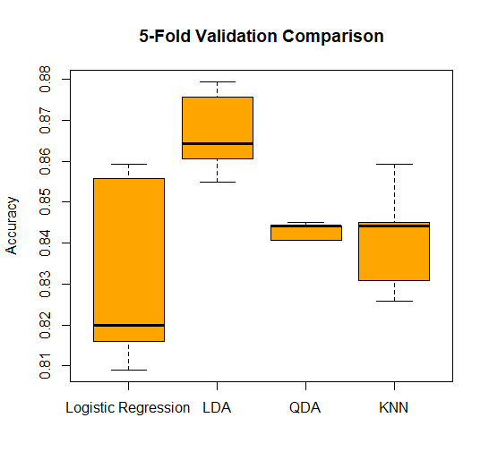

|  |  |  |
| --- | --- | --- |
| **Leave One Out Validation** | | |
|  | Accuracy | Standard Deviation |
| Logistic Regression | 83.2% | 2.4% |
| LDA | 86.7% | 1.0% |
| QDA | 84.3% | 0.0% |
| K-NN (With K=3) | 84.1% | 1.3% |

