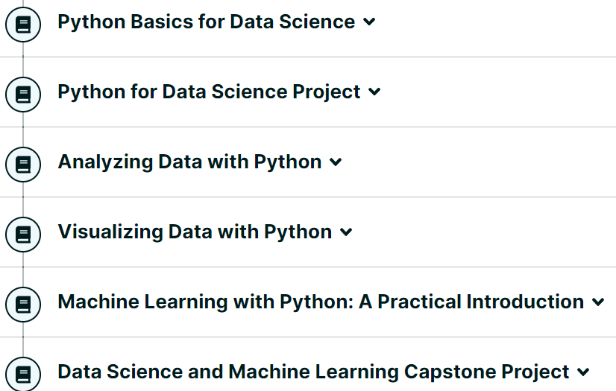

**Syllabus**

**Module 1: Python Basics**

* Types
* Practice Quiz
* Expressions & Variables
* Hands-On Lab: Your First Program, Types, Expressions, and Variables
* Practice Quiz
* String Operations
* Hands-On Lab: Strings
* Practice Quiz
* Graded Quiz

**Module 2: Python Data Structures**

* Lists and Tuples
* Hands-On Lab: Lists
* Hands-On Lab: Tuples
* Practice Quiz
* Dictionaries
* Hands-On Lab: Dictionaries
* Practice Quiz
* Sets
* Hands-On Lab: Sets
* Practice Quiz
* Graded Quiz

**Module 3: Python Programming Fundamentals**

* Conditions and Branching
* Hands-On Lab: Conditions and Branching
* Practice Quiz
* Loops
* Hands-On Lab: Loops
* Practice Quiz
* Functions
* Hands-On Lab: Functions
* Practice Quiz
* Exception Handling
* Hands-On Lab: Exception Handling
* Practice Quiz
* Objects and Classes
* Hands-On Lab: Objects and Classes
* Practice Quiz
* Graded Quiz

**Module 4: Working with Data in Python**

* Reading Files with Open
* Hands-On Lab: Reading Files with Open
* Writing Files with Open
* Hands-On Lab: Writing Files with Open
* Practice Quiz
* Loading Data with Pandas
* Pandas: Working with and Saving Data
* Hands-On Lab: Pandas with IBM Watson Studio
* Practice Quiz
* One Dimensional Numpy
* Hands-On Lab: One Dimensional Numpy
* Two Dimensional Numpy
* Hands-On Lab: Two Dimensional Numpy
* Practice Quiz
* Graded Quiz

**Module 5: APIs and Data Collection**

* Simple APIs - Part 1
* Simple APIs - Part 2
* Hands-On Lab: Instruction for Speech to Text and Language Translator API Keys
* Hands-On Lab: Introduction to API
* Hands-On Lab: Watson Speech to Text and Language Translator API
* Practice Quiz
* REST APIs & HTTP Requests - Part 1
* REST APIs & HTTP Requests - Part 2
* Hands-on Lab: Access REST APIs & Request HTTP
* Optional: HTML for Webscraping
* Webscraping
* Hands-on Lab: Webscraping
* Working with different file formats (csv, xml, json, xlsx)
* Hands-on Lab: Working with different file formats
* Practice Quiz
* Graded Quiz

**Final Exam**

**Python Code Quick Reference Guide**

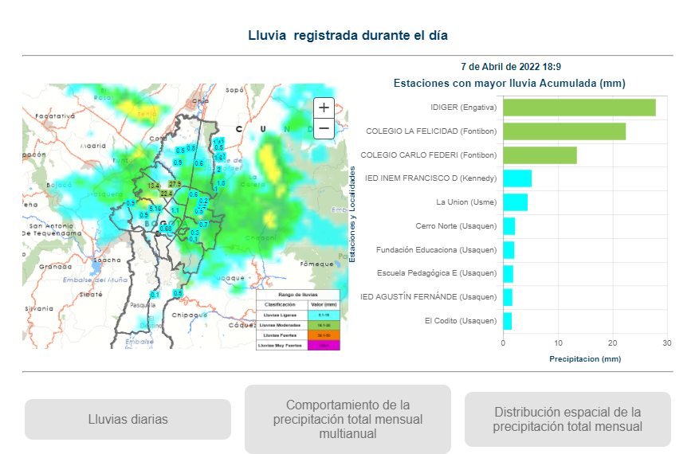

Acumulado de lluvia superior a 20 mm en lo corrido del día de hoy en estaciones ubicadas en las localidades de Fontibón y Engativá.

No se han registrado tormentas eléctricas en Bogotá en los últimos 30 minutos