Question 1: Use yfinance to Extract Stock Data

Reset the index, save, and display the first five rows of the tesla_data dataframe using the head function. Upload the screenshot of the results.

import yfinance as yf

import pandas as pd

ticker = yf.Ticker("TSLA")

tesla_data = ticker.history(period="max")

tesla_data.reset_index(inplace=True)

tesla_data.head()

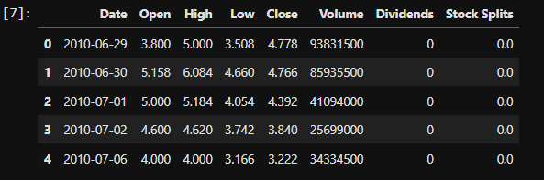

Question 2: Use Webscraping to Extract Tesla Revenue Data

Display the last five rows of the *tesla_revenue* dataframe using the *tail* function. Upload a screenshot of the results. Make sure you are using the data from the table named **Tesla Quarterly Revenue**on the website.

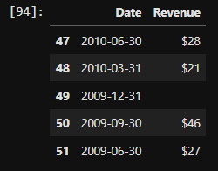

Question 3: Use yfinance to Extract Stock Data

Reset the index, save, and display the first five rows of the *gme_data* dataframe using the *head* function. Upload a screenshot of the results.

ticker = yf.Ticker("GME")

gme_data = ticker.history(period="max")

gme_data.reset_index(inplace=True)

gme_data.head()

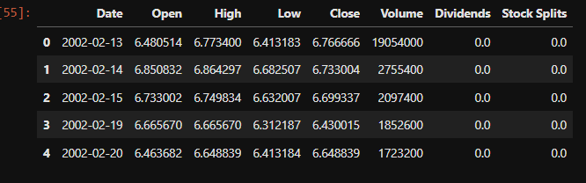

Question 4: Use Webscraping to Extract GME Revenue Data

Display the last five rows of the gme_revenue dataframe using the tail function. Upload a screenshot of the results. Make sure you are using the data from the table named **GameStop Quarterly Revenue**on the website.

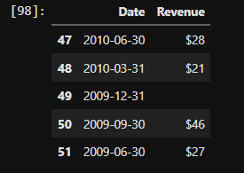

Question 5: Plot Tesla Stock Graph

Use the make_graph function to graph the Tesla Stock Data, also provide a title for the graph.

Upload a screenshot of your results.

make_graph(tesla_data, tesla_revenue, 'Tesla')

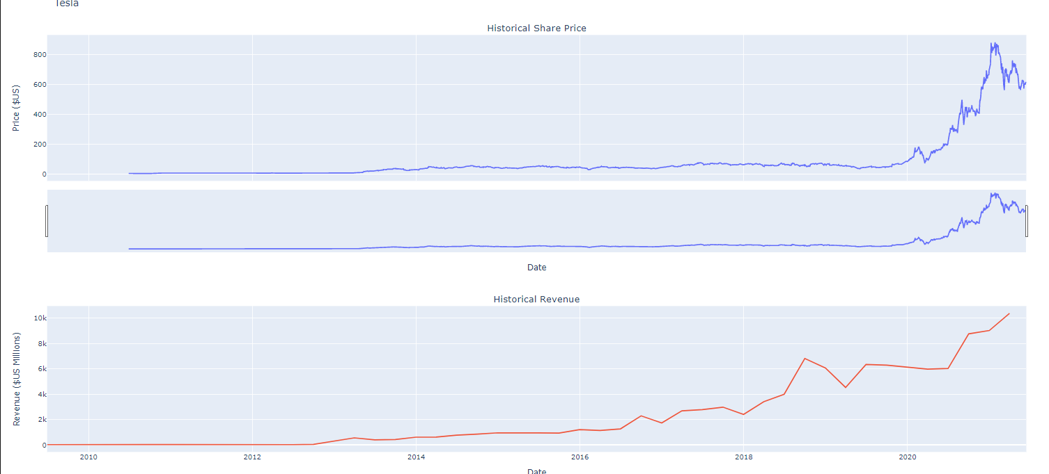

Question 6: Plot GameStop Stock Graph

Use the make_graph function to graph the GameStop Stock Data, also provide a title for the graph.

Upload a screenshot of your results.

make_graph(gme_data, gme_revenue, 'GameStop')

