OSINT Executive Summary

Open Source Intelligence (OSINT) model is a collection of information on a target. Information includes available employee data and contributions to the business and official government files.

The OSINT report is being performed for Due Diligence Company. The goal of this report is:

* Information on FTX from publicly available sources, using openly available tools.
* Founder information as well as partners information.
* Financial data from Founder and FTX

FTX Overview

FTX is a cryptocurrency exchange and crypto hedge fund which went bankrupt in 2022. Founder of FTX is Samuel Bankman Fried, which was founded on May 2019, and it was incorporated in Antigua and Barbuda. The headquarters of FTX is in the Bahamas. Officer of FTX are Gary Wang, Constance Wang Zhe, Devon Bernard, John J. Ray III, Jen Chan, Will Stroud.

**FTX Investments**

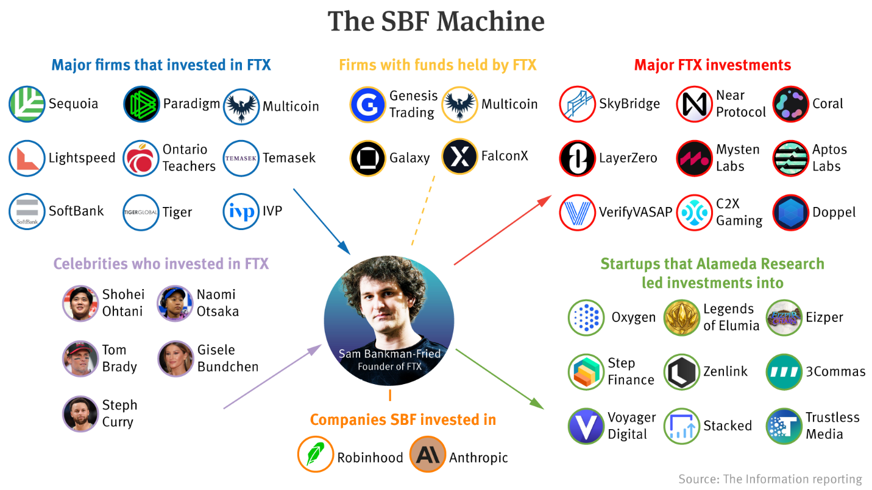

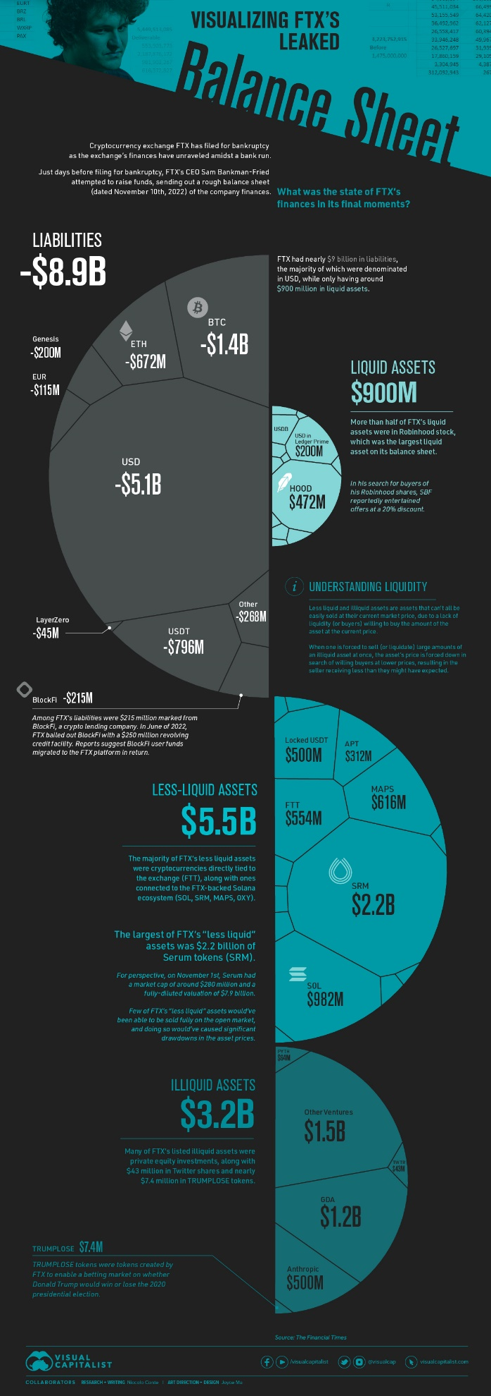**FTX Finances**

This diagram shows the balance sheets that were leaked about FTX.

**Founder’s social media**

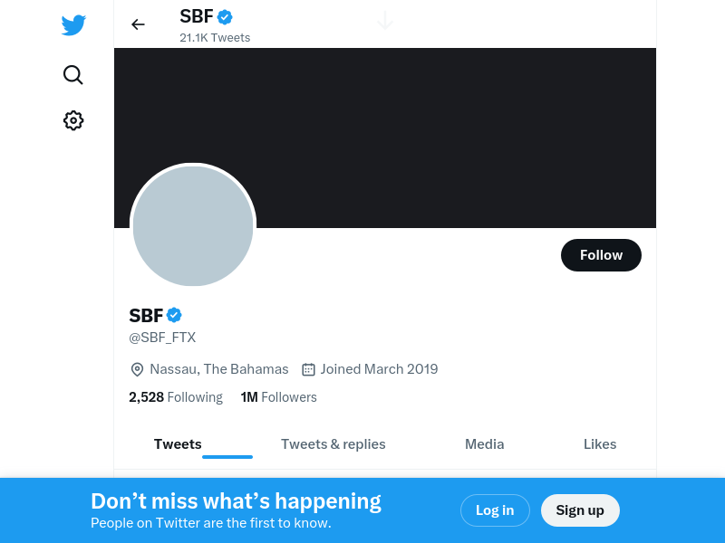

**FTX Associates social media**

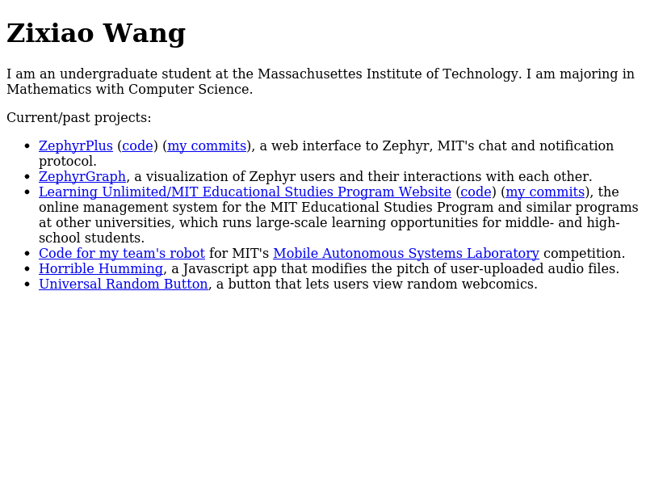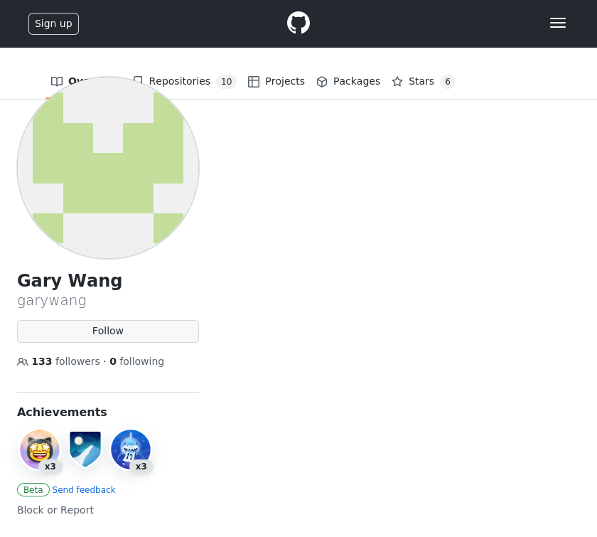**Gary Wang**

**Court Documents**

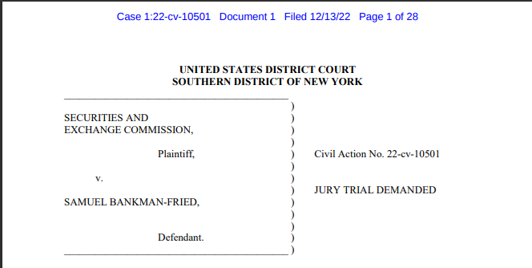

**Warrant Against Samuel Bankman-Fried**

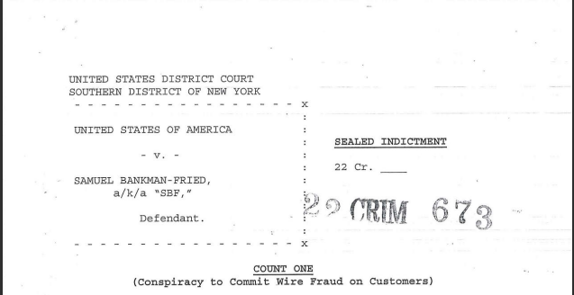

**FTX Website IP Addresses**

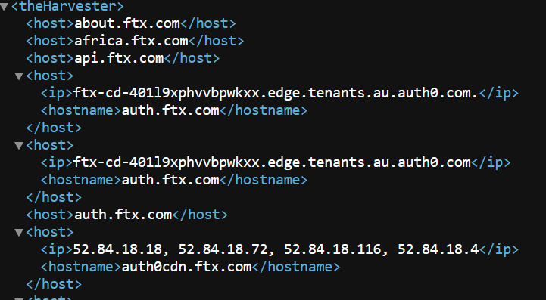

**Article About Founder**

**Background Information**

Samuel Bankman Fried’s parents are Barbara Fried and Joseph Bankman.

Gary Wang’s actual name is Zixiao Wang, and he went to MIT with Samuel Bankman Fried.

**Other Information**

Official warrant for Samuel Bankman Fried is included and federal documents that have to do with FTX case. There is also a video found of the founder where he is interviewed.

**Links**

Partners of FTX - https://www.crunchbase.com/organization/ftx-exchange/people

Interview with Founder - https://www.youtube.com/watch?v=IyoGdwVIwWw

Article Links - https://www.coindesk.com/markets/2021/12/07/most-influential-2021-sam-bankman-fried/

https://www.forbes.com/sites/stevenehrlich/2021/10/06/the-richest-under-30-in-the-world-all-thanks-to-crypto/?sh=4d8ceba13f4d

Addresses - Veridian Corporate Center Building 27, Western Road

Bahamas