**James Phipps**  
 **IT-230**  
 **Final Project Part I – ConsoleRegisterStudent**

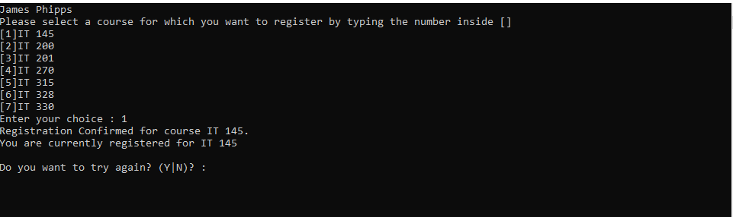The program starts by displaying my name first then a list of course options. The user enters 1, and the program confirms registration for IT 145. It then shows the current registration status with IT 145 listed. This confirms correct course registration and output functionality for a valid choice.

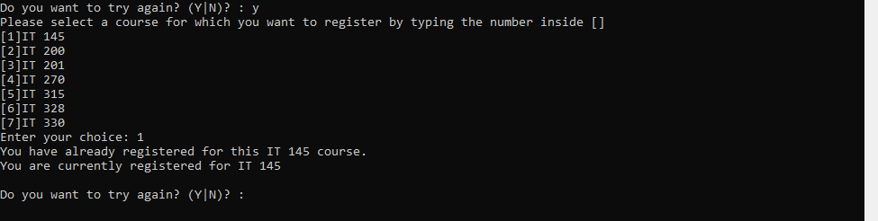After registering for IT 145, the user attempts to register for course 1 again. The program correctly identifies the course as already registered and displays an error message. It also shows the current list of registered courses.

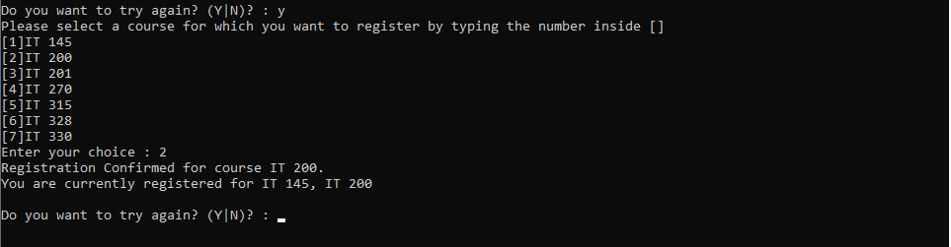The user enters 2, successfully registering for IT 200. The program adds it to the registered course list and displays both IT 145 and IT 200. This demonstrates that multiple unique courses can be registered correctly.

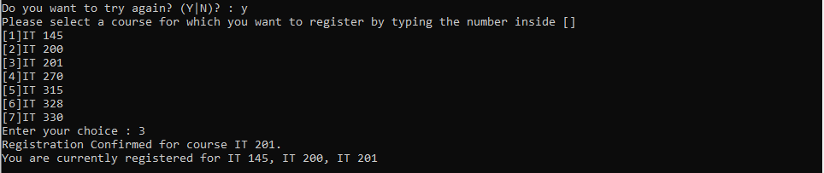The user selects 3 and is registered for IT 201. The current registration now includes IT 145, IT 200, and IT 201. This confirms that up to 9 credit hours (3 courses) are allowed.

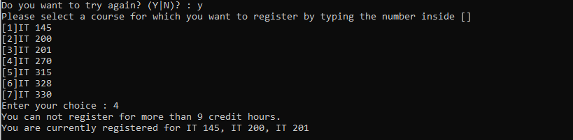After reaching the 9 credit hour limit, the user attempts to register for another course by entering 4. The program correctly displays an error message stating that no more than 9 credit hours are allowed and reaffirms the user’s current registration list.

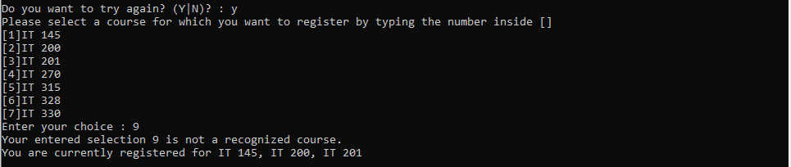The user enters 9, which is not one of the listed courses. The program responds with an error message indicating an unrecognized course and displays the current list of registered classes. This confirms that out-of-range numbers are handled correctly.

The user selects N when asked to register again. The program thanks the user and exits gracefully. This demonstrates the program’s end condition and successful handling of user decisions to stop registering.

The following is the complete, final version of the C# source code from Program.cs used in this assignment. The code includes all required logic, fixes, and inline comments for clarity.

// IT-230 Final Project Part I: ConsoleRegisterStudent

// James Phipps

// This program allows a student to register for up to 3 courses (9 credit hours max) with validation and input checking.

using System;

namespace ConsoleRegisterStudent

{

class Program

{

static void Main(string[] args)

{

// Entry point of the application

(new Program()).run();

}

void run()

{

// Variables for user selection and registration tracking

int choice;

int firstChoice = 0, secondChoice = 0, thirdChoice = 0;

int totalCredit = 0;

string yesOrNo = "";

Console.WriteLine("James Phipps"); // Required name output

// Loop to allow multiple course registration attempts

do

{

WritePrompt(); // Display course options

// Input validation using TryParse to prevent crashing on non-integer input

bool validNumber;

do

{

Console.Write("Enter your choice : ");

validNumber = int.TryParse(Console.ReadLine(), out choice);

if (!validNumber)

Console.WriteLine("Invalid input. Please enter a number between 1 and 7.");

} while (!validNumber);

// Validate course selection

switch (ValidateChoice(choice, firstChoice, secondChoice, thirdChoice, totalCredit))

{

case -1:

Console.WriteLine("Your entered selection {0} is not a recognized course.", choice);

WriteCurrentRegistration(firstChoice, secondChoice, thirdChoice);

break;

case -2:

Console.WriteLine("You have already registered for this {0} course.", ChoiceToCourse(choice));

WriteCurrentRegistration(firstChoice, secondChoice, thirdChoice);

break;

case -3:

Console.WriteLine("You can not register for more than 9 credit hours.");

WriteCurrentRegistration(firstChoice, secondChoice, thirdChoice);

break;

case 0:

Console.WriteLine("Registration Confirmed for course {0}.", ChoiceToCourse(choice));

totalCredit += 3;

if (firstChoice == 0)

firstChoice = choice;

else if (secondChoice == 0)

secondChoice = choice;

else if (thirdChoice == 0)

thirdChoice = choice;

WriteCurrentRegistration(firstChoice, secondChoice, thirdChoice);

break;

}

// Prompt to continue registering with proper input validation

do

{

Console.Write("\nDo you want to try again? (Y|N)? : ");

yesOrNo = Console.ReadLine().Trim().ToUpper();

if (yesOrNo != "Y" && yesOrNo != "N")

Console.WriteLine("Invalid input. Please enter 'Y' for yes or 'N' for no.");

} while (yesOrNo != "Y" && yesOrNo != "N");

} while (yesOrNo == "Y");

Console.WriteLine("Thank you for registering with us"); // Exit message

Console.WriteLine("Press enter to exit");

Console.ReadLine();

}

// Displays list of available courses

void WritePrompt()

{

Console.WriteLine("Please select a course for which you want to register by typing the number inside []");

Console.WriteLine("[1]IT 145\n[2]IT 200\n[3]IT 201\n[4]IT 270\n[5]IT 315\n[6]IT 328\n[7]IT 330");

}

// Validates the selected course

int ValidateChoice(int choice, int firstChoice, int secondChoice, int thirdChoice, int totalCredit)

{

if (choice < 1 || choice > 7)

return -1;

else if (choice == firstChoice || choice == secondChoice || choice == thirdChoice)

return -2;

else if (totalCredit >= 9)

return -3;

return 0;

}

// Shows current registered courses

void WriteCurrentRegistration(int firstChoice, int secondChoice, int thirdChoice)

{

if (secondChoice == 0)

Console.WriteLine("You are currently registered for {0}", ChoiceToCourse(firstChoice));

else if (thirdChoice == 0)

Console.WriteLine("You are currently registered for {0}, {1}", ChoiceToCourse(firstChoice), ChoiceToCourse(secondChoice));

else

Console.WriteLine("You are currently registered for {0}, {1}, {2}", ChoiceToCourse(firstChoice), ChoiceToCourse(secondChoice), ChoiceToCourse(thirdChoice));

}

// Maps course number to course name

string ChoiceToCourse(int choice)

{

string course = "";

switch (choice)

{

case 1: course = "IT 145"; break;

case 2: course = "IT 200"; break;

case 3: course = "IT 201"; break;

case 4: course = "IT 270"; break;

case 5: course = "IT 315"; break;

case 6: course = "IT 328"; break;

case 7: course = "IT 330"; break;

}

return course;

}

}

}