Using biased data skews estimates of power law exponents, but can be solved by censoring the data

Empirical data generated from a power law function is biased: Problems and solutions for estimating individual size distribution parameters

  - Justin Pomeranz, Jeff Wesner, Jim Junker

Box 1 / Glossary.
λ – Exponent controlling the rate of decline in the frequency of observed body sizes (m) as in $f\left(m\right)∝cm^{λ}$. Smaller (more negative) values indicate steep, more rapid declines in body size, whereas larger (less negative) values indicate shallower, less rapid declines in body size.
True data, $m$ – Individual body size data which are simulated from a bounded power law distribution. $m$ is used to represent true data.
True λ – Known value used to simulate data observations. $λ$ is used to represent the true lambda.
Sampling probability function – Mathematical function which determines the probability of the true data, $m$, being retained in the biased data, $\overset{⃖}{m}$.
Biased data, $\overset{⃖}{m}$ – Individual body size data which has fewer observations of small body sizes than would be expected from a power law distribution. $\overset{⃖}{m}$ is used to represent biased data (i.e., includes observations of small body sizes to the left of the number line).
Biased λ, $\overset{⃖}{λ}$ – coefficient estimate of λ estimated from biased data. $\overset{⃖}{λ}$ is used to represent the biased λ estimate.
${\hat{m}}_{min}$ – The estimated threshold where biased data begins. Values of ${\overset{⃖}{m} ≤\hat{m}}_{min}$ are biased and are removed in the censored data (see below).
Censored data, $\vec{m}$ – Empirical data of individual body sizes which has been censored to remove body sizes which are below the estimated ${\hat{m}}_{min}$. $\vec{m}=\overset{⃖}{m }≥{\hat{m}}_{min}$
Censored λ, $\vec{λ}$ – coefficient estimate of λ estimated from censored data. $\vec{λ}$ is used to represent the censored λ estimate.
$N, \overset{⃖}{N}, \vec{N}$ – The number of body sizes in the true, biased, and censored data, respectively. The number of observations must remain the same or decrease in each step such that $N≥\overset{⃖}{N}≥\vec{N}$

Introduction
Power laws describe many phenomena in the natural and biological sciences. Empirical data that is generated from power law functions are often biased where common, frequent occurrences are often observed at lower rates than would be expected from theoretical expectations. The result of this bias is that often only the tail of the empirical data set follows the patterns expected from a power law relationship and estimates of the power law exponent can deviate substantially when using biased data.
In ecology, a common pattern in biological communities is the rapid decline in abundance with increasing organismal body size. Declining abundance with increasing body size has captivated ecologists for over one hundred years and has received much attention in the literature under myriad names including size spectra, mass-abundance relationships, community biomass distributions, and individual size distributions (hereafter referred to individual size distributions or ISD).
Clauset paper – review reasons for biased observations.
General papers about fish gear recruitment? I know these exist but I haven’t been able to pin them down or find good examples.
Morin paper – specific analysis of biases in observed body size from benthic macroinvertebrate communities in relationship to mesh size used.
Individual size distributions are well described by a power law relationship. Traditionally, ISD relationships are estimated by grouping observations into bins of body sizes and counting or summing the individuals in each bin. An ordinary least squares (OLS) linear regression is then performed with the bin center on the x-axis and the count or sum on the y-axis in log-log space. The resulting slope coefficient is then used as an estimate for the power law exponent.
Previous studies of ISD relationships (albeit generally published under different names) have used various methods for attempting to correct for the lower-than-expected observations of small body sizes. Fore example, Dossena et al. (2012) and Perkins et al. (2018) compared body sizes that were retained on different mesh sizes (i.e., 250 µm vs 80 µm; 500 and 350 µm vs. 250 µm), and set the lower bound (i.e., minimum body size in the data) at the average body size that passed through the larger mesh size. The average size that passed through the larger mesh size was then set as the lower boundary, and all body sizes less than this value were censored (removed from the data) before estimating ISD parameters (most often the slope coefficient from OLS regressions). Perkins et al. (2018) reported this value as 0.0026 mg of dry mass, and this value has been used extensively(?) in subsequent publications (Pomeranz et al. 2022, [More citations?].
Other ways of censoring data have also been implemented. For example, Arranz et al. (2021) grouped fish into size classes across sites and then determined the mode of the size class that had the highest abundance, which was then set as the minimum size class across the global data set. Similarly, Arranz et al. (2023) compiled collections of electrofishing data across France and used histograms to visually determine the “peak” of the data (i.e., the point at which the abundance in each size class was consistently declining. In that case, a value of 0.5 g (total mass). Again, the body size at the peak was set as the minimum boundary, and all individuals below that size were removed from the global data set before estimating ISD parameters on a site-specific basis.
Finally, arbitrary cutoffs have also been used. Pomeranz et al. (2018) stated that sampling of the smallest individuals in benthic communities is difficult, individuals ≤ 0.5 mm in length were removed, although no data was presented or reference was cited to support this value. Likewise, McGarvey and Kirk (2018) stated that the Hess sampler employed was inefficient at sampling individuals smaller than 0.0064 mg dry mass but again no data was supplied or reference cited to support this claim.
Although several papers state that biased data (i.e., data which has fewer observations of small body sizes than would be expected) impacts estimates of power law relationships, to our knowledge a systematic analysis of these effects is lacking. In addition to quantifying the effects that biased data has, we test functions from the poweRlaw package for estimating where the observation bias occurs (or more accurately, where it disappears). The data is then censored at this location to see if known ISD parameters can be accurately estimated. Recent work has shown that maximum likelihood estimation methods generally outperform other methods for estimating ISD parameters (Edwards et al. 2017, Pomeranz et al. 2023) and are used here. Our results show that estimating ISD parameters on biased data severely affects coefficient estimates. Likewise, the poweRlaw package offers a robust method for determining where to censor the data, and estimates from censored data are generally closer to known values.

while the issue of using biased data (with reduced observations in small, frequently observed body sizes) has been discussed previously, no systematic work that we are aware of has specifically examined the effects that using biased data has on the estimates of power law exponents.
Here, we are specifically interested in constructing individual size distributions as defined by White et al. 2007.

Methods

General approach
We use a simulation approach to accomplish the following tasks (Figure 1):
- Simulate body size observations, $m$, from a bounded power law with a known value of λ.
- Calculate sampling probability as a function of body sizes. Sampling probability is calculated with a sigmoid function such that small body sizes have an extremely low probability of being sampled which rises rapidly with increasing body size and saturates around a probability of ~0.99. This results in small body sizes having low sampling probabilities, while large body sizes have a high sampling.
- Create a biased data set ($\overset{⃖}{m}$) by performing Bernoulli trials according to the sample probabilities calculated in step 2.
- Create the censored data, $\vec{m}$, by determining the ${\hat{m}}_{min}$ of the biased data and removing all individual observations which are smaller than the estimated minimum size. i.e,. $\vec{m}=\overset{⃖}{m} ≥{\hat{m}}_{min}$
- Estimate $\overset{⃖}{λ}$ from the biased data and $\vec{λ}$ from the censored data and compare them with known values of $λ$.
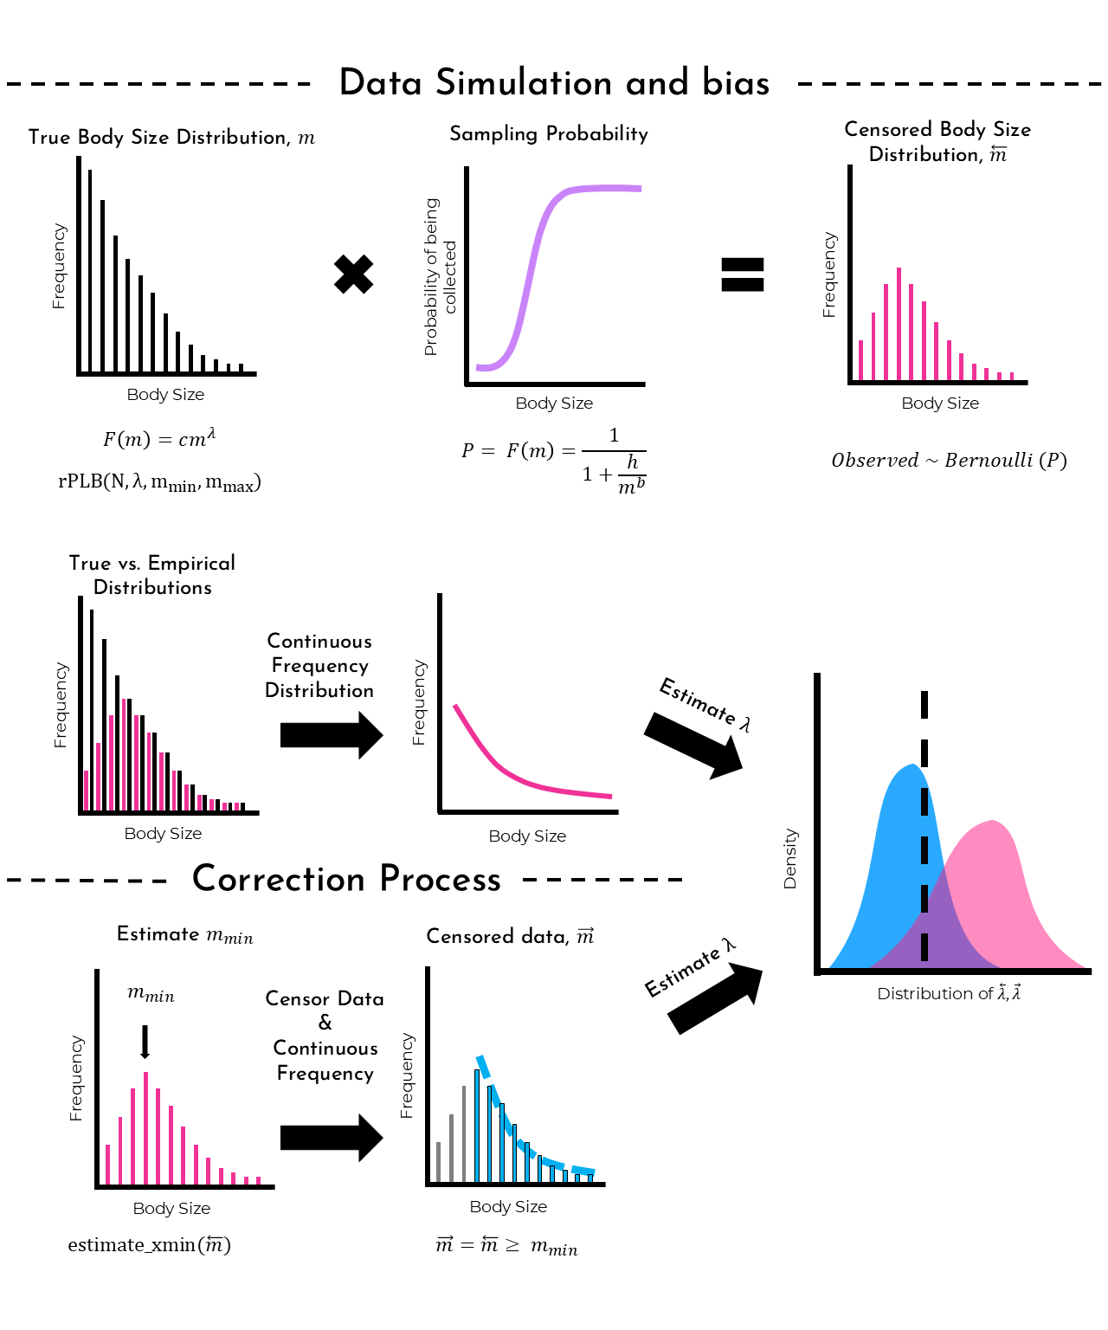
Figure 1. Conceptual figure of the simulation and analysis procedure. Body sizes are simulated from a bounded power law (black bars). Biased data is created by calculating sampling probability as a function of body size (purple curve) and then conducting Bernoulli trials (pink bars). True and biased data are compared on the same plot (black and pink bars), and a continuous frequency distribution is visualized (pink curve). Biased data is corrected by estimating the minimum body size (black arrow) and censoring (removing) data that is less than this value (grey bars), leaving only the observations which follow a power law (blue bars). The continuous frequency distribution is also visualized as a dashed blue curve. Power law exponents are estimated from replicates, and a distribution of estimates (pink and blue density plots) are compared with the true value (dashed vertical black reference line).

Data simulation
We simulated body sizes by sampling N observations from a bounded power law distribution using the rPLB() function from the sizeSpectra package (Edwards 2020) in the R statistical language (Version XXX, citation). In put arguments for rPLB() include N, λ, m_{min}, m_{max}. For all simulations, we set the range of m to be between 0.001 and 100. For different simulation scenarios, we varied N (1000, 5000, 10000) and λ (-1.5, -2, -2.5). Each simulation scenario was repeated 500 times.

Sampling probability

Sampling probability was calculated as a sigmoidal function of body size. We based this on the findings of Morin et al. (2004) which found that sampling probability was a function of body length and had a sigmoidal response. Here, body sizes are recorded in mass (i.e., dry weight), instead of length, but we defined a function which has qualitatively the same shape (see Figure 1 in Morin et al. 2004). Specifically, we calculated individual sampling probability (P_{i}) as:
$$P_{i}= \frac{1}{1+ \frac{h}{{m_{i}}^{b}}}$$
Where m_{i} is individual body size, and h and b are parameters controlling the location and rate of increasing probability. Four probability scenarios were examined (Table 1), and the sampling probability across body sizes can be seen in Figure 2. Sampling probability approached 1 for body sizes greater than 0.01 to 1, depending on the degree of bias.
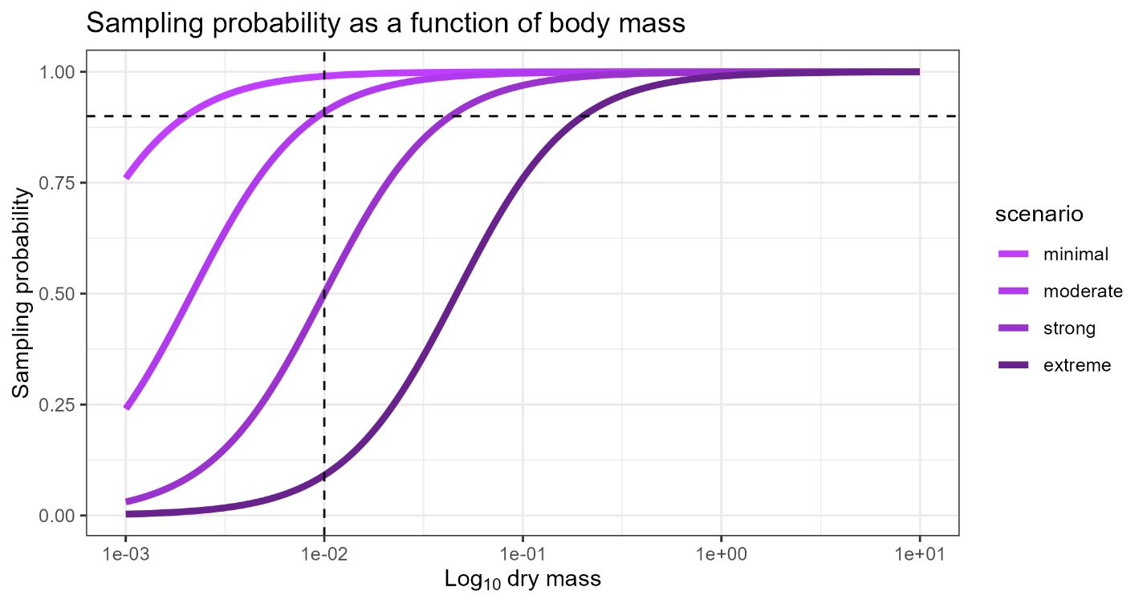
Figure 2. Sampling probability as a function of body size. Four different scenarios were examined with decreasing sampling probability. The dashed lines represent 90% sampling probability (horizontal) and a body size of 0.01 mg mass (vertical) for reference.
Table 1. Parameters and categories describing the degree of bias in the data. The proportion of retained individuals was robust to the original sample size investigated.
Scenario | h | b | Degree of bias | Mean proportion of observations retained
1 | 1 x 10⁻⁵ | 1.5 | Minimal | 89.8
2 | 1 x 10⁻⁴ | 1.5 | Moderate | 53.2
3 | 1 x 10⁻² | 1.5 | Strong | 18
4 | 1 x 10⁻¹ | 1.5 | Extreme | 8

Biased data
To create a biased data set, $\overset{⃖}{m}$, we performed Bernoulli trials based on the individual sampling probability calculated above. Individual body sizes were retained (observed) if the trial returned a 1 according to:
$${Observed}_{i} \sim Bernuolli(P_{i})$$
An example of a simulated and biased data set is shown in figure 3. Note that histogram bins are only used for visualization. Analyses (described below) were based on continuous frequency distributions where every individual observation of body size was retained.
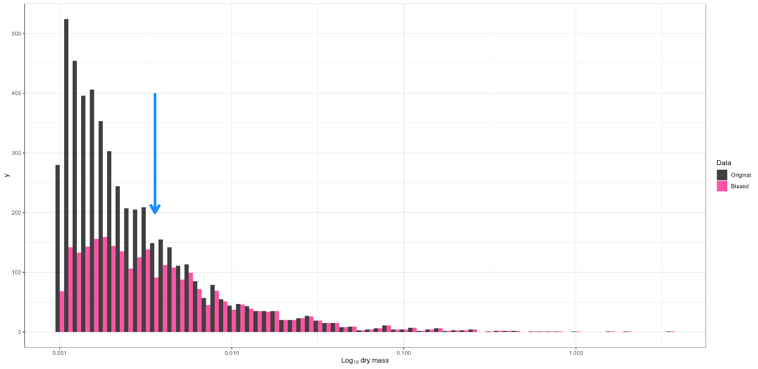
Figure 3. An example of simulated body size observations (black) and the resulting biased data set (pink). The blue arrow indicates where to censor the data according to the estimate_xmin() function from the poweRlaw package. Parameters for this example were N = 5000, λ = -2, h = 1 x 10⁻⁴, b = 1.5. Histogram bins are just used for visualization. Analysis is conducted as a frequency distribution on continuous (non-binned) data.

Censored data
To create a censored data set, $\vec{m}$, we first estimated what range of the data best fit a bounded power law distribution according to the estimate_xmin() function from the poweRlaw package (Gilespie 2015). This function estimates where the bias (i.e., lower frequency of observations than expected based on a power law distribution) occurs. We label this value as ${\hat{m}}_{min}$. To censor the data, we keep all values in the biased data which are greater than or equal to ${\hat{m}}_{min}$: $\vec{m}=\overset{⃖}{m }≥{\hat{m}}_{min}$.

Estimates of λ
We estimate λ using maximum likelihood methods as described in Edwards et al. (2017). Estimates are calculated from both the biased and the censored data which creates $\overset{⃖}{λ}$ and $\vec{λ}$, respectively. The distribution of estimated λ’s are plotted compared with the known value of λ.

Performance
We compared the known values of λ with the estimates calculated from the biased and censored data. For each replication we also calculated the width of the 95% CI for the λ estimates from each data source and determined whether the known λ fell within the CI or not. In addition, we determined bias as the median absolute difference between the known and estimated values of λ, averaged across all replicates.

Results

Biased data
The proportion of observations which were retained varied considerably across the four sampling probability scenarios we investigated (Table 1). Across the four sampling probability scenarios the body size which had a 95% of being retained varied from ~0.003 in the “minimal” degree of bias, up to 0.38 in the “extreme” scenario.

Estimates of m_{min}
As expected, the value of the ${\hat{m}}_{min}$ increased with increasing degree of bias. The estimated mmin was robust to variation in the original N
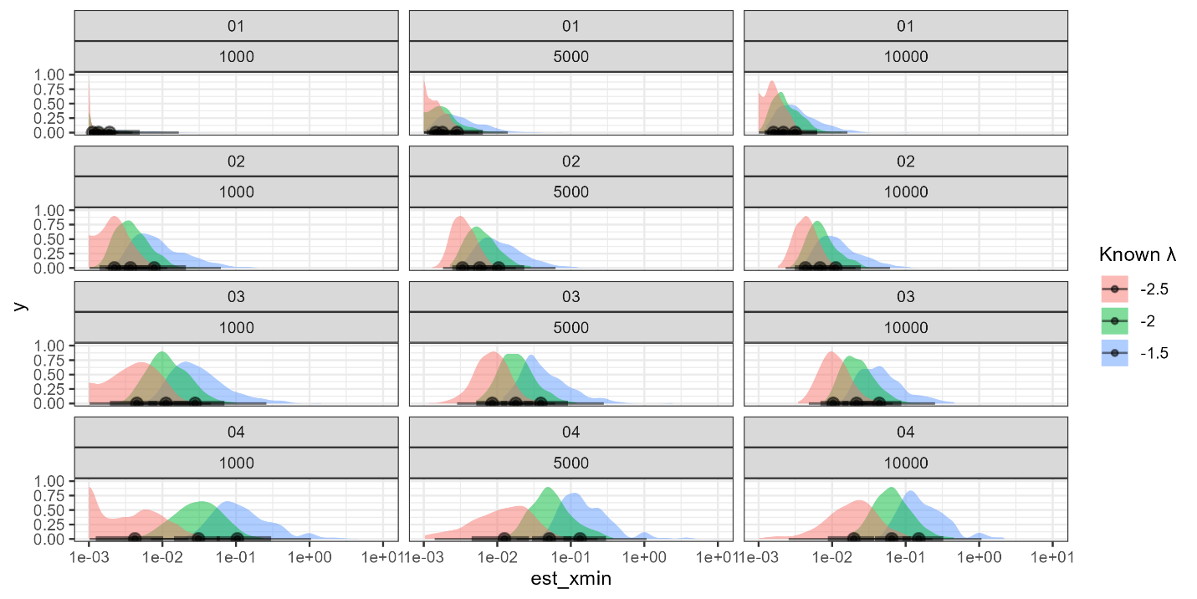

Estimates of λ
