Plots

Javier Porras

2024-02-27

### Plots

Dynamics of abundance and richness

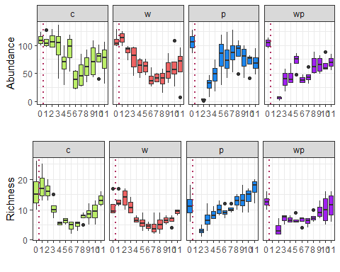

Coefficient of variation (CV) dynamics of abundance and richness

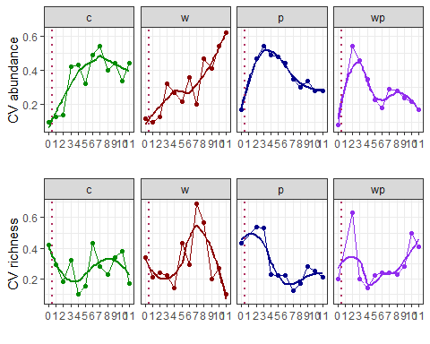

Dynamics of evenness index from Rank Abundance Distribution (RADs) models (zipf and lognormal)

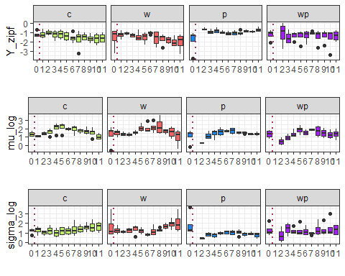

CV of evenness index

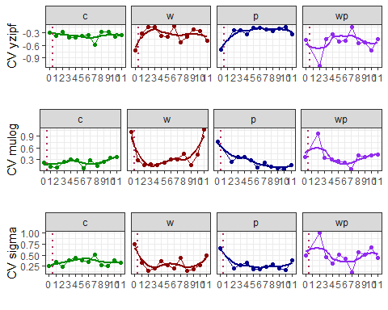

Differences at sampling 0

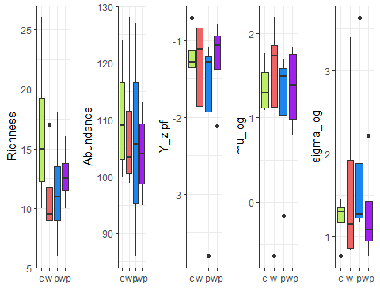

Response Ratio (RR) of abundance and richness with control as reference

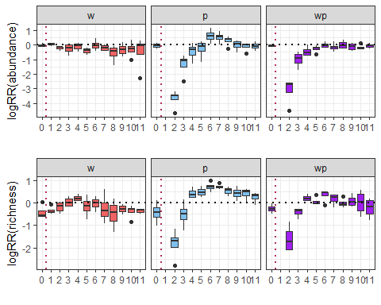

RR(CV abundance and richness) with control as reference

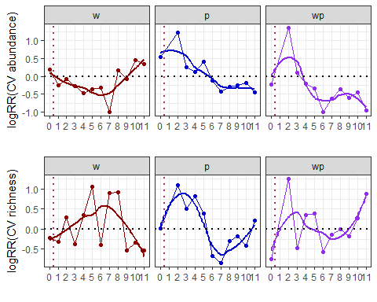

RR(evenness) with control as reference

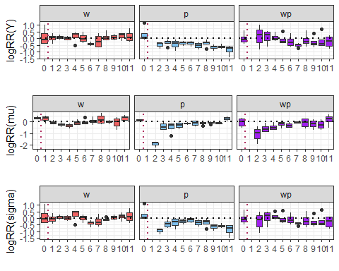

RR(CV eveness) with control as reference

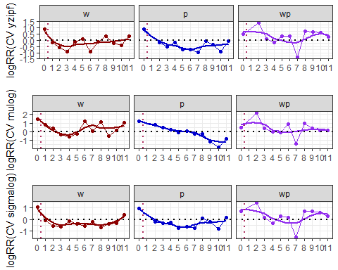

RR(abundance and richness). P and W as references of WP

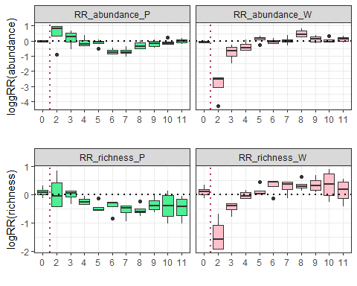

RR(CV abundance and richness): P and W as references of WP

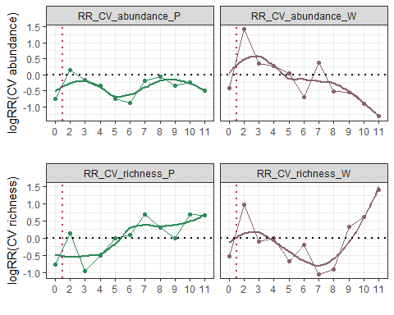

RR(eveness): P and W as references of WP

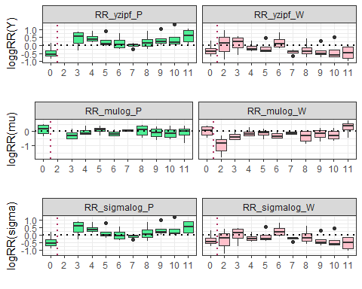

RR(CV eveness): P and W as references of WP

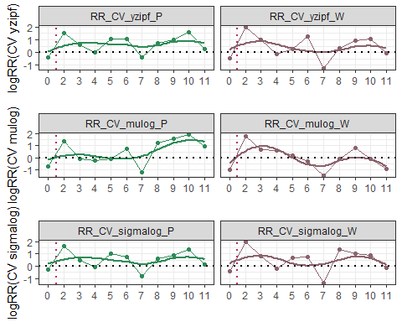

Species turnover

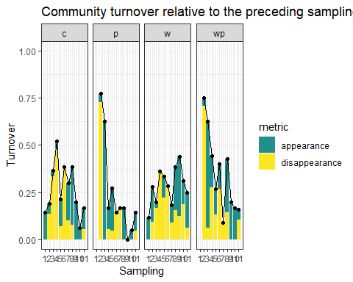

PCoA using Hellinger distance

