Financial Portfolio

Josue Kula

Java Programming I – CIS406

Strayer University

Prof. Bahram Abgoon

August 16, 2015

1. **Creating the Composition Financila Portfolio**

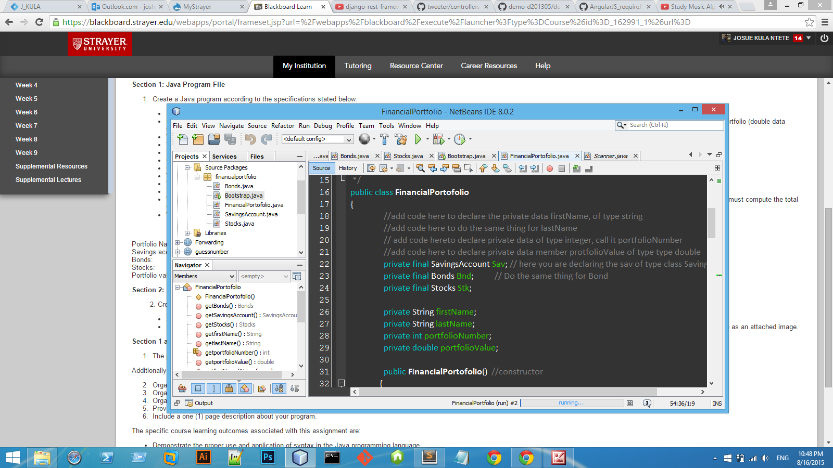

This Screen Describes the composition class Financial Portfolio that wraps up relatives classes like stocks, SavingsAccount, and class Bonds.

1. **Creating the class Stocks**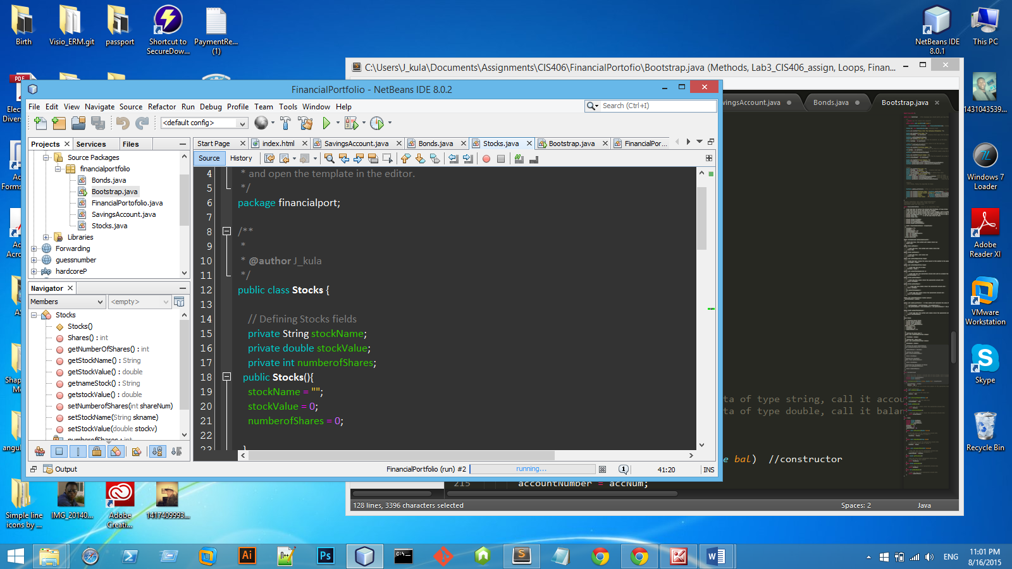
2. **Final Screen and result**

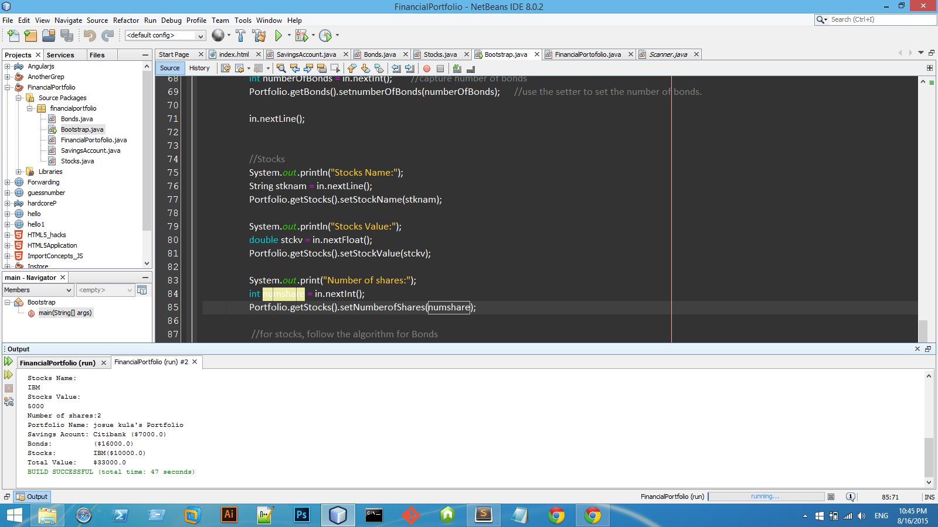

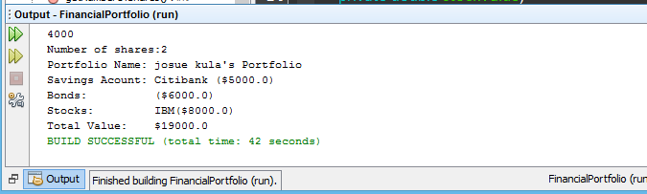

the above screen details the final results.