Application Architecture

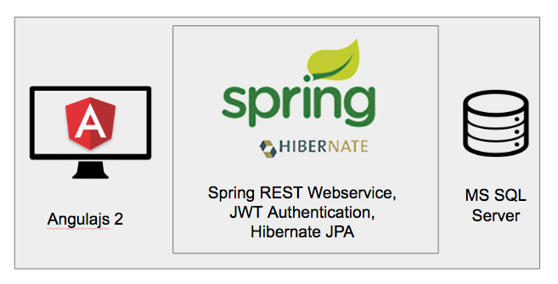

### System Requirement :

1. Java 8
2. Maven
3. Tomcat Server
4. MS SQL Server
5. NodeJS

### Frameworks

1. Angularjs 2
2. Spring 4
3. Hibernate

### IDE

1. Eclipse
2. Visual Code Studio

### Recommendations :

We can user Swagger(http://swagger.io) for REST API Documentations.

We can use <http://www.jasypt.org/> for Encryption which is used In PQMP.

### SQL Server Naming Convention:

1. Table name should start with uppercase letter.
2. Column name should start with lowecase letter.
3. Both Table and Column name should be camel case ,If name is combined with two words, second word will start with uppercase letter always e.g. SpectralCurve, ProcessColorDefinition.
4. Lookup table foreign key should have a postfix of “LookupId”.

### Java Application Flow :

1. Application is build by MAVEN.
2. Every request validated by Spring security which uses the Java Web Token (JWT) instead of sessionId
3. Every service should be based on Restful Service, request and response data should be in JSON format.
4. Application will have 3 layer of Abstraction Controller , Service and Repository.
5. Repository layer uses the Hibernate JPA framework for database interactions.
6. All the transactions are manage at the service layer.

### Java Project Folder Structure

com.phototype.ccl : This package will contain all the project setup related classes.

com.phototype.ccl.security : This package will contains application security configuration classes and all the classes should have Security postfix

com.phototype.ccl.model : This package will contain all the Entity classes and all the classes should have Model postfix

com.phototype.ccl.dtos : This package will contain all the Bean classes and all the classes should have Dto postfix

com.phototype.ccl.controllers : This package will contain all the Rest Controller classes and all the classes should have Controller postfix

com.phototype.ccl.service : This package will contain all the Service classes that comunicate with Repositories and all the classes should have Service postfix

com.phototype.ccl.repositories : This package will contain all the Classes that interact with database for CRUD operations and all the classes should have Repository postfix

com.phototype.ccl.utils : This package will contains the utils classes and all the classes should have Util postfix

resources : This folder contain properties file relation to application configuration and logger.

