**Face recognition punching system**

**ABSTRACT**

The Face Recognition Punching System using Data Analysis is an innovative approach designed to enhance security and efficiency in attendance systems. Traditional punching systems often rely on card swipes or manual entries, both of which can be easily compromised or manipulated. This system integrates facial recognition technology with data analysis algorithms to provide a highly secure, accurate, and efficient method for tracking attendance and monitoring time management in organizations or institutions.

The system captures the facial features of an individual using high-resolution cameras and processes the images through a deep learning-based facial recognition model. This model compares the captured facial data with a pre-existing database of registered individuals, ensuring that only authorized personnel can mark their attendance. Additionally, the system logs data in real-time, storing timestamps and relevant information for further analysis.

Data analytics algorithms are employed to monitor and analyze attendance patterns, employee punctuality, and other relevant metrics. These insights can be used to optimize workflows, identify trends, and ensure that employees or students adhere to the expected schedules. The system's integration with cloud databases allows for remote access and continuous data updates, providing a scalable and flexible solution for any organization.

This innovative system not only eliminates the possibility of "buddy punching" (where one person punches in for another) but also streamlines attendance recording, reducing human error and administrative overhead. Through the combination of advanced facial recognition and data analytics, this system offers a forward-thinking solution to modern attendance tracking and time management.

**PROJECT WORK**

**Project Title:** **Face Recognition Punching System Using Data Analysis**

**Introduction :**

With the rise of technology, traditional methods of employee attendance, such as punch cards and biometric fingerprint scanners, are being replaced by more secure and efficient systems. A face recognition punching system using data analysis represents a next-generation solution that integrates machine learning and facial recognition technologies to streamline the attendance process and enhance workplace security. The primary aim of this project is to develop a system that records employee attendance by recognizing their faces, eliminating the risk of fraud or human error while providing valuable data insights.

**Objectives:**

* To develop a face recognition-based attendance system that ensures secure and accurate employee identification.
* To integrate data analytics for real-time attendance tracking and analysis of patterns (e.g., employee punctuality, attendance trends).
* To build a scalable system that can be implemented across various organizations, supporting remote data storage and access.
* To provide a user-friendly interface for both employees and administrators.

**System Design:**

**The system consists of several key components:**

**Face Recognition Module:**

Utilizes machine learning models (such as Convolutional Neural Networks - CNN) to capture and recognize employee faces. It compares real-time facial images with pre-enrolled images stored in the database.

**Attendance Logging:**

The system automatically logs the time of successful face recognition and stores the data (employee ID, time of entry/exit) in a centralized database.

**Data Analytics Engine:**

This component analyzes attendance data, generating reports on punctuality, absenteeism, and other relevant metrics. The insights generated are stored and accessible to managers or HR personnel for decision-making.

**Database:**

A cloud-based database system that securely stores employee data, images, and logs. It supports real-time data updates and access.

**User Interface (UI):**

Provides a simple and intuitive interface for both employees to view their attendance status and for administrators to manage the system.

**Methodology:**

**Step 1: Data Collection**

A dataset of facial images is required to train the recognition model. The data can be collected by capturing multiple images of each employee under different lighting conditions, angles, and expressions to ensure robust recognition performance.

**Step 2: Preprocessing**

The captured images are preprocessed to normalize lighting, detect faces, and align facial features for optimal recognition. This step improves accuracy and reduces errors in the face detection process.

**Step 3: Face Recognition Model**

Using deep learning techniques such as CNN or pre-trained models like OpenCV or FaceNet, a model is trained to identify and verify faces based on the collected dataset.

**Step 4: System Integration**

Once the face recognition model is ready, it is integrated with the attendance logging module, which records employee attendance when a face is successfully recognized. The data is stored in the cloud-based database.

**Step 5: Data Analytics**

The attendance logs are processed to generate insights, such as attendance patterns, trends in tardiness, or frequent absences. These insights are displayed on a dashboard for administrators to review.

**Step 6: Testing and Evaluation**

The system is tested for accuracy and reliability in various environments. Factors like lighting conditions, camera quality, and employee diversity are considered to ensure that the system performs optimally in real-world scenarios.

**Technologies Used:**

**Face Recognition Frameworks:** OpenCV, Dlib, or FaceNet for facial detection and recognition.

**Data Analytics Tools:** Python (Pandas, Matplotlib) for data processing and visualization.

**Backend:** Flask/Django for building the web server that interacts with the database and handles API requests.

**Database:** MySQL or MongoDB for storing attendance data and employee profiles.

**Cloud Storage:** Amazon AWS or Google Cloud for data storage and system scalability.

**Results:**

**The system should be able to:**

* + Accurately recognize employee faces and record attendance with a high success rate.
  + Store and display attendance data in real-time.
  + Provide detailed reports on employee attendance and punctuality.
  + Integrate seamlessly into organizational workflows with minimal disruption.

**Future Work:**

**Improved Accuracy:** Further enhance the model's accuracy by training it with a larger and more diverse dataset.

**Mobile Application:** Develop a mobile application for remote attendance tracking.

**Integration with HR Systems:** Integrate the system with payroll and other HRmanagement software to automate attendance reporting and salary calculations.

**Multi-Modal Authentication:** Implement additional layers of authentication (e.g., facial recognition + fingerprint scanning) to increase security.

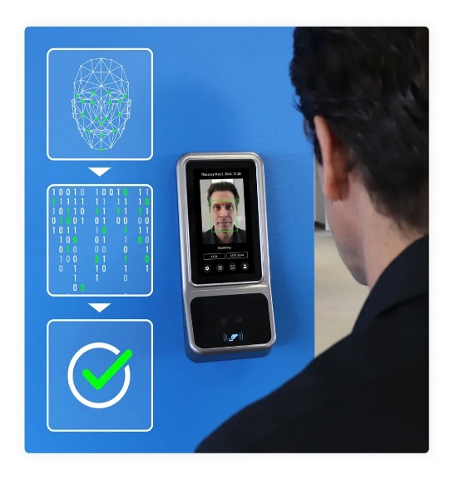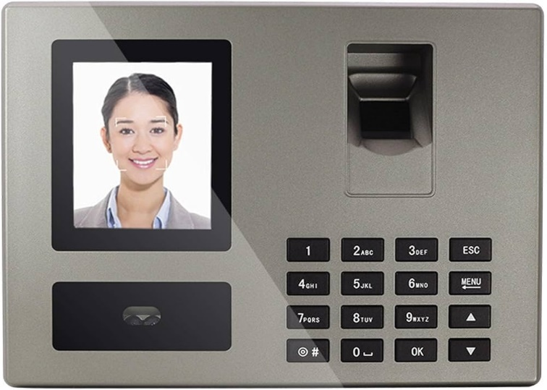

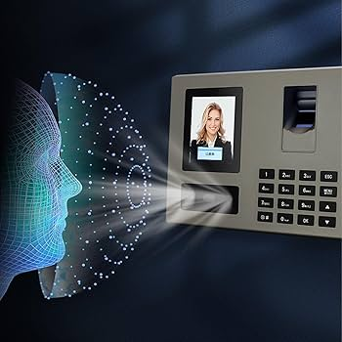

**Conclusion:**

The Face Recognition Punching System, enhanced with data analysis capabilities, offers a secure, reliable, and efficient solution for modern attendance management. By leveraging advanced facial recognition technology and data analytics, the system ensures that organizations can accurately track employee attendance while also gaining valuable insights into workforce trends. This system not only reduces the risk of attendance fraud (e.g., "buddy punching") but also provides businesses with a scalable, easy-to-use tool for improving time management and operational efficiency.

**References:**

* + OpenCV: https://opencv.org/
  + Dlib: http://dlib.net/
  + FaceNet: https://arxiv.org/abs/1503.03832
  + AWS: https://aws.amazon.com/
  + Python Data Analysis: <https://pandas.pydata.org/>