SMAI

Sentiment Analysis in Twitter



National Institute of Technology Karnataka Surathkal

Date: 15/02/2018

Submitted To :
Sushmita Mam

Group Members :
Gunjan Paliwal 15CO134
Rahul Kumar 15CO137
Jay Prakash 15CO219

Introduction

With the enormous increase in web technologies, number of people expressing their views and opinions via web are increasing. This information is very useful for businesses, governments and individuals. With over 500+ million Tweets (short text messages) per day, Twitter is becoming a major source of information. Twitter is a micro-blogging site, which is popular because of its short text messages popularly known as Tweets. Tweets have a limit of 140 characters. Twitter has a user base of 240+ million active users and thus is a useful source of information. Users often discuss on current affairs and share their personals views on various subjects via tweets. Out of all the popular social medias like Facebook, Google+, Myspace and Twitter, we chose Twitter because of the following reasons:

● Twitter contains an enormous number of text posts and it grows every day. The
collected corpus can be arbitrarily large.

● Twitter’s audience varies from regular users to celebrities, company representatives, politicians, and even country presidents. Therefore, it is possible to collect text posts of users from different social and interests groups.

● Tweets are small in length, thus less ambiguous.

● Tweets are unbiased in nature.

Using this social media we built two models for classifying ”tweets”. In the first one, we classify the tweets into positive, negative and neutral classes. We build models for two classification tasks: a 3-way classification of already demarcated phases in a tweet into positive, negative and neutral classes and another 3-way classification of entire message into positive, negative and neutral classes. We experiment with the baseline model and feature based model. We do an incremental analysis of the features. We also experiment with a combination of models: combining baseline and feature based model.

In the second model, we classify the tweets into subjective sentiments of sad, happy, angry and surprised. We experiment with various hyperparameters and features in a GMM. The GMM gives us a relative score for the tweet instead of an absolute classification which is in line with the subjectivity of any tweet.

DATASET

Twitter is a social networking and microblogging service that allows users to post real time messages, called tweets. Tweets are short messages, restricted to 140 characters in length. Due to the nature of this microblogging service, people use acronyms, make spelling mistakes, use emoticons and other characters that express special meanings. Following is a brief terminology associated with tweets.

●Emoticons: These are facial expressions: pictorially represented using punctuation
and letters; they express the user’s mood.

●Target: Users of Twitter use the @ symbol to refer to other users on the microblog.
Referring to other users in this manner automatically alerts them.

●Hashtags: Users usually use hashtags to mark topics. This is primarily done to
increase the visibility of their tweets.

In this project, for the multipolar classification we use the dataset collected and annotated for the SMILE project. This collection of tweets mentioning 13 Twitter handles associated with British museums was gathered between May 2013 and June 2015. It was created for the purpose of classifying emotions, expressed on Twitter towards arts and cultural experiences in museums.
It contains 3,085 tweets, with 4 emotions namely anger, happiness, surprise and sadness. Out of them, we used 2,500 tweets for training the GMM and the rest 1,085 were used for the testing of the model. This was done in multiple folds with a change in training, validation and testing dataset each time for better results.

For the bipolar classification of tweets using SVM, the dataset is based on data from the following two sources:

● University of Michigan Sentiment Analysis competition on Kaggle
● Twitter Sentiment Corpus by Niek Sanders

The Twitter Sentiment Analysis Dataset contains 1,578,627 classified tweets, each row is marked as 1 for positive sentiment and 0 for negative sentiment.

RESOURCES AND TOOLS

In this work we use various external resources in order to preprocess the data and provide prior score for some of the commonly used words:

●Emoticon Dictionary​ : We use the emoticons list extracted from a CLARIN.SI
repository titled Emoji Sentiment Ranking 1.0 which contains a lexicon of 751 emoji
characters (in Unicode format) with automatically assigned sentiment. The
sentiments are computed from 70,000 tweets, labeled by 83 human annotators in
13 European languages. The table below shows a small snapshot of the dictionary:

Emoticon Polarity
: −) :) : o) :] : 3 Positive
: −D : D 8D xD XD Extremely Positive
: −/ : / = / = < /3 Negative
D: D8 D= DX v.v Dx Extremely Negative
>:) B) B-) :) :−) > Neutral

● Acronym Dictionary ​: We created a custom acronym dictionary from scratch which sits in the ​ utils ​ module. We created this using information regarding the most used acronyms on the internet for texting, tweeting and other social network updates.

The table below is a snapshot of the acronym dictionary:

Acronym Expansion
admin administrator
afaik as far as I know
omg oh my god
rofl rolling on the floor laughing
rip rest in peace

● Sklearn​ -Scikit-learn (formerly scikits.learn) is a free software machine learning
library for the Python programming language. It features various classification,
regression and clustering algorithms including support vector machines, random
forests, gradient boosting, k-means and ​ and DBSCAN, and is designed to interoperate with the Python numerical and scientific libraries NumPy and SciPy.

● Nltk​ - The Natural Language Toolkit, or more commonly NLTK, is a suite of libraries and programs for symbolic and statistical natural language processing(NLP) for English written in the Python programming language.

● Python spell checker​ - It tries to choose the most likely spelling correction for a
word. Probabilities are used to select most likely spelling.

● SentiWordNet​ - SentiWordNet is a lexical resource for opinion mining. SentiWordNet assigns to each synset of WordNet three sentiment scores: positivity, negativity, objectivity.
● Tweepy​ - It is an easy to use Python library for accessing the twitter API.
● Hashtag segmenter

PREPROCESSING

A. Tokenisation -
After downloading the tweets using the tweet id’s provided in the dataset, we first tokenize the tweets. This is done using the Tweet-Tokenizer provided by the NLTK library. It is important to note that this is a twitter specific tokenizer in the sense that it tokenizes the twitter specific entries like Emoticons, Hashtag and Mentions too. After obtaining the tokenized tweet we move to the next step of preprocessing.
B. Replacing Emoticons -
Emoticons play an important role in determining the sentiment of the tweet. Hence we replace the emoticons by their sentiment polarity by looking up in the Emoticon Dictionary that we have created using Emoji Sentiment Dataset used in the ‘emoji’ python library.
C. Remove Url -
The url’s which are present in the tweet are shortened using TinyUrl due to the limitation on the tweet text. These shortened url’s did not carry much information regarding the sentiment of the tweet. Thus these are removed.
D. Remove Target -
The target mentions in a tweet done using ’@’ are usually the twitter handle of people or organisation. This information is also not needed to determine the sentiment of the tweet. Hence they are removed.
E. Replace Negative Mentions -
Tweets consists of various notions of negation. In general, words ending with ’nt’ are appended with a not. Before we remove the stopwords ’not’ is replaced by the word ’negation’. Negation play a very important role in determining the sentiment of the tweet. This is discussed later in detail.

F. Hashtags - Hashtags are basically summariser of the tweet and hence are very critical. In order to capture the relevant information from hashtags, all special characters and punctuations are removed before using it as a feature.

G. Sequence of Repeated Characters -
Twitter provides a platform for users to express their opinion in an informal way. Tweets are written in random form, without any focus given to correct structure and spelling. Spell correction is an important part in sentiment analysis of user-generated content. People use words like ’coooool’ and ’hunnnnngry’ in order to emphasise the emotion. In order to capture such expressions, we replace the sequence of more than three similar characters by three characters. For example, wooooow is replaced by wooow. We replace by three characters so as to distinguish words like ’cool’ and ’cooooool’.

H. Numbers -
Numbers are of no use when measuring sentiment. Thus, numbers which are obtained as tokenized unit from the tokenizer are removed in order to refine the tweet content.

I. Nouns and Prepositions -
Given a tweet token, we identify the word as a Noun word by looking at its part of speech tag given by the tokenizer. If the majority sense (most commonly used sense) of that word is Noun, we discard the word. Noun words don't carry sentiment and thus are of no use in our experiments. The same reasoning go for prepositions too.
J. Stop-word Removal -
Stop words play a negative role in the task of sentiment classification. Stop words occur in both positive and negative training set, thus adding more ambiguity in the model formation. And also, stop words don’t carry any sentiment information and thus are of no use to us. We create a list of stop words

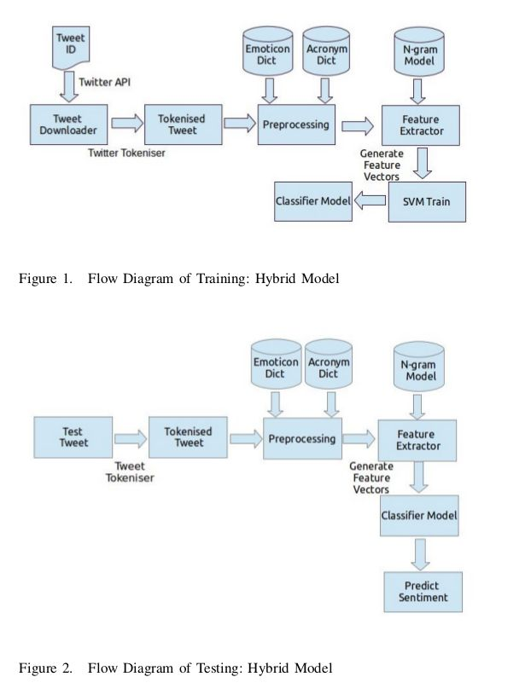
APPROACH

In Twitter sentiment analysis we build baseline model and feature based model. Figure 1 and 2 represent the approach of our training and testing model.

For multipolar data, instead of SVM Train, we train a Gaussian Mixture Model using the base and feature model and later instead of absolute classification and accuracy scores we use posterior probabilities obtained and log likelihood to measure relative accuracy of the model. Hence for the multipolar data, we are comparing which features are better for such an analysis instead of absolute accuracies.

A. Baseline Model
In the baseline approach, we first clean the tweets. We perform the preprocessing
steps listed in section 4. This gives us tokenized text, tokenized hashtags, emoticons. Now we create a feature vector of tokens which can distinguish the twitter to be positive, negative or neutral with high confidence. For example, presence of tokens like, “horrible day”, “feeling blessed”, etc help in determining that the tweet carries positive, negative or neutral sentiment with high confidence. We call such words as E
motion Determiner.

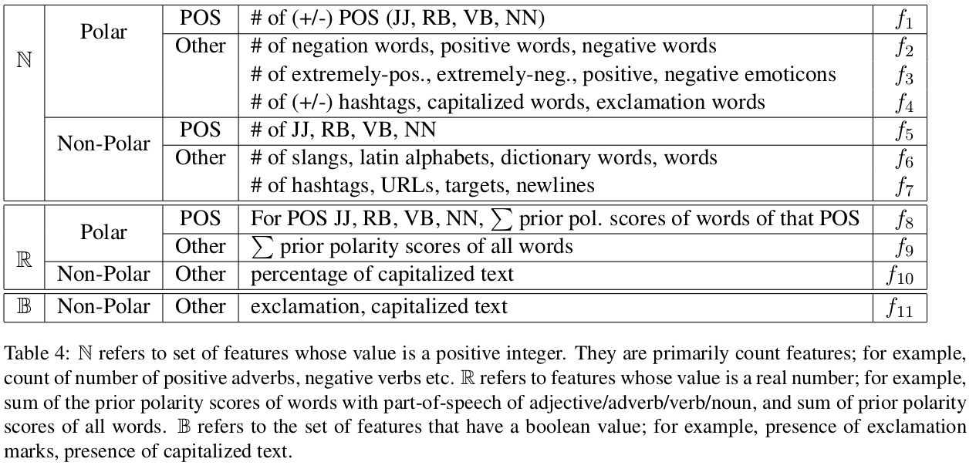

B. Feature Model
Next, we determine the attributes which would play a role in determining the
polarity of any tweet. Table 4 shows a reference of features we have used. We have in total 21 feature as listed below:
#f0: Percentage of capitalized text
#f1: COMPLETELY CAPITAL text (Emphasis words)
#f2: Capital + exclamation presence in a tweet
#f3-f6: No. of nouns, adjectives, verbs and adverbs.
#f7-10: No. of positive [nouns, adj, verbs, adv]
#f11-14: No. of negative [nouns, adj, verbs, adv]
#f15: Summation of prior polarity scores of words of that POS (Baseline)
#f16: Sentence polarity
#f17-18: No. of [positive hashtags, negative hashtags]
#f19: No. of hashtags
#f20: Emoticon polarity score

LITERATURE SURVEY

In the previous works of sentimental analysis the sentiments of a tweet were described as opinion representing one’s feelings.
Some examples features that have been reported in literature are:
1. Words And Their Frequencies : Unigrams, bigrams and n-gram models with their frequency counts are considered as features. There has been more research on using word presence rather than frequencies to better describe this feature. Panget al. [23] showed better results by using presence instead of frequencies.
2. Parts Of Speech Tags : Parts of speech like adjectives, adverbs and somegroups of verbs and nouns are good indicators of subjectivity and sentiment. We can generate syntactic dependency patterns by parsing or dependency trees.
3. Opinion Words And Phrases : Apart from specific words, some phrases and idioms which convey sentiments can be used as features. e.g. cost someone an arm and leg.
4. Position Of Terms : The position of a term with in a text can affect on how much the term makes difference in overall sentiment of the text.
5. Negation : Negation is an important but difficult feature to interpret. The presence of a negation usually changes the polarity of the opinion.

In the previous researches the classifier was based on the multinomial Na¨ıve Bayes classifier that uses N-gram and POS-tags as features.
The best score obtained on an overall performance system is about 55%.

** Learning from the read papers and improving the already used features, we have developed 12 features for which would be used for preprocessing.

References:
● Sentiment Analysis of Twitter Data: A Survey of Techniques
● Twitter as a Corpus for Sentiment Analysis and Opinion Mining
● Natural Language Processing with Python – Analyzing Text with the Natural Language Toolkit
● ● Brendan O'Connor, Michel Krieger, and David Ahn. TweetMotif: Exploratory Search and Topic Summarization for Twitter. ICWSM-2010. Python spell checker
● Twitter Sentiment Analysis- The good, the bad, the neutral!
● SVM: Scikit-learn
● Sentiment Analysis of Twitter Data - Columbia University
● Sentiment Analysis on Multi-View Social Data - University of Ottawa
● Twitter Sentiment Analysis: The Good the Bad and the OMG!

