**OXYGEN REQUIREMENTS & MOTILITY**

23. Explain one source of error that could lead to a false positive test result when performing a motility test, using Motility Test Media (MTM), for a particular bacterial species.

**Not removing the loop/needle along the same stab line.**

24. Using the provided term bank, label each of the following Fluid Thioglycolate Media (FTM) tubes with the category that corresponds with the residing bacteria’s oxygen requirement:

(5 points)

|  |  |  |
| --- | --- | --- |
| Aerophobe | Aerotolerant | Facultative Aerobe |
| Obligate Anaerobe | Obligate Aerobe | Microaerophile |

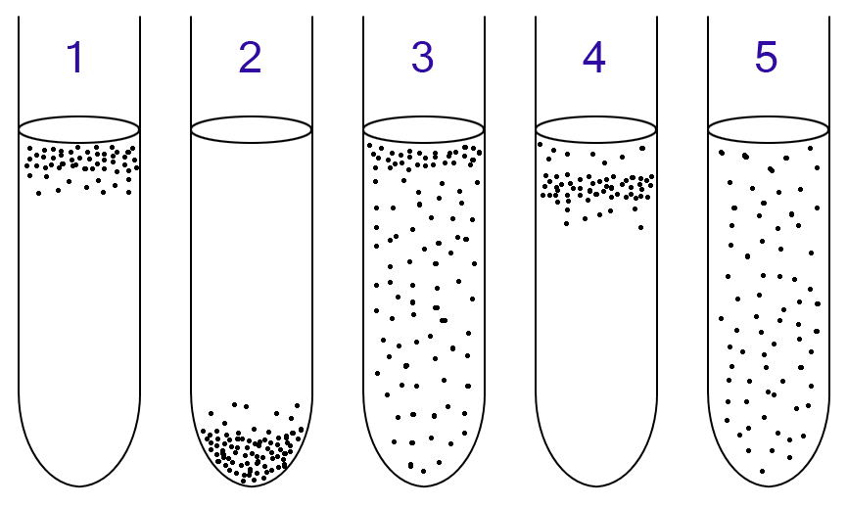

1. **Obligate Aerobe**

**2. Obligate Anaerobe**

**3. Aerotolerant**

**4. Microaerophile**

**5. Facultative aerobe**

12. You want to determine the oxygen requirements of a bacteria sample. Which media should you use to determine oxygen requirements?

|  |  |
| --- | --- |
| A. | MIO |
| **B.** | **FTM** |
| C. | SIM |
| D. | MTM |

13. Under which oxygen concentrations would anaerobic bacterium grow most efficiently?

|  |  |
| --- | --- |
| A. | 20% Oxygen |
| B. | 12% Oxygen |
| **C.** | **3% Oxygen** |
| D. | 80% Oxygen |

14. In the fluid thioglycollate medium, the oxidized portion will be

|  |  |
| --- | --- |
| A. | Yellow |
| B. | Red |
| **C.** | **Pink** |
| D. | Orange |