|  |  |
| --- | --- |
| 用例名称 | 加入心愿单AddToWishingList |
| 参与者 | 由用户User启动 |
| 事件流 | 1.用户User点击“加入心愿单”按钮  2.Booking接收用户User选择加入心愿单的酒店信息，将该酒店加入收藏列表，显示已收藏  3. 用户点击心愿单按钮  3.宾客 |
| 入口条件 | * 用户User进入酒店详细信息页面 |
| 出口条件 | * 该酒店已收藏 |
| 质量需求 | * 网络连接正常 |

|  |  |  |
| --- | --- | --- |
| **Part** | **Model Component** | **Example** |
|  | class | Wishinglist |
|  | attri | hotel |
|  | attri | user |
|  | method | addSuccessful |
|  | class | Wishinglistbutton |
|  | method | create |
|  | method | setHotel |
|  | class | Wishinglistcontrol |
|  | method | update |
|  | method | jump |

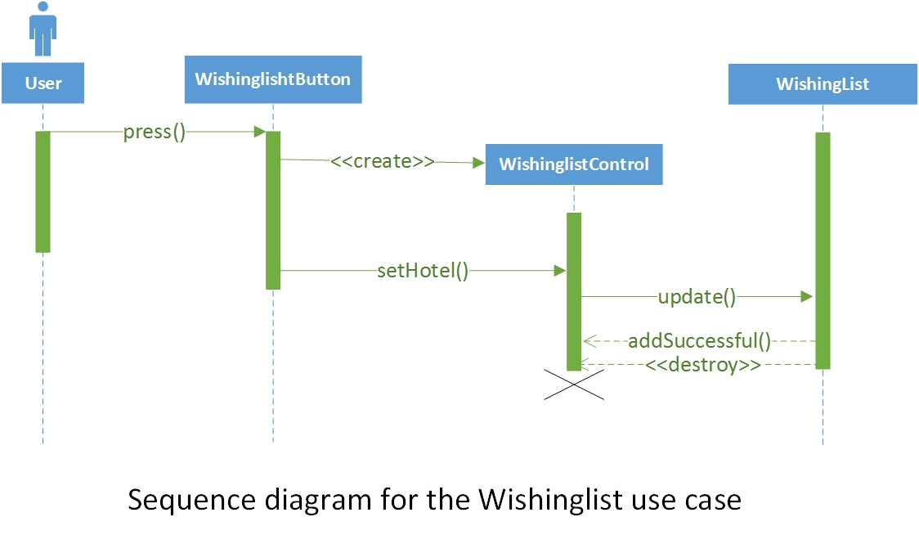

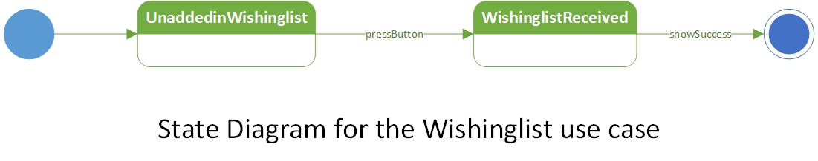

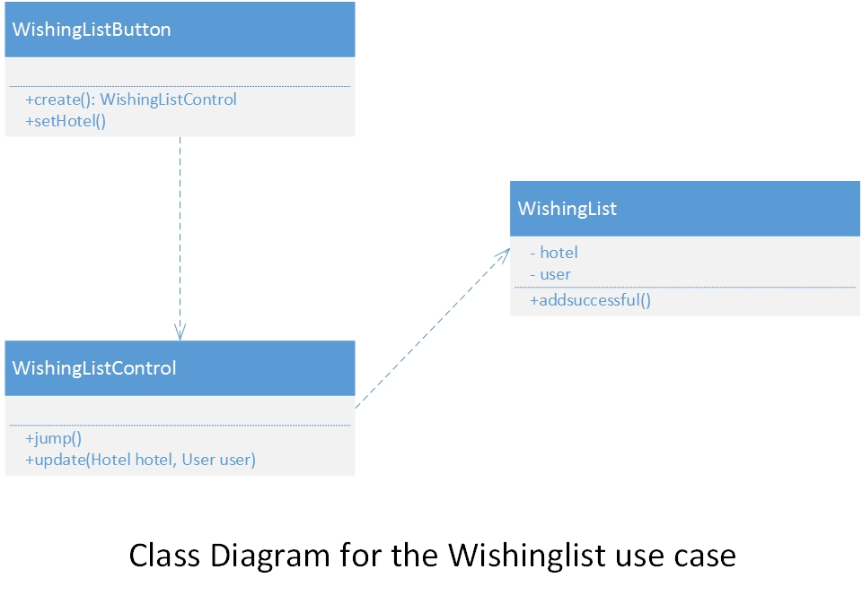

11.

|  |  |  |  |
| --- | --- | --- | --- |
| 用例名称 | 设置语言SetLanguage | | |
| 参与者 | 由用户User启动 | | |
| 事件流 | 1.用户User点击“设置语言”  2.Booking接收用户User设置语言请求，显示可设置的语言  3.用户选择语言  4.Booking系统接收User所选语言信息，设置相应系统语言 | | |
| 入口条件 | * 用户User进入Booking网站 | | |
| 出口条件 | * 用户选择语言 | | |
| 质量需求 | * 网络连接正常 | | |
| **Part** | | **Model Component** | **Example** | |
|  | | class | EnvirLangButton | |
|  | | method | create | |
|  | | method | chooseLanguage | |
|  | | class | SpecificLanguage | |
|  | | class | EnvirLangcontrol | |
|  | | attri | languageList | |
|  | | method | setLanguage | |
|  | | method | refreshMainPage | |

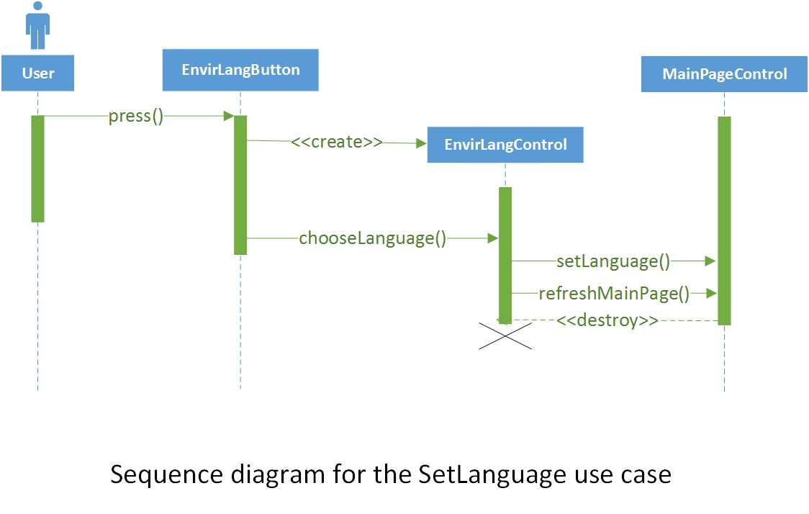

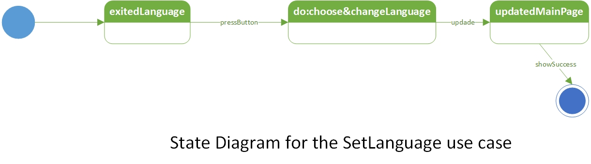

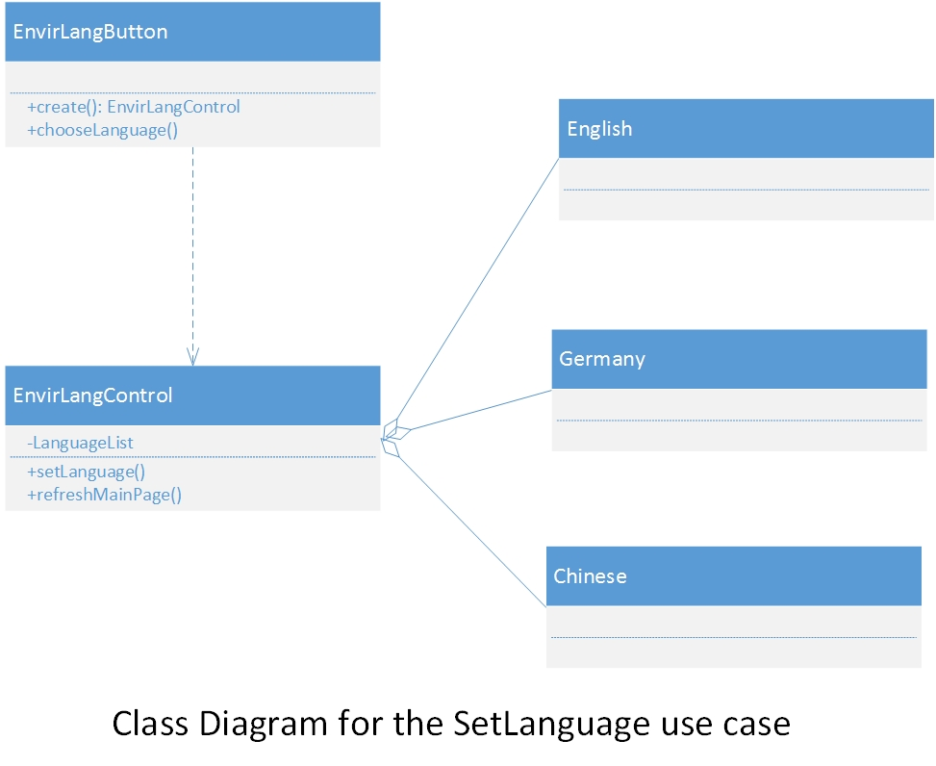

12.

|  |  |  |  |
| --- | --- | --- | --- |
| 用例名称 | 设置货币SetCurrency | | |
| 参与者 | 由用户User启动 | | |
| 事件流 | 1.用户User点击“设置货币”  2.Booking接收用户User设置货币请求，显示可设置的货币  3.用户选择货币  4.Booking系统接收User所选货币信息，设置相应系统货币 | | |
| 入口条件 | * 用户User进入Booking网站 | | |
| 出口条件 | * 用户选择货币 | | |
| 质量需求 | * 网络连接正常 | | |
| **Part** | | **Model Component** | **Example** | |
|  | | class | EnvirCurrencyButton | |
|  | | method | create | |
|  | | method | chooseCurrency | |
|  | | class | SpecificCurrency | |
|  | | class | EnvirCurrencyControl | |
|  | | method | setCurrency | |
|  | | attri | currencyList | |
|  | | method | refreshMainpage | |

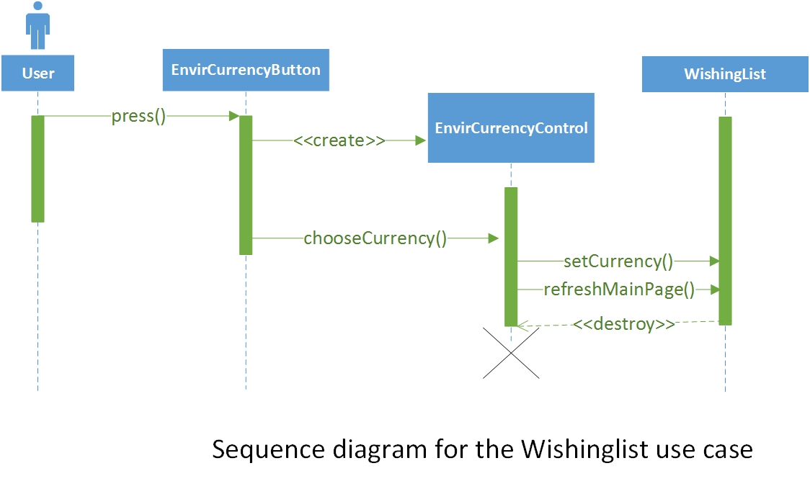

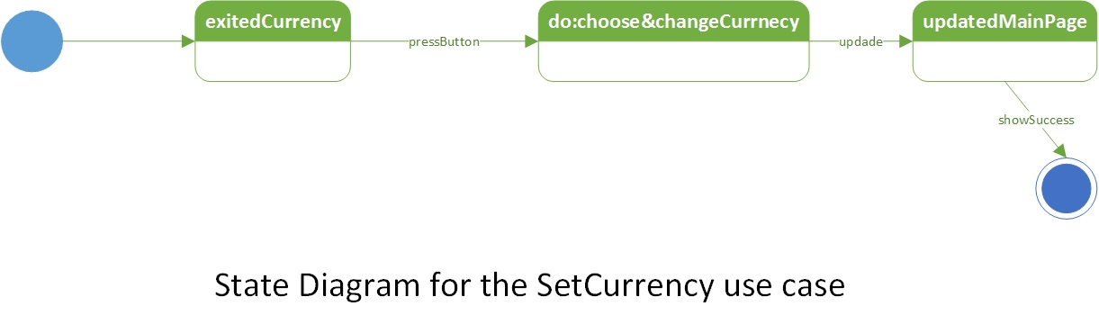

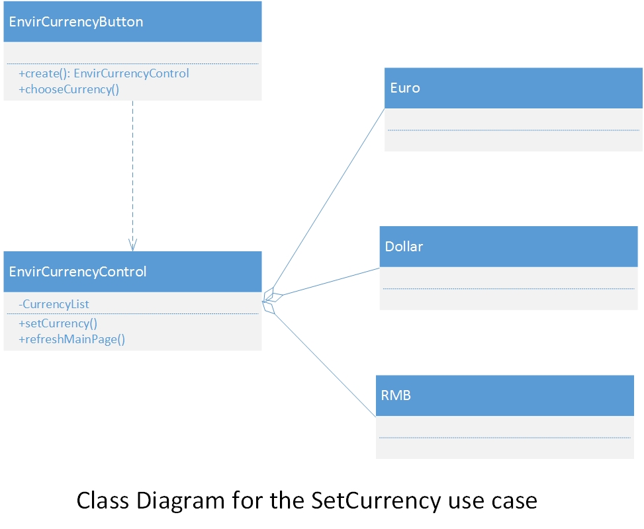

22.

|  |  |
| --- | --- |
| 用例名称 | 酒店确认线下收款ConfirmOfflinePayment |
| 参与者 | 酒店方Hotel |
| 事件流 | 1.酒店方登录酒店账户  2.Booking系统跳转至酒店管理系统  3酒店方在线下收款模块确认旅客提交给Booking的订单  4. Booking后台接收确认信息，修改数据库，并同步到网站上 |
| 入口条件 | * 酒店方打开Booking网站 |
| 出口条件 | * 酒店方收到收款成功通知 |
| 质量需求 | * 网络连接正常 |

|  |  |  |
| --- | --- | --- |
| **Part** | **Model Component** | **Example** |
| improper noun | Class | ConfirmOfflinePayment  Button |
| Doing verb | Method | create |
| improper noun | Class | confirm |
| Doing verb | class | ConfirmOfflinePayment  Control |
| Doing verb | method | create |
| Doing verb | method | reconfirm |
| Doing verb | Method | Confirm |
| improper noun | Class | OfflineTransaction |
| Doing verb | Method | updateDateBase |

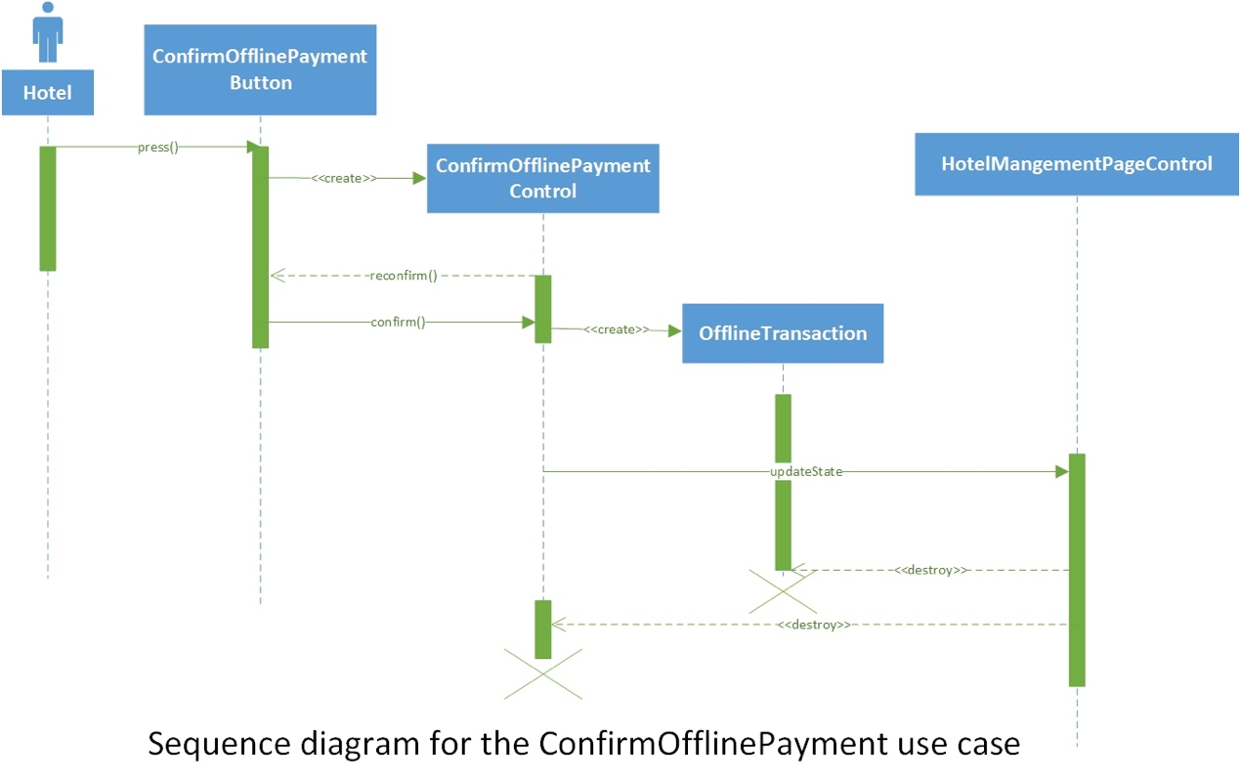

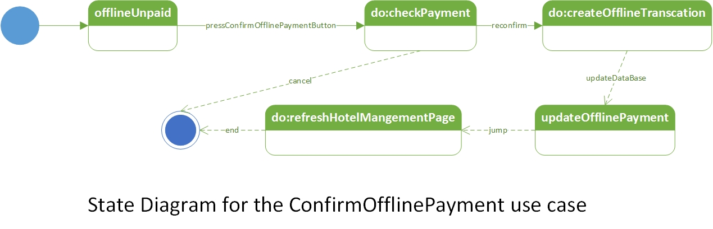

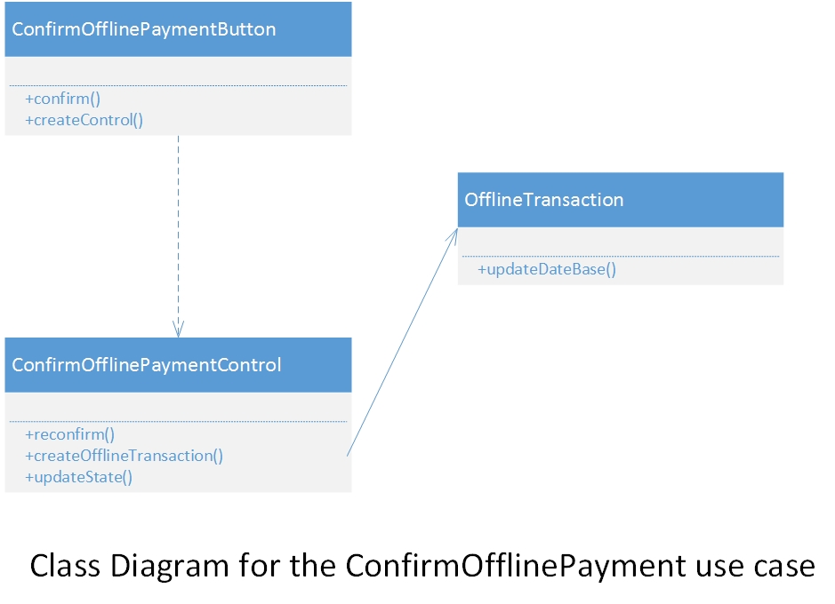

23.

|  |  |
| --- | --- |
| 用例名称 | 用户取消订单CancelOrder |
| 参与者 | 用户User，酒店方Hotel |
| 事件流 | 1.用户登录Booking网站并进入我的账户的订单模块  2.Booking系统跳转至订单模块  3用户点击取消订单  4. Booking后台接收取消订单的请求，修改数据库，并同步到酒店方，同时进入退款流程 |
| 入口条件 | * 用户打开Booking网站 |
| 出口条件 | * 网站提示取消订单操作完成 |
| 质量需求 | * 网络连接正常 |

|  |  |  |
| --- | --- | --- |
| **Part** | **Model Component** | **Example** |
| improper noun | Class | CancelOrderButton |
| Doing verb | Method | Create |
| Doing verb | Method | Confirm |
| improper noun | Class | CancelOrderControl |
| Doing verb | Method | reconfirm |
| improper noun | Class | cancellationRequest |
| Doing verb | Method | sendCancellation |
| improper noun | Class | CancellationControl |
| Doing verb | Method | sendresult |
| Doing verb | Method | updateState |
| Doing verb | Method | notifyHotel |

