CHAPTER 3

METHODOLOGY

3.1 Introduction
The methodology defines the structured engineering approach adopted to design, develop, and implement PlaceX, an integrated Artificial Intelligence-powered career operating system for undergraduate engineering students. The overarching objective of this methodology is to build a high-performance, modular, and scalable platform that unifies fragmented placement preparation activities into a cohesive, data-driven workflow. A hybrid Software Development Life Cycle (SDLC) model was selected, combining structured architectural planning with iterative, component-level refinement. This engineering methodology balances rigorous system boundaries with the agility needed to tune generative reasoning prompts, deterministic scoring algorithms, and multi-modal interaction loops based on empirical evaluations. The methodology spans six distinct development phases, ensuring end-to-end traceability from initial problem diagnosis through operational deployment.

Table 3.1: Overview of Methodology

PHASE | DESCRIPTION
Phase 1:  Requirement  Analysis | Diagnosing placement preparation challenges, analyzing user needs, and establishing functional and non-functional specifications.
Phase 2: System  Design | Designing the multi-tier client-server architecture, relational data schemas, and Host Agent orchestration boundaries.
Phase 3: Data  and Context | Extracting resume text, parsing job descriptions, defining skill taxonomies, and building AST evaluation pipelines.
Phase 4: Implementation | Developing the React frontend, FastAPI backend services, Monaco coding sandbox, and Gemini AI reasoning modules.
Phase 5: Testing and Evaluation | Conducting unit tests, integration tests, system workflows, execution security verification, and usability assessments.
Phase 6:  Deployment and  Maintenance | Configuring runtime environments, ASGI server hosting, database migrations, and operational maintenance routines.

3.2 Overview of Methodology
The development of PlaceX is executed across six structured phases: requirement analysis, modular system design, context and data preparation, component implementation, multi-tier testing and evaluation, and deployment with operational maintenance. Each phase governs a vital dimension of system dependability and performance. The system workflow captures student telemetry across specialized preparation modules, synchronizes analytical records within a persistent database, and exposes aggregated evaluation vectors to the central Host Agent orchestration engine to deliver actionable, real-time mentorship guidance.

3.2.1 Phase 1: Requirement Analysis
The initial phase focuses on diagnosing undergraduate placement preparation challenges and formulating technical system specifications. Students traditionally suffer from fragmented preparation ecosystems, switching between disconnected tools for resume formatting, coding practice, mock interviews, and roadmap tracking without unified skill-gap feedback. Functional requirements encompass authenticated student access, ATS-compliant resume parsing and job description matching, in-browser multi-language code execution with abstract syntax tree (AST) complexity analysis, live multi-modal AI mock interviews, adaptive knowledge testing, automated career roadmapping, real-time notification dispatch, and a centralized Host Agent. Non-functional requirements include sub-second local code evaluation, robust exception handling, strict database integrity via foreign key constraints, high usability across responsive screen viewports, and secure credential storage.

3.2.2 Phase 2: System Design
In this phase, empirical requirements are translated into a scalable, multi-layered architecture. PlaceX follows a client-server paradigm featuring a modern single-page frontend application, a high-throughput asynchronous REST backend, an AI reasoning engine, and relational data persistence. The presentation tier is built in React 18 and TypeScript with Tailwind CSS, delivering responsive workspaces for code editing, real-time video simulation, and analytical telemetry. The application tier is powered by Python and FastAPI, exposing structured RESTful endpoints organized by domain routers. Relational persistence is managed through SQLite and SQLAlchemy ORM. The system architecture enforces a clean separation of concerns: specialized operational engines independently compute deterministic metrics (such as ATS keyword density, AST execution cyclomatic depth, and test suite pass rates), while the central Host Agent orchestrator ingests normalized context vectors to formulate strategic advice via Google Gemini.

3.2.3 Phase 3: Data and Context Preparation
The platform ingests, processes, and maintains multi-modal career preparation data across several structured domains. Internal persistence stores student profile metadata, uploaded resumes in PDF and DOCX formats, synthesized question blueprints, code submissions, assessment attempts, and time-stamped activity events.

Data preprocessing involves extracting raw text from uploaded resumes using PyMuPDF and python-docx, parsing structural sections, and isolating technical skill keywords against a canonical taxonomy. Job descriptions undergo TF-IDF vectorization and keyword extraction to calculate cosine similarity scores. Student coding submissions are statically parsed into Abstract Syntax Trees using Python's native ast module to extract time and space complexity indicators prior to execution.

3.2.4 Phase 4: Implementation
The implementation phase realizes the system architecture through modular, decoupled software components. The frontend workspace integrates Monaco Editor for syntax-highlighted programming, interactive analytics charts, and a slide-over Host Agent drawer. The backend implements dedicated micro-services for resume analysis, coding evaluation, interview synthesis, knowledge testing, and readiness aggregation. Coding submissions are validated through a hybrid execution engine that leverages Judge0 API alongside an isolated local Python subprocess runner equipped with base64 transport, linecache injection, and memory monitoring. The mock interview engine researches target companies via Tavily web intelligence, generates tiered behavioral and technical questions via Gemini, and coordinates real-time speech recognition and video telemetry. The Host Agent operates as a central cognitive copilot, synthesizing student state across all modules into actionable next-step interventions.

3.2.5 Phase 5: Testing and Evaluation
PlaceX undergoes rigorous multi-tier testing to validate functional correctness, execution safety, and user experience integrity. Unit testing verifies discrete utility functions including resume section segmenters, AST tree walkers, and quiz scoring routines. Integration testing validates synchronous communication between FastAPI REST endpoints, SQLAlchemy database sessions, and the React client. System testing exercises complete end-to-end workflows, verifying that actions taken in the coding sandbox or mock interview room reliably update the student's placement readiness score and trigger contextual Host Agent notifications. Performance and usability testing confirm smooth editor responsiveness, low-latency API dispatch, and intuitive cross-device interface navigation.

Table 3.2: Types of Testing
Type | Description
Unit Testing | Validation of individual functions: AST parsing, resume section extraction, and quiz scoring algorithms.
Integration Testing | Testing synchronous interaction between FastAPI REST endpoints, SQLAlchemy database sessions, and UI components.
System Testing | End-to-end verification of complete student journeys from resume upload to mock interview and readiness aggregation.
Performance Testing | Benchmarking API latency, code execution sandbox timeouts, and real-time Host Agent response speeds.
Usability Testing | Evaluating interface accessibility, responsive layout clarity, Monaco Editor ergonomics, and navigation flow.

PlaceX is deployed using standard modern runtime environments, utilizing Uvicorn as an asynchronous ASGI server for FastAPI and Vite for optimized production asset bundling. Relational persistence is maintained through ACID-compliant SQLite databases with structured SQLAlchemy migrations. Configuration parameters, security secrets, and API access tokens are securely managed through isolated environment variables. Continuous maintenance protocols encompass API regression monitoring, dependency security auditing, prompt template refinement, and test case expansion to ensure sustained platform reliability and student preparation fidelity.

3.3 Advantages of the Methodology
The adopted methodology yields significant architectural and operational benefits for AI-driven educational software. Its modular architecture isolates domain failures and facilitates independent component scaling. The deliberate architectural separation between deterministic algorithmic computation (ATS parsing, AST analysis, test validation) and generative LLM reasoning eliminates AI hallucinations in critical student assessments while preserving high conversational empathy in mentorship. Centralizing student telemetry within the Host Agent guarantees coherent, longitudinal guidance across preparation domains, offering undergraduate students an integrated, rigorous, and actionable pathway to campus placement readiness.

3.4 System Workflow
The operational workflow of PlaceX begins when an authenticated student accesses the platform to pursue targeted placement preparation. Upon authenticating and establishing their target job role, company profile, and seniority level, the student navigates through specialized career modules. Each module captures domain-specific artifacts, computes deterministic performance metrics, persists longitudinal progress records, and emits standardized telemetry to the central Host Agent orchestration engine. The Host Agent analyzes the aggregated preparation state to synthesize actionable recommendations, update global readiness indices, and guide ongoing student development.
- Authentication and Onboarding: The authentication interface serves as the entry portal for PlaceX, providing students with secure credentials management. It supports standard email registration alongside Google OAuth 2.0 single sign-on. During initial onboarding, students define their academic background, target software engineering roles, dream companies, and primary technical domains, establishing the baseline profile necessary to personalize all downstream preparation modules and analytical rubrics.
- Student Profile and External Sync: The profile workspace enables students to maintain comprehensive academic and professional identities. Beyond standard biographical details, it integrates external verified platforms including GitHub repositories, LeetCode contest statistics, and LinkedIn credentials. This module validates external handles, fetches live problem-solving tallies, and incorporates external achievements directly into the platform's career database.
- ATS Resume Analyzer and Matcher: This module allows students to upload resumes in PDF or DOCX formats for automated evaluation against industry standards. It executes a dual-mode analysis: Mode A computes a comprehensive ATS health score across contact formatting, section completeness, action verbs, and quantifiable impact, while Mode B evaluates keyword alignment against specific job descriptions using TF-IDF vectorization and semantic matching to identify skill gaps.
- Interactive Coding Sandbox: The coding sandbox provides an in-browser development environment powered by Monaco Editor. Students solve algorithmic problems across multiple programming languages with custom test cases, automated multi-case grading, and static AST complexity analysis. The sandbox features an integrated Host Agent Explain and Fix assistant that analyzes compilation errors and algorithmic bugs to provide structured, Socratic debugging hints.
- AI Mock Interview Module: The mock interview module simulates realistic placement interviews through a multi-stage process. The Prep Brain conducts automated company intelligence research via Tavily and synthesizes tiered technical and behavioral question banks. During live simulation, real-time speech-to-text captures student responses, audio prosody and facial geometry evaluate non-verbal communication, and each turn is scored against calibrated rubrics before generating a comprehensive debrief.
- Adaptive Roadmap and Knowledge Quiz: This combined module guides structured learning and conceptual verification. The Career Roadmap dynamically sequences milestone topics, recommended resources, and practical milestones tailored to the student's target role. The Knowledge Quiz module tests foundational computer science domains, evaluating accuracy and speed across randomized question banks to identify specific conceptual weaknesses.
- Mission Control Dashboard and Host Agent: The PlaceX dashboard functions as the centralized mission control, consolidating metrics from all preparatory modules into an interactive command interface. It visualizes overall placement readiness percentages, weekly activity streaks, competency radar breakdowns, and real-time notification alerts. Operating ubiquitously across the dashboard, the Main Host Agent maintains multi-turn conversational context, analyzes student performance history, and proactively recommends the highest-leverage preparation tasks to maximize campus recruitment success.

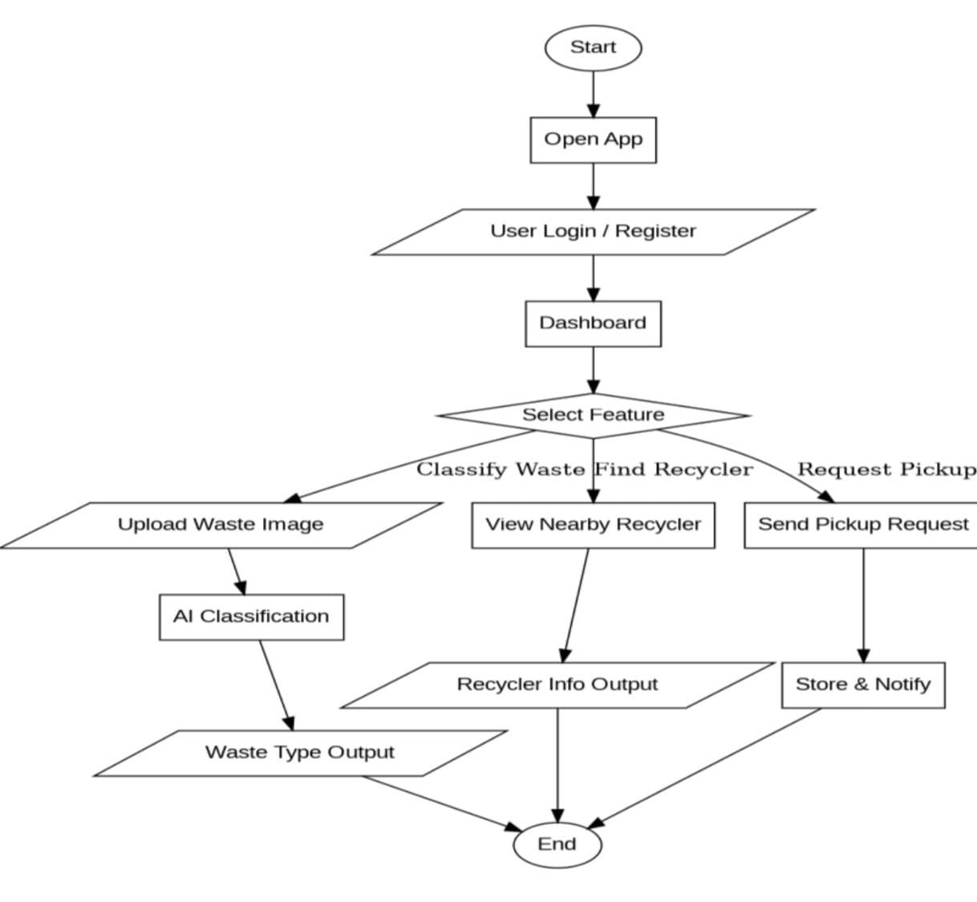

Fig 3.1: System Workflow Diagram

3.5 Tools and Technologies used

The PlaceX career operating system leverages a modern, robust full-stack technology ecosystem. The presentation layer is built with React.js 18, TypeScript, Vite, and Tailwind CSS, incorporating Monaco Editor for programming workflows. The backend application layer is developed with Python 3.12 and FastAPI, providing asynchronous RESTful APIs and robust data validation. Relational data persistence is managed via SQLAlchemy ORM and SQLite. Cognitive reasoning and conversational orchestration are powered by Google Gemini, while Tavily Search API, Deepgram speech recognition, and Judge0 deliver specialized company intelligence, multi-modal interview analysis, and secure code execution.

Table 3.3: Tools and Technologies

Components | Technologies/Tools | Purpose
Frontend Tier | React.js 18, TypeScript, Vite, Tailwind CSS, Monaco Editor | Delivers responsive, accessible user interfaces, interactive code editing, and real-time telemetry visualization.
Backend Tier | Python 3.12, FastAPI, Uvicorn, Pydantic, RESTful APIs | Executes core application logic, manages RESTful endpoints, coordinates micro-services, and authenticates requests.
Data Tier | SQLite, SQLAlchemy ORM, Alembic Migrations | Stores student profiles, resumes, coding submissions, interview evaluations, quiz results, and activity telemetry.
AI & External Services | Google Gemini LLM, Judge0 API, Tavily API, Deepgram STT | Drives Host Agent reasoning, automated interview question synthesis, company research, and isolated code execution.

3.6 System Architecture

PlaceX is engineered upon a decoupled, five-tier modular architecture designed to maximize operational maintainability, horizontal component extensibility, and low-latency user interactivity. The architecture cleanly segregates presentation delivery, application business logic, artificial intelligence reasoning, relational data persistence, and specialized external execution services.

3.6.1 Presentation Layer (Frontend)
The Presentation Layer comprises the client-side single-page application built using React 18, TypeScript, Vite, and Tailwind CSS. It delivers responsive, high-contrast workspaces for the central dashboard, ATS resume diagnostics, coding sandbox IDE with Monaco Editor, live video interview rooms, skill roadmaps, and the slide-over Host Agent workspace. It handles local state management, optimistic UI updates, and secure JWT authentication storage.

3.6.2 Application Layer (Backend)
The Application Layer represents the core backend server developed using Python and FastAPI. It exposes structured RESTful API routers governing authentication, resume evaluation, code execution coordination, interview blueprint synthesis, quiz assessment, profile management, notifications, and Host Agent reasoning. This layer handles JWT authorization, request payload validation via Pydantic schemas, and orchestration of domain services.

3.6.3 AI Processing Layer (AI Engine)
The AI Processing Layer serves as the intelligence core of PlaceX. Powered by Google Gemini large language models, it hosts the Main Host Agent reasoning engine, dynamic resume improvement generators, Socratic coding error diagnostic assistants, and calibrated interview question synthesizers. The layer operates on structured context prompts, enforcing deterministic output formatting and conversational mentor personas without contaminating algorithmic scoring routines.

3.6.4 Data Layer (Database)
The Data Layer guarantees ACID-compliant persistence and relational integrity across the platform using SQLite and SQLAlchemy ORM. It securely stores student account records, detailed academic profiles, parsed resume data, job descriptions, coding problem catalogues and submission histories, interview question rubrics and evaluations, quiz results, connected profile tokens, and time-stamped system notifications.

3.6.5 Integration Layer (External Services)
The Integration Layer connects PlaceX with specialized external engines, third-party cloud services, and verified developer platforms. For secure code execution, it interfaces with the Judge0 API alongside an isolated local Python execution runner to grade code against multiple test inputs safely. In the mock interview module, it integrates Tavily web search API to extract up-to-date company technical stack signals and interview trends, and coordinates Deepgram automated speech recognition for real-time vocal transcription. For professional identity verification, the layer interfaces with Google OAuth 2.0, GitHub GraphQL APIs, and LeetCode public endpoints to pull verified contest badges, problem-solving numbers, and open-source contributions directly into the student's profile. This multi-system integration architecture ensures that PlaceX functions as a comprehensive, real-world career operating system.

