UNIVERSITY OF DAR ES SALAAM



DEPARTMENT OF COMPUTER SCIENCE AND ENGINEERING

PRACTICAL TRAINING REPORT FOR ACADEMIC YEAR (2025/2026)

REPORT TITLE: ELECTRONIC LOGBOOK MANAGEMENT SYSTEM.

Student Name: JUNIOR RICHARD MEELA.

Registration Number: 2024-04-06327

Degree Program of Study: BSc Computer Science

Practical Training Course Code: PT1

Company/Organization Name: ICTPACK SOLUTIONS LTD.

Industrial Supervisor’s Name: Mussa Shomari.

Academic Supervisor’s Name: Dr. Ally Bitebo.

ABSTRACT

Since businesses offering recurring services face challenge in managing service reminders, follow-ups, and customer information, often leading to missed appointments and poor communication. Notify, a customer relation management system as it offers this through automated SMS/email reminders, a centralized dashboard, and service tracking.

Through market research, iterative design, and client feedback we shaped the system's development. Achievements during the Practical Training (PT) period include the successful implementation of automated reminders, predictive scheduling, and follow-up tracking, enhancing operational efficiency.

This report consists of two chapters, chapter one describing StartHub historical background, organizational flowchart, mission and vision of startHub Africa. Chapter two is structured to detail the problem, user research and marketing of the product(notify). Key challenges involved in coming up with the product to ensure effective customer relation management also improving system scalability. Future improvements are suggested for enhanced analytics and automation.

ACKNOWLEDGEMENTS

I would like to thank God for the strength, good health and ability to undertake my Practical Training safe for the whole period, also I extend my grateful thanks of gratitude to my parents for enabling me to get my education at UNIVERSITY OF DAR ES SALAAM. Also, my special thanks go to the staffs and the whole organization of (UDSM) for facilitating my field to take place at University of Dar es salaam deepest thanks go to the UDICTI leadership, Dr. Diana Rwegasira, whose mentorship and support were invaluable throughout the PT. Also garage owners provided insights during market research which were essential in developing the CRM so as may solve real business challenges.
Likewise, I acknowledge and express my sincere gratitude to StartHub Africa for granting me the opportunity to conduct practical training at their esteemed organization. Also, the team of
mentors Mr. Timothy Maenda and Mr. Zagaro Emanueli, provided crucial mentorship, networking and guidance helping to adopt the entrepreneurial mindset. This inspired innovative approaches, on solving customer’s pain points also providing access to a wide network of entrepreneurs, business leaders, and mentors, offering valuable connections and insights.

DECLARATION.

I Victoria Renatus Mashenene with registration number 2023-04- 06825, hereby declare that I have prepared this report with the knowledge gained during my first Practical Training at UDICTI with partnership with Starthub Africa as according to the regulations of the College of Information and Communication Technologies of the University of Dar es Salaam so as to accomplish the curriculum requirement of Bachelor of Science in business information technology.

………………………………… ……………………………..
VICTORIA RENATUS MASHENENE ZAGARO EMANUELI

Contents
ABSTRACT i
ACKNOWLEDGEMENTS ii
DECLARATION iii
LIST OF FIGURES v
LIST OF ABBREVIATION vi
CHAPTER ONE: ORGANIZATION PROFILE 1
  - : INTRODUCTION 1
  - : HISTORICAL BACKGROUND 1
  - : MISSION AND VISION 1
  - : ORGANZATIONAL PROFILE 2
  - : MAIN ACTIVITIES 3
  - : SAFETY REGULATION AND GENERAL WALFARE 4
  - : RECRUITMENT AND TRAINING POLICIES OF THE COMPANY 4
CHAPTER 2: NOTIFY 5
  - PROBLEM IDENTIFICATION 5
  - : WHY NOTIFY 6
    - : Automated Service Reminders 6
    - : Bridge the gap between service providers and customers 7
  - : TRADE-OFFS OF NOTIFY 10
    - : pros of using notify 10
    - : Cons of Using Notify 11
  - : TOP EXISTING SOLUTIONS OTHER THAN NOTIFY. 11
CHALLENGES FACED DURING PRACTICAL TRAINING 15
SOLUTION TO THE CHALLENGES FACED 15
RECOMMENDATIONS 18
REFERENCES 19

LIST OF FIGURES

Figure 1.1: UDICTI organizational structure 2
Figure 2.2: existing solution in managing customer's information 6
Figure 3.2: Notify dashboard showing customer information 8
Figure 4.2: Notify Dashboard showing revenue generated 9
Figure 5.2: ZOHO CRM sales analytics 12
Figure 6.2: Hubspot dashboard showing customer's contact details 13
Figure 7.2: collecting feedback and views from users 16

LIST OF ABBREVIATION

Advanced Standard Encryption Customer Relation Management System
ASE | -
CRM | -
ICT | -
PT | -
RIO | -
SMS | -
SSL | -
UDICTI | -
USD | -
USH | -

Information Communication Technology Practical Training
Return On Investment Short Message Service Secure Socket Layer
University of Dar es salaam ICT innovation United States Dollar
Ugandan shilling

CHAPTER ONE: ORGANIZATION PROFILE

  - : INTRODUCTION
UDICTI is an umbrella innovation unit located in the College of Information and Communication Technologies (CoICT) at the University of Dar es Salaam. Provide a platform for addressing social and corporate challenges by creating social solutions and commercial ventures. UDICTI offers innovation space, hands-on training on innovation and entrepreneurship, mentorship, coaching, networking opportunities, and technical skills development such as programming and mobile app development. Also supports students in turning their business ideas into startups. UDICTI offers startup program and upskilling program. As in 2023 UDICTI partnered with Starthub Africa (A Uganda based company) to provide crucial mentorship, networking and guidance helping students to adopt the entrepreneurial mindset.
  - : HISTORICAL BACKGROUND
UDICTI was established in 2009, as a part of University’s broader mission to promote technological innovation and entrepreneurial among its student and faculty. Initially, UDICTI focused on supporting early-stage ICT projects by offering resources such as workspace, mentorship, and networking opportunities. Over time, it expanded its services to include access to funding, advanced workshops, and partnerships with established tech firms. In 2023, a significant milestone was achieved through a partnership with Starthub Africa, a Uganda-based company. This collaboration aimed to equip student entrepreneurs with essential skills by offering crucial mentorship, networking and guidance helping to adopt the entrepreneurial mindset.
  - : MISSION AND VISION
UDICTI mission is to cultivate an innovation-driven environment that empowers students to tackle societal and corporate challenges by creating sustainable business solutions in information and communication technologies. Their vision is to be a leading hub for ICT innovation and entrepreneurship, empowering students and professionals to create impactful, tech-driven solutions that advance Tanzania’s socio-economic development.

: ORGANZATIONAL PROFILE
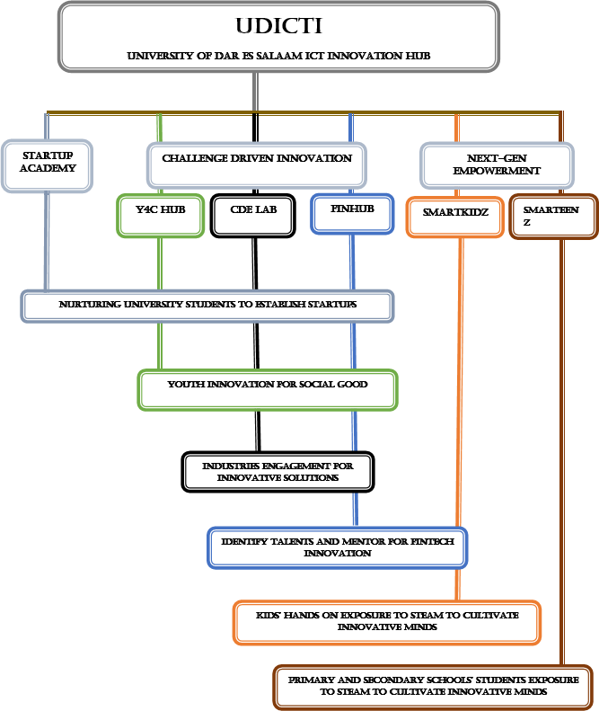
Figure 1.1: UDICTI organizational structure

  - : MAIN ACTIVITIES
The main activities of the organization encompass two core programs:

Startup Program: Designed to nurture and support startups, aiming to create six to ten strong businesses within a year. It includes phases focused on foundational learning in innovative business building, team formation, ideation and validation, product development, business model (how to monetize their solution), market researching and validation, funding, launching and scale up also how to seek investors. Activities also involve skill building for those not pursuing startups and regular sessions, competition, and events to build networks and mentorship.
Upskilling talents: is a training initiative aimed at helping students, professionals, and entrepreneurs gain the skills needed for success in the tech industry. The program offers workshops, hands-on training, and regular sessions on essential topics like programming, digital marketing, data analysis, and project management.
By focusing on high-demand tech skills, UDICTI’s Upskilling Talent Program prepares participants to meet industry needs, enhancing their career opportunities and making them more effective contributors to tech-driven projects. This program also supports those not actively building startups, helping everyone involved stay competitive and adaptable in a rapidly evolving field.

: SAFETY REGULATION AND GENERAL WALFARE
At UDICTI there many nearby fire extinguishers in case of explosion also there are many exits in case of an emergence. About the general welfare, UDICTI provides a free good Wi-Fi Internet connection that can be used for innovation activities as well as for research and learning. The Hub also provides refreshments such as tea and coffee to help students get through tiring days. Use of nice training spaces, projectors, whiteboards, and a comfortable, air-conditioned environment. Furniture at UDICTI is so designed to allow the innovators to take a small rest or naps if they wish to. The working conditions are friendly and conducive.

: RECRUITMENT AND TRAINING POLICIES OF THE COMPANY
Recruitment for challenge-driven innovation programs takes place at end of the academic year. The organization announces the application round across various platforms like WhatsApp, LinkedIn, Twitter, and through physical posters. This open call invites University of Dar es Salaam students who wish to create startups. While primary applicants should be from the university, they have the opportunity. UDICTI Startup Academy recruitment is finalized at the beginning of a new academic year, giving first-year students the chance to join the program.

CHAPTER 2: NOTIFY

PROBLEM IDENTIFICATION
Introduction

Challenges facing most of recurring services providers such as garages, drycleaners including inefficiency in managing service reminders, follow-ups, and customer information often leading to missed appointments and poor communication between service providers and customers also contributing to high loss of customers. This is what brought us to the development of NOTIFY (a customer relation Management system). Below is the explanation of each key problem.

Problem justification

Many businesses with recurring services, such as drycleaners and garages like HUCA Garage, currently rely heavily on manual processes and paperwork to manage communication, service reminders, and customer engagement. At HUCA Garage, for instance, Veronica and her team often use physical documents to handle customer information, schedule service appointments, and notify clients. This leads to inefficiencies, poor data management, and a lack of streamlined workflows.

The manual approach at HUCA Garage requires staff to track service requests, reminders, and approvals using paperwork, which can be time-consuming and prone to errors. This system slows down response times and reduces the overall productivity of the team as they handle the back-and-forth communication with clients. Delays in responding to customer requests or confirming appointments result in missed opportunities and a poor customer experience.

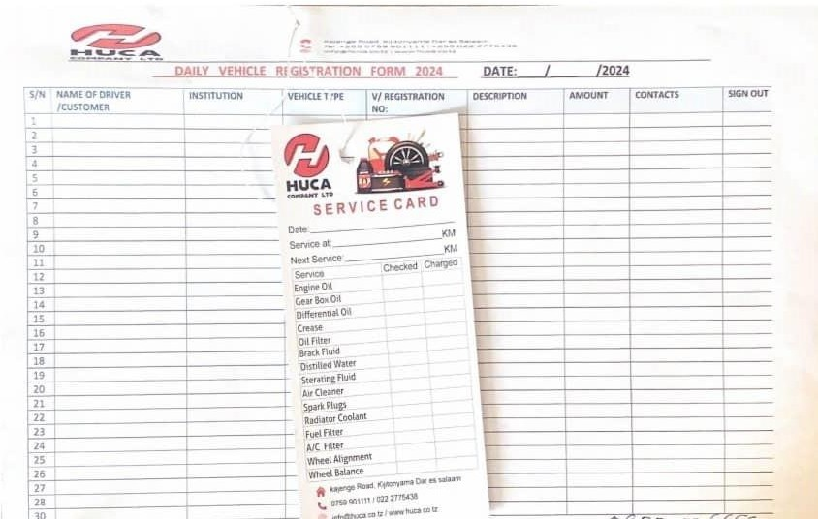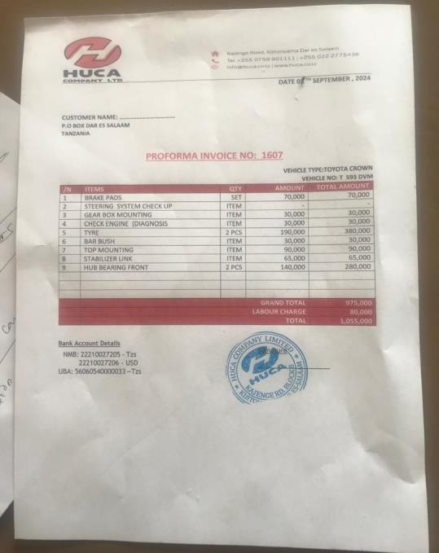
Figure 2.2: existing solution in managing customer's information

: WHY NOTIFY

Notify is a web application designed to streamline these processes by offering a centralized platform for CRM. As with notify offers recurring service providers with

    - : Automated Service Reminders

Notify allows service providers to effortlessly send automated SMS reminders to their customers. For instance, garages typically recommend customers return every two months for service. After each appointment, customers receive a service card indicating this interval. With Notify, a clerk can schedule SMS reminders appointment approaches. The system automatically sends alerts to remind customers of their upcoming visit. We prefer SMS because they are quicker and more engaging than email notifications. This automation helps reduce missed appointments and strengthens customer relationships, ensuring timely communication and improved satisfaction

    - : Bridge the gap between service providers and customers

Notify ensures that both customers and business owners are kept informed about important service details. Through real time notifications, the platform enhances transparency and effectiveness in business operations.

As when a service is scheduled, SMS alerts are automatically sent to customers, providing essential information such as the service type, date, and time, name of the service provider. These notifications also include a clear explanation of the respective prices for the services offered, helping customers understand what to expect. Not only that but also business owners receive copies of these alerts, enabling them to stay updated on customer appointments and service requests. This dual notification system fosters better communication and coordination between the business and its clients.

    - : Centralized Admin Dashboard.
Notify offers centralized and intuitive admin dashboard designed to streamline operations and enhance management efficiency for service providers. This dashboard serves as a comprehensive control center, offering administrators a clear overview of essential business metrics and customer interactions.

Key features of the admin dashboard

      - : customer information tracking
Customer tracking is a crucial since it allows administrators to access detailed profiles of customers served on any specific day. This includes essential data such as names, contact details, and service preferences, enabling staff to provide personalized and responsive service. The dashboard tracks appointment history, identifying repeat customers and improving communication by allowing staff to refer to previous interactions easily.

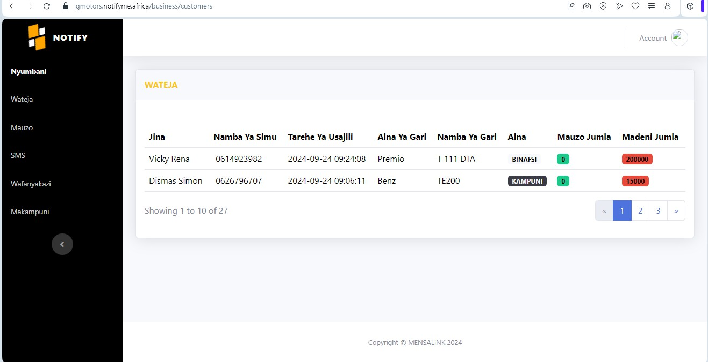

Figure 3.2: Notify dashboard showing customer information

      - : Service provider insights
Notify allows administrators to monitor the performance of employees who deliver services to customers. The dashboard highlights individual contributions, enabling effective performance evaluations and the recognition of high achievers. Through SMS alerts, service providers can easily track which worker provided a specific service, giving administrators real-time insights into employee performance. This capability ensures that businesses can identify strengths and areas for improvement among their staff, fostering a culture of accountability and excellence in service delivery.

      - : revenue monitoring
The admin dashboard that provides a comprehensive financial overview, allowing administrators to track the revenue collected on specific days, over set periods, or annually. Graphs offers detailed statistics and insights into sales trends, enabling businesses to analyze their financial performance with greater precision. By presenting data on daily, monthly, and yearly earnings, the dashboard helps identify peak periods of revenue generation, seasonal trends, and areas where income may fluctuate. These insights support informed financial planning, helping businesses allocate resources effectively, set realistic sales targets, and make strategic decisions to maximize profitability.

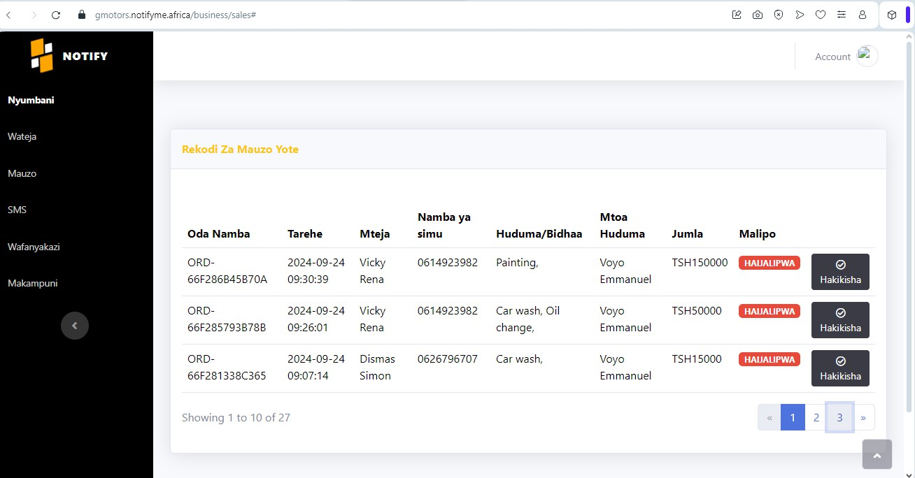
Figure 4.2: Notify Dashboard showing revenue generated

: TRADE-OFFS OF NOTIFY
    - : pros of using notify

      - Automated Service Reminders: Notify sends automatic SMS reminders to customers about their upcoming appointments, reducing the likelihood of missed services and improving customer satisfaction.
      - Centralized Customer Management: The platform provides a centralized admin dashboard that enables businesses to track customer information, service history, worker performance, and revenue in one place, making operations more streamlined and organized.
      - Enhanced Customer Communication: SMS notifications are direct and highly engaging, making them more likely to be seen by customers compared to emails. This helps maintain clear and consistent communication.
      - Improved Transparency: Notify ensures that both customers and business owners receive notifications, enhancing transparency in service delivery and improving trust between the business and its clients.
      - Service Provider Insights: The dashboard tracks the performance of individual employees, allowing for better evaluation, recognition of top performers, and identification of areas for improvement.
      - Revenue Monitoring: Detailed financial tracking allows businesses to monitor daily, monthly, and annual revenue, providing insights into sales trends and supporting better financial planning.
      - Data-Driven Decisions: By offering comprehensive data and analytics on customer behavior and business performance, notify enables businesses to make informed decisions, optimize strategies, and improve overall service quality.

    - : Cons of Using Notify

- Dependence on Technology: Small businesses without a stable internet connection or technical know-how might find it challenging to fully utilize Notify’s features since notify is a web app and requires a person to have a stable network connection.

- SMS Costs: Sending bulk SMS messages could incur additional costs, which may become significant for businesses with a large customer base, especially if not managed properly.

- Data Privacy Concerns: Notify can be subjected to data insecurity concern, handling sensitive customer data requires strict data protection measures. Any security breaches damage customer trust and potentially lead to legal issues.

- Limited Customer Reach: While SMS is highly effective, not all customers prefer text messages, as we found that other service providers favor email and WhatsApp notifications. As for those who favor email, WhatsApp notification or other communication channels, Notify’s SMS-first approach is limiting for them.

: TOP EXISTING SOLUTIONS OTHER THAN NOTIFY.
ZOHO CRM.:Zoho CRM is built to help businesses to simplify and make effective the sales process, improve customer interaction, also converting people who show interest in the company’s/organization’s product into loyal customers. Since it offers tools for managing customer data, tracking sales pipeline, automating workflow. also providing sales analyst, performance reports, marketing analyst (campaigning performance, ROI analyst for different marketing efforts and help to identify which effort is effective). Zoho CRM is suitable for small sized businesses, medium sized -businesses also large enterprise since operate using different tires.
BENEFITS OF ZOHO CRM

- Zoho CRM offers data security using SSL/TLS (Secure Socket Layer/Transport Layer Security) encryptions to protect data during transmition between businesses/user’s device and Zoho’s servers.

Not only that but also Zoho CRM uses AES-256(Advanced Encryption Standard) to secures data even when is stored into Zoho servers. This make it to be the world’s favorite CRM.
- Cost effective, Zoho CRM provide different payment plans including the freemium model, providing the basic version of Zoho CRM free, making it more friendly for small sized businesses and medium businesses.
- Ease of use.
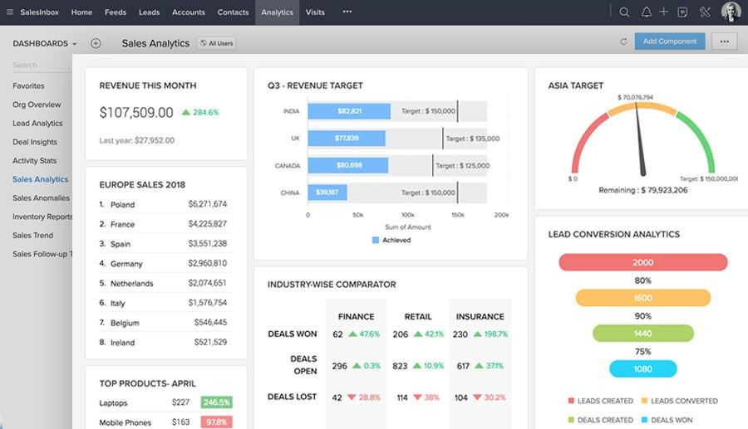

Figure 5.2: ZOHO CRM sales analytics
HUBSPOT CRM

This is a customer relationship management platform designed purposely to enable businesses manage their sales, customer service and customer interaction in a single platform. Hubspot offers a unified database as it provides a central place to store contact details, leads information and customer’s interaction. also enables automatically tracking of emails, calls, meeting and notes offering a complete customer engagement. Hubspot CRM also offers content management as it is integrated with Content Management System (CMS) ensuring smooth and continuous campaign execution.

Benefits of Hubspot

Integrate sales and marketing tools: HubSpot handles marketing campaign (email and marketing ads) also sales tasks including tracking deals also making follow ups with leads in one platform, as no need of switching between different software or tools. Creating more consistent experience when engaging with customers.
Offers free and flexible payment plans: It offers free version of Hubspot purposely to attract small business also businesses may upgrade into premium versions as they scale.
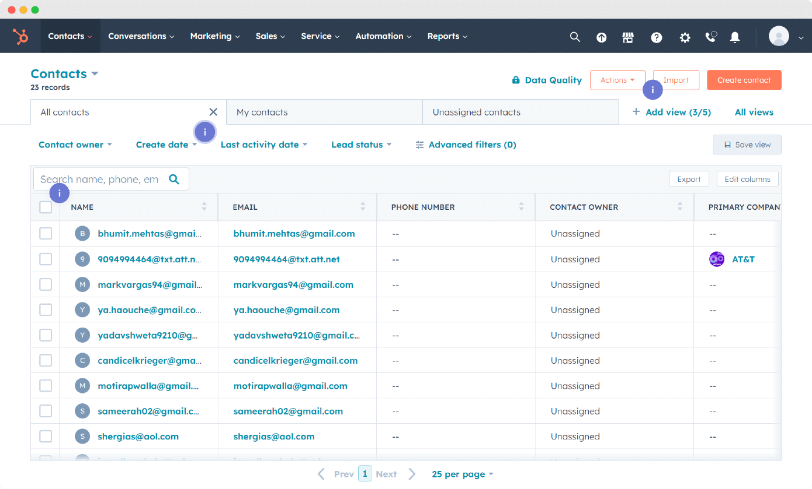

Figure 6.2: Hubspot dashboard showing customer's contact details

Comparison between Notify, HubSpot and Zoho customer relation management system.

feature | Notify | Hubspot | Zoho
Target audience | Small businesses needing  remainders and real time notification is the first priority. | Businesses for all sizes. | SMBs and enterprise looking for flexibility.
Pricing | Affordable pricing. | Offers a free trial also basic, standard and premium tires. higher tires are costly. | Flexible pricing according to pricing.
Key features  Ease of use | Automated services remainders Centralized dashboard  Bulky SMS integration. Simple interface easy to use. | Advanced email tracking Service hub for customer support.  Very easy to use and simple to understand. | Integration with other Zoho products.  Workflow and process automation.  Take time to learn since it has many features.
scalability | Limited scalability focusing on  recurring services | Highly scalable, grows with  the business. | Scalable and adaptable to  various business sizes.

CHALLENGES FACED DURING PRACTICAL TRAINING
  - Requirement gathering, understanding the specific needs for service-based businesses was difficult, this brought some difficult also in coming up with features which could solve businesses pain points.
  - Scalability: we initially developed Notify with a focus on garages and we managed even to make partnership with some of them. However, expanding our services to other service providers such as cleaning services was challenging because we have to make some adjustment to meet their specific needs.
  - Building trust and credibility: notify is new product, it was difficult to win potential customer’s trust, since most of the prefer using tried and tested platforms.
  - Market differentiation: it is so challenging to standout in CRMs market, competing with other world’s favorite CRMs (Zoho, Hubspot).it is challenging to communicate the unique value offered by Notify for businesses with recurring services so as to gain a competitive edge against other established CRMs.
  - Lack of efficient and reliable technical team, this slowed down our development process and it took time deliver the system to our customer this rose some trust issues.

SOLUTION TO THE CHALLENGES FACED.
- building trust and credibility

We offer one-week free trial for business allowing them to try Notify without any commitment, so as we can collect some stories and testimonials from our early adopters. this can be helpful in building trust and credibility.
- we had to outsource, so as we can add some strength on technical team purposely to fasten development.

- Requirement gathering

we conducted a deep research and interview with potential customers to understand their specific needs and solve their pain points. Also continuously gathering of feedback from users was the only way we used so as we can design a more relevant product.
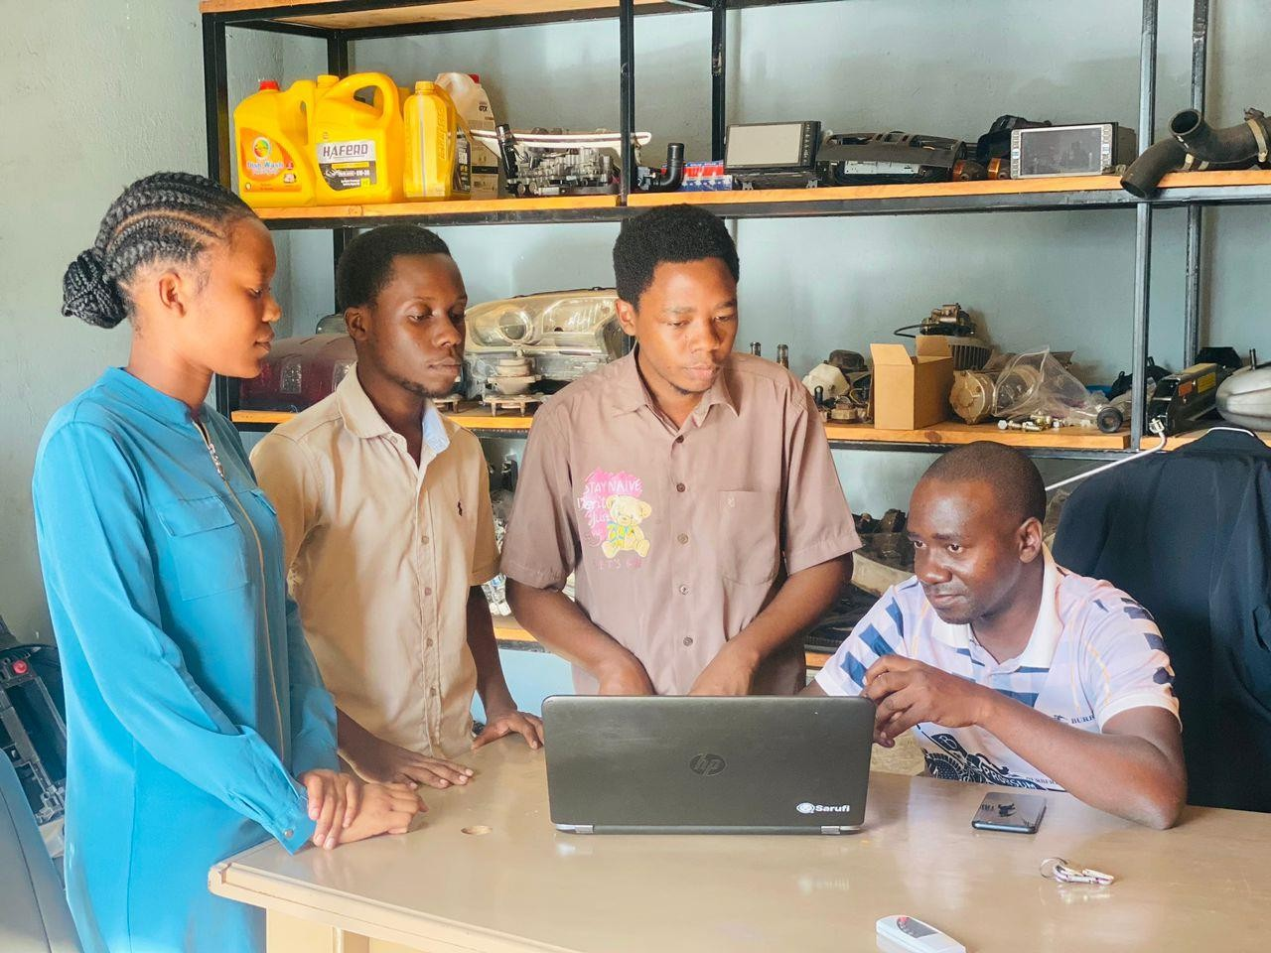

Figure 7.2: collecting feedback and views from users

CONCLUSION

Fieldwork plays a crucial role in bridging the gap between theoretical learning and practical application. It enables students to see the value and real-world significance of what they are taught theoretically, making the learning process more meaningful. Engaging in fieldwork not only enhances passion for studies but also provides a broader perspective on the working environment.

The practical training experience allowed me to integrate theory with practice, an essential aspect of learning in the Information Technology field. By the end of the training, I had developed important skills, improved my working abilities, and cultivated a positive attitude towards my area of specialization. The exposure to the IT market and real-world challenges deepened my understanding of the industry.

This experience also helped me enhance my leadership and communication skills. Leading the project and collaborating with team members sharpened my problem-solving abilities and decision-making processes, especially in handling the challenges we faced during development. These skills are vital in the ICT sector, where clear communication and teamwork are crucial to project success.

Facing different challenges and solving them improved may confidence, also interacting with customers and colleagues during this period gave me valuable insights into understanding customer needs, refining service offerings, and preparing for industry-specific needs. The feedback from clients helped me understand market trends, tailor solutions, and gain confidence in my capabilities to work in the IT field.

Moreover, the field training boosted my confidence, making me feel capable of working in any organization.

RECOMMENDATIONS
The college should keep consideration on increasing practical works to prepare student who can compete in the technological world. Practical provide high experience to learners when they enter the real world, they also become more profitable. Strict practical timetable supervision and implementation should be put on place.
In addition, the college should take responsibility for securing field placements for students. By carefully selecting fieldwork locations that meet all the training needs, so students get the best experience and learning possible, so as students gain relevant experience and skills in their area of study.
In order to ensure organization/institution that gave us a place to conduct field training, provide chance to students from our college for the next time, administration should make appreciation to them, even sending a certificate of appreciation is a great thing, it will strengthen good relationship with these institutions/organization.

REFERENCES
StartHub Africa. (2017). Empowering young innovators in Africa. Consulting – StartHub Africa

University of Dar es Salaam. University of Dar es salaam ICT Incubator (UDICTI). https://udicti.udsm.ac.tz

