CMIS-4900-400
Team 2
Production Data Information System
DFD PROCESS 1

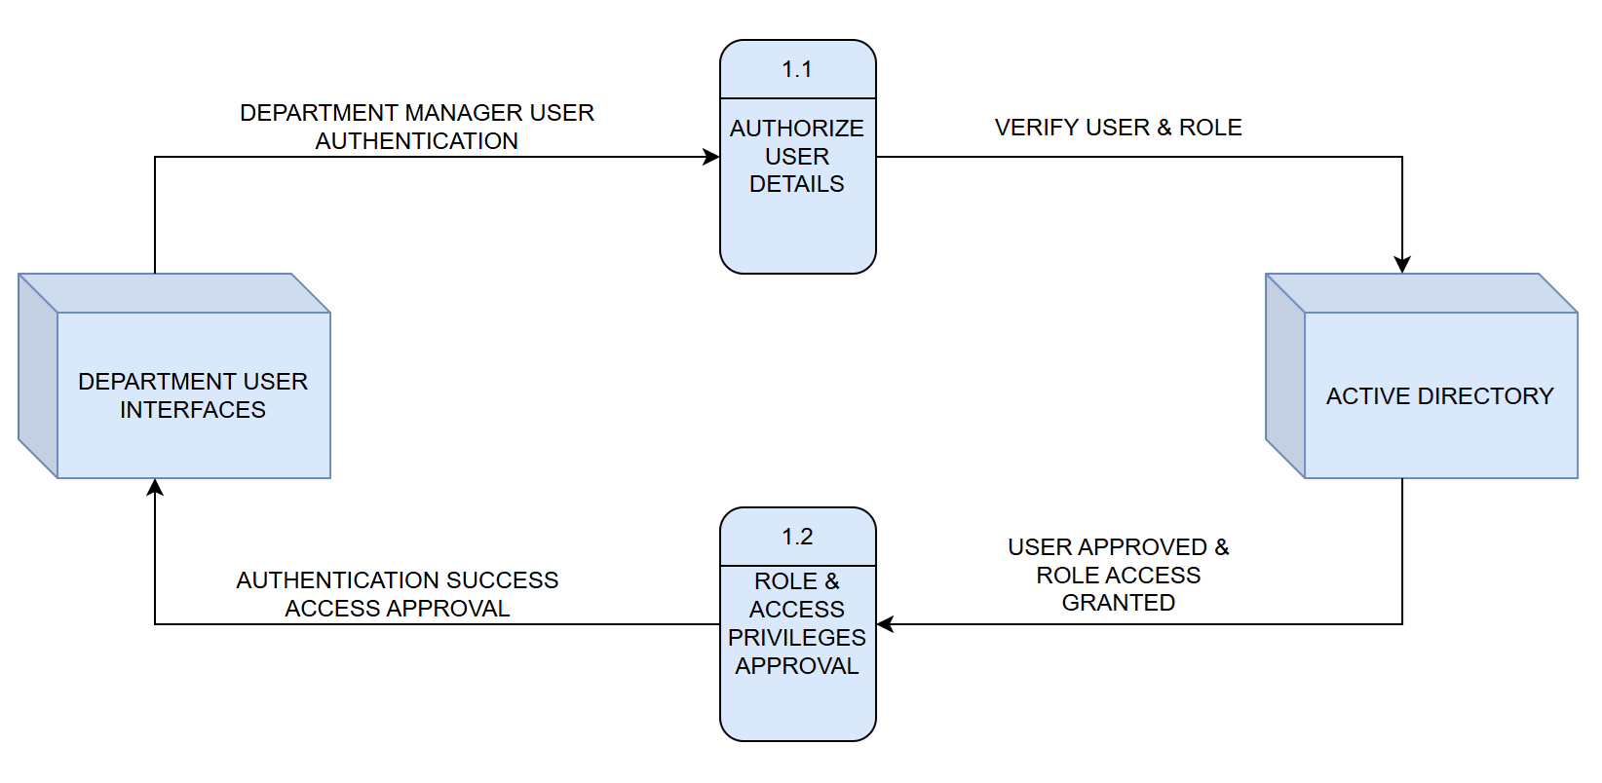

Label: | AUTHORIZE USER DETAILS
Entry Type: | Process
Description: | Receive Department Manager user credentials for authorization and verify role with ACTIVE DIRECTORY.
Process #: | 1.1
Process Description: | Input Data Flows:  - DEPARTMENT MANAGER USER AUTHENTICATION  Output Data Flows:  - VERIFY USER & ROLE  RECEIVE the DEPARTMENT MANAGER USER AUTHENTICATION from the DEPARTMENT USER INTERFACES entity.  VERIFY USER & ROLE with the ACTIVE DIRECTORY entity.
Notes: | Department user authorization credentials must be verified for role and access privilege with Active Directory before approvals and sent notifications are generated.

Label: | ROLE & ACCESS PRIVILEGES APPROVAL
Entry Type: | Process
Description: | Receive role & access approvals for corresponding Department Manager user credentials and allow respective access privileges for each Department Manager.
Process #: | 1.2
Process Description: | Input Data Flows:  - USER APPROVED & ROLE ACCESS GRANTED  Output Data Flows:  - AUTHENTICATION SUCCESS ACCESS APPROVAL  RECEIVE the USER APPROVED & ROLE ACCESS GRANTED notification from the ACTIVE DIRECTORY entity.  SEND the AUTHENTICATION SUCCESS ACCESS APPROVAL authorization to DEPARTMENT USER INTERFACES.
Notes: | Once authorization and the corresponding access privileges have been approved, Fabrication and Machine Shop Department Managers are granted C/U/D (Create, Update, Delete (soft-delete)) privileges. Quality and Shipping Department Managers are granted Read-Only privileges.

