CMIS-4900-400
Team 2
Production Data Information System
DFD LVL 1

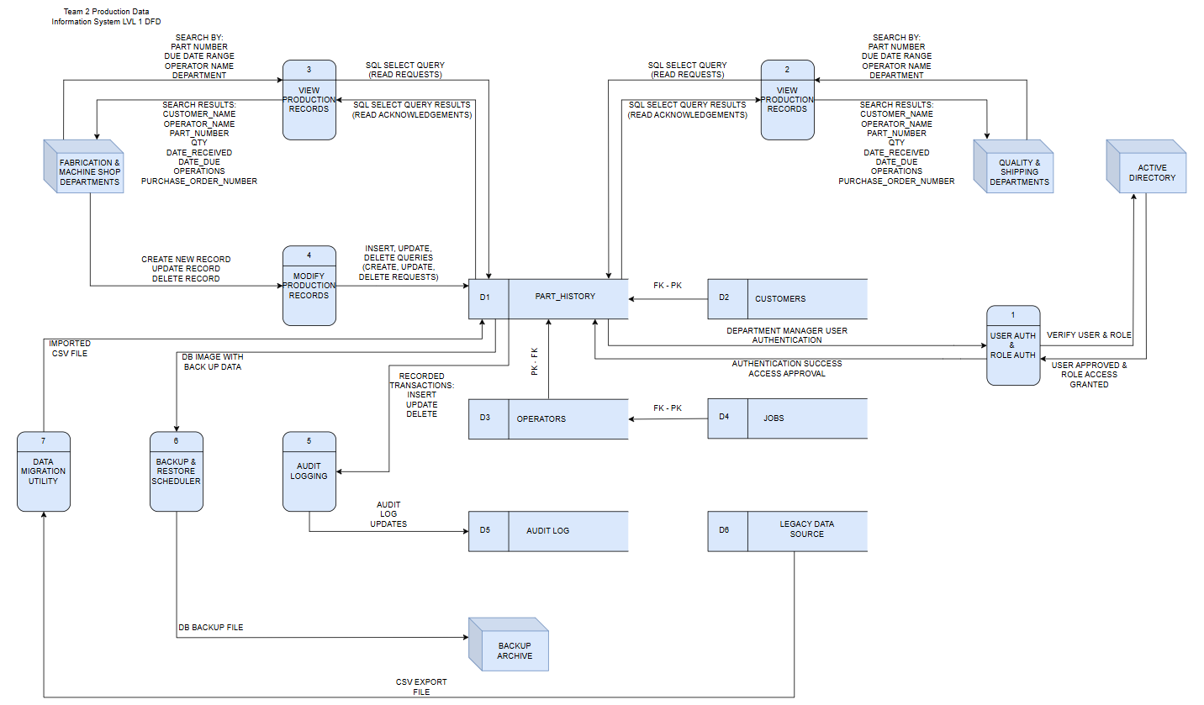

Data Dictionary:

Label: | USER AUTH & ROLE AUTH
Entry Type: | Process
Description: | Authenticate managers through user and role verification to grant role-based action privileges on the PART_HISTORY table.
Process #: | 1
Process Description: | Input Data Flows:  - DEPARTMENT MANAGER USER AUTHENTICATION  - USER APPROVED & ROLE ACCESS GRANTED  Output Data Flows:  - VERIFY USER & ROLE  - AUTHENTICATION SUCCESS ACCESS APPROVAL  RECEIVE the DEPARTMENT MANAGER AND USER AUTHENTICATION from the system where the PART_HISTORY table is located.  VERIFY the USER & ROLE with the ACTIVE DIRECTORY entity.  RECEIVE USER APPROVED & ROLE ACCESS GRANTED from the ACTIVE DIRECTORY entity.  SEND the AUTHENTICATION SUCCESS ACCESS APPROVAL to the system where the PART_HISTORY table is located.
Notes: | Process 1 must take place before manager entities may submit CRUD requests to the system.

Label: | VIEW PRODUCTION RECORDS
Entry Type: | Process
Description: | Query the system to search by parameters such as PART NUMBER, DUE DATE RANGE, OPERATOR NAME, and DEPARTMENT. Receive the query results from the system which returns CUSTOMER_NAME, OPERATOR_NAME, PART_NUMBER, QTY, DATE_RECEIVED, DATE_DUE, OPERATIONS, and PURCHASE_ORDER_NUMBER
Process #: | 2
Process Description: | Input Data Flows:  - SEARCH BY: PART NUMBER, DUE DATE RANGE, OPERATOR NAME, DEPARTMENT.  - SQL SELECT QUERY RESULTS (READ ACKNOWLEDGEMENTS)  Output Data Flows:  - SQL SELECT QUERY (READ REQUESTS)  - SEARCH RESULTS: CUSTOMER_NAME, OPERATOR_NAME, PART_NUMBER, QTY, DATE_RECEIVED, DATE_DUE, OPERATIONS, PURCHASE_ORDER_NUMBER  RECEIVE the SEARCH BY: PART NUMBER, DUE DATE RANGE, OPERATOR NAME, and DEPARTMENT request from the QUALITY & SHIPPING DEPARTMENTS entity.  SEND the SQL SELECT QUERY (READ REQUESTS) to the system where the PART_HISTORY table is located.  RECEIVE the SQL SELECT QUERY RESULTS (READ ACKNOWLEDGEMENTS) from the system where the PART_HISTORY table is located.  SEND the SEARCH RESULTS: CUSTOMER_NAME, OPERATOR_NAME, PART_NUMBER, QTY, DATE_RECEIVED, DATE_DUE, OPERATONS, and PURCHASE_ORDER_NUMBER to the QUALITY & SHIPPING DEPARTMENTS entity.
Notes: | Process 1 must take place before process 2.

Label: | VIEW PRODUCTION RECORDS
Entry Type: | Process
Description: | Query the system to search by parameters such as PART NUMBER, DUE DATE RANGE, OPERATOR NAME, and DEPARTMENT. Receive the query results from the system which returns CUSTOMER_NAME, OPERATOR_NAME, PART_NUMBER, QTY, DATE_RECEIVED, DATE_DUE, OPERATIONS, and PURCHASE_ORDER_NUMBER
Process #: | 3
Process Description: | Input Data Flows:  - SEARCH BY: PART NUMBER, DUE DATE RANGE, OPERATOR NAME, DEPARTMENT.  - SQL SELECT QUERY RESULTS (READ ACKNOWLEDGEMENTS)  Output Data Flows:  - SQL SELECT QUERY (READ REQUESTS)  - SEARCH RESULTS: CUSTOMER_NAME, OPERATOR_NAME, PART_NUMBER, QTY, DATE_RECEIVED, DATE_DUE, OPERATIONS, PURCHASE_ORDER_NUMBER  RECEIVE the SEARCH BY: PART NUMBER, DUE DATE RANGE, OPERATOR NAME, and DEPARTMENT request from the FABRICATION & MACHINE SHOP DEPARTMENTS entity.  SEND the SQL SELECT QUERY (READ REQUESTS) to the system where the PART_HISTORY table is located.  RECEIVE the SQL SELECT QUERY RESULTS (READ ACKNOWLEDGEMENTS) from the system where the PART_HISTORY table is located.  SEND the SEARCH RESULTS: CUSTOMER_NAME, OPERATOR_NAME, PART_NUMBER, QTY, DATE_RECEIVED, DATE_DUE, OPERATONS, and PURCHASE_ORDER_NUMBER to the FABRICATION & MACHINE SHOP DEPARTMENTS entity.
Notes: | Process 1 must take place before process 3.

Label: | MODIFY PRODUCTION RECORDS
Entry Type: | Process
Description: | Query the system to CREATE new records, UPDATE existing records, and (soft) DELETE existing records.
Process #: | 4
Process Description: | Input Data Flows:  - CREATE NEW RECORD, UPDATE RECORD, DELETE RECORD  Output Data Flows:  - INSERT, UPDATE, DELETE QUERIES (CREATE, UPDATE, DELETE REQUESTS)  RECEIVE the CREATE NEW RECORD, UPDATE RECORD, DELETE RECORD request.  SEND the INSERT, UPDATE, DELETE QUERIES (CREATE, UPDATE, DELETE REQUESTS) to the system where the PART_HISTORY table is located.
Notes: | Process 1 must take place before process 4.

