Final Design Specification

Project Title: Kiczan Manufacturing Production Information System

CMIS-4900-400: Senior Capstone 1
Date: November 25th, 2025
Professor: Dr. Menon

Prepared By:
Daniel Puharic
Elian Garcia
Justin Kisner
Josh Stanczyk

Table of Contents

Contents
Project Introduction 7
Project Charter 8
Introduction 8
Abstract 8
Anticipated Completion 8
Approved Budgets 9
Hardware Requirements 9
Success Criteria 9
Governance & Decision Rights 9
Deliverables & Gates 9
Assumptions & Budget Rationalization 10
Stakeholders 10
Project Team 10
Stakeholder Signatures 10
Conclusion 11
Project Scope 12
Introduction 12
Problem Description 12
Anticipated Business Benefits 12
System Capabilities 13
Input Validation & Data Integrity 13
Role Permission Table (CRUD) 14
Data Model 14
Data Migration 15
Field Mapping 15
Non-Functional Requirements 16
System Backup and Restore 17
Security 17
Transaction Audit 17
Risk Analysis 17
Feasibility Evaluation 17
Constraints and Limitations 18
Onboarding Procedures and Guidelines 19
Conclusion 21
Design Topology 22
Introduction 22
Conclusion 22
Context and Data Flow (DFD) Diagrams 23
Introduction 23
Context Diagram 24
Data Flow Diagrams 25
Level 1 Data Flow Diagram 25
LVL 1 Data Dictionary 26
Process 1 Data Flow Diagram 31
Process 1 Data Dictionary 32
Process 2 Data Flow Diagram 33
Process 2 Data Dictionary 34
Process 3 Data Flow Diagram 39
Process 3 Data Dictionary 40
Conclusion 45
Entity Relationship Diagram (ERD) 46
Introduction 46
Entity Relationship Diagram 46
Field Mappings 47
Conclusion 48
Screen Sequence with Dialog 49
Introduction 49
Screen Sequence Menu Hierarchy 50
Main User Interface Wireframe – Initial Empty State at Application Start 50
Main User Interface Wireframe – Search by Part Number – Query Success but No Records Found State 51
Main User Interface Wireframe – Search by Part Number – Query Failure with Validation Error State 52
Main User Interface Wireframe – Search by Part Number – Query Success State 53
Main User Interface Wireframe – Search by Due Date Range – Query Failure with Validation Error State 54
Main User Interface Wireframe – Search by Due Date Range – Query Failure with Validation Error State 55
Main User Interface Wireframe – Search by Due Date Range – Query Success State 56
Main User Interface Wireframe – Search by Fabrication Department – Query Success State 57
Main User Interface Wireframe – Search by Fabrication Department – Query Success with Paged Results State 58
Main User Interface Wireframe – Search by Operator Name – Query Success State 59
Main User Interface Wireframe – Search by Part Number – Query Success with Delete Record Selection State 60
Main User Interface Wireframe – Search by Part Number – Query Success with Update Record Selection State 61
Main User Interface Wireframe – Search by Part Number in Archive – Query Success with Restore Record Selection State 62
Create Record Interface Wireframe – Initial Empty State 63
Create Record Interface Wireframe – Part Number Error Validation State 64
Create Record Interface Wireframe – Quantity Error Validation State 65
Create Record Interface Wireframe – Purchase Order Number Error Validation State 66
Create Record Interface Wireframe – Operations Error Validation State 67
Create Record Interface Wireframe – Date Format Error Validation State 68
Create Record Interface Wireframe – Date Due Error Validation State 69
Create Record Interface Wireframe – Customer Error Validation State 70
Create Record Interface Wireframe – Record Insertion Success State 71
Create Record Interface Wireframe – Clear and Menu Button State 72
Update Record Wireframe – Initial Empty State 73
Update Record Wireframe – Example Record, with Record Selected 74
Update Record Wireframe – Missing Customer Entry Error 75
Update Record Wireframe – Missing Operator Entry Error 76
Update Record Wireframe – Missing Operations Entry Error 77
Update Record Wireframe – Quantity Entry Error 78
Update Record Wireframe – Part Number Entry Error 79
Update Record Wireframe – Order Number Entry Error 80
Update Record Wireframe – Received and Due Date Entry Error 81
Update Record Wireframe – Due Date Entry (Earlier than Received) Error 82
Update Record Wireframe – Successful Entry State 83
Update Record Wireframe – Using the “Clear” and “Back to Menu” Buttons 84
Conclusion 85
User Stories 86
Introduction 86
User Story 1 86
User Story 2 87
User Story 3 87
User Story 4 88
User Story 5 88
User Story 6 89
User Story 7 91
Project Management Plan 92
Introduction 92
Work Breakdown Structure 93
Project Phases 93
Conclusion 96
Project Summary 97
Appendix 98
Appendix A – Gantt Chart 98

Project Introduction

The Kiczan Manufacturing Production Information System is designed to address the organization’s growing need for a unified and reliable method of tracking work orders across all four departments. Currently, production data is fragmented, inconsistently captured, and dependent on outdated tools such as Excel workbooks and Microsoft Access databases. This limits visibility, slows decision-making, and increases the risk of delays, redundant work, and inaccurate reporting.

In today’s manufacturing environment, driven by rapid demand cycles, tight delivery expectations, and increasing global competition, accurate and centralized production data is no longer optional; it is a foundational requirement. Modern manufacturing standards emphasize real-time visibility, traceability, and data-driven decision-making to maintain efficiency and remain competitive. Organizations that rely on manual or decentralized systems face growing challenges, including inefficient workflows, limited process transparency, and a higher likelihood of errors that can disrupt production or compromise customer satisfaction.
This project directly supports these modern standards by introducing a centralized information system capable of storing, retrieving, validating, and managing production data through a MySQL backend, a C# application layer, and a Windows Forms Application (.NET Framework) user interface. By modernizing the data flow and standardizing how work orders are documented, the system ensures that department managers have timely access to accurate, complete, and searchable information. Ultimately, the Production Information System enhances operational efficiency, supports better planning, strengthens compliance with industry expectations, and reinforces Kiczan Manufacturing’s commitment to on-time delivery and high-quality service.

Project Charter

Introduction
This Project Charter defines the objectives, scope, stakeholders, governance structure, and success criteria for the development of the Kiczan Manufacturing Production Information System. The purpose of this initiative is to establish a centralized database and user-friendly interface that allows department managers to capture, monitor, and analyze production data across the entire fabrication and machining process.
The project seeks to eliminate fragmented data sources, streamline the tracking of work orders, and improve visibility into daily operations. By deploying a MySQL database, implementing a C# backend, and creating a Windows Forms front end, the system will enable users to efficiently input and query production data in a controlled, validated, and secure environment. This charter ensures alignment across stakeholders, clarifies development expectations, and establishes the foundation for successful system implementation by May 2026.

Project Name:
Production Information Database

Abstract
The database will store row and column tabular data for part numbers that are received as work orders for the shop to produce. Data stored in record format will include part number, customer id & name, date received & due, quantity, operator id & name, job id & name, and the process description. The data will be migrated to a MySQL database, where users will interact with the database through a front-end interface created with Microsoft Forms, and data will be transported and interacted with utilizing a back end programmed in C#. The project will help current managers at Kiczan Manufacturing to identify if work orders are currently in process, inspect job volume through date ranges, operator, and department, and identify if work orders are on schedule or behind. Critical success factors will be met when user story requirements are completed, allowing users to easily navigate through the user interface to query, input, delete, and edit data stored within the database as needed.

Anticipated Completion
The currently anticipated completion date of a fully planned, implemented, and deployed information system solution is early May of 2026.

Approved Budgets
Because the information system will be developed using free resources and existing hardware can be used to host required software for the technology stack, the budget for the project is zero dollars and has no cost.

Hardware Requirements
The front-end will be a Windows Forms Application (.NET Framework), deployed to four Windows terminals representing the departments, with a backend in C#, and a database in MySQL to be installed on a Windows Server OS already onsite.

Success Criteria
Upon Project completion, 100% tracked work orders across all four departments to show full implementation of the project. A search query time of less than ten seconds would be ideal for the project to be considered 100% done before the stretch goals of dashboards to perform analytics on their business operations.

Governance & Decision Rights
The project will follow a clear governance structure to ensure accountability and alignment with organizational priorities. The Vice President of Kiczan Manufacturing will serve as the project sponsor and has the authority to approve or deny any scope changes. The Project Liaison will oversee all technical decisions, with input from the project team as needed. Weekly or bi-weekly demonstrations will be conducted to review progress, validate functionality, and gather feedback from stakeholders. Any requested changes will be documented, logged, and evaluated for impact on schedule and scope before approval.

Deliverables & Gates
Project delivery will be structured into the following phases with defined gates:
- Gate 1: Development of the database model, migration of existing data, and CRUD functionality for one department.
- Gate 2: Implementation of advanced search and filtering features, report generation, and rollout across all four departments.
- Gate 3: System hardening, including database backup and auditing, as well as development of simple training materials such as a user guide for long-term system use.
Progress through each gate is subject to sponsor approval to ensure the system meets requirements and remains aligned with business needs.

Assumptions & Budget Rationalization
The project assumes that all necessary hardware and infrastructure are already in place, including four Windows terminals and an onsite Windows Server capable of hosting the MySQL database. It is further assumed that all required software tools (MySQL Community Edition, Visual Studio Community, and Windows Forms .NET framework) are available at no cost. Because of these conditions, the project is set to operate with a budget of $0, relying exclusively on free open source resources and existing company hardware. No additional licenses, third-party libraries, or new hires are required.

Stakeholders
The following stakeholders have been identified relative to the project:
- Vice President (Sponsor): Provides project approval and scope oversight.
- Department Managers (Primary Users): Responsible for entering and querying work order data at their respective terminals.
- Shop Operators (Indirect Users): Data originators whose work order activities are tracked in the system.
- IT Staff: Provides support for system deployment, database backup, and security policy enforcement.
- Project Team: Responsible for design, development, testing, and delivery of the system.

Project Team
Daniel Puharic
Elian Garcia
Justin Kisner
Josh Stanczyk

Stakeholder Signatures
Bud Bradley (VP of Kizcan Manufacturing)
Daniel Puharic (Project Team)
Elian Garcia (Project Team)
Justin Kisner (Project Team)
Josh Stanczyk (Project Team)
Bill Margie (Machine Shop Department Manager)
Brandon Copeland (Laser Operator)
Matt Snyder (Water Jet Operator)
Jennifer Briggs (Shipping Department Manager)
George Dearth (Quality Control Department Manager)

Conclusion
The Kiczan Manufacturing Production Information System represents an essential advancement in the company’s operational capability. By unifying production data, improving access to real-time information, and eliminating reliance on outdated tools, the project directly supports organizational efficiency and customer responsiveness. Approval of this charter signals a shared commitment from all stakeholders to the project's objectives, scope, and expected benefits.
With this alignment in place, the project team will move forward into detailed planning, iterative development, and stakeholder-driven refinement following Agile principles. The successful delivery of this system will equip Kiczan Manufacturing with a dependable platform for managing work orders, reducing errors, and supporting strategic growth. The project team is prepared to proceed with development, with confidence in the collaborative framework and clear expectations established in this charter.

Project Scope

Introduction
The explicit objective of this project is to create a modern and easily assessable web-based application for Kiczan Manufacturing and increase the availability of information to the business. The scope incorporates replacing the current system of Microsoft Access and Excel files used currently to track work orders. This new system is a standalone Web Application, using a MySQL database to hold and manage new and old work order data. This new system will authenticate user roles through a role-based login. This project is expected to increase the overall efficiency of the company, by reducing the occurrence of work orders completed past their delivery date and to reduce the shrink in overall inventory, through the ability to track 100% of work orders digitally.

Problem Description
Production data is currently only tracked by three out of four departments at Kiczan Manufacturing. This data is tracked using a Microsoft Access database and Microsoft Excel workbook. For management at Kiczan Manufacturing to accurately track work orders through the fabrication process after a purchase order is received from a customer, the fourth department’s data must be included to guarantee accuracy across all data for the entire shop. To achieve this, an information system must be implemented and deployed to four user terminals, consisting of an intuitive and easy to navigate front end interface, a database to store and query production data, and a programmed back end to facilitate data exchange and manipulation.

Anticipated Business Benefits
- Work order production data input by fabrication and machine shop department managers at their terminals.
- Accurate record storage with identifiable attributes.
- Record retrieval and sort mechanisms to present department managers with accurate production data.
- Query by specific date ranges, as well as part numbers, operators, and departments to observe volume.
- Retrieve data in the event of lost physical work order to prevent the occurrence of redundant production.
- Multiuser access will provide those with access the ability to find sought after information in a self-reliant manner.
- Business Outcomes- KPIs
  - Upon completion of the project, the department managers are expected to digitally track 100% of work orders within the new database with a 24-hour window of validation.
  - Work Orders being tracked after 90 days of going live should decrease the number of partial orders shipped by 5%.
  - Reduce the occurrence of work orders completed past their scheduled delivery date by 10% from going live after 90 days.
  - Reduce shrink in inventory by 5% after 6 months from live deploy by reducing redundant purchase orders on fabrication materials.

System Capabilities
- Database table structure written in SQL and host on MySQL DBMS.
- SQL queries written as stored procedures that serve the needs of department managers.
- A simple and intuitive front end written in Windows Forms (.NET) that provides ease of use.
- A backend written in C# to facilitate the database connection, data transfer, and data manipulation.
- A backend written with modularity and customization, to allow for the possibility of additional functionality as needed in the future.
- Returned query results presented to the user in a row and column table structure.
- Input validation on all required fields for SELECT, INSERT, UPDATE, and DELETE queries.
- Inline alert messages that inform the user of the field whose input is incorrect, and what the proper format is to pass validation constraints.
- Queries will not execute until all required fields have passed validation conditional checks.

Input Validation & Data Integrity
- Part Number: Must be alphanumeric + hyphen only.
- Quantity: Integer ≥ 1. Error if invalid.
- Dates: Must be entered in mm/dd/yyyy format.
  - Error if Due Date < Received Date.
- Purchase Order Number: Must be alphanumeric + hyphen only.
- Required Fields: PART_NUMBER, DATE_RECEIVED, DATE_DUE, PURCHASE_ORDER_NUMBER, QTY.
- Controlled Picks: CUSTOMER_ID and OPERATOR_ID must be selected from drop-down lists populated from the CUSTOMERS and OPERATORS tables. OPERATIONS must be chosen from the hardcoded backend list.
- Soft Delete (TO_DELETE flag): All records default to TO_DELETE = FALSE. On delete action, TO_DELETE is set to TRUE, and the record is hidden from future queries.
- Hard Delete: Reserved only for Database Administrator.

Role Permission Table (CRUD)

Department | Create | Read/Search | Update | Soft Delete | Hard Delete
Fabrication | ✓ | ✓ | ✓ | ✓ | X
Machining | ✓ | ✓ | ✓ | ✓ | X
Quality | X | ✓ | X | X | X
Shipping | X | ✓ | X | X | X
Database Admin | ✓ | ✓ | ✓ | X | ✓

Data Model

Entity Relationship Diagram
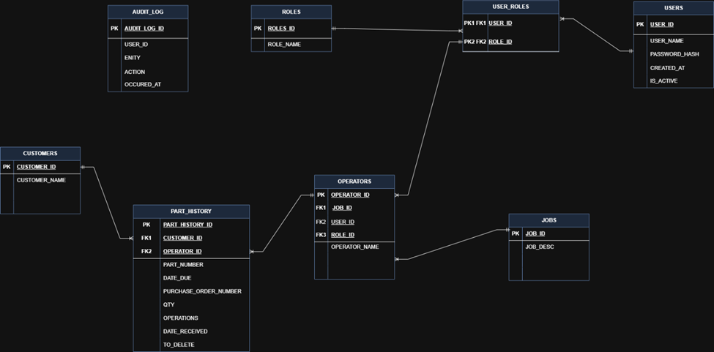

Data Migration
- All existing records on each of the four tables will be exported as .csv (comma separated values) from the Microsoft Excel Workbook that currently serves as a data entry method. There will be one .csv file per table containing the stored records on each table.
- MySQL import wizard will be utilized through the MySQL DBMS, importing each .csv file to its corresponding table to store the records in the new database.
- No attributes in records will contain null values.
- The bridging table PART_HISTORY uses the primary key PART_HISTORY_ID, and two foreign keys, CUSTOMER_ID, and OPERATOR_ID, to uniquely identify a record on the table to prevent the occurrence of duplicate records.

Field Mapping
Source: CUSTOMERS Table | Target: CUSTOMERS Table
CUSTOMER_ID (Integer) | CUSTOMER_ID (Integer)
CUSTOMER_NAME (Varchar 48) | CUSTOMER_NAME (Varchar 48)

Source: OPERATORS Table | Target: OPERATORS Table
OPERATOR_ID (Integer) | OPERATOR_ID (Integer)
JOB_ID (Integer) | JOB_ID (Integer)
USER_ID (Integer) | USER_ID (Integer)
ROLE_ID (Integer) | ROLE_ID (Integer)
OPERATOR_NAME (Varchar 48) | OPERATOR_NAME (Varchar 48)

Source: JOBS Table | Target: JOBS Table
JOB_ID (Integer) | JOB_ID (Integer)
JOB_DESC (Text) | JOB_DESC (Text)

Source: PART_HISTORY Table | Target: PART_HISTORY Table
PART_HISTORY_ID (Integer) | PART_HISTORY_ID (Integer)
CUSTOMER_ID (Integer) | CUSTOMER_ID (Integer)
OPERATOR_ID (Integer) | OPERATOR_ID (Integer)
PART_NUMBER (Varchar 128) | PART_NUMBER (Varchar 128)
DATE_DUE (Date) | DATE_DUE (Date)
PURCHASE_ORDER_NUMBER (Varchar 128) | PURCHASE_ORDER_NUMBER (Varchar 128)
QTY (Integer) | QTY (Integer)
OPERATIONS (Text) | OPERATIONS (Text)
DATE_RECEIVED (Date) | DATE_RECEIVED (Date)
TO_DELETE (Boolean) | TO_DELETE (Boolean)

Source: ROLES Table | Target: ROLES Table
ROLE_ID (Integer) | ROLE_ID (Integer)
ROLE_NAME (Varchar 48) | ROLE_NAME (Varchar 48)

Source: USER_ROLES Table | Target: USER_ROLES Table
USER_ID (Integer) (U) | USER_ID (Integer) (U)
ROLE_ID (Integer) (U) | ROLE_ID (Integer) (U)

Source: USERS Table | Target: USERS Table
USER_ID (Integer) | USER_ID (Integer)
USER_NAME (Varchar 48) (U) | USER_NAME (Varchar 48) (U)
PASSWORD_HASH (Text) | PASSWORD_HASH (Text)
CREATED_AT (Timestamp) | CREATED_AT (Timestamp)
IS_ACTIVE (Boolean) | IS_ACTIVE (Boolean)

Source: AUDIT_LOG Table | Target: AUDIT_LOG Table
AUDIT_LOG_ID (Integer) | AUDIT_LOG_ID (Integer)
USER_ID (Integer) | USER_ID (Integer)
ENTITY (Varchar 48) | ENTITY (Varchar 48)
ACTION (Varchar 48) | ACTION (Varchar 48)
OCCURRED_AT (Timestamp) | OCCURRED_AT (Timestamp)

Non-Functional Requirements
- Performance:
  - Queries that return records with search criteria such as date ranges, operators, department & part number will return results to the user in less than ten seconds if the returned data set is large (greater than 1000 records).
  - An average query time of less than five seconds for small to medium sized query results.
- Availability:
  - The system will be available to department managers during the operating hours of 7:00 AM to 3:30PM Monday through Friday.
  - The system will be available to department managers during the overtime operating hours 7:00 AM to 12:00 PM on Saturday.

- Validation:
  - Input validation will be implemented for required fields for SELECT, INSERT, UPDATE, and DELETE queries to enforce validation constraints on all user input to prevent the submission of bad data during use.
  - Alert messages will inform the user of the occurrence of a data entry that violates a validation constraint and present the user with the proper format.
  - Queries will not execute until the user input passes validation conditional checks for all required fields.

System Backup and Restore
- The MySQL database will have a scheduled nightly backup procedure to reflect any changes made during the operating hours that precede the backup procedure. This backup file will be stored on the server hosting the database.
- On the last Friday of every month, a copy of the most recent backup file will be saved on a USB flash drive and stored in the Fabrication Managers office, inside of a locked filing cabinet.

Security
- Department managers each have login credentials for their respective work terminals where the application will be installed.
- Security policies are assigned and enforced with Microsoft Active Directory for all terminals on the Kiczan Windows domain network.

Transaction Audit
- The audit function will be enabled on the MySQL database using the general log to track events and transactions that take place.
- If the general log does not provide sufficient information, the MariaDB Audit Plugin will be installed and configured on the database to meet information requirements.

Risk Analysis

Feasibility Evaluation
  - Organizational/Culture: Kiczan Manufacturing follows a horizontal organization structure comprised of four departments, shipping, quality, machining, and fabrication. Each department manager has expressed an interest in the need for a centralized information source to ensure that the jobs received have been entered into the business’ production process.
  - Technological: C#, MySQL, and Windows Forms (.NET) will be the technology stack utilized during the implementation of the information system. Hardware necessities will be fulfilled by existing onsite hardware which consists of preexisting work terminals for the application to be installed on, and an onsite Windows OS server to host the database itself through MySQL DBMS.
  - Schedule: The currently anticipated completion date of a fully planned, implemented, and deployed information system solution is early May of 2026. To maintain schedule feasibility, the team will meet weekly and use the following RACI matrix to assign tasks, ensuring all deliverables are obtained within the given timeframe and adhering to the 4 milestones listed ahead.
    - Milestone 1 Dec 2025: fully designed and documented within the scope of the project.
    - Milestone 2 Apr 2026: Complete finalized and fully tested application.
    - Milestone 3 Apr 2026: Deploy Database on target Kiczan server, deploy application on target Kiczan terminals.
    - Milestone 4 May 2026: Work through any deployment issues on deployed terminals and servers, distribute user support documentation, provide user training, and hand off to stakeholders.
  - Resources: Human Resources: The required personnel are already available within Kiczan Manufacturing. Department managers and staff will operate and maintain the system, while management can participate in system testing and implementation. No additional hiring is necessary.
Technological Resources: The technological requirements are feasible with existing infrastructure. Kiczan Manufacturing already owns the necessary Windows computers and a Windows Server. Community editions of MySQL, Visual Studio, and Windows Forms (.NET) will be used to prevent additional licensing costs.
Financial Resources: The project is financially feasible despite having no dedicated budget. By relying on community software versions and existing onsite hardware, direct costs are eliminated. Potential indirect costs include staff time for implementation and testing, along with minimal expenses for backup storage devices.

Constraints and Limitations
  - Budgetary: No funds are allocated for purchasing software licenses or new hardware. All needs will be met through free community editions and existing onsite equipment, including the Windows Server and four departmental terminals.
  - Hardware/Environment: All onsite hardware operates on Windows OS. The application must run on the four existing terminals and the onsite Windows Server hosting MySQL, with no cloud or external hosting options.
  - Network Dependence: If the WAN connection is lost, terminals and the server will maintain local connectivity. However, if an intermediary network device fails, any terminals downstream from it will lose access to the database until restored.
  - Technology: The system is restricted to a MySQL database, a C# backend, and a Windows Forms (.NET) front end.
  - Schedule: The project must be fully completed and deployed by May 2026, with an internal target of mid-April 2026. Expansion of scope beyond the defined features (CRUD, queries, reporting, backups) risks delay.
  - Organizational: Department managers and operators must transition from Excel/Access into the new system. Because training resources are limited, the user interface must remain simple and intuitive.
  - System Limitations:
    - Access is restricted to onsite shop-floor terminals; no mobile or remote use.
    - Reporting is limited to basic tabular and filtered outputs, not advanced dashboards or analytics.
    - Data entry remains manual by managers; no automated imports or IoT integration with shop machines.
    - Security is limited to Windows login credentials and Active Directory policies, with basic database logging and auditing.

Onboarding Procedures and Guidelines
This document outlines the onboarding process for users of the new Kiczan Manufacturing Production Tracking System. The goal is to ensure that all department managers and system administrators can successfully log in, enter, retrieve, and manage work order data with confidence and accuracy.
Step 1 – Account Setup
- The IT administrator creates Windows user accounts for each department manager.
- User roles and permissions are assigned in both Active Directory and the MySQL system.
- Each manager confirms their login credentials before training.
Step 2 – System Access
- The Production Tracking Application is installed on all four department terminals.
- Each user logs into their respective terminal using their assigned credentials.
- The IT administrator verifies that all connections to the MySQL database are functioning properly.
Step 3 – User Orientation
- Each manager receives a short walkthrough of the system interface:
  - Navigation (menu, search bar, input form)
  - Data Entry (creating and updating records)
  - Query/Search Functions (by part number, date, operator, etc.)
  - Soft Delete Process (marking records for removal)
Step 4 – Practice Session
- Managers complete a mock data entry exercise:
  - Entering a sample work order with required fields
  - Searching for the entered order
  - Updating a record
  - Performing a soft delete
- The admin verifies data accuracy and system response times.
Step 5 – Validation and Go-Live
- Once each department manager demonstrates proper use of their functions, they are cleared for production use.
- All departments go live simultaneously to ensure full data synchronization.
- Any errors or user issues are reported directly to the project team for review and resolution.
- Training and Support
- Initial Training: Conducted by project team members during installation week (approx. 1 hour per manager).
- Reference Guide: A printed quick-start guide with screenshots and field descriptions will be provided.
- Ongoing Support: The IT admin will handle login issues, while the Database Admin will maintain data integrity and backups.
- Feedback: Users will be encouraged to report interface or functionality issues during the first 30 days post-launch.

- Post-Onboarding Review
After two weeks of active use, the project team will:
- Collect feedback from all department managers.
- Review common errors or bottlenecks.
- Apply any necessary minor updates or documentation adjustments.
- Success Indicators
- All department managers successfully log in and record data within 24 hours of go-live.
- 100% of work orders entered within one business day of receipt.
- No data entry or permission errors reported after the first week of operation

Conclusion
This project aims to develop a modern web-based management system to enhance Kiczan Manufacturing production data for every department. The goal of the project is to streamline processes and improve efficiency by replacing the individual systems with one encompassing system to align all departmental data together and to create a secure database, ensuring data accuracy and authenticity.

Design Topology

Introduction
The Design Topology document provides a detailed visual representation of the architecture and structure of the system. Its purpose is to show the relationships between each piece of the system to accurately show how data flows through the environment, and each of those relationships is responsible for handling the data. This document is important to stakeholders in their understanding of the technical design of the project. This understanding will allow the stakeholders to ensure the system aligns with the goals of the project. The document serves as a reference for administrators and managers to maintain consistency and coherence of the system.
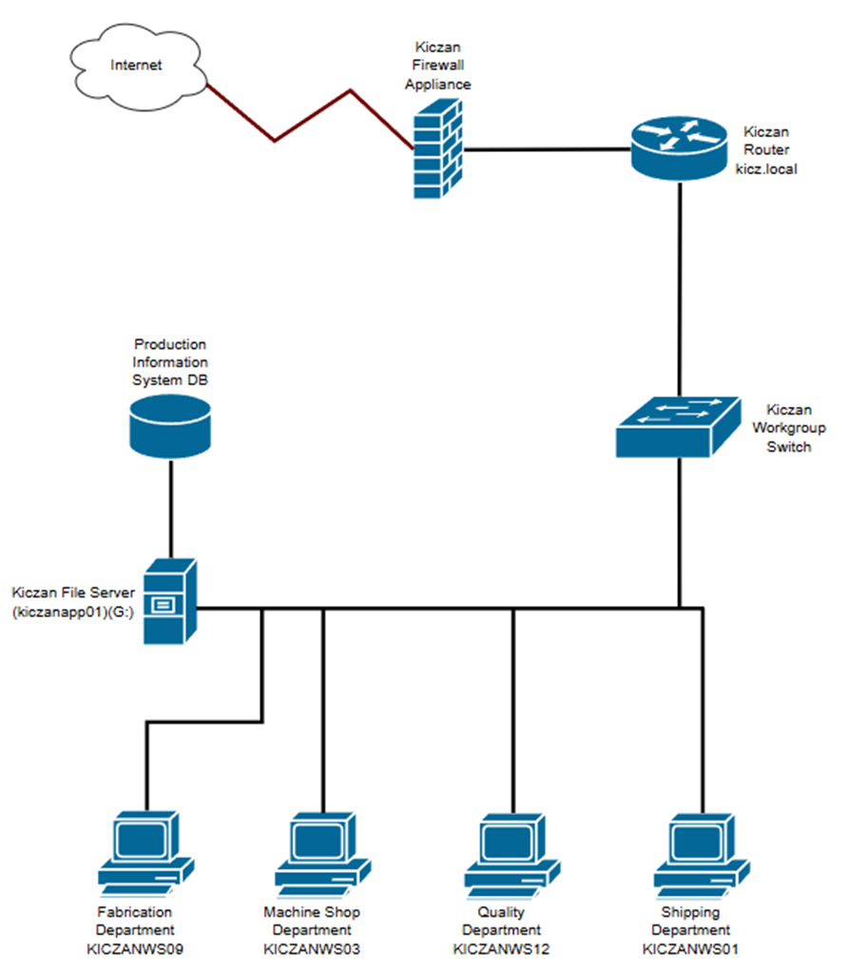

Conclusion
The Design Topology document allows for a shared understanding of the system’s architecture and will incorporate the staging process for the system. This understanding will provide the foundation for refinement of the system. By mapping the relationships and data flows between components, it ensures an informed stakeholder group and aligns the effort for the development and management of the project.

Context and Data Flow (DFD) Diagrams

Introduction
The Context and Data Flow Diagrams provide a comprehensive visualization of how information moves through the Production Information System and defines the logical foundation that supports all system functions. These diagrams illustrate the flow of data beginning at the highest level, showing the system’s interaction with external entities such as department managers and Active Directory and then progresses into detailed level 1 and subprocess diagrams that map authentication, search execution, record modification, auditing, data migration, and scheduled backups. Each diagram demonstrates how data is validated, transformed, and routed between processes and data stores, ensuring that every user action follows the required business rules, role permissions, and input constraints. By capturing these workflows in a clear, structured format, the DFDs serve as an essential reference for system developers, stakeholders, and future maintainers, providing a shared understanding of how the system functions operationally and how data consistently moves between components during official use.

Context Diagram

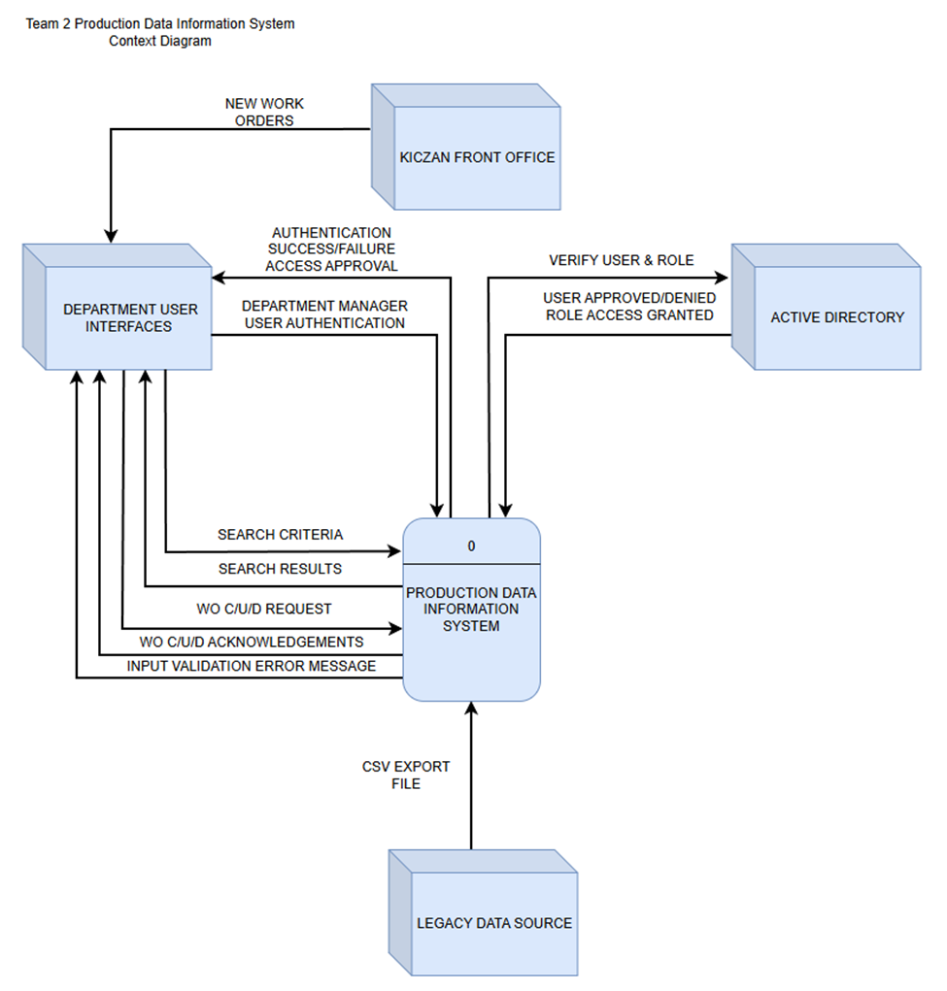

Data Flow Diagrams

Level 1 Data Flow Diagram
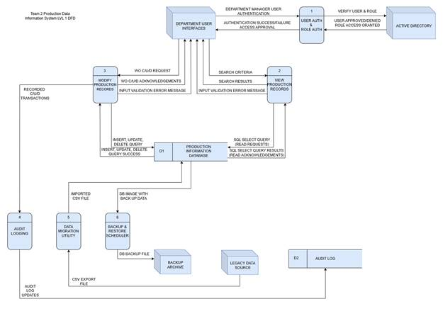

LVL 1 Data Dictionary
Label: | USER AUTH & ROLE AUTH
Entry Type: | Process
Description: | Authenticate department manager user interfaces through user and role verification to grant role-based action privileges on the PART_HISTORY table within the database.
Process #: | 1
Process Description: | Input Data Flows:  - DEPARTMENT MANAGER USER AUTHENTICATION  - USER APPROVED/DENIED ROLE ACCESS GRANTED  Output Data Flows:  - VERIFY USER & ROLE  - AUTHENTICATION SUCCESS/FAILURE ACCESS APPROVAL  RECEIVE the DEPARTMENT MANAGER AND USER AUTHENTICATION from the DEPARTMENT USER INTERFACES entity.  VERIFY the USER & ROLE with the ACTIVE DIRECTORY entity.  RECEIVE USER APPROVED/DENIED ROLE ACCESS GRANTED notification from the ACTIVE DIRECTORY entity.  SEND the AUTHENTICATION SUCCESS/FAILURE ACCESS APPROVAL authorization to the DEPARTMENT USER INTERFACES entity.
Notes: | Process 1 must take place before manager entities may submit CRUD requests to the system.  Approved Roles:  - Fabrication & Machine Shop: C/R/U/D Requests with soft-delete privileges.  - Quality & Shipping: Ready Only privileges.

Label: | VIEW PRODUCTION RECORDS
Entry Type: | Process
Description: | Query the system to search by parameters such as PART NUMBER, DUE DATE RANGE, OPERATOR NAME, and DEPARTMENT. Receive the query results from the system which returns CUSTOMER_NAME, OPERATOR_NAME, PART_NUMBER, QTY, DATE_RECEIVED, DATE_DUE, OPERATIONS, and PURCHASE_ORDER_NUMBER.
Process #: | 2
Process Description: | Input Data Flows:  - SEARCH CRITERIA:  - PART NUMBER  - DUE DATE RANGE  - OPERATOR NAME  - DEPARTMENT.  - SQL SELECT QUERY RESULTS (READ ACKNOWLEDGEMENTS)  Output Data Flows:  - SQL SELECT QUERY (READ REQUESTS)  - SEARCH RESULTS:  - CUSTOMER_NAME, OPERATOR_NAME  - PART_NUMBER, QTY  - DATE_RECEIVED, DATE_DUE  - OPERATIONS, PURCHASE_ORDER_NUMBER  - INPUT VALIDATION ERROR MESSAGE  RECEIVE the SEARCH CRITERIA from the DEPARTMENT USER INTERFACES entity.  SEND the SQL SELECT QUERY (READ REQUESTS) to the PRODUCTION INFORMATION DATABASE where the PART_HISTORY table is located.  RECEIVE the SQL SELECT QUERY RESULTS (READ ACKNOWLEDGEMENTS) from the PRODUCTION INFORMATION DATABASE where the PART_HISTORY table is located.  SEND the SEARCH RESULTS to the DEPARTMENT USER INTERFACES entity.  SEND the INPUT VALIDATION ERROR MESSAGE to the DEPARTMENT USER INTERFACES entity when SEARCH CRITERIA required field input fails validation constraints.
Notes: | Process 1 must take place before process 2.  Approved Roles: Fabrication & Machine Shop. Quality & Shipping.

Label: | MODIFY PRODUCTION RECORDS
Entry Type: | Process
Description: | Query the system to CREATE new records, UPDATE existing records, and (soft) DELETE existing records.
Process #: | 3
Process Description: | Input Data Flows:  - WO C/U/D REQUEST  - INSERT, UPDATE, DELETE QUERY SUCCESS  Output Data Flows:  - INSERT, UPDATE, DELETE QUERY  - WO C/U/D ACKNOWLEDGEMENTS  - INPUT VALIDATION ERROR MESSAGE  RECEIVE the WO C/U/D REQUEST from the DEPARTMENT USER INTERFACES entity.  SEND the INSERT, UPDATE, DELETE QUERY to the PRODUCTION INFORMATION DATABASE.  RECEIVE the INSERT, UPDATE, DELETE QUERY SUCCESS notice from the PRODUCTION INFORMATION DATABASE.  SEND the WO C/U/D ACKNOWLEDGEMENTS to the DEPARTMENT USER INTERFACES entity.  SEND the INPUT VALIDATION ERROR MESSAGE to the DEPARTMENT USER INTERFACES entity when WO C/U/D REQUEST required field input fails validation constraints.
Notes: | Process 1 must take place before process 3.  Approved Roles:  - Fabrication & Machine Shop: Full C/R/U/D with soft-delete access privileges.

Label: | AUDIT LOGGING
Entry Type: | Process
Description: | Record Create, Update, and Delete (soft) transactions from Fabrication & Machine Shop departments. Update the audit log file stored in directory on server that hosts database.
Process #: | 4
Process Description: | Input Data Flows:  - RECORDED C/U/D TRANSACTIONS  Output Data Flows:  - AUDIT LOG UPDATES  RECEIVE the C/U/D TRANSACTIONS from the PRODUCTION INFORMATION DATABASE.  SEND the AUDIT LOG UPDATES to the AUDIT LOG.
Notes: | C/U/D transactions are recorded daily and are sent to the AUDIT LOG at the time they are recorded.

Label: | DATA MIGRATION UTILITY
Entry Type: | Process
Description: | Import Legacy Data from previous Microsoft Access Database in a .CSV file format.
Process #: | 5
Process Description: | Input Data Flows:  - CSV EXPORT FILE  Output Data Flows:  - IMPORTED CSV FILE  RECEIVE the CSV EXPORT FILE from the LEGACY DATA SOURCE.  SEND the IMPORTED CSV FILE to the PRODUCTION INFORMATION DATABASE.
Notes: | .CSV file to be imported using MySQL DBMS import utility for record transfer.

Label: | BACKUP & RESTORE SCHEDULER
Entry Type: | Process
Description: | Create MySQLDump files as backup copies for Database restoration on a nightly schedule in the event of hardware or software failure.
Process #: | 6
Process Description: | Input Data Flows:  - DB IMAGE WITH BACKUP DATA  Output Data Flows:  - DB BACKUP FILE  RECEIVE the DB IMAGE WITH BACKUP DATA from the PRODUCTION INFORMATION DATABASE.  SEND the DB BACKUP FILE to the BACKUP ARCHIVE.
Notes: | The BACKUP ARCHIVE will be a directory on the servers storage device dedicated to storing copies of the DB BACKUP FILE for future retrieval and restoration needs if necessary.

Process 1 Data Flow Diagram
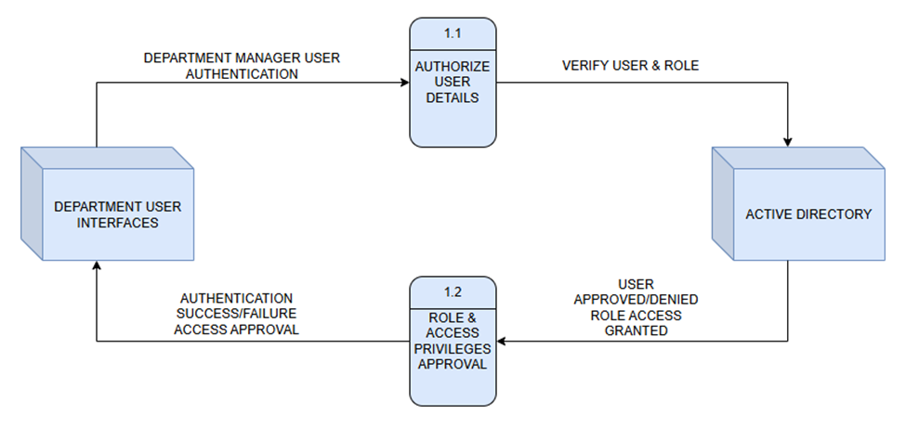

Process 1 Data Dictionary
Label: | AUTHORIZE USER DETAILS
Entry Type: | Process
Description: | Receive Department Manager user credentials for authorization and verify role with ACTIVE DIRECTORY.
Process #: | 1.1
Process Description: | Input Data Flows:  - DEPARTMENT MANAGER USER AUTHENTICATION  Output Data Flows:  - VERIFY USER & ROLE  RECEIVE the DEPARTMENT MANAGER USER AUTHENTICATION from the DEPARTMENT USER INTERFACES entity.  VERIFY USER & ROLE with the ACTIVE DIRECTORY entity.
Notes: | Department user authorization credentials must be verified for role and access privilege with Active Directory before approvals and sent notifications are generated.

Label: | ROLE & ACCESS PRIVILEGES APPROVAL
Entry Type: | Process
Description: | Receive role & access approvals for corresponding Department Manager user credentials and allow respective access privileges for each Department Manager.
Process #: | 1.2
Process Description: | Input Data Flows:  - USER APPROVED/DENIED ROLE ACCESS GRANTED  Output Data Flows:  - AUTHENTICATION SUCCESS/FAILURE ACCESS APPROVAL  RECEIVE the USER APPROVED/DENIED ROLE ACCESS GRANTED notification from the ACTIVE DIRECTORY entity.  SEND the AUTHENTICATION SUCCESS/FAILURE ACCESS APPROVAL authorization to DEPARTMENT USER INTERFACES entity.
Notes: | Once authorization and the corresponding access privileges have been approved, Fabrication and Machine Shop Department Managers are granted C/U/D (Create, Update, Delete (soft-delete)) privileges. Quality and Shipping Department Managers are granted Read-Only privileges.

Process 2 Data Flow Diagram
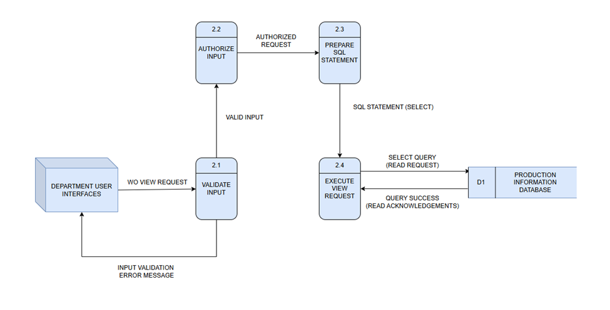

Process 2 Data Dictionary
Label: | VALIDATE INPUT
Entry Type: | Process
Description: | Validate Work Order(WO) view requests received from the DEPARTMENT USER INTERFACES.
Process #: | 2.1
Process Description: | Input Data Flows:  1) WO View Request  Output Data Flows:  1) Valid Input  2) Input Validation Error Message  RECEIVE the WO View Request from the DEPARTMENT USER INTERFACES.  VALIDATE that the request includes all required parameters (e.g., work order ID, date range).  SEND VALID INPUT to AUTHORIZE INPUT(2.2).  SEND Input Validation Error Message to DEPARTMENT USER INTERFACES if validation fails.
Notes: | Ensures that only properly formatted and complete view requests are sent for authorization and database querying.

Label: | AUTHORIZE INPUT
Entry Type: | Process
Description: | Check user permissions and determine if the requested view action is allowed for the Department user.
Process #: | 2.2
Process Description: | Input Data Flows:  1) Valid Input  Output Data Flows:  1) Authorized Request  RECEIVE Valid Input from VALIDATE INPUT (2.1).  VERIFY user’s authorization for viewing the requested production data.  SEND Authorized Request to PREPARE SQL STATEMENT (2.3).
Notes: | Authorization ensures that only users with view privileges can access production information records.

Label: | PREPARE SQL STATEMENT
Entry Type: | Process
Description: | Generate the SQL SELECT statement to retrieve data from the PRODCUTION INFROMATION DATABASE based on the authorized input.
Process #: | 2.3
Process Description: | Input Data Flows:  1) Authorized Request  Output Data Flows:  1) SQL Statement (SELECT)  RECEIVE Authorized Request from AUTHORIZED INPUT (2.2).  CONSTRUCT a SQL SELECT statement matching the specified filters or criteria.  SEND SQL Statement (SELECT) to EXECUTE VIEW REQUEST(2.4).
Notes: | Ensures SQL syntax and query parameters are correctly formed to retrieve accurate and relevant data.

Label: | EXECUTE VIEW REQUEST
Entry Type: | Process
Description: | Run SQL SELECT statements on the PRODUCTION INFORMATION DATABASE and return results to the user interface.
Process #: | 2.4
Process Description: | Input Data Flows:  1) SQL Statement (SELECT)  Output Data Flows:  1) Query Success (Read Acknowledgements)  RECEIVE SQL Statement (SELECT) from PREPARE SQL STATEMENT (2.3).  EXECUTE the SQL query on the PRODUCTION INFORMATION DATABASE (D1).  RECEIVE Query Success (Read Acknowledgements) from PRODUCTION INFORMATION DATABASE(D1).  RETURN Query Success results to DEPARTMENT USER INTERFACES.
Notes: | Executes read-only queries to fetch and display production information data to authorized department users.

Label: | PRODUCTION INFORMATION DATABASE (D1)
Entry Type: | Data Store
Description: | Central repository containing production information records, including work order details accessible by authorized users.
Process #: | D1
Process Description: | Input Data Flows:  1) Select Query (Read Request)  Output Data Flows:  1) Query Success (Read Acknowledgements)  RECEIVE Select Query (Read Request) from EXECUTE VIEW REQUEST (2.4).  SEND Query Success (Read Acknowledgements) with retrieved data back to EXECUTE VIEW REQUEST (2.4).
Notes: | Stores all production-related data accessible through authorized view requests from departmental interfaces.

Process 3 Data Flow Diagram
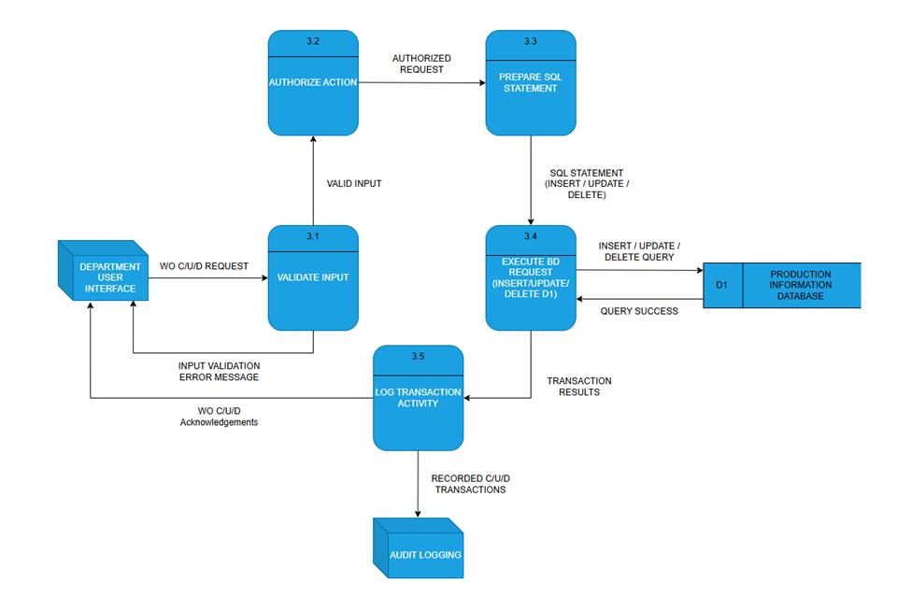

Process 3 Data Dictionary
Label: | VALIDATE INPUT
Entry Type: | Process
Description: | Validate Create/Update/Delete (C/U/D) requests received from the DEPARTMENT USER INTERFACE.
Process #: | 3.1
Process Description: | Input Data Flows:  1) WO C/U/D Request  Output Data Flows:  1) Valid Input  2) Input Validation Error Message  RECEIVE WO C/U/D Request from the DEPARTMENT USER INTERFACE.  VALIDATE request fields to ensure all required data and formats meet validation rules.  SEND Valid Input to AUTHORIZE ACTION (3.2).  SEND Input Validation Error Message to DEPARTMENT USER INTERFACE if validation fails.
Notes: | Input validation prevents incorrect or incomplete data from being authorized or executed in the system.

Label: | AUTHORIZE ACTION
Entry Type: | Process
Description: | Check user permissions and determine if the requested C/U/D action is allowed.
Process #: | 3.2
Process Description: | Input Data Flows:  1) Valid Input  Output Data Flows:  1) Authorized Request  RECEIVE Valid Input from VALIDATE INPUT (3.1).  VERIFY that the user has appropriate authorization for the requested transaction type.  SEND Authorized Request to PREPARE SQL STAEMENT(3.3).
Notes: | Authorization ensures that only users with the proper role privileges can perform modifications to production information data.

Label: | PREPARE SQL STATEMENT
Entry Type: | Process
Description: | Construct the SQL command for insert, update, or delete operations based on authorized input.
Process #: | 3.3
Process Description: | Input Data Flows:  1) Authorized Request  Output Data Flows:  1) SQL Statement (Insert/Update/Delete)  RECEIVE Authorized Request from AUTHORIZE ACTION(3.2).  GENERATE an SQL statement formatted for the specific database operation (INSERT, UPDATE, or DELETE).  SEND SQL Statement to EXECUTE DB REQUEST(3.4).
Notes: | SQL statement generation ensures that all database transactions follow the defined schema and syntax.

Label: | EXECUTE DB REQUEST (Insert/Update/Delete D1)
Entry Type: | Process
Description: | Execute prepared SQL statements on the Production Information Database and return results.
Process #: | 3.4
Process Description: | Input Data Flows:  1) SQL Statement (Insert/Update/Delete)  Output Data Flows:  1) Transaction Results  2) Query Success  RECEIVE SQL Statement from PREPARE SQL STATEMENT (3.3).  EXECUTE the SQL command on PRODUCTION INFORMATION DATABEASE (D1).  RECEIVE Query Success confirmation from PRODUCTION INFORMATION DATABEASE (D1).  SEND Transaction Results to LOG TRANSACTION ACTIVITY (3.5).
Notes: | Execution ensures persistent changes to the Production Information Database, reflecting accurate and current data.

Label: | LOG TRANSACTION ACTIVITY
Entry Type: | Process
Description: | Record all CRUD transactions for auditing and send acknowledgements back to the user interface.
Process #: | 3.5
Process Description: | Input Data Flows:  1) Transaction Results  Output Data Flows:  1) Recorded C/U/D Transactions  2) WO C/U/D Acknowledgements  RECEIVE Transaction Results from EXECUTE DB REQUEST(3.4).  LOG the transaction details (user, action type, timestamp, result).  SEND Recorded C/U/D Transactions to AUDIT LOGGING.  SEND WO C/U/D Acknowledgements to DEPARTMENT USER INTERFACE.
Notes: | Logging ensures accountability and traceability for all database operations performed by users.

Label: | PRODUCTION INFORMATION DATABASE (D1)
Entry Type: | Data Store
Description: | Centralized repository storing all production-related records, including work orders and department activity data.
Process #: | D1
Process Description: | Input Data Flows:  1) Insert/Update/Delete Query  Output Data Flows:  1) Query Success  RECEIVE Insert/Update/Delete Query from EXECUTE DB REQUEST(3.4).  SEND Query Success back to EXECUTE DB REQUEST (3.4) after execution.
Notes: | The database maintains integrity and supports CRUD operations for all production data used by department interfaces.

Conclusion
The Data Flow Diagrams form a critical component of the system’s design documentation by clearly illustrating how each process within the Production Information System receives, handles, and outputs data. These diagrams validate that the system adheres to required validation measures and role-based permissions while maintaining accurate interactions with the central database. By capturing both the broad, system-wide workflow and the detailed subprocess logic, the DFDs confirm that the system’s architecture is capable of supporting the operational needs of all four departments and ensuring accuracy in work-order tracking. They also serve as a long-term guide for developers and administrators by providing a visual representation of the system’s behavior that can be used for troubleshooting, optimization, and future enhancements. Ultimately, the DFDs ensure that the system’s logic remains transparent, consistent, and aligned with stakeholder expectations throughout its lifecycle.

Entity Relationship Diagram (ERD)

Introduction
The Entity Relationship Diagram establishes the structural blueprint of the database that enables the Production Information System to store, relate, and retrieve production-related information with accuracy and consistency. This section documents each entity, such as customers, operators, jobs, users, roles, audit logs, and part history. The ERD also defines the attributes and relationships necessary to support work-order tracking and controlled access across departments. By outlining primary and foreign keys, uniqueness constraints, and referential integrity rules, the ERD ensures that data remains structured, reliable, and interconnected in a way that reflects actual business operations. The ERD provides a clear and comprehensive foundation for database implementation, backend logic, user-interface design, and long-term system maintenance.

Entity Relationship Diagram

Field Mappings
Source: CUSTOMERS Table | Target: CUSTOMERS Table
CUSTOMER_ID (Integer) | CUSTOMER_ID (Integer)
CUSTOMER_NAME (Varchar 48) | CUSTOMER_NAME (Varchar 48)

Source: OPERATORS Table | Target: OPERATORS Table
OPERATOR_ID (Integer) | OPERATOR_ID (Integer)
JOB_ID (Integer) | JOB_ID (Integer)
USER_ID (Integer) | USER_ID (Integer)
ROLE_ID (Integer) | ROLE_ID (Integer)
OPERATOR_NAME (Varchar 48) | OPERATOR_NAME (Varchar 48)

Source: JOBS Table | Target: JOBS Table
JOB_ID (Integer) | JOB_ID (Integer)
JOB_DESC (Text) | JOB_DESC (Text)

Source: PART_HISTORY Table | Target: PART_HISTORY Table
PART_HISTORY_ID (Integer) | PART_HISTORY_ID (Integer)
CUSTOMER_ID (Integer) | CUSTOMER_ID (Integer)
OPERATOR_ID (Integer) | OPERATOR_ID (Integer)
PART_NUMBER (Varchar 128) | PART_NUMBER (Varchar 128)
DATE_DUE (Date) | DATE_DUE (Date)
PURCHASE_ORDER_NUMBER (Varchar 128) | PURCHASE_ORDER_NUMBER (Varchar 128)
QTY (Integer) | QTY (Integer)
OPERATIONS (Text) | OPERATIONS (Text)
DATE_RECEIVED (Date) | DATE_RECEIVED (Date)
TO_DELETE (Boolean) | TO_DELETE (Boolean)

Source: ROLES Table | Target: ROLES Table
ROLE_ID (Integer) | ROLE_ID (Integer)
ROLE_NAME (Varchar 48) | ROLE_NAME (Varchar 48)

Source: USER_ROLES Table | Target: USER_ROLES Table
USER_ID (Integer) (U) | USER_ID (Integer) (U)
ROLE_ID (Integer) (U) | ROLE_ID (Integer) (U)

Source: USERS Table | Target: USERS Table
USER_ID (Integer) | USER_ID (Integer)
USER_NAME (Varchar 48) (U) | USER_NAME (Varchar 48) (U)
PASSWORD_HASH (Text) | PASSWORD_HASH (Text)
CREATED_AT (Timestamp) | CREATED_AT (Timestamp)
IS_ACTIVE (Boolean) | IS_ACTIVE (Boolean)

Source: AUDIT_LOG Table | Target: AUDIT_LOG Table
AUDIT_LOG_ID (Integer) | AUDIT_LOG_ID (Integer)
USER_ID (Integer) | USER_ID (Integer)
ENTITY (Varchar 48) | ENTITY (Varchar 48)
ACTION (Varchar 48) | ACTION (Varchar 48)
OCCURRED_AT (Timestamp) | OCCURRED_AT (Timestamp)

Conclusion
Together, the ERD and field mappings establish a reliable and scalable database foundation that supports every functional requirement of the Production Information System. By detailing the structure of each entity and enforcing the relationships that connect users, operators, roles, and production history, the data model ensures consistency throughout all CRUD operations and reporting functions. This properly defined schema not only allows for accurate data retrieval and validation but also positions the system for future enhancements without compromising stability or integrity. The ERD serves as a critical reference point throughout development, deployment, and ongoing maintenance.

Screen Sequence with Dialog

Introduction
Screen sequences and dialog boxes demonstrate the importance of planning the logical flow of events that will take place during user interaction with an application. They serve as a foundation for the development and implementation of an application, ensuring that user needs and functional requirements are met. The screen sequences themselves provide a road map for developers to reference during the development stage of an application project, and users can utilize them as a visual tool to walk them through the sequencing of events during their interaction with the application.

Each screen sequence provides a visualization of user interaction when utilizing the application to perform query functions on data stored within the connected database. The events that occur during application use are shown to display to the user the various states that can occur during their time spent interacting with the application. The dialog box provided with each illustration provides a detailed explanation of what is occurring in each screen sequence, defining what is occurring, and the events that led to the captured event.

By combining the illustrated screen sequences with their corresponding dialog boxes, a reference tool is provided for both end users and developers for both the development and deployment phases. End users will have an expectation of what the final delivered application will include, and have familiarity with the application prior to installation, and developers will have a critical point of reference during the development stage, ultimately ensuring the satisfaction of the end user, a cohesive and structured development stage, and overall project success upon delivery to the stakeholders at Kiczan Manufacturing.

Screen Sequence Menu Hierarchy

Main User Interface Wireframe – Initial Empty State at Application Start
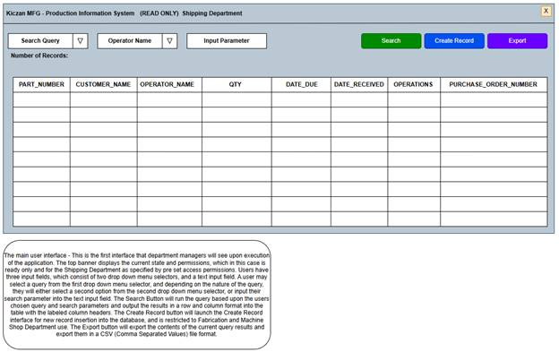
User Story | ERD
1, 2, 3, 4, 5 | PART_HISTORY:  PART_NUMBER,CUSTOMER_NAME  OPERATOR_NAME, QTY, DATE_DUE  DATE_RECEIVED, OPERATIONS  PURCHASE_ORDER_NUMBER

Main User Interface Wireframe – Search by Part Number – Query Success but No Records Found State
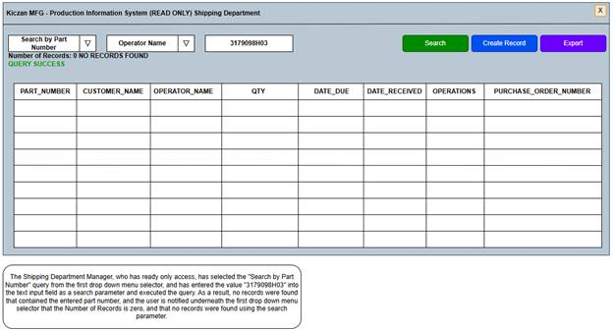
User Story | ERD
1 | CUSTOMERS:  CUSTOMER_ID, CUSTOMER_NAME  OPERATORS:  OPERATOR_ID, OPERATOR_NAME  JOBS:  JOB_ID  PART_HISTORY:  PART_NUMBER,CUSTOMER_NAME  OPERATOR_NAME, QTY, DATE_DUE  DATE_RECEIVED, OPERATIONS  PURCHASE_ORDER_NUMBER

Main User Interface Wireframe – Search by Part Number – Query Failure with Validation Error State
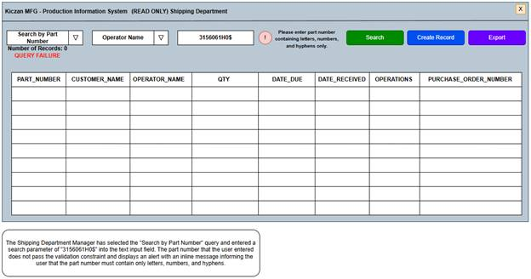
User Story | ERD
1, 6 | CUSTOMERS:  CUSTOMER_ID, CUSTOMER_NAME  OPERATORS:  OPERATOR_ID, OPERATOR_NAME  JOBS:  JOB_ID  PART_HISTORY:  PART_NUMBER,CUSTOMER_NAME  OPERATOR_NAME, QTY, DATE_DUE  DATE_RECEIVED, OPERATIONS  PURCHASE_ORDER_NUMBER

Main User Interface Wireframe – Search by Part Number – Query Success State
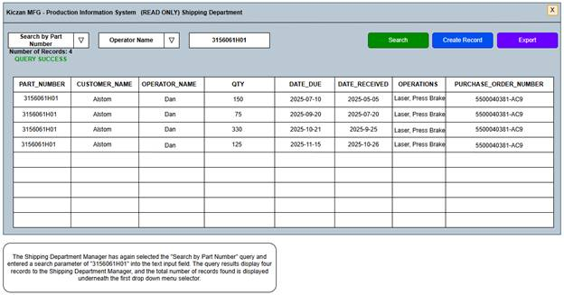
User Story | ERD
1 | CUSTOMERS:  CUSTOMER_ID, CUSTOMER_NAME  OPERATORS:  OPERATOR_ID, OPERATOR_NAME  JOBS:  JOB_ID  PART_HISTORY:  PART_NUMBER,CUSTOMER_NAME  OPERATOR_NAME, QTY, DATE_DUE  DATE_RECEIVED, OPERATIONS  PURCHASE_ORDER_NUMBER

Main User Interface Wireframe – Search by Due Date Range – Query Failure with Validation Error State
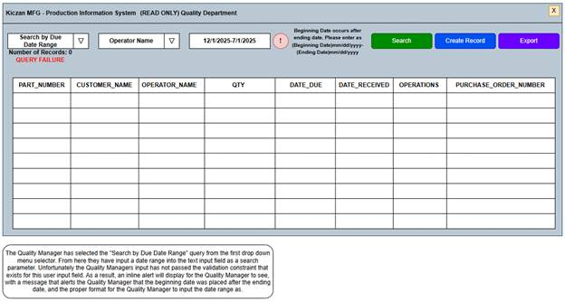
User Story | ERD
2, 6 | CUSTOMERS:  CUSTOMER_ID, CUSTOMER_NAME  OPERATORS:  OPERATOR_ID, OPERATOR_NAME  JOBS:  JOB_ID  PART_HISTORY:  PART_NUMBER,CUSTOMER_NAME  OPERATOR_NAME, QTY, DATE_DUE  DATE_RECEIVED, OPERATIONS  PURCHASE_ORDER_NUMBER

Main User Interface Wireframe – Search by Due Date Range – Query Failure with Validation Error State
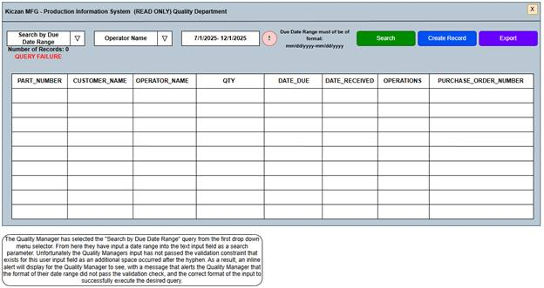
User Story | ERD
2, 6 | CUSTOMERS:  CUSTOMER_ID, CUSTOMER_NAME  OPERATORS:  OPERATOR_ID, OPERATOR_NAME  JOBS:  JOB_ID  PART_HISTORY:  PART_NUMBER,CUSTOMER_NAME  OPERATOR_NAME, QTY, DATE_DUE  DATE_RECEIVED, OPERATIONS  PURCHASE_ORDER_NUMBER

Main User Interface Wireframe – Search by Due Date Range – Query Success State
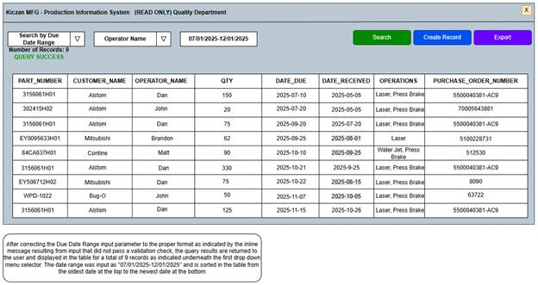
User Story | ERD
2 | CUSTOMERS:  CUSTOMER_ID, CUSTOMER_NAME  OPERATORS:  OPERATOR_ID, OPERATOR_NAME  JOBS:  JOB_ID  PART_HISTORY:  PART_NUMBER,CUSTOMER_NAME  OPERATOR_NAME, QTY, DATE_DUE  DATE_RECEIVED, OPERATIONS  PURCHASE_ORDER_NUMBER

Main User Interface Wireframe – Search by Fabrication Department – Query Success State
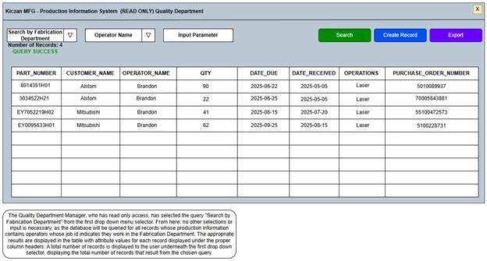
User Story | ERD
4 | CUSTOMERS:  CUSTOMER_ID, CUSTOMER_NAME  OPERATORS:  OPERATOR_ID, OPERATOR_NAME  JOBS:  JOB_ID  PART_HISTORY:  PART_NUMBER,CUSTOMER_NAME  OPERATOR_NAME, QTY, DATE_DUE  DATE_RECEIVED, OPERATIONS  PURCHASE_ORDER_NUMBER

Main User Interface Wireframe – Search by Fabrication Department – Query Success with Paged Results State
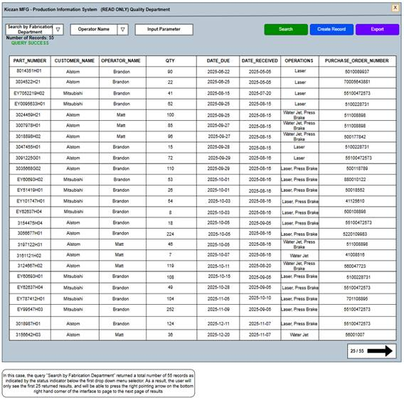
User Story | ERD
4, 7 | CUSTOMERS:  CUSTOMER_ID, CUSTOMER_NAME  OPERATORS:  OPERATOR_ID, OPERATOR_NAME  JOBS:  JOB_ID  PART_HISTORY:  PART_NUMBER,CUSTOMER_NAME  OPERATOR_NAME, QTY, DATE_DUE  DATE_RECEIVED, OPERATIONS  PURCHASE_ORDER_NUMBER

Main User Interface Wireframe – Search by Operator Name – Query Success State
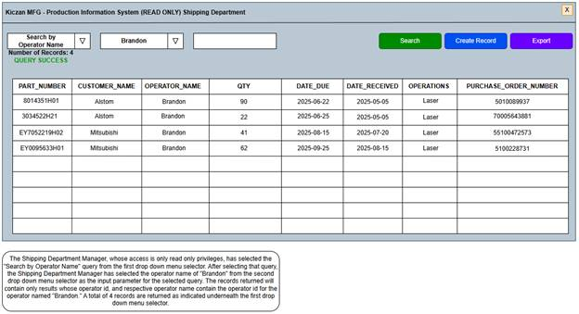
User Story | ERD
3 | CUSTOMERS:  CUSTOMER_ID, CUSTOMER_NAME  OPERATORS:  OPERATOR_ID, OPERATOR_NAME  JOBS:  JOB_ID  PART_HISTORY:  PART_NUMBER,CUSTOMER_NAME  OPERATOR_NAME, QTY, DATE_DUE  DATE_RECEIVED, OPERATIONS  PURCHASE_ORDER_NUMBER

Main User Interface Wireframe – Search by Part Number – Query Success with Delete Record Selection State
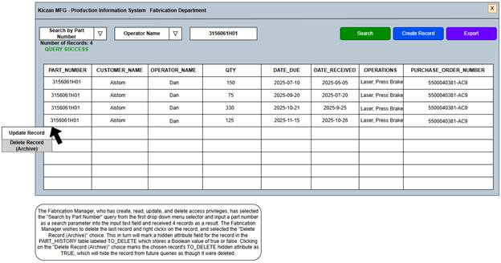
User Story | ERD
5 | PART_HISTORY:  PART_NUMBER  CUSTOMER_NAME  OPERATOR_NAME  QTY  DATE_DUE  DATE_RECEIVED  OPERATIONS  PURCHASE_ORDER_NUMBER  TO_DELETE

Main User Interface Wireframe – Search by Part Number – Query Success with Update Record Selection State
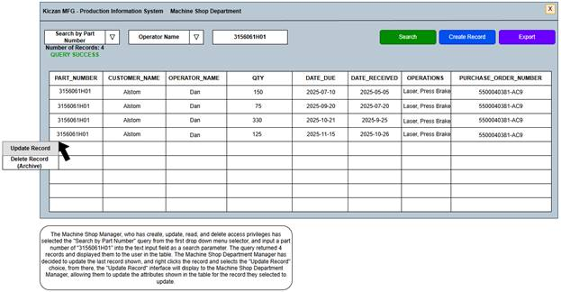
User Story | ERD
5 | PART_HISTORY:  PART_NUMBER  CUSTOMER_NAME  OPERATOR_NAME  QTY  DATE_DUE  DATE_RECEIVED  OPERATIONS  PURCHASE_ORDER_NUMBER

Main User Interface Wireframe – Search by Part Number in Archive – Query Success with Restore Record Selection State
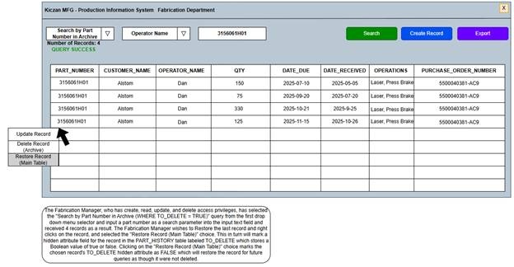
User Story | ERD
5 | PART_HISTORY:  PART_NUMBER  CUSTOMER_NAME  OPERATOR_NAME  QTY  DATE_DUE  DATE_RECEIVED  OPERATIONS  PURCHASE_ORDER_NUMBER  TO_DELETE

Create Record Interface Wireframe – Initial Empty State
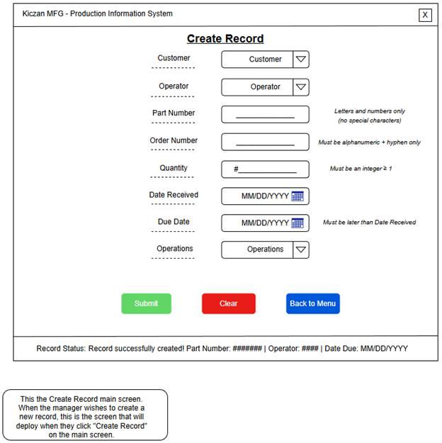
User Story | ERD
5, 6 | PART_HISTORY:  CUSTOMER_ID  OPERATOR_ID  PART_NUMBER  PURCHASE_ORDER_NUMBER  QTY  DATE_RECEIVED  DATE_DUE  OPERATIONS

Create Record Interface Wireframe – Part Number Error Validation State
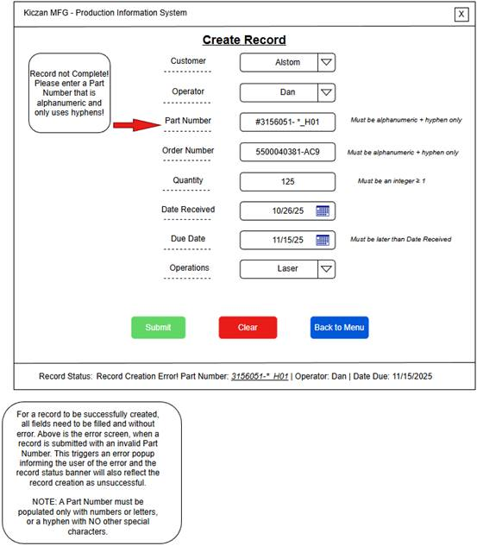
User Story | ERD
5, 6 | PART_HISTORY:  CUSTOMER_ID  OPERATOR_ID  PART_NUMBER  PURCHASE_ORDER_NUMBER  QTY  DATE_RECEIVED  DATE_DUE  OPERATIONS

Create Record Interface Wireframe – Quantity Error Validation State
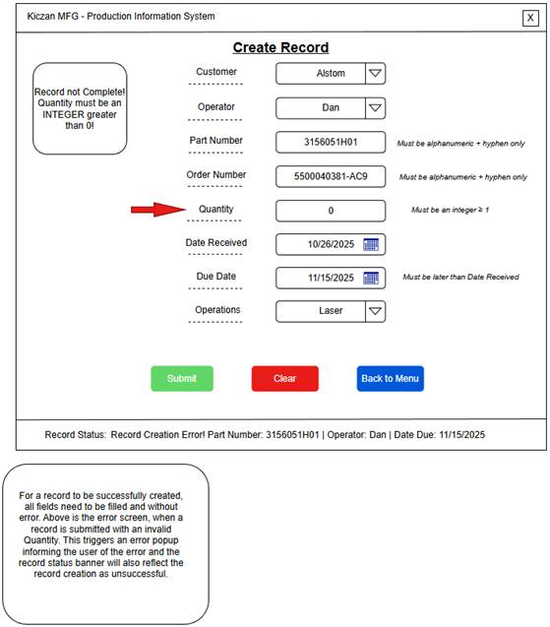
User Story | ERD
5, 6 | PART_HISTORY:  CUSTOMER_ID  OPERATOR_ID  PART_NUMBER  PURCHASE_ORDER_NUMBER  QTY  DATE_RECEIVED  DATE_DUE  OPERATIONS

Create Record Interface Wireframe – Purchase Order Number Error Validation State
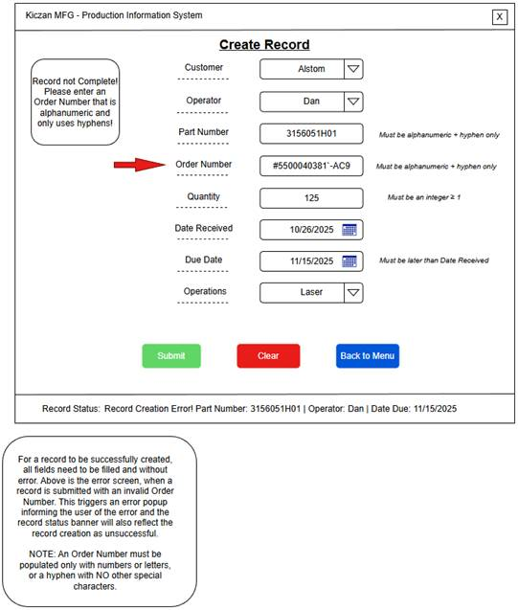
User Story | ERD
5, 6 | PART_HISTORY:  CUSTOMER_ID  OPERATOR_ID  PART_NUMBER  PURCHASE_ORDER_NUMBER  QTY  DATE_RECEIVED  DATE_DUE  OPERATIONS

Create Record Interface Wireframe – Operations Error Validation State
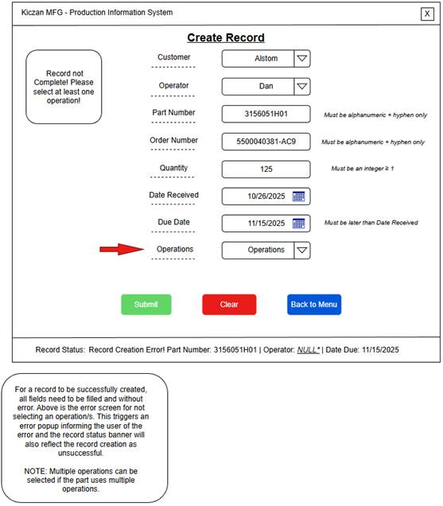
User Story | ERD
5, 6 | PART_HISTORY:  CUSTOMER_ID  OPERATOR_ID  PART_NUMBER  PURCHASE_ORDER_NUMBER  QTY  DATE_RECEIVED  DATE_DUE  OPERATIONS

Create Record Interface Wireframe – Date Format Error Validation State
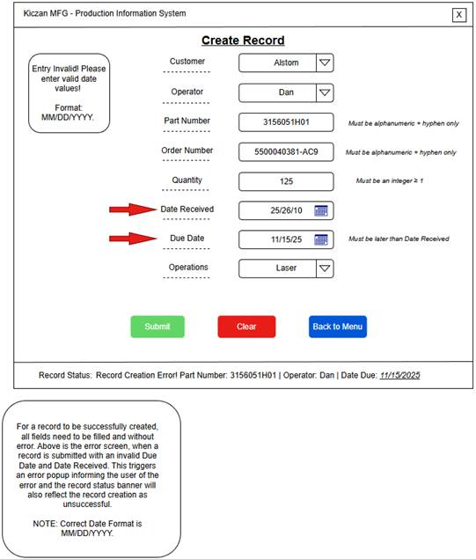
User Story | ERD
5, 6 | PART_HISTORY:  CUSTOMER_ID  OPERATOR_ID  PART_NUMBER  PURCHASE_ORDER_NUMBER  QTY  DATE_RECEIVED  DATE_DUE  OPERATIONS

Create Record Interface Wireframe – Date Due Error Validation State
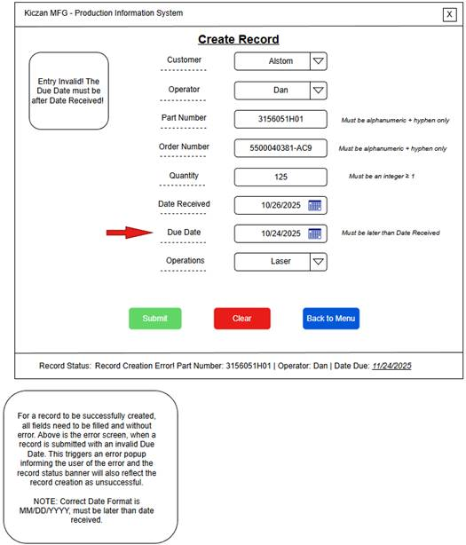
User Story | ERD
5, 6 | PART_HISTORY:  CUSTOMER_ID  OPERATOR_ID  PART_NUMBER  PURCHASE_ORDER_NUMBER  QTY  DATE_RECEIVED  DATE_DUE  OPERATIONS

Create Record Interface Wireframe – Customer Error Validation State
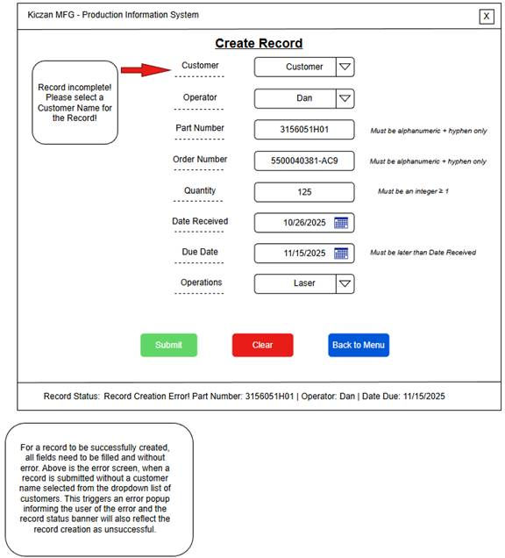
User Story | ERD
5, 6 | PART_HISTORY:  CUSTOMER_ID  OPERATOR_ID  PART_NUMBER  PURCHASE_ORDER_NUMBER  QTY  DATE_RECEIVED  DATE_DUE  OPERATIONS

Create Record Interface Wireframe – Record Insertion Success State
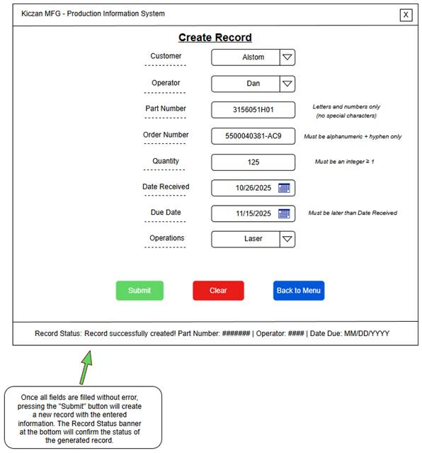
User Story | ERD
5, 6 | PART_HISTORY:  CUSTOMER_ID  OPERATOR_ID  PART_NUMBER  PURCHASE_ORDER_NUMBER  QTY  DATE_RECEIVED  DATE_DUE  OPERATIONS

Create Record Interface Wireframe – Clear and Menu Button State
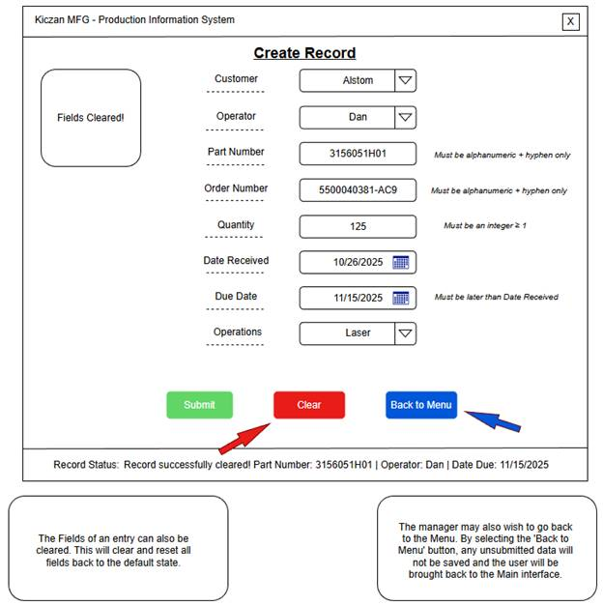
User Story | ERD
5, 6 | PART_HISTORY:  CUSTOMER_ID  OPERATOR_ID  PART_NUMBER  PURCHASE_ORDER_NUMBER  QTY  DATE_RECEIVED  DATE_DUE  OPERATIONS

Update Record Wireframe – Initial Empty State
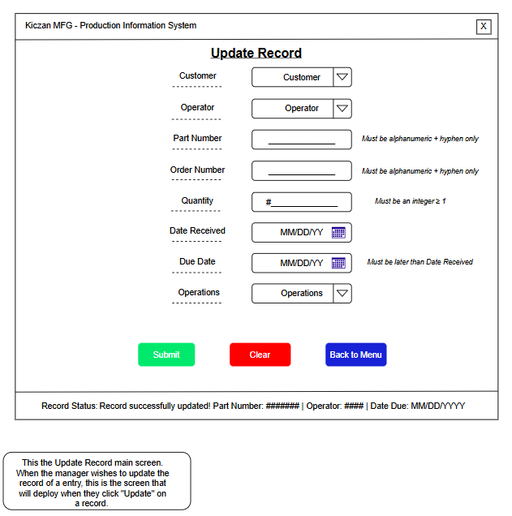
User Story | ERD
5, 6 | PART_HISTORY:  CUSTOMER_ID  OPERATOR_ID  PART_NUMBER  PURCHASE_ORDER_NUMBER  QTY  DATE_RECEIVED  DATE_DUE  OPERATIONS

Update Record Wireframe – Example Record, with Record Selected
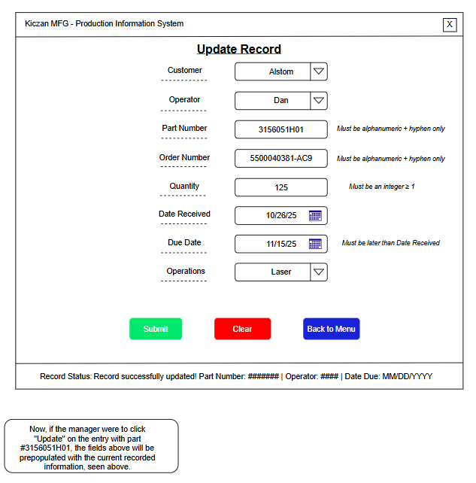
User Story | ERD
5, 6 | PART_HISTORY:  CUSTOMER_ID  OPERATOR_ID  PART_NUMBER  PURCHASE_ORDER_NUMBER  QTY  DATE_RECEIVED  DATE_DUE  OPERATIONS

Update Record Wireframe – Missing Customer Entry Error
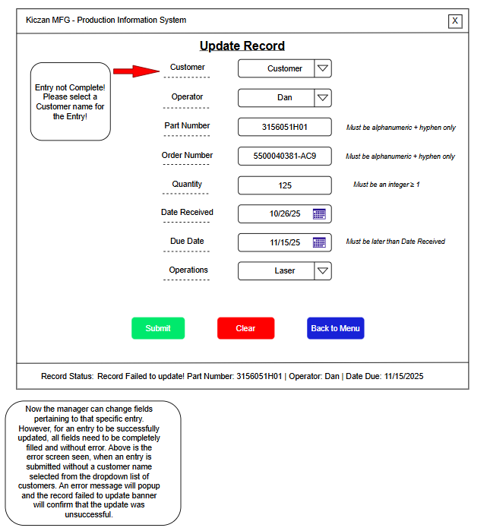
User Story | ERD
5,6 | PART_HISTORY:  CUSTOMER_ID, OPERATOR_ID  PART_NUMBER, PURCHASE_ORDER_NUMBER  QTY, DATE_RECEIVED, DATE_DUE  OPERATIONS

Update Record Wireframe – Missing Operator Entry Error
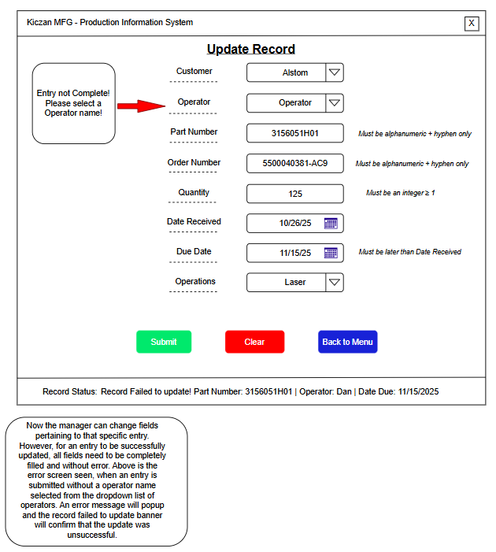
User Story | ERD
5,6 | PART_HISTORY:  CUSTOMER_ID, OPERATOR_ID  PART_NUMBER, PURCHASE_ORDER_NUMBER  QTY, DATE_RECEIVED, DATE_DUE  OPERATIONS

Update Record Wireframe – Missing Operations Entry Error
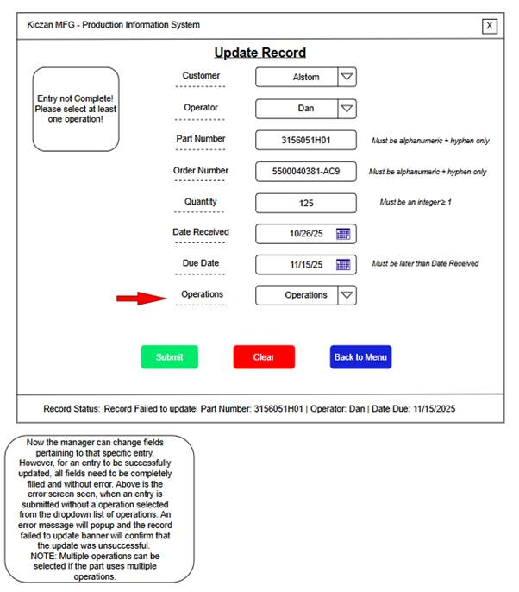
User Story | ERD
5,6 | PART_HISTORY:  CUSTOMER_ID, OPERATOR_ID  PART_NUMBER, PURCHASE_ORDER_NUMBER  QTY, DATE_RECEIVED, DATE_DUE  OPERATIONS

Update Record Wireframe – Quantity Entry Error
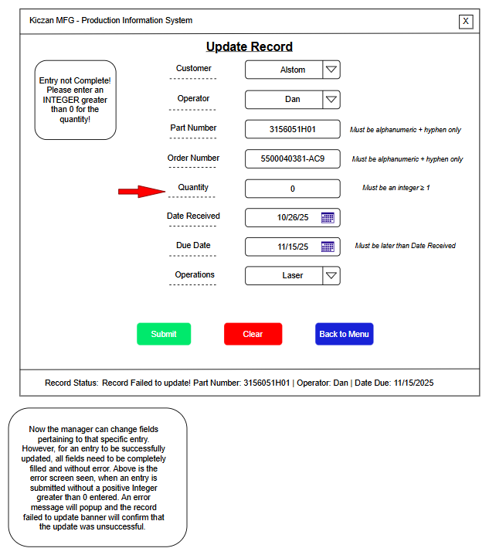
User Story | ERD
5,6 | PART_HISTORY:  CUSTOMER_ID, OPERATOR_ID  PART_NUMBER, PURCHASE_ORDER_NUMBER  QTY, DATE_RECEIVED, DATE_DUE  OPERATIONS

Update Record Wireframe – Part Number Entry Error
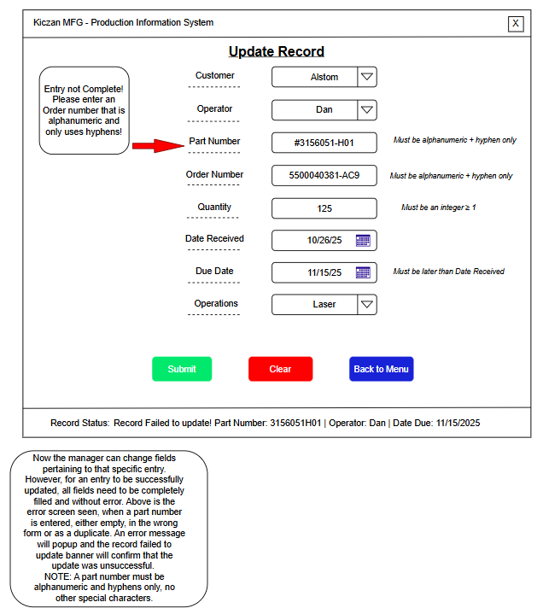
User Story | ERD
5,6 | PART_HISTORY:  CUSTOMER_ID, OPERATOR_ID  PART_NUMBER, PURCHASE_ORDER_NUMBER  QTY, DATE_RECEIVED, DATE_DUE  OPERATIONS

Update Record Wireframe – Order Number Entry Error
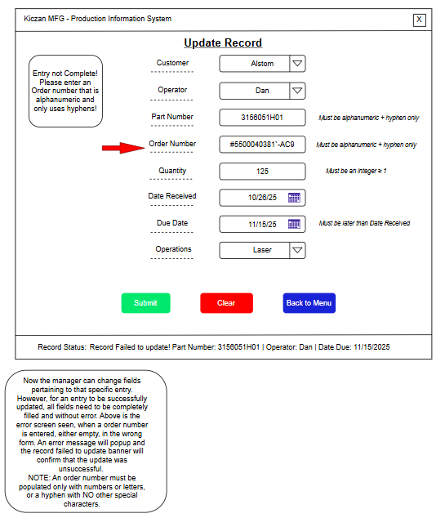
User Story | ERD
5,6 | PART_HISTORY:  CUSTOMER_ID, OPERATOR_ID  PART_NUMBER, PURCHASE_ORDER_NUMBER  QTY, DATE_RECEIVED, DATE_DUE  OPERATIONS

Update Record Wireframe – Received and Due Date Entry Error
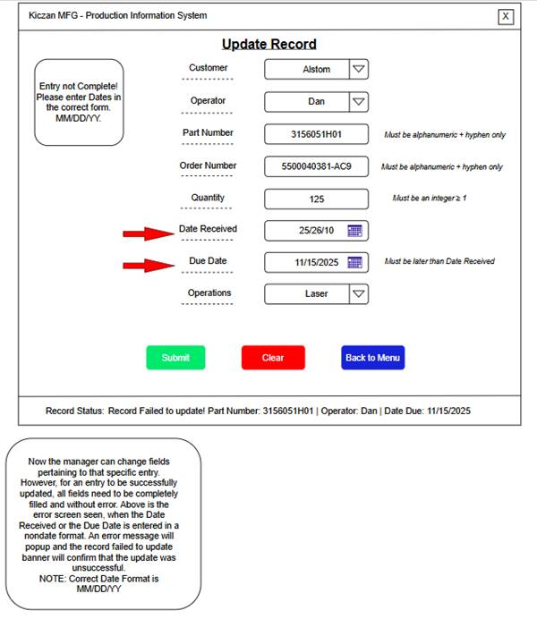
User Story | ERD
5,6 | PART_HISTORY:  CUSTOMER_ID, OPERATOR_ID  PART_NUMBER, PURCHASE_ORDER_NUMBER  QTY, DATE_RECEIVED, DATE_DUE  OPERATIONS

Update Record Wireframe – Due Date Entry (Earlier than Received) Error
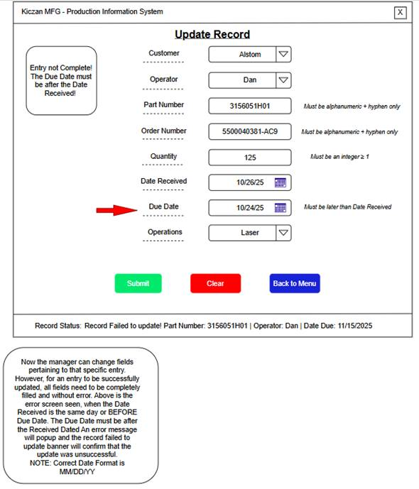
User Story | ERD
5,6 | PART_HISTORY:  CUSTOMER_ID, OPERATOR_ID  PART_NUMBER, PURCHASE_ORDER_NUMBER  QTY, DATE_RECEIVED, DATE_DUE  OPERATIONS

Update Record Wireframe – Successful Entry State
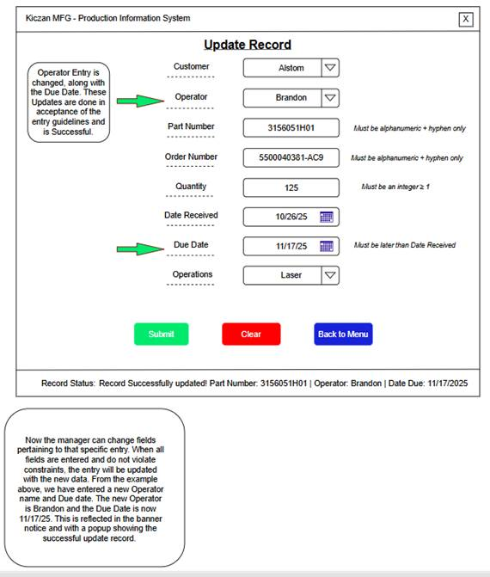

User Story | ERD
5,6 | PART_HISTORY:  CUSTOMER_ID, OPERATOR_ID  PART_NUMBER, PURCHASE_ORDER_NUMBER  QTY, DATE_RECEIVED, DATE_DUE  OPERATIONS

Update Record Wireframe – Using the “Clear” and “Back to Menu” Buttons
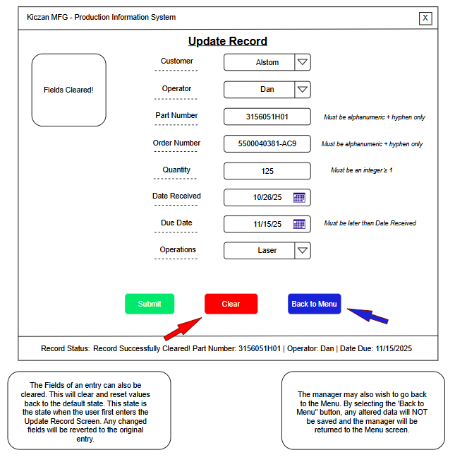
User Story | ERD
5,6 | PART_HISTORY:  CUSTOMER_ID, OPERATOR_ID  PART_NUMBER, PURCHASE_ORDER_NUMBER  QTY, DATE_RECEIVED, DATE_DUE  OPERATIONS

Conclusion
To summarize, the importance of screen sequences and dialogue boxes cannot be stressed enough, as they are a critical tool that is necessary to ensure a cohesive application development process, and ensure user satisfaction and achieve expectations. They are fundamentally necessary to guide end users through the navigation and use of the application, and to help map the necessary tasks that will be performed during the project’s development from one project sprint to another, all the way to the delivery of a fully functional application. The screen sequences and their respective dialog boxes carefully illustrate the sequence of events that occur during all user interactions with the application, from initial execution, to actively querying, creating, and updating. These captured events play a role of utmost importance that will guarantee the successful development and launch of the Production Information System, contributing to the achievement of business goals and the vision of Kiczan Manufacturing.

User Stories

Introduction
User stories capture the very essence of the functional requirements and needs of the end user to ensure the successful development of the application. These narrative descriptions of how the user wants to interact with the application, and the results of a successful interaction define the expectations the end user has for the finalized application. By utilizing user stories during the design of the application and fully incorporating them into the development of the project, the needs and requirements of the end user are directly translated into itemized deliverables that can be developed as stand-alone tasks, further providing organization to the development phase of the project. Through the utilization of user stories, developers can gain further insight into the needs of the user as it relates to the scope of the project, simplifying the development process and translating user stories into project deliverables, which in turn elicit feedback from the end user to the project developers as defined by the agile development methodology. By integrating user stories into sprint deliverables, an incremental process of delivery is achieved where end users can interact with the results of each sprints deliverable, ensuring that each subsequent sprint is building upon the previous, incorporating the requirements and needs from the end user’s perspective, and ensuring that a finalized product application is delivered that achieves stakeholder satisfaction.

User Story 1
- As a manager, I want to search by part number so that I can view the customer name, operator name, part number, quantity, date received, date due, operations, and purchase order number for the part number entered in the search box, along with a count of how many records are returned by the search.

Acceptance Criteria:
Given the search interface, when a manager selects “Search by Part Number” from the drop-down menu listing search types, and enters a part number of “3156018H03” into the search text box, then the results include rows whose PART_NUMBER = 3156018H03, showing CUSTOMER_NAME, OPERATOR_NAME, PART_NUMBER, QTY, DATE_RECEIVED, DATE_DUE, OPERATIONS, and PURCHASE_ORDER_NUMBER, with an accompanying “Number of Records: #” next to the search button.

Given no matches, when the manager filters by PART_NUMBER = BADNUM111, then the manager will see 0 results and a “Number of Records: 0” notice in the user interface.

Given an invalid input, when the manager filters by PART_NUMBER = 315%515, then they will see a validation error message, informing the manager that part numbers must only contain letters, numbers, and hyphens.

User Story 2
- As a manager, I want to search by a range of due dates so that I can view customer name, operator name, part number, quantity, date received, date due, operations, and purchase order number for records whose due date range falls within the range entered in the search box, along with a count of how many records are returned by the search.

Acceptance Criteria:
Given the search interface, when a manager selects “Search by Due Date Range” from the drop-down menu listing search types, and enters a due date range of “3/1/2024-5/1/2024” into the search text box, then the results include rows whose DATE_DUE falls within the range of “3/1/2024-5/1/2024” showing CUSTOMER_NAME, OPERATOR_NAME, PART_NUMBER, QTY, DATE_RECEIVED, DATE_DUE, OPERATIONS, and PURCHASE_ORDER_NUMBER, with an accompanying “Number of Records: #” next to the search button.

Given an invalid date range (beg > end), when the manager runs the search, then they see a validation error message, informing the manager that the input is in the incorrect format, what the correct format is, and no query executes.

Given an invalid date range (3/1/2024-5/1/202) or empty date range, when the manager runs the search, then they see a validation error message, informing the manager that the input is in the incorrect format, what the correct format is, and no query executes.

User Story 3
- As a manager, I want to search by operator name, so that I can view customer name, operator name, part number, quantity, date received, date due, operations, and purchase order number for the operator’s name, along with a count of how many records are returned by the search.

Acceptance Criteria:
Given the search interface, when a manager selects “Search by Operator Name” from the drop-down menu listing search types, and selects an operator name from a second drop down list whose values are populated from the OPERATORS table using OPERATOR_ID and OPERATOR_NAME, then the results include rows whose OPERATOR_ID from the OPERATORS table matches the foreign key OPERATOR_ID on the PART_HISTORY bridging table, showing CUSTOMER_NAME, OPERATOR_NAME, PART_NUMBER, QTY, DATE_RECEIVED, DATE_DUE, OPERATIONS, and PURCHASE_ORDER_NUMBER, with an accompanying “Number of Records: #” next to the search button.

User Story 4
- As a manager, I want to search by department, so that I can view customer name, operator name, part number, quantity, date received, date due, operations, and purchase order number for a department, along with a count of how many records are returned by the search.

Acceptance Criteria:
Given the search interface, when a manager selects “Search by Fabrication” or “Search by Machine Shop” from the drop-down menu listing search types, then the results include rows whose OPERATOR_ID from the OPERATORS table matches the foreign key OPERATOR_ID on the PART_HISTORY bridging table and JOB_ID from the JOBS table matches the foreign key JOBS_ID on the OPERATORS table, where each JOB_ID assigned to each OPERATOR_ID represents the corresponding department the OPERATOR_ID is assigned to, showing CUSTOMER_NAME, OPERATOR_NAME, PART_NUMBER, QTY, DATE_RECEIVED, DATE_DUE, OPERATIONS, and PURCHASE_ORDER_NUMBER, with an accompanying “Number of Records: #” next to the search button.

User Story 5
- As a manager of the fabrication or machine shop department, I want to create, update, (soft) delete, and restore records in the PART_HISTORY table with controlled picks such as customer, operator, and operations to maintain the consistency of data in the PART_HISTORY table.

Acceptance Criteria:
Given the search interface, when a manager wants to create a new record on the PART_HISTORY table, then the manager will click a button on the search interface titled “Create New Record”, and a corresponding interface will open in a new window with a form for the manager to enter in required values for new record creation.

Given the search interface, when a manager wants to update an existing record after a search query to change values, then the manager will right click on the record and select “Update Record”, and a corresponding interface will open in a new window with a form for the manager to enter in required values for record updates.

Given the search interface, when a manager wants to delete an existing record after a search query, then the manager will right click on the record and select “Delete Record.”

- Delete will function as a soft delete, where an additional attribute titled TO_DELETE on the PART_HISTORY table with a Boolean value of TRUE will flag the record for deletion. This column will be hidden from the user, and only records with a value of FALSE will return as a search query result. By default, all newly created records will have TO_DELETE set to FALSE.

- Restore will function as an undo to the soft delete, where an additional attribute titled TO_DELETE on the PART_HISTORY table with a Boolean value of FALSE will flag the record for restoration. This column will be unhidden from the user, and only records with a value of FALSE will return as a search query result. By default, all newly created records will have TO_DELETE set to FALSE.

- Create and update require the fields of CUSTOMER_ID, PART_NUMBER, DATE_DUE, PURCHASE_ORDER_NUMBER, QTY, OPERATOR_ID, OPERATIONS, and DATE_RECEIVED.

- The values for CUSTOMER_ID, OPERATOR_ID, and OPERATIONS will be selected from a drop-down menu as controlled picks. The values for CUSTOMER_ID and OPERATOR_ID will be populated using the CUSTOMERS and OPERATORS table, the OPERATIONS value will be hardcoded.

- Uniqueness constraints on the PART_HISTORY table will be enforced using an auto incremented index value for each record on the PART_HISTORY table, ensuring record uniqueness and preventing the occurrence of duplicate records. Resequencing will not occur in the event of a record deletion or restoration.

- Hard delete privileges will be restricted to the Database Administrator access.

- Create, update, and delete queries will be captured in a transaction log, noting the user, timestamp, and changed values.

User Story 6
- As a manager of any department, I want field-level validation with clear and descriptive messages to describe how data should be entered so I don’t submit bad data into text fields.

Acceptance Criteria:
Given the search interface, when a manager uses a selected search query and inputs invalid data, then the manager will be alerted that the search parameter has violated a validation constraint and must be corrected before the query executes, examples include:

- An alert box displaying the message “Please enter Part Number containing letters, numbers, and hyphens only.”
- An alert box displaying the message “Please enter date format as mm/dd/yy-mm/dd/yy.”
- An alert box displaying the message “Beginning date occurs after ending date. Please enter as (Beginning Date)1/1/2024-(Ending Date)3/1/2024”.

Given the search interface, when a manager wants to create or update a record and inputs invalid data in required fields, then the manager will be alerted that the input field has violated a validation constraint and must be corrected before a record can be created or updated.

- The required fields for text input are PART_NUMBER, DATE_DUE, PURCHASE_ORDER_NUMBER, QTY, and DATE_RECEIVED.
- The required fields of CUSTOMER_ID, OPERATOR_ID, and OPERATIONS will be controlled picks implemented using a drop-down menu.
- An inline error message displaying the message “Quantity must be greater than 0.” QTY(INT) > 0.
- An inline error message displaying the message “Please enter Part Number containing letters, numbers, and hyphens only.”
- An inline error message displaying the message “Please enter Purchase Order Number containing letters, numbers, and hyphens only.”
- An inline error message displaying the message “Date Due must be of the format mm/dd/yyyy.”
- An inline error message displaying the message “Date Received must be of the format mm/dd/yyyy.”

Given the search interface, when a manager wants to create or update a record, only the authorized users of the Machine Shop and Fabrication departments can create, update, or delete. Quality and Shipping department managers will have read-only access.

User Story 7
- As a manager of any department, I want the results to be paged and not continuously scrolled, so that I can click on the columns and have them reorganize the page in a descending order depending on which column I click on.

Acceptance Criteria:
Given the search interface, when a manager performs a search query, and the record results are returned to the search interface, then a manager will see a search interface that shows the record results in a paged order, whose columns can be clicked to organize the records in descending or ascending order depending on which column the manager clicks.

- Given the search query results that contain a number of records greater than 50, when a manager views the returned records, then the results will be organized in pages, where each page stores up to 50 results, and a manager can click on each attribute column of the results page to sort by the selected column in a descending or ascending order.
- Given the search query results that contain a number of records greater than or equal to 1,000, when a manager views the returned records, then the results of the query will be displayed to the manager in a time of less or equal to 10 seconds.
- Given the search query results that contain a number of records less than 1,000, when a manager views the returned records, then the results of the query will function with a median query time of less than 2 seconds.

Project Management Plan

Introduction
The development plan for the implementation of Kiczan’s Production Information System requires the alignment of several critically important components to be conducted successfully. Stakeholders, requirements, software resources, security and authorization, stakeholder satisfaction, collaboration, communication, and system development and deployment are all vital to the success of the project and must be organized in a manner that contributes to the delivery of a product that meets the expectations and requirements of the stakeholders. To reinforce the alignment of these aspects, a Work Breakdown Structure was developed to assist in breaking down and organizing the primary tasks and their respective subtasks, from planning, requirements analysis and design, to development of both the front and back ends of the application during each scheduled sprint, and the deployment of the system to its respective environments, all the way to the finalized product hand off to stakeholders.

By taking a systematic sequenced approach for the project, project developers will be assigned tasks to complete from one bi-weekly sprint to the next, and task tracking will provide status updates for other project team members to be aware of the overall progress of the project. Attached as part of the appendix to this document is the Gantt chart that will be utilized by project team members and stakeholders. The data stored there will provide start and end dates for both primary tasks and their associated sub tasks. Task dependencies are also shown on the Gantt chart along with the project's critical path, current progress, and assigned resources. In addition to the Gantt Chart and Work Breakdown Structure, which were both created by utilizing Microsoft Project, GitHub Projects will be utilized to enhance and enrich the collaborative and communicative processes that will occur during project execution, especially during the development phase.

The Agile Methodology will be the guiding force behind the development of the Production Information System for Kiczan Manufacturing. An incremental development process will be facilitated with bi-weekly sprints, where fully tested, functional software is delivered to the stakeholders at Kiczan Manufacturing at the end of each sprint. Feedback and suggestions from Kiczan’s stakeholders will be openly encouraged for each software deliverable and will be incorporated into subsequent sprints to fully ensure that stakeholder satisfaction is achieved. By adhering to the principles of the Agile Methodology, Team 2 will efficiently respond to stakeholder feedback and any changing requirements, whose primary focus will be on delivering to Kiczan a product that delivers on expectations, stakeholder satisfaction, and contributes to organizational success at Kiczan Manufacturing.

Work Breakdown Structure
By creating a Work Breakdown Structure to accompany Team 2’s project for Kiczan, a visualized representation of the key tasks can be observed through establishing a hierarchy for the project that shows a sequenced series of events that demonstrate the start to finish of the project and every process that takes place in between. The project’s primary tasks are organized into smaller subtasks and can even be made into a more granular state as demonstrated in the development phase for Team 2’s project. By organizing the project in this manner, project planning, execution, and ongoing monitoring are simplified to streamline the process and increase Team 2’s efficiency.

The Production Information System Team 2 will be developing for Kiczan Manufacturing is a comprehensive endeavor that will be completed in six phases, each phase has been divided into its respective subtasks to ensure that each phase is completed in its entirety from beginning to end before the next phase commences. Each subtask has been crafted to define every detail that the scope of the project encompasses to reinforce the successful implementation and deployment of the project. By utilizing this breakdown Team 2 can assign and allocate resources, work toward clearly defined project milestones, and adhere to a well-structured and detailed project plan that guides both stakeholders and team members through the six phases of the project. In the section that follows, an overview of the project’s phases and their corresponding sub tasks is shown to provide a detailed view of the entire process.

Project Phases
- Project Management & Planning
- Requirement Analysis
- System Design
- System Development
- System Deployment
- Maintenance & Support

- Project Management & Planning Phase
  - Project Planning
  - Resource Allocation
  - Progress and Monitoring Report
  - Risk Management
  - Stakeholder Communication
- Requirements Analysis
  - Gather User Requirements
  - Define Technical Specifications
  - Review Security and Compliance Specifications
  - Project Charter
  - Project Scope
  - Topology Diagram
  - User Stories
- System Design
  - System Context Diagram
  - System Level 1 Data Flow Diagram
  - Sub Process Data Flow Diagrams
  - Entity Relationship Diagrams
  - Wireframes & Dialog Scripts
  - Final Design Specification
  - Front End Design & Code
  - M1 – Design & Documentation Complete
- System Development
  - Sprint 1 – Database Script/Deployment & Main User Interface Development & Testing
    - Write & Deploy Database Script Development & Testing
    - Main User Interface – Initial Application State – Develop & Test – User Stories 1, 2, 3, 4, 5, 6, 7
    - Main User Interface – Search by Part Number – Develop & Test – Query Success/Failure, No Records, Validation States – User Stories 1, 5, 6, 7
    - Main User Interface - Search by Due Date Range - Develop & Test - Query Success/Failure, No Records, Validation States - User Stories 2, 6, 7
  - Sprint 2 - Main User Interface & Create Record Interface Development & Testing
    - Main User Interface - Search by Operator Name - Develop &
Test - User Stories 3, 7
    - Main User Interface - Search by Fabrication Department - Develop & Test - User Stories 4, 7
    - Create Record Interface - Initial State - Develop & Test - User Stories 5, 6
  - Sprint 3 - Create Record Interface Development & Testing
    - Create Record Interface - Part Number & Purchase Order Number Validation - Develop & Test - User Stories 5, 6
    - Create Record Interface - Quantity & Operations Validation - Develop & Test - User Stories 5, 6
  - Sprint 4 - Create Record Interface Development & Testing
    - Create Record Interface - Date Received/Due Validation - Develop & Test - User Stories 5, 6
    - Create Record Interface - Customer Validation - Develop & Test - User Stories 5, 6
    - Create Record Interface - Record Insertion - Develop & Test - User Stories 5, 6
  - Sprint 5 - Create Record Interface & Update Record Interface Development & Testing
    - Create Record Interface - Clear & Menu Buttons - Develop & Test - User Stories 5, 6
    - Update Record Interface - Initial State - Develop & Test - User Stories 5, 6
    - Update Record Interface - Customer & Operator Validation - Develop & Test - User Stories 5, 6
    - Update Record Interface - Operations & Quantity Validation - Develop & Test - User Stories 5, 6
  - Sprint 6 - Update Record Interface Development & Testing
    - Update Record Interface - Part & Order Number Validation - Develop & Test - User Stories 5, 6
    - Update Record Interface - Date Received/Due Validation - Develop & Test - User Stories 5, 6
    - Update Record Interface - Update Record - Develop & Test - User Stories 5, 6
  - Sprint 7 - Update Record Interface Development & Testing
    - Update Record Interface - Clear & Menu Buttons - Develop & Test- User Stories 5, 6
  - M2 - Development & Testing Complete
- System Deployment
  - Deploy Database to Kiczan Local Server
  - Deploy to Fabrication Department Terminal
  - Deploy to Machine Shop Department Terminal
  - Deploy to Quality Department Terminal
  - Deploy to Shipping Department Terminal
  - M3 - Deployment to Target Server & Terminals Complete
- Maintenance & Support
  - Distribute User Support Documentation
  - User Training
  - Correct Deployment Issues
  - Stakeholder Handoff
  - M4 - Complete Deployment Issue & Bug Corrections, User Support Documentation & Training Completed, Stakeholder Hand Off Completed

Conclusion
The Kiczan Production Information System plan includes many critical to function aspects that include Kiczan stakeholders, Team 2 members, project objectives, scheduled dates, necessary resources, user requirements, system design, development, project quality, authorization, security, system deployment, and user documentation. To ensure that these aspects are fully incorporated into the project, a Work Breakdown Structure has been documented to accompany the project that establishes a hierarchy of phases and tasks to allow for the organization and prioritization of the project during implementation. Each phase achieves a granular nature that makes each critical task more manageable to achieve project success. The Gantt chart resulting from the use of Microsoft Project in creating the Work Breakdown Structure assists the project in efficiently scheduling each phase and subtask and allowing for the allocation of resources and team members to each task and can be found in the appendix of this document.

GitHub Projects will further assist with the vital aspects of collaboration and communication necessary to achieve project completion, while the principles of the Agile Methodology will guide Team 2 through each phase of development to encourage a project environment that promotes flexibility to change, and incorporates stakeholder feedback and incremental development. By establishing a clear and comprehensive project plan, accompanied by a framework of phases defined by the Work Breakdown Structure, a solid foundation can be set for Team 2’s implementation of Kiczan Manufacturing’s Production Information System that ensures a streamlined and efficient project management process, and delivers a finished product that meets stakeholder expectations, satisfies end users, and contributes to future organizational success at Kiczan Manufacturing.

Project Summary
The development and implementation of the Kiczan Manufacturing Production Information System is highlighted by the project team’s unified vision of an application that delivers value to its stakeholders and is a result of Team 2’s carefully detailed planning and commitment to providing an application that enhances Kiczan’s productivity. It will serve as a pillar of Kiczan’s commitment to achieving customer satisfaction through on-time product delivery and organized work order records. This system incorporates Entity Relationship Diagrams (ERDs) to fully map and structure the organization’s database that will serve as the central repository for stored work order data, customer, role, and operator identification, and connect all necessary data points through recognized relationships to ensure that the user interface provides accurate and rapidly delivered information to end users while interacting with the system.

Screen Sequences and their accompanying Dialog Boxes are critical to function components to illustrate the user’s perspective of interacting with the application, and demonstrating the applications functionality, to deliver a user experience that is highlighted by its ease of use and streamlined nature, allowing users to quickly find necessary production information to increase business productivity. These foundational components demonstrate an efficient project management process, and a devotion to delivering an experience to the user that enhances their day-to-day responsibilities. By utilizing this approach during the project development process, a streamlined user interface that provides accessibility and accurate production data through an application and database that act in tandem is the result. In addition, this project delivers a software application that contributes to the organizational success of Kiczan Manufacturing by serving as a viable tool to achieve customer satisfaction for a diverse list of clients.

This project management plan provides a structured and clearly defined point of reference for both stakeholders and the development team to map phases to their necessary tasks, allocate necessary resources, view scheduled start and completion dates, and work towards achievable project milestones. It will guide the development team through project execution and assist the team with an Agile incremental software development process. In addition, this document is available as a critical resource for stakeholders to view all details relevant to the project's lifecycle and to refer to as necessary.

Appendix

Appendix A – Gantt Chart

