CMIS-4900-400
Team 2
Production Data Information System
DFD LVL 1

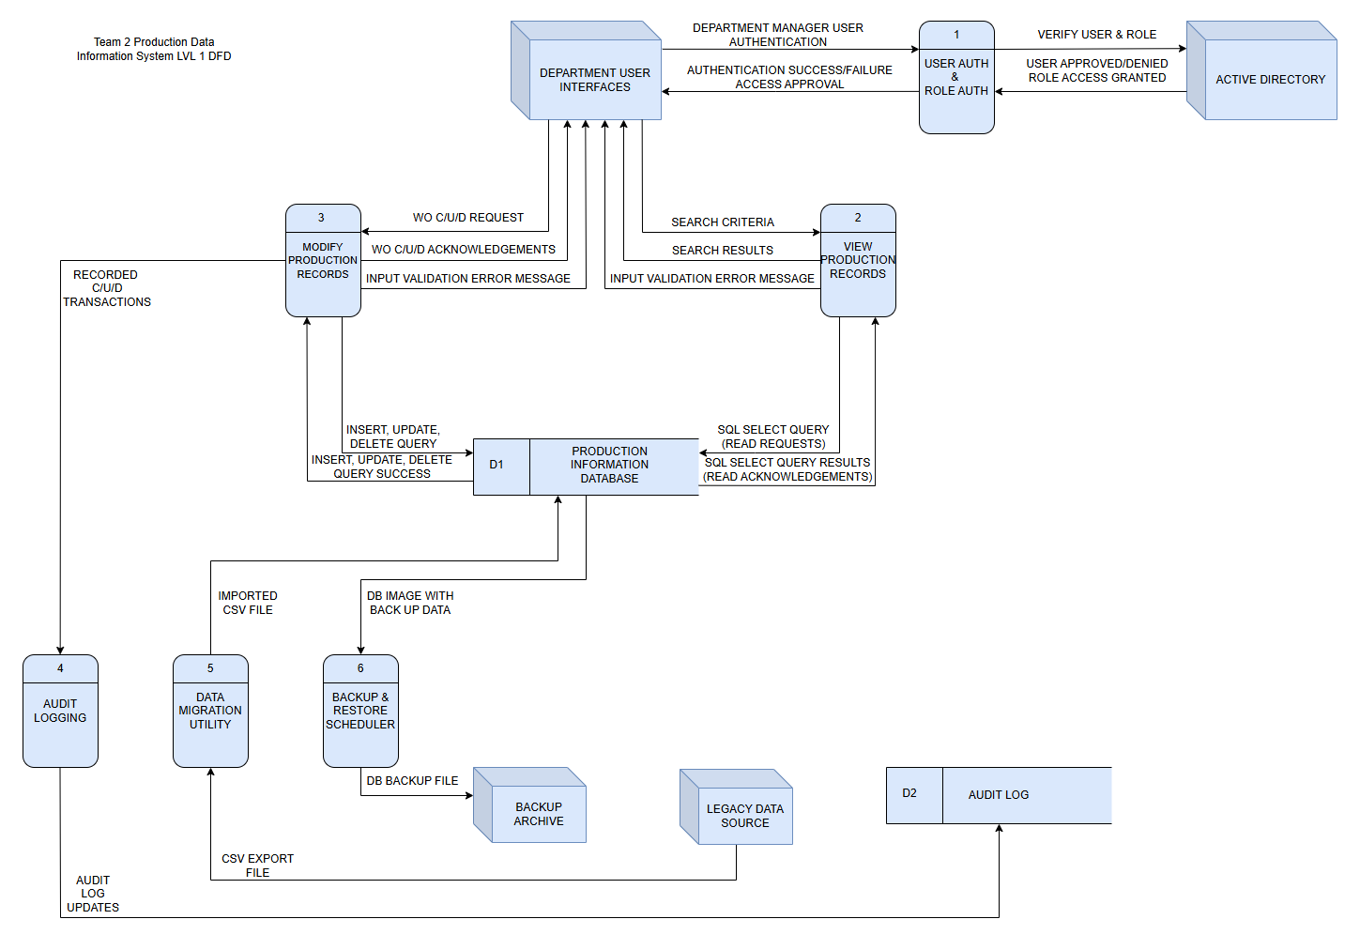

LVL 1 Data Dictionary:

Label: | USER AUTH & ROLE AUTH
Entry Type: | Process
Description: | Authenticate department manager user interfaces through user and role verification to grant role-based action privileges on the PART_HISTORY table within the database.
Process #: | 1
Process Description: | Input Data Flows:  - DEPARTMENT MANAGER USER AUTHENTICATION  - USER APPROVED/DENIED ROLE ACCESS GRANTED  Output Data Flows:  - VERIFY USER & ROLE  - AUTHENTICATION SUCCESS/FAILURE ACCESS APPROVAL  RECEIVE the DEPARTMENT MANAGER AND USER AUTHENTICATION from the DEPARTMENT USER INTERFACES entity.  VERIFY the USER & ROLE with the ACTIVE DIRECTORY entity.  RECEIVE USER APPROVED/DENIED ROLE ACCESS GRANTED notification from the ACTIVE DIRECTORY entity.  SEND the AUTHENTICATION SUCCESS/FAILURE ACCESS APPROVAL authorization to the DEPARTMENT USER INTERFACES entity.
Notes: | Process 1 must take place before manager entities may submit CRUD requests to the system.  Approved Roles:  - Fabrication & Machine Shop: C/R/U/D Requests with soft-delete privileges.  - Quality & Shipping: Ready Only privileges.

Label: | VIEW PRODUCTION RECORDS
Entry Type: | Process
Description: | Query the system to search by parameters such as PART NUMBER, DUE DATE RANGE, OPERATOR NAME, and DEPARTMENT. Receive the query results from the system which returns CUSTOMER_NAME, OPERATOR_NAME, PART_NUMBER, QTY, DATE_RECEIVED, DATE_DUE, OPERATIONS, and PURCHASE_ORDER_NUMBER.
Process #: | 2
Process Description: | Input Data Flows:  - SEARCH CRITERIA:  - PART NUMBER  - DUE DATE RANGE  - OPERATOR NAME  - DEPARTMENT.  - SQL SELECT QUERY RESULTS (READ ACKNOWLEDGEMENTS)  Output Data Flows:  - SQL SELECT QUERY (READ REQUESTS)  - SEARCH RESULTS:  - CUSTOMER_NAME, OPERATOR_NAME  - PART_NUMBER, QTY  - DATE_RECEIVED, DATE_DUE  - OPERATIONS, PURCHASE_ORDER_NUMBER  - INPUT VALIDATION ERROR MESSAGE  RECEIVE the SEARCH CRITERIA from the DEPARTMENT USER INTERFACES entity.  SEND the SQL SELECT QUERY (READ REQUESTS) to the PRODUCTION INFORMATION DATABASE where the PART_HISTORY table is located.  RECEIVE the SQL SELECT QUERY RESULTS (READ ACKNOWLEDGEMENTS) from the PRODUCTION INFORMATION DATABASE where the PART_HISTORY table is located.  SEND the SEARCH RESULTS to the DEPARTMENT USER INTERFACES entity.  SEND the INPUT VALIDATION ERROR MESSAGE to the DEPARTMENT USER INTERFACES entity when SEARCH CRITERIA required field input fails validation constraints.
Notes: | Process 1 must take place before process 2.  Approved Roles:  - Fabrication & Machine Shop.  - Quality & Shipping.

Label: | MODIFY PRODUCTION RECORDS
Entry Type: | Process
Description: | Query the system to CREATE new records, UPDATE existing records, and (soft) DELETE existing records.
Process #: | 3
Process Description: | Input Data Flows:  - WO C/U/D REQUEST  - INSERT, UPDATE, DELETE QUERY SUCCESS  Output Data Flows:  - INSERT, UPDATE, DELETE QUERY  - WO C/U/D ACKNOWLEDGEMENTS  - INPUT VALIDATION ERROR MESSAGE  RECEIVE the WO C/U/D REQUEST from the DEPARTMENT USER INTERFACES entity.  SEND the INSERT, UPDATE, DELETE QUERY to the PRODUCTION INFORMATION DATABASE.  RECEIVE the INSERT, UPDATE, DELETE QUERY SUCCESS notice from the PRODUCTION INFORMATION DATABASE.  SEND the WO C/U/D ACKNOWLEDGEMENTS to the DEPARTMENT USER INTERFACES entity.  SEND the INPUT VALIDATION ERROR MESSAGE to the DEPARTMENT USER INTERFACES entity when WO C/U/D REQUEST required field input fails validation constraints.
Notes: | Process 1 must take place before process 3.  Approved Roles:  - Fabrication & Machine Shop: Full C/R/U/D with soft-delete access privileges.

Label: | AUDIT LOGGING
Entry Type: | Process
Description: | Record Create, Update, and Delete (soft) transactions from Fabrication & Machine Shop departments. Update the audit log file stored in directory on server that hosts database.
Process #: | 4
Process Description: | Input Data Flows:  - RECORDED C/U/D TRANSACTIONS  Output Data Flows:  - AUDIT LOG UPDATES  RECEIVE the C/U/D TRANSACTIONS from the PRODUCTION INFORMATION DATABASE.  SEND the AUDIT LOG UPDATES to the AUDIT LOG.
Notes: | C/U/D transactions are recorded daily and are sent to the AUDIT LOG at the time they are recorded.

Label: | DATA MIGRATION UTILITY
Entry Type: | Process
Description: | Import Legacy Data from previous Microsoft Access Database in a .CSV file format.
Process #: | 5
Process Description: | Input Data Flows:  - CSV EXPORT FILE  Output Data Flows:  - IMPORTED CSV FILE  RECEIVE the CSV EXPORT FILE from the LEGACY DATA SOURCE.  SEND the IMPORTED CSV FILE to the PRODUCTION INFORMATION DATABASE.
Notes: | .CSV file to be imported using MySQL DBMS import utility for record transfer.

Label: | BACKUP & RESTORE SCHEDULER
Entry Type: | Process
Description: | Create MySQLDump files as backup copies for Database restoration on a nightly schedule in the event of hardware or software failure.
Process #: | 6
Process Description: | Input Data Flows:  - DB IMAGE WITH BACKUP DATA  Output Data Flows:  - DB BACKUP FILE  RECEIVE the DB IMAGE WITH BACKUP DATA from the PRODUCTION INFORMATION DATABASE.  SEND the DB BACKUP FILE to the BACKUP ARCHIVE.
Notes: | The BACKUP ARCHIVE will be a directory on the servers storage device dedicated to storing copies of the DB BACKUP FILE for future retrieval and restoration needs if necessary.

