CMIS-4900-400
Team 2
Production Data Information System
Sub Level Data Flow Diagrams
Processes 1 – 3

PROCESS 1 DFD

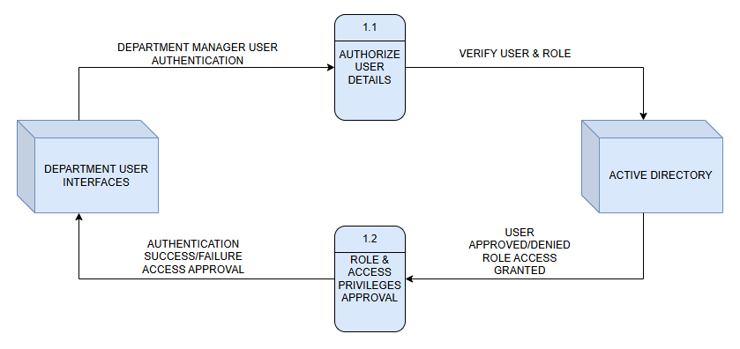

PROCESS 1 DATA DICTIONARY

Label: | AUTHORIZE USER DETAILS
Entry Type: | Process
Description: | Receive Department Manager user credentials for authorization and verify role with ACTIVE DIRECTORY.
Process #: | 1.1
Process Description: | Input Data Flows:  - DEPARTMENT MANAGER USER AUTHENTICATION  Output Data Flows:  - VERIFY USER & ROLE  RECEIVE the DEPARTMENT MANAGER USER AUTHENTICATION from the DEPARTMENT USER INTERFACES entity.  VERIFY USER & ROLE with the ACTIVE DIRECTORY entity.
Notes: | Department user authorization credentials must be verified for role and access privilege with Active Directory before approvals and sent notifications are generated.

Label: | ROLE & ACCESS PRIVILEGES APPROVAL
Entry Type: | Process
Description: | Receive role & access approvals for corresponding Department Manager user credentials and allow respective access privileges for each Department Manager.
Process #: | 1.2
Process Description: | Input Data Flows:  - USER APPROVED/DENIED ROLE ACCESS GRANTED  Output Data Flows:  - AUTHENTICATION SUCCESS/FAILURE ACCESS APPROVAL  RECEIVE the USER APPROVED/DENIED ROLE ACCESS GRANTED notification from the ACTIVE DIRECTORY entity.  SEND the AUTHENTICATION SUCCESS/FAILURE ACCESS APPROVAL authorization to DEPARTMENT USER INTERFACES entity.
Notes: | Once authorization and the corresponding access privileges have been approved, Fabrication and Machine Shop Department Managers are granted C/U/D (Create, Update, Delete (soft-delete)) privileges. Quality and Shipping Department Managers are granted Read-Only privileges.

PROCESS 2 DFD

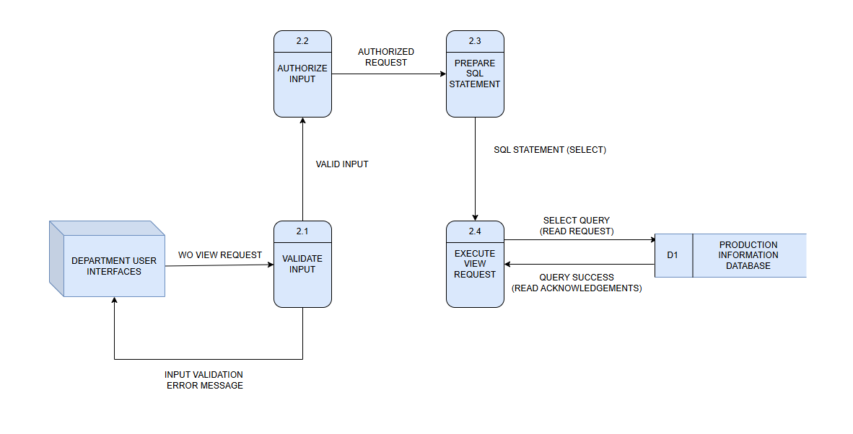

PROCESS 2 DATA DICTIONARY
Label: | VALIDATE INPUT
Entry Type: | Process
Description: | Validate Work Order(WO) view requests received from the DEPARTMENT USER INTERFACES.
Process #: | 2.1
Process Description: | Input Data Flows:  1) WO View Request  Output Data Flows:  1) Valid Input  2) Input Validation Error Message  RECEIVE the WO View Request from the DEPARTMENT USER INTERFACES.  VALIDATE that the request includes all required parameters (e.g., work order ID, date range).  SEND VALID INPUT to AUTHORIZE INPUT(2.2).  SEND Input Validation Error Message to DEPARTMENT USER INTERFACES if validation fails.
Notes: | Ensures that only properly formatted and complete view requests are sent for authorization and database querying.

Label: | AUTHORIZE INPUT
Entry Type: | Process
Description: | Check user permissions and determine if the requested view action is allowed for the Department user.
Process #: | 2.2
Process Description: | Input Data Flows:  1) Valid Input  Output Data Flows:  1) Authorized Request  RECEIVE Valid Input from VALIDATE INPUT (2.1).  VERIFY user’s authorization for viewing the requested production data.  SEND Authorized Request to PREPARE SQL STATEMENT (2.3).
Notes: | Authorization ensures that only users with view privileges can access production information records.

Label: | PREPARE SQL STATEMENT
Entry Type: | Process
Description: | Generate the SQL SELECT statement to retrieve data from the PRODCUTION INFROMATION DATABASE based on the authorized input.
Process #: | 2.3
Process Description: | Input Data Flows:  1) Authorized Request  Output Data Flows:  1) SQL Statement (SELECT)  RECEIVE Authorized Request from AUTHORIZED INPUT (2.2).  CONSTRUCT a SQL SELECT statement matching the specified filters or criteria.  SEND SQL Statement (SELECT) to EXECUTE VIEW REQUEST(2.4).
Notes: | Ensures SQL syntax and query parameters are correctly formed to retrieve accurate and relevant data.

Label: | EXECUTE VIEW REQUEST
Entry Type: | Process
Description: | Run SQL SELECT statements on the PRODUCTION INFORMATION DATABASE and return results to the user interface.
Process #: | 2.4
Process Description: | Input Data Flows:  1) SQL Statement (SELECT)  Output Data Flows:  1) Query Success (Read Acknowledgements)  RECEIVE SQL Statement (SELECT) from PREPARE SQL STATEMENT (2.3).  EXECUTE the SQL query on the PRODUCTION INFORMATION DATABASE (D1).  RECEIVE Query Success (Read Acknowledgements) from PRODUCTION INFORMATION DATABASE(D1).  RETURN Query Success results to DEPARTMENT USER INTERFACES.
Notes: | Executes read-only queries to fetch and display production information data to authorized department users.

Label: | PRODUCTION INFORMATION DATABASE (D1)
Entry Type: | Data Store
Description: | Central repository containing production information records, including work order details accessible by authorized users.
Process #: | D1
Process Description: | Input Data Flows:  1) Select Query (Read Request)  Output Data Flows:  1) Query Success (Read Acknowledgements)  RECEIVE Select Query (Read Request) from EXECUTE VIEW REQUEST (2.4).  SEND Query Success (Read Acknowledgements) with retrieved data back to EXECUTE VIEW REQUEST (2.4).
Notes: | Stores all production-related data accessible through authorized view requests from departmental interfaces.

PROCESS 3 DFD

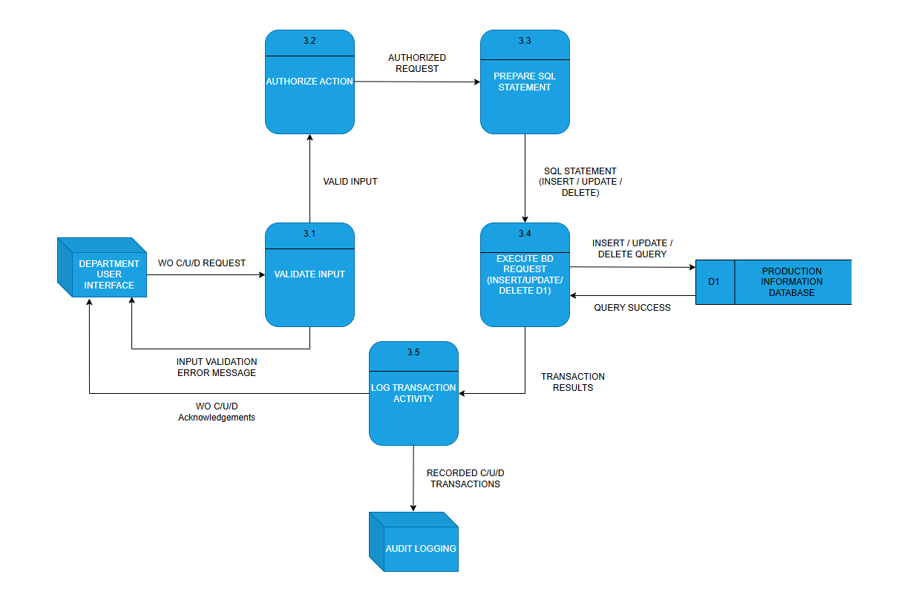

PROCESS 3 DATA DICTIONARY

Label: | VALIDATE INPUT
Entry Type: | Process
Description: | Validate Create/Update/Delete (C/U/D) requests received from the DEPARTMENT USER INTERFACE.
Process #: | 3.1
Process Description: | Input Data Flows:  1) WO C/U/D Request  Output Data Flows:  1) Valid Input  2) Input Validation Error Message  RECEIVE WO C/U/D Request from the DEPARTMENT USER INTERFACE.  VALIDATE request fields to ensure all required data and formats meet validation rules.  SEND Valid Input to AUTHORIZE ACTION (3.2).  SEND Input Validation Error Message to DEPARTMENT USER INTERFACE if validation fails.
Notes: | Input validation prevents incorrect or incomplete data from being authorized or executed in the system.

Label: | AUTHORIZE ACTION
Entry Type: | Process
Description: | Check user permissions and determine if the requested C/U/D action is allowed.
Process #: | 3.2
Process Description: | Input Data Flows:  1) Valid Input  Output Data Flows:  1) Authorized Request  RECEIVE Valid Input from VALIDATE INPUT (3.1).  VERIFY that the user has appropriate authorization for the requested transaction type.  SEND Authorized Request to PREPARE SQL STAEMENT(3.3).
Notes: | Authorization ensures that only users with the proper role privileges can perform modifications to production information data.

Label: | PREPARE SQL STATEMENT
Entry Type: | Process
Description: | Construct the SQL command for insert, update, or delete operations based on authorized input.
Process #: | 3.3
Process Description: | Input Data Flows:  1) Authorized Request  Output Data Flows:  1) SQL Statement (Insert/Update/Delete)  RECEIVE Authorized Request from AUTHORIZE ACTION(3.2).  GENERATE an SQL statement formatted for the specific database operation (INSERT, UPDATE, or DELETE).  SEND SQL Statement to EXECUTE DB REQUEST(3.4).
Notes: | SQL statement generation ensures that all database transactions follow the defined schema and syntax.

Label: | EXECUTE DB REQUEST (Insert/Update/Delete D1)
Entry Type: | Process
Description: | Execute prepared SQL statements on the Production Information Database and return results.
Process #: | 3.4
Process Description: | Input Data Flows:  1) SQL Statement (Insert/Update/Delete)  Output Data Flows:  1) Transaction Results  2) Query Success  RECEIVE SQL Statement from PREPARE SQL STATEMENT (3.3).  EXECUTE the SQL command on PRODUCTION INFORMATION DATABEASE (D1).  RECEIVE Query Success confirmation from PRODUCTION INFORMATION DATABEASE (D1).  SEND Transaction Results to LOG TRANSACTION ACTIVITY (3.5).
Notes: | Execution ensures persistent changes to the Production Information Database, reflecting accurate and current data.

Label: | LOG TRANSACTION ACTIVITY
Entry Type: | Process
Description: | Record all CRUD transactions for auditing and send acknowledgements back to the user interface.
Process #: | 3.5
Process Description: | Input Data Flows:  1) Transaction Results  Output Data Flows:  1) Recorded C/U/D Transactions  2) WO C/U/D Acknowledgements  RECEIVE Transaction Results from EXECUTE DB REQUEST(3.4).  LOG the transaction details (user, action type, timestamp, result).  SEND Recorded C/U/D Transactions to AUDIT LOGGING.  SEND WO C/U/D Acknowledgements to DEPARTMENT USER INTERFACE.
Notes: | Logging ensures accountability and traceability for all database operations performed by users.

Label: | PRODUCTION INFORMATION DATABASE (D1)
Entry Type: | Data Store
Description: | Centralized repository storing all production-related records, including work orders and department activity data.
Process #: | D1
Process Description: | Input Data Flows:  1) Insert/Update/Delete Query  Output Data Flows:  1) Query Success  RECEIVE Insert/Update/Delete Query from EXECUTE DB REQUEST(3.4).  SEND Query Success back to EXECUTE DB REQUEST (3.4) after execution.
Notes: | The database maintains integrity and supports CRUD operations for all production data used by department interfaces.

