CMIS-4900-400
Team 2
Production Data Information System
DFD PROCESS 2

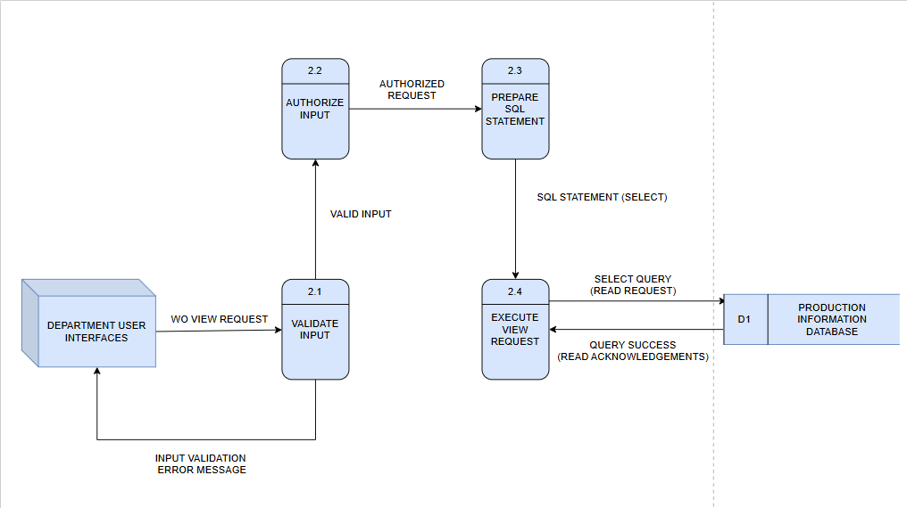

Label: | VALIDATE INPUT
Entry Type: | Process
Description: | Validate Work Order(WO) view requests received from the DEPARTMENT USER INTERFACES.
Process #: | 2.1
Process Description: | Input Data Flows:  1) WO View Request  Output Data Flows:  1) Valid Input  2) Input Validation Error Message  RECEIVE the WO View Request from the DEPARTMENT USER INTERFACES.  VALIDATE that the request includes all required parameters (e.g., work order ID, date range).  SEND VALID INPUT to AUTHORIZE INPUT(2.2).  SEND Input Validation Error Message to DEPARTMENT USER INTERFACES if validation fails.
Notes: | Ensures that only properly formatted and complete view requests are sent for authorization and database querying.

Label: | AUTHORIZE INPUT
Entry Type: | Process
Description: | Check user permissions and determine if the requested view action is allowed for the Department user.
Process #: | 2.2
Process Description: | Input Data Flows:  1) Valid Input  Output Data Flows:  1) Authorized Request  RECEIVE Valid Input from VALIDATE INPUT (2.1).  VERIFY user’s authorization for viewing the requested production data.  SEND Authorized Request to PREPARE SQL STATEMENT (2.3).
Notes: | Authorization ensures that only users with view privileges can access production information records.

Label: | PREPARE SQL STATEMENT
Entry Type: | Process
Description: | Generate the SQL SELECT statement to retrieve data from the PRODCUTION INFROMATION DATABASE based on the authorized input.
Process #: | 2.3
Process Description: | Input Data Flows:  1) Authorized Request  Output Data Flows:  1) SQL Statement (SELECT)  RECEIVE Authorized Request from AUTHORIZED INPUT (2.2).  CONSTRUCT a SQL SELECT statement matching the specified filters or criteria.  SEND SQL Statement (SELECT) to EXECUTE VIEW REQUEST(2.4).
Notes: | Ensures SQL syntax and query parameters are correctly formed to retrieve accurate and relevant data.

Label: | EXECUTE VIEW REQUEST
Entry Type: | Process
Description: | Run SQL SELECT statements on the PRODUCTION INFORMATION DATABASE and return results to the user interface.
Process #: | 2.4
Process Description: | Input Data Flows:  1) SQL Statement (SELECT)  Output Data Flows:  1) Query Success (Read Acknowledgements)  RECEIVE SQL Statement (SELECT) from PREPARE SQL STATEMENT (2.3).  EXECUTE the SQL query on the PRODUCTION INFORMATION DATABASE (D1).  RECEIVE Query Success (Read Acknowledgements) from PRODUCTION INFORMATION DATABASE(D1).  RETURN Query Success results to DEPARTMENT USER INTERFACES.
Notes: | Executes read-only queries to fetch and display production information data to authorized department users.

Label: | PRODUCTION INFORMATION DATABASE (D1)
Entry Type: | Data Store
Description: | Central repository containing production information records, including work order details accessible by authorized users.
Process #: | D1
Process Description: | Input Data Flows:  1) Select Query (Read Request)  Output Data Flows:  1) Query Success (Read Acknowledgements)  RECEIVE Select Query (Read Request) from EXECUTE VIEW REQUEST (2.4).  SEND Query Success (Read Acknowledgements) with retrieved data back to EXECUTE VIEW REQUEST (2.4).
Notes: | Stores all production-related data accessible through authorized view requests from departmental interfaces.

