CMIS-4900-400
Team 2
Production Data Information System
DFD PROCESS 3

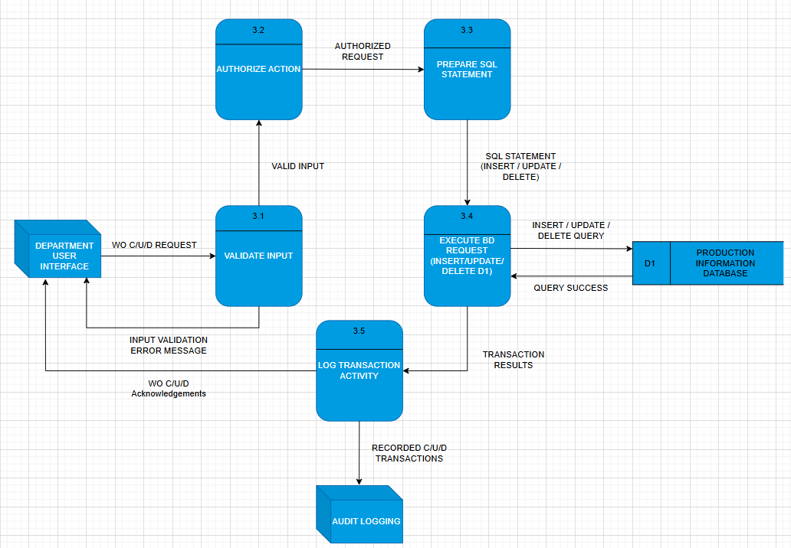

Label: | VALIDATE INPUT
Entry Type: | Process
Description: | Validate Create/Update/Delete (C/U/D) requests received from the DEPARTMENT USER INTERFACE.
Process #: | 3.1
Process Description: | Input Data Flows:  1) WO C/U/D Request  Output Data Flows:  1) Valid Input  2) Input Validation Error Message  RECEIVE WO C/U/D Request from the DEPARTMENT USER INTERFACE.  VALIDATE request fields to ensure all required data and formats meet validation rules.  SEND Valid Input to AUTHORIZE ACTION (3.2).  SEND Input Validation Error Message to DEPARTMENT USER INTERFACE if validation fails.
Notes: | Input validation prevents incorrect or incomplete data from being authorized or executed in the system.

Label: | AUTHORIZE ACTION
Entry Type: | Process
Description: | Check user permissions and determine if the requested C/U/D action is allowed.
Process #: | 3.2
Process Description: | Input Data Flows:  1) Valid Input  Output Data Flows:  1) Authorized Request  RECEIVE Valid Input from VALIDATE INPUT (3.1).  VERIFY that the user has appropriate authorization for the requested transaction type.  SEND Authorized Request to PREPARE SQL STAEMENT(3.3).
Notes: | Authorization ensures that only users with the proper role privileges can perform modifications to production information data.

Label: | PREPARE SQL STATEMENT
Entry Type: | Process
Description: | Construct the SQL command for insert, update, or delete operations based on authorized input.
Process #: | 3.3
Process Description: | Input Data Flows:  1) Authorized Request  Output Data Flows:  1) SQL Statement (Insert/Update/Delete)  RECEIVE Authorized Request from AUTHORIZE ACTION(3.2).  GENERATE an SQL statement formatted for the specific database operation (INSERT, UPDATE, or DELETE).  SEND SQL Statement to EXECUTE DB REQUEST(3.4).
Notes: | SQL statement generation ensures that all database transactions follow the defined schema and syntax.

Label: | EXECUTE DB REQUEST (Insert/Update/Delete D1)
Entry Type: | Process
Description: | Execute prepared SQL statements on the Production Information Database and return results.
Process #: | 3.4
Process Description: | Input Data Flows:  1) SQL Statement (Insert/Update/Delete)  Output Data Flows:  1) Transaction Results  2) Query Success  RECEIVE SQL Statement from PREPARE SQL STATEMENT (3.3).  EXECUTE the SQL command on PRODUCTION INFORMATION DATABEASE (D1).  RECEIVE Query Success confirmation from PRODUCTION INFORMATION DATABEASE (D1).  SEND Transaction Results to LOG TRANSACTION ACTIVITY (3.5).
Notes: | Execution ensures persistent changes to the Production Information Database, reflecting accurate and current data.

Label: | LOG TRANSACTION ACTIVITY
Entry Type: | Process
Description: | Record all CRUD transactions for auditing and send acknowledgements back to the user interface.
Process #: | 3.5
Process Description: | Input Data Flows:  1) Transaction Results  Output Data Flows:  1) Recorded C/U/D Transactions  2) WO C/U/D Acknowledgements  RECEIVE Transaction Results from EXECUTE DB REQUEST(3.4).  LOG the transaction details (user, action type, timestamp, result).  SEND Recorded C/U/D Transactions to AUDIT LOGGING.  SEND WO C/U/D Acknowledgements to DEPARTMENT USER INTERFACE.
Notes: | Logging ensures accountability and traceability for all database operations performed by users.

Label: | PRODUCTION INFORMATION DATABASE (D1)
Entry Type: | Data Store
Description: | Centralized repository storing all production-related records, including work orders and department activity data.
Process #: | D1
Process Description: | Input Data Flows:  1) Insert/Update/Delete Query  Output Data Flows:  1) Query Success  RECEIVE Insert/Update/Delete Query from EXECUTE DB REQUEST(3.4).  SEND Query Success back to EXECUTE DB REQUEST (3.4) after execution.
Notes: | The database maintains integrity and supports CRUD operations for all production data used by department interfaces.

