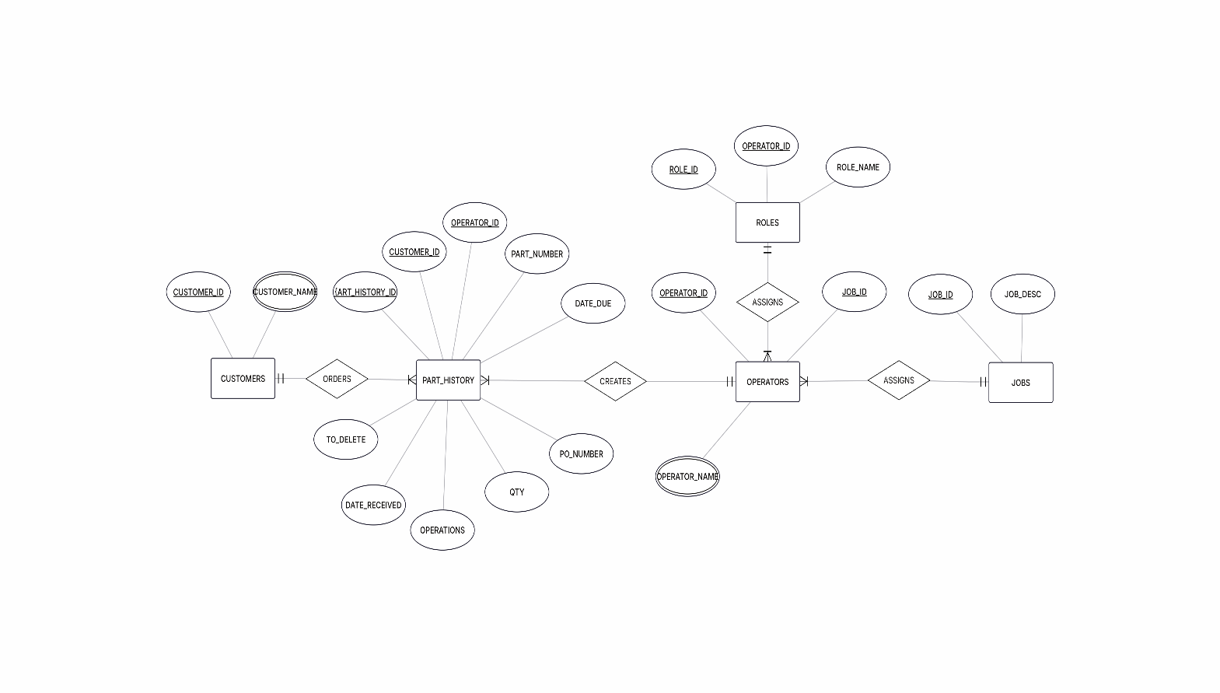
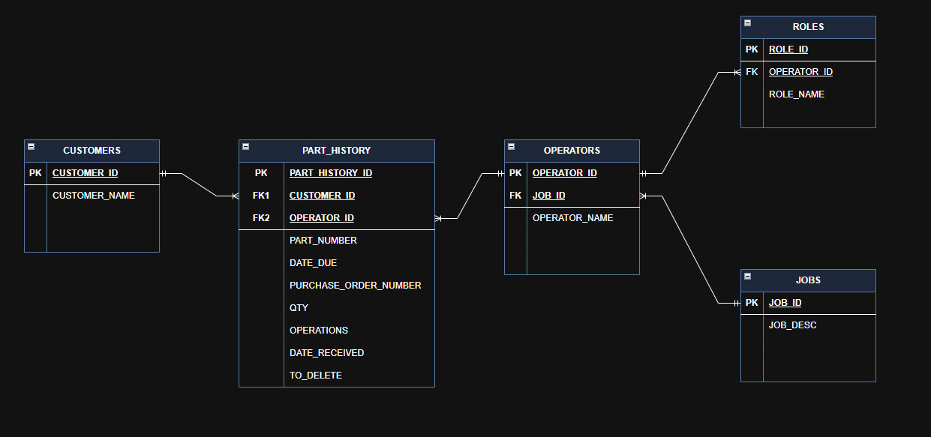

Field Mapping

Source: CUSTOMERS Table | Target: CUSTOMERS Table
CUSTOMER_ID (Integer) | CUSTOMER_ID (Integer)
CUSTOMER_NAME (Text) | CUSTOMER_NAME (Text)

Source: OPERATORS Table | Target: OPERATORS Table
OPERATOR_ID (Integer) | OPERATOR_ID (Integer)
OPERATOR_NAME (Text) | OPERATOR_NAME (Text)
JOB_ID (Integer) | JOB_ID (Integer)

Source: JOBS Table | Target: JOBS Table
JOB_ID (Integer) | JOB_ID (Integer)
JOB_DESC (Text) | JOB_DESC (Text)

Source: PART_HISTORY Table | Target: PART_HISTORY Table
CUSTOMER_ID (Integer) | CUSTOMER_ID (Integer)
OPERATOR_ID (Integer) | OPERATOR_ID (Integer)
PART_NUMBER (Text) | PART_NUMBER (Text)
DATE_DUE (Date) | DATE_DUE (Date)
PURCHASE_ORDER_NUMBER (Text) | PURCHASE_ORDER_NUMBER (Text)
QTY (Integer) | QTY (Integer)
OPERATIONS (Text) | OPERATIONS (Text)
DATE_RECEIVED (Date) | DATE_RECEIVED (Date)

Source: ROLES Table | Target: ROLES Table
ROLE_ID (Integer) | ROLE_ID (Integer)
ROLE_NAME (Text) | ROLE_NAME (Text)
OPERATOR_ID (Integer) | OPERATOR_ID (Integer)

