**MATE7015 – Semester 2, 2024**

**Additive Manufacturing Design Project – Assignment Report**

[Name]: Jared Tucker

[Student number]: s46267454

* **All the figures/tables in this template must be replaced by your work.**
* **Please be aware that the figures/tables in this template are only examples and may not reflect the quality required for submission.**
* **All questions in this template need to be filled with your own words.**
* **Please keep the text of the template.**
* **Please do NOT change the format of the text.**

1. **Component Selection & Background Research**
   1. **Discuss the choice of your component** (400 words max)

|  |
| --- |
| * *What were the decisive factors in the selection of this component?* * *In what way are you planning to use Additive Manufacturing to improve/optimise the component?* * *What aspect(s) of your component can justify the use of AM? (Geometry complexity, customisation, functional structure, small batch, etc…)* |

* 1. **Discuss dimensional, materials and structural requirements of the component** (500words max)

|  |
| --- |
| * *What are some of the critical dimensions your component must have? How will it be interfacing with other components?* * *What material is best suited to make your component? What makes this material the best candidate for making this component?* * *What types of loads will the component have to withstand? (Magnitude, location, direction, etc…)* * *Drawing/illustration may be used to present load cases.* |

1. **Initial Design**
   1. **Describe the design approach you have used to generate the component in CAD** (300 words max)

|  |
| --- |
| * *How have you implemented design for AM considerations in your design?* * *Screenshots should be used to support the discussion.* |

* 1. **Include realistic render(s) of your component BEFORE OPTIMISATION**

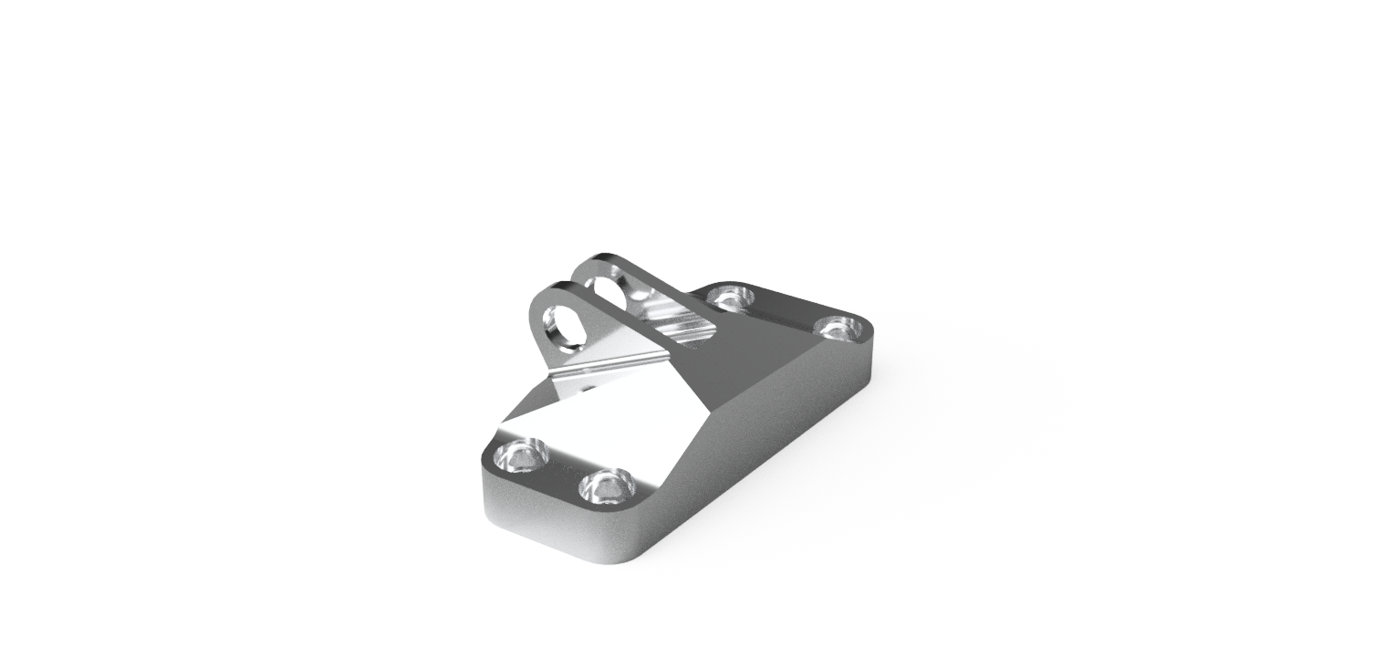

Figure 1. Example of a render before optimisation. REPLACE WITH YOUR OWN WORK.

1. **Process & Material**

*This section should be based on your final decisions in terms of material and processes. If you have changed the process and/or material as part of your optimisation process, this should be discussed in section 4.*

* 1. **Describe the factors that influenced the choice of your AM process** (400 wordsmax)

|  |
| --- |
| * *Powder-based AM or Wire-Based AM?* * *A better surface finish with a longer production time or a shorter lead time with inferior surface finishing that requires additional CNC machining* * *Cost of manufacturing* |

* 1. **Describe the factors that influenced the choice of your material and provide relevant material properties** (300 words max)

|  |
| --- |
| *A table is a good option to present material properties, eg. below.* |

Table 1. Example of material properties table. REPLACE WITH YOUR OWN WORK

|  |  |
| --- | --- |
| **Material name** | Ti-25Ta alloy (powder blend) |
| **Composition (if known)** | 75% Titanium, 25% Tantalum |
| **Melting point** | Titanium: 1668°C, Tantalum: 3017°C |
| **Density** | 5.45 g/cm3 |
| **Cost** | 1550 USD/kg |
| **Young’s Modulus** | 74 GPa |
| **Compressive Yield Strength** | -620 MPa |
| **Powder characteristic** | Spherical particles with 95% <45 µm |

* 1. **What process parameters would you use for the specific AM process you chose and why? Provide the set of properties you would be using for the manufacturing of your component** (300 words max)

|  |
| --- |
| *A table is a good option to present selected printer properties, eg. below* |

Table 2. Example of process properties table (with SLM). REPLACE WITH YOUR OWN WORK.

|  |  |
| --- | --- |
| **Laser Power (P)** | 95 W |
| **Layer thickness (t)** | 0.025 mm |
| **Hatch distance (h)** | 0.035 mm |
| **Scanning speed (v)** | 300 mm/s |
| **Platform heating** | 200°C |

* 1. **Is there any post-processing that should be considered to meet the final dimensional and/or structural requirements for the part? Justify your answer** (300 words max)

|  |
| --- |
| * *Heat treatment? Hot Isostatic Pressing? CNC machining?* |

1. **Component simulation**
   1. **Based on the structural requirements you presented in Q1.b, describe how you set up the simulation of your component in Fusion 360** (300 words max)

|  |
| --- |
| * *The screenshot can be used to illustrate the loading scenario* * *What are the load types?* * *Where are they applied?* * *What is their magnitude, and where do the values come from?* * *If applicable, what are the limitations of this numerical model?* |

* 1. **Describe the simulation results of your original design and analyse the structural integrity** (300 words max)

|  |
| --- |
| * *Is your original design structurally sound?* * *Is it over-engineered?* * *Justify your answers.* |

1. **Component optimisation** 
   1. **Describe and justify the structural optimisation process of your component** (400 words max)

|  |
| --- |
| * E.g. Reducing weight, maximising strength/ stiffness * Screenshots should be used * What were your optimisation goals? * What tools did you use to achieve these goals? * Have you considered changing the manufacturing process/material? |

* 1. **How else could you optimise your initial design besides weight and mechanical properties?** (300 words max)

|  |
| --- |
| * *E.g. (price, print time, minimising support, minimising post-processing…)* * *If you judge that no further optimisation could be done, you should justify your answer.* |

* 1. **Include a few realistic render images of your component AFTER OPTIMISATION**

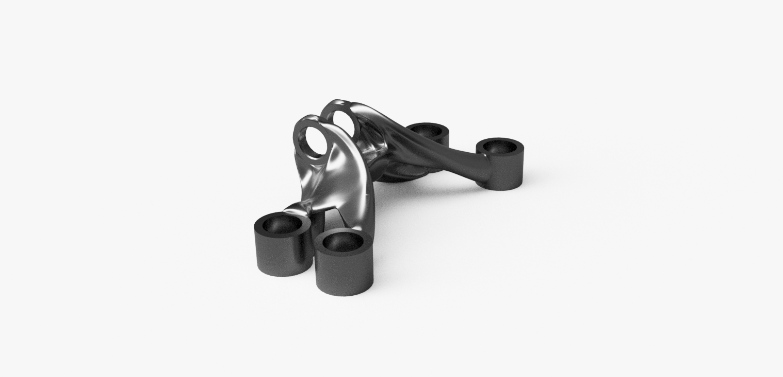

Figure 2. Example of a render after optimisation. REPLACE WITH YOUR OWN WORK.

1. **Component manufacturing**
   1. **Provide pictures of your manufactured component (or prototype)**
   2. **Discuss the quality of the printed part(s), possible dimensional mismatch and compare the fabricated component with the CAD model** (500 words max).

|  |
| --- |
| * *If defects/discrepancies are present on the printed part, how could you fix these? (This includes process, material or design related fixes)* * *In what ways can prototyping with alternative materials help anticipate the quality of the final product, and what benefits can be derived from this approach in terms of material behavior, design validation, performance characteristics, and manufacturing process refinement?* |

1. **2D engineering drawing**

|  |
| --- |
| * *Provide a A4 or A3 engineering drawing of your part as a* ***separate .PDF file****.* |