Virtual Cybersecurity Lab: Network Security Monitoring, IDS and Firewall Configuration
Practical work with VirtualBox, Kali Linux, Metasploitable 2/3, Snort and pfSense
Scope: Built an isolated virtual cybersecurity lab, established connectivity between vulnerable systems, deployed Snort for custom and built-in intrusion detection, and configured pfSense for routing, firewall filtering, and port forwarding.
- Virtual Network Configuration
Configured the VirtualBox DHCP service for the VulnLabs internal network, including the lab subnet and IP address range used by the virtual machines.

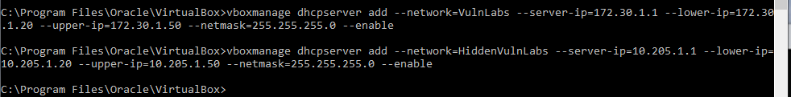
- Configured the Kali Linux VM in VirtualBox to use the VulnLabs internal network, allowing it to communicate with the vulnerable lab machines.
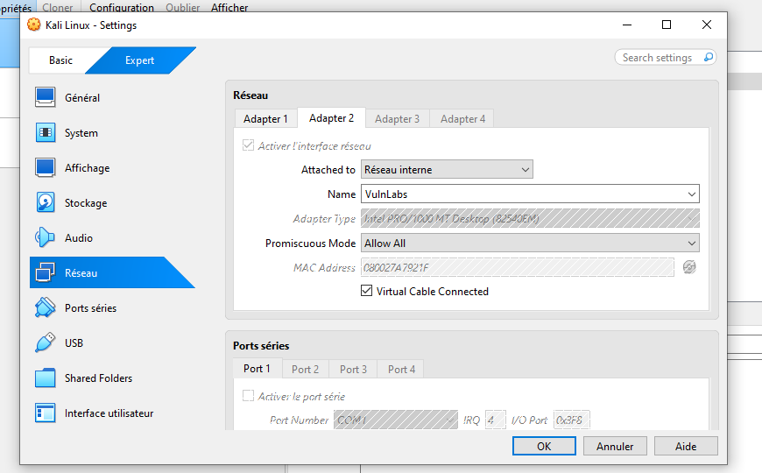
- Configured Metasploitable 2 in VirtualBox to use the same VulnLabs internal network as Kali Linux.
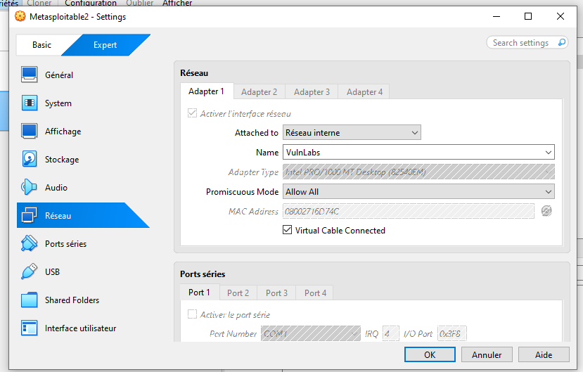
- Verified connectivity between Kali Linux (172.30.1.20) and Metasploitable 2 (172.30.1.21) using ICMP ping. Successful replies confirmed that both VMs were correctly connected to the same lab network.
- Performed service and version detection against Metasploitable 2 using Nmap (-sV) to identify open TCP ports and the services and versions exposed on the target.
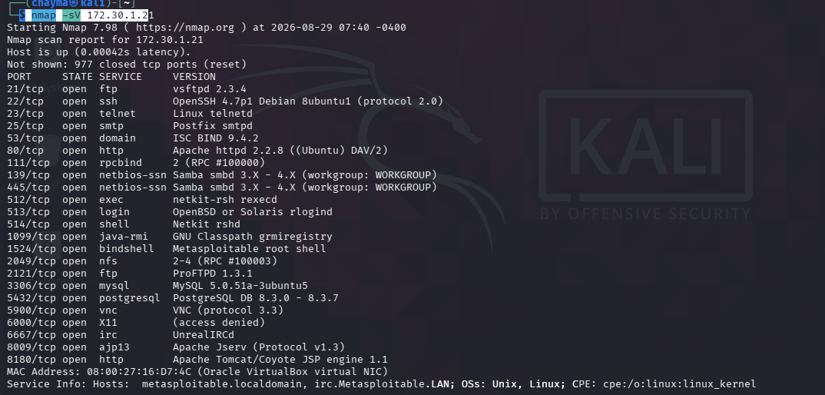

- Deployed Metasploitable 3 as a vulnerable Windows VM using Vagrant and VirtualBox.
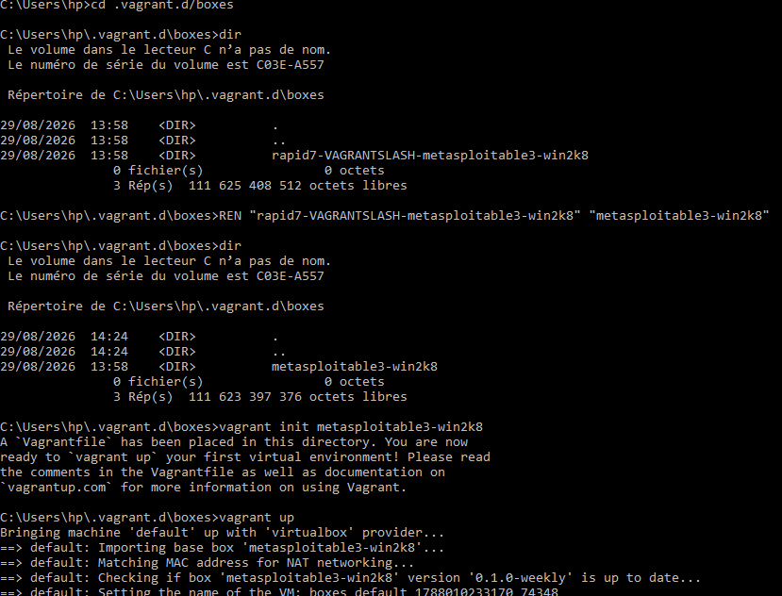
Verified the Metasploitable 3 network configuration with Windows ipconfig; the VM was assigned IPv4 address 172.30.1.22/24.
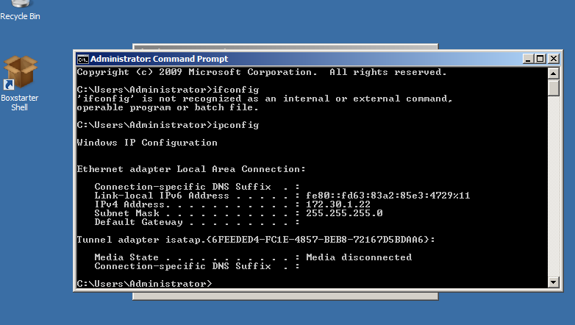

Verified connectivity between Kali Linux (172.30.1.20) and Metasploitable 3 (172.30.1.22) using ICMP ping. Successful replies confirmed that the VM was reachable on the lab network.
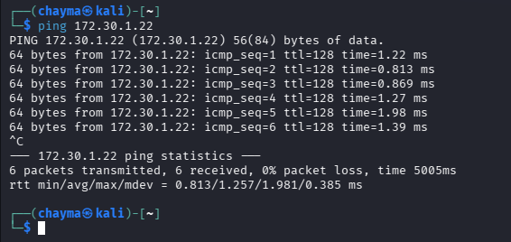

- Deployed an Ubuntu Server VM for Snort and verified the Snort installation and version from the command line.
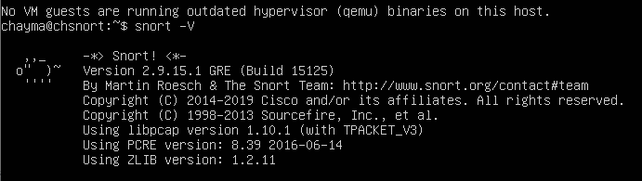
- Configured the Snort HOME_NET variable for the lab network (172.30.1.0/24), defining the internal network that Snort should monitor.
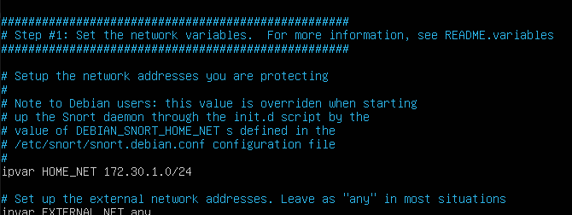

- Created a custom Snort ICMP rule in local.rules to generate an alert when ICMP traffic from any source is directed to the defined HOME_NET.
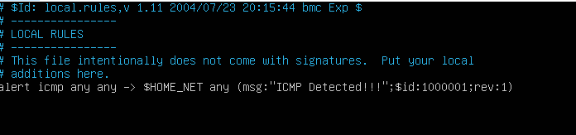

Launched Snort in console alert mode and generated ICMP traffic from Kali Linux to Metasploitable 2. Snort detected the traffic and displayed the custom “ICMP Detected!!!” alert in real time, confirming that the rule was triggered successfully.

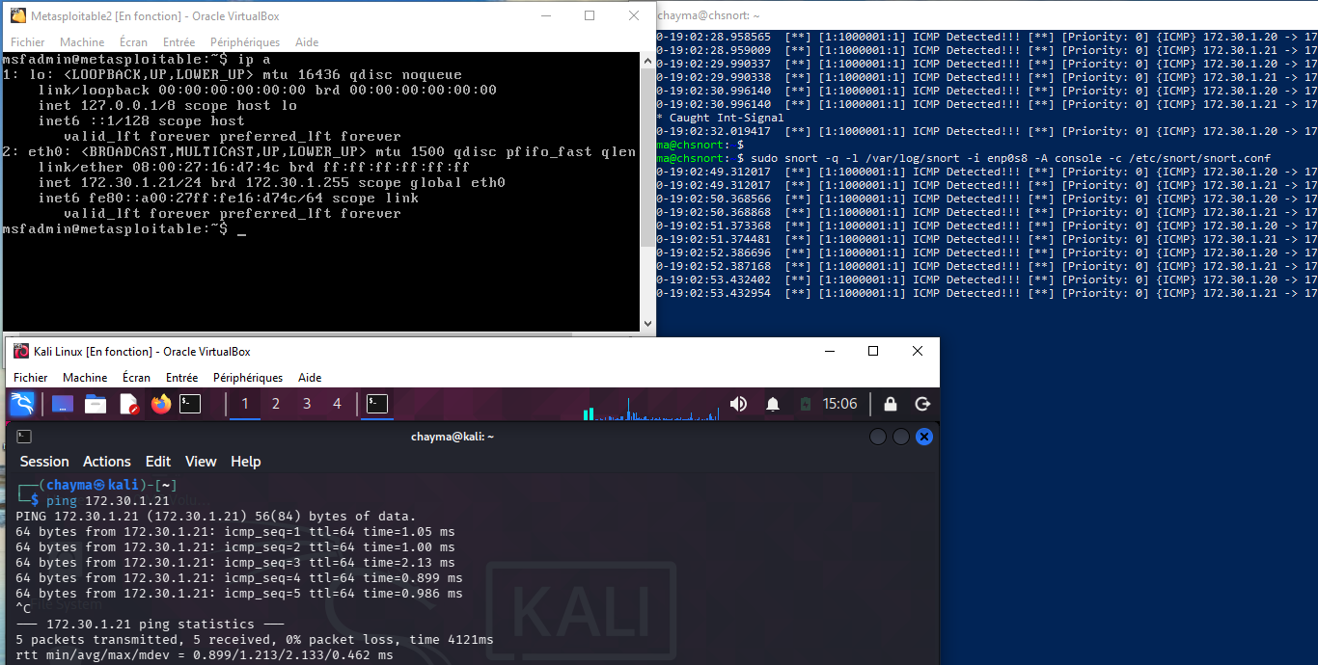

- Added a second custom Snort ICMP rule using dsize:>500 to detect ICMP packets with a payload larger than 500 bytes and generate a “Large ICMP Detected!!!” alert (SID 1000002).
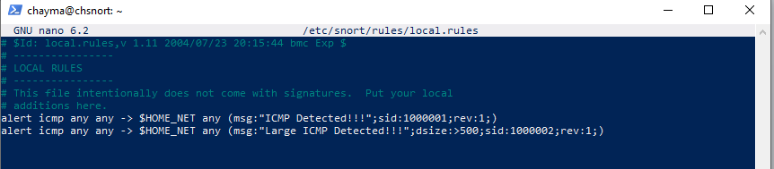
- Tested the oversized-payload rule by sending 501-byte ICMP payloads from Kali Linux to Metasploitable 2 with ping 172.30.1.21 -s 501. Snort detected the traffic and generated the expected “Large ICMP Detected!!!” alert, confirming that the dsize condition worked.
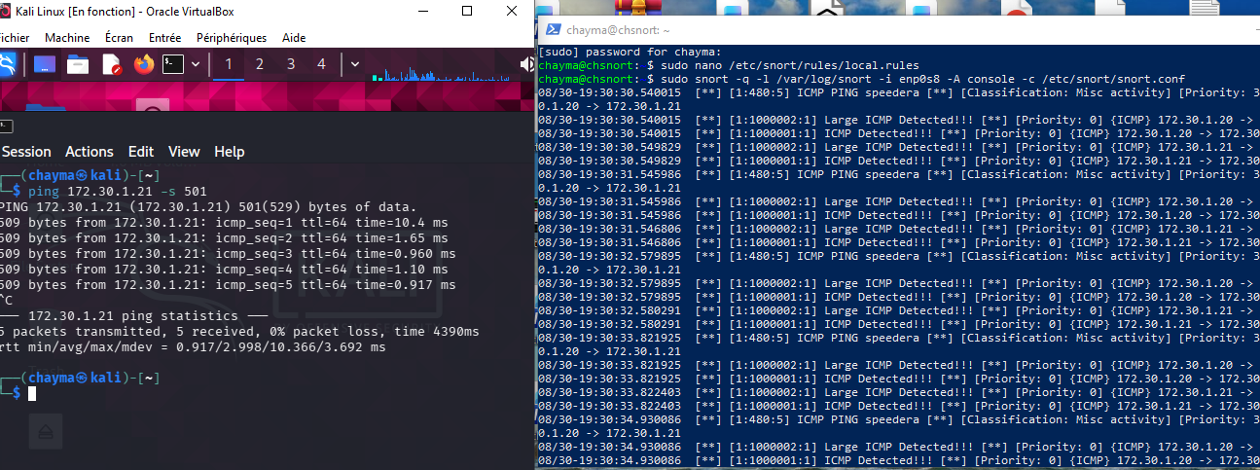

- Added three custom Snort TCP rules to monitor FTP (port 21), SSH (port 22), and HTTP (port 80). The HTTP rule specifically detects an HTTP GET request targeting /chaymaadmin.php.

- Tested the SSH rule by attempting an SSH connection from Kali Linux (172.30.1.20) to Metasploitable 2 (172.30.1.21) with ssh msfadmin@172.30.1.21. Although the SSH session failed because of a host-key algorithm mismatch, the connection attempt generated the expected Snort SSH alert (SID 1000004), demonstrating that the rule detected the network traffic.
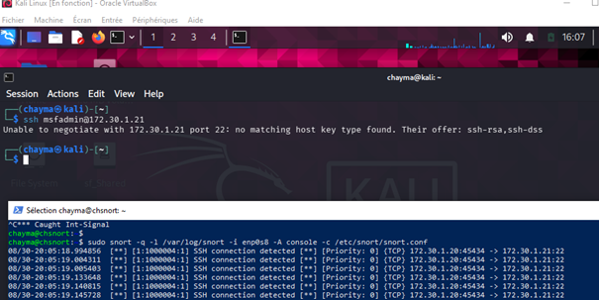
- Tested the FTP rule with an Nmap SYN scan (-sS) from Kali Linux against Metasploitable 2. The scan generated TCP SYN traffic to the target, including port 21, and Snort produced the expected FTP connection alert (SID 1000003).
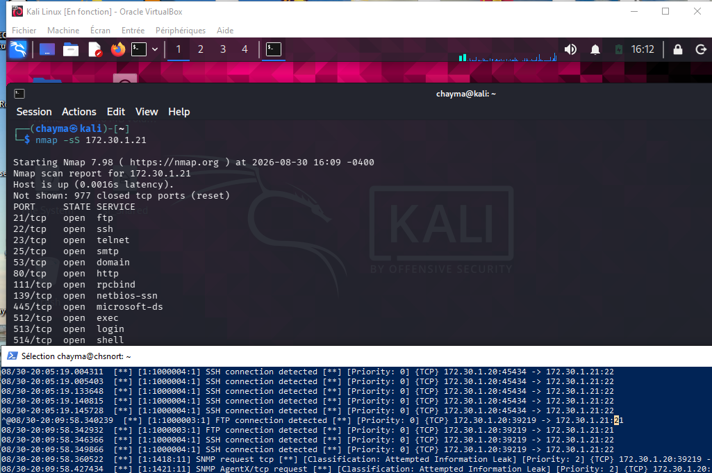

- Tested the custom HTTP rule by requesting http://172.30.1.21/chaymaadmin.php from Kali Linux with curl. The web server returned 404 Not Found, but the requested URL matched the Snort rule and generated the “Attempt to get into protected page” alert (SID 1000005).

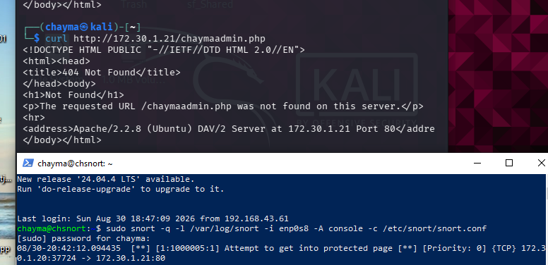

- Tested Snort’s built-in detection rules by requesting http://172.30.1.21/admin.php from Kali Linux. The request triggered the pre-installed community rules and generated a WEB-PHP admin.php access alert (SID 1301), classified as an attempted information leak.
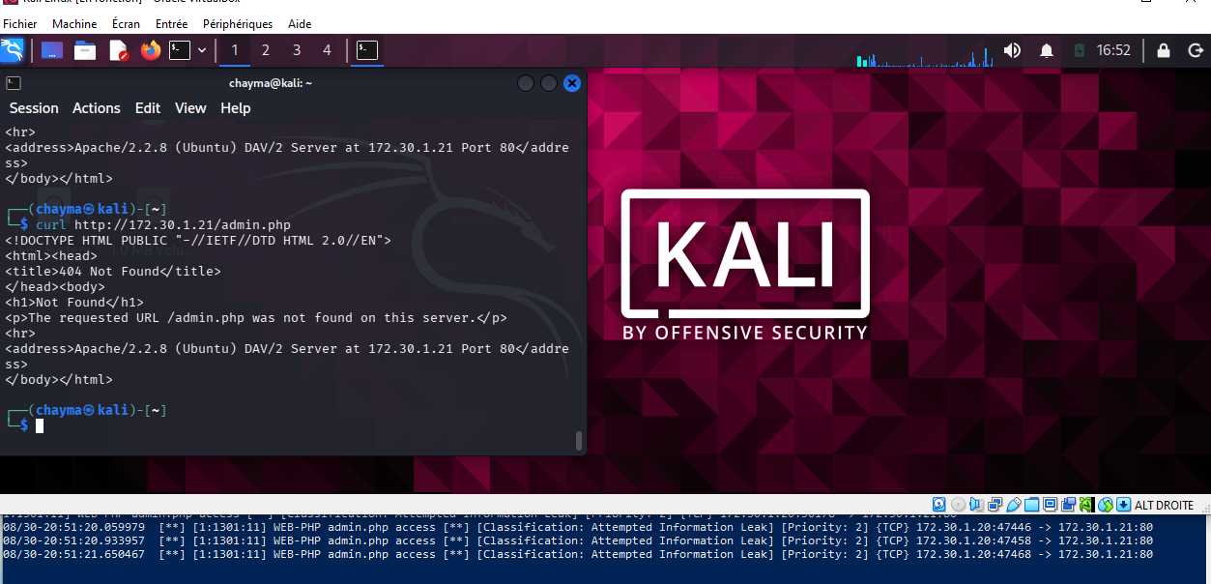

- Deployed and configured pfSense as the lab’s firewall and routing gateway.
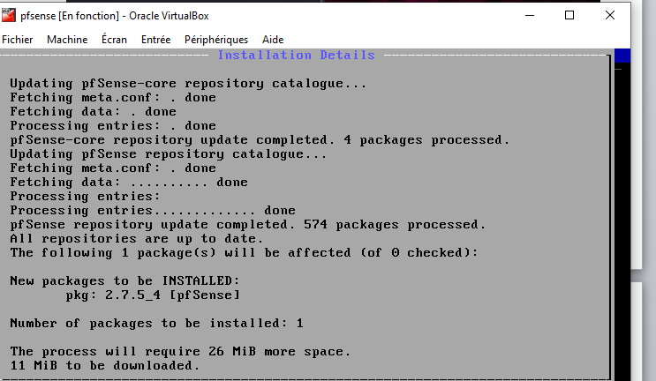

- Configured the pfSense LAN interface (em1) with the static IPv4 address 172.30.2.1/24 and disabled DHCP on that interface. This address serves as the default gateway for hosts on the internal lab network.
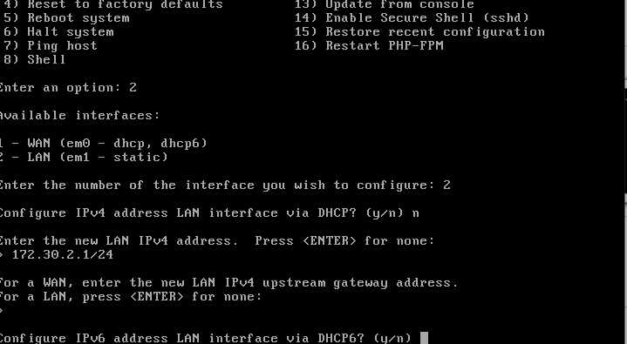

Connected Kali Linux, Metasploitable 2, and Metasploitable 3 to the pfVulnLabs internal network in VirtualBox. This placed the three VMs on the isolated lab segment behind the pfSense LAN interface.

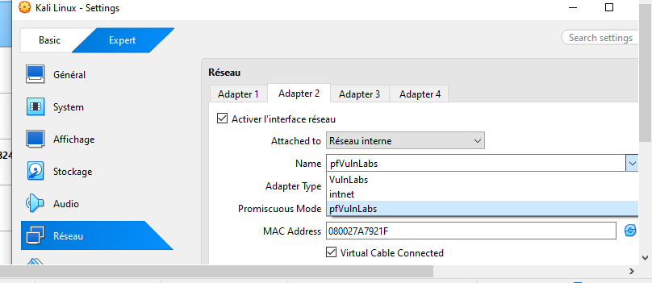

- Verified LAN connectivity to pfSense by accessing its WebGUI at http://172.30.2.1 from Kali Linux. The successful login page confirmed that Kali could reach the pfSense LAN interface over the internal lab network.

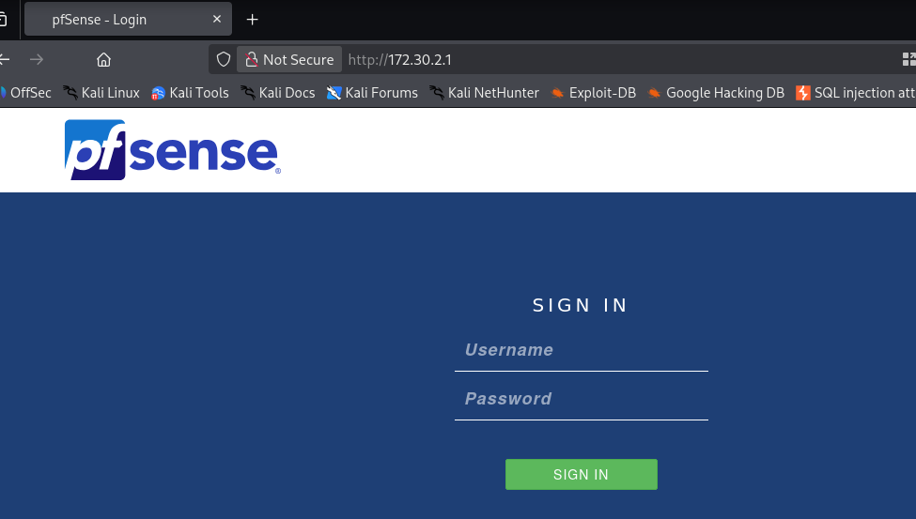

- Verified the pfSense dashboard and interface status. The WAN interface was shown at 192.168.43.120 and the LAN interface at 172.30.2.1, confirming that pfSense had both an upstream connection and an active internal LAN interface for routing and firewall functions.

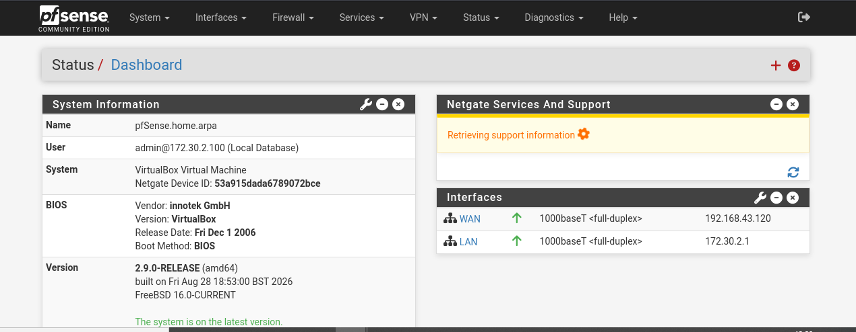

- Verified outbound routing through pfSense by pinging google.com from Metasploitable 2. Successful replies confirmed that internal traffic could be routed through the pfSense LAN and WAN interfaces to the external network.

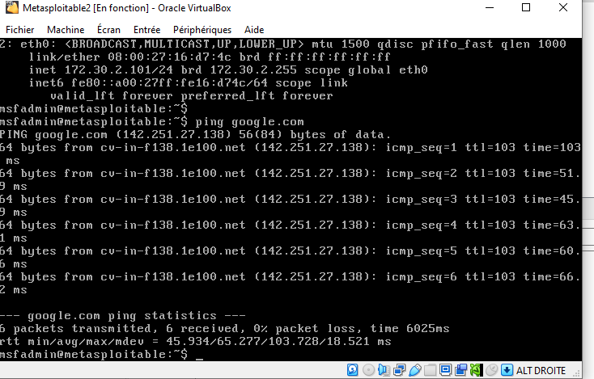

- Created a pfSense LAN firewall rule with Action set to “Block”, Address Family set to IPv4, Protocol set to Any, and Source set to LAN subnets.
Set the rule Destination to Any, causing matching IPv4 traffic originating from the LAN subnet to be blocked by the firewall.

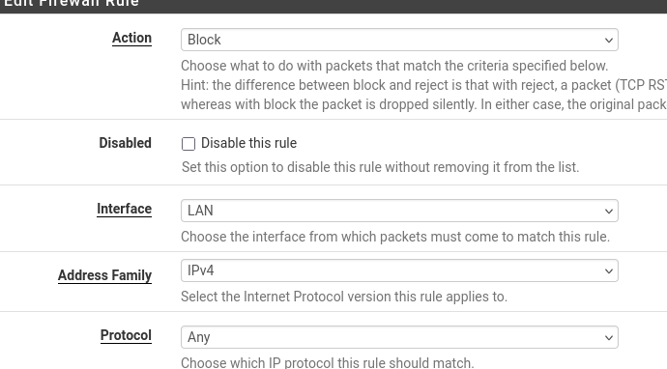

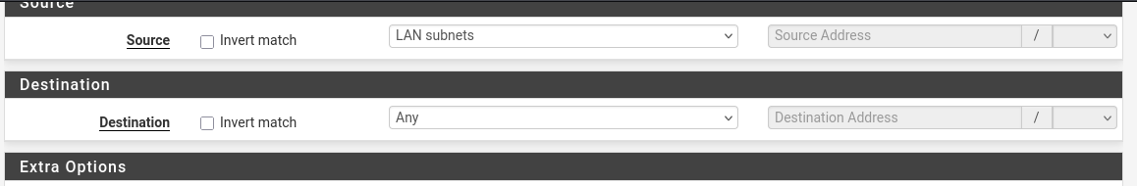
- Tested the blocking rule by pinging google.com again from Metasploitable 2. No replies were received, demonstrating that the new LAN firewall rule blocked the outbound traffic.

- Configured a pfSense WAN port-forwarding rule to redirect selected inbound connections received on the WAN address to Metasploitable 2 at 172.30.2.101. This demonstrates how pfSense can publish a selected internal service through the WAN interface using destination NAT/port forwarding.
