README.md

Learnyounode

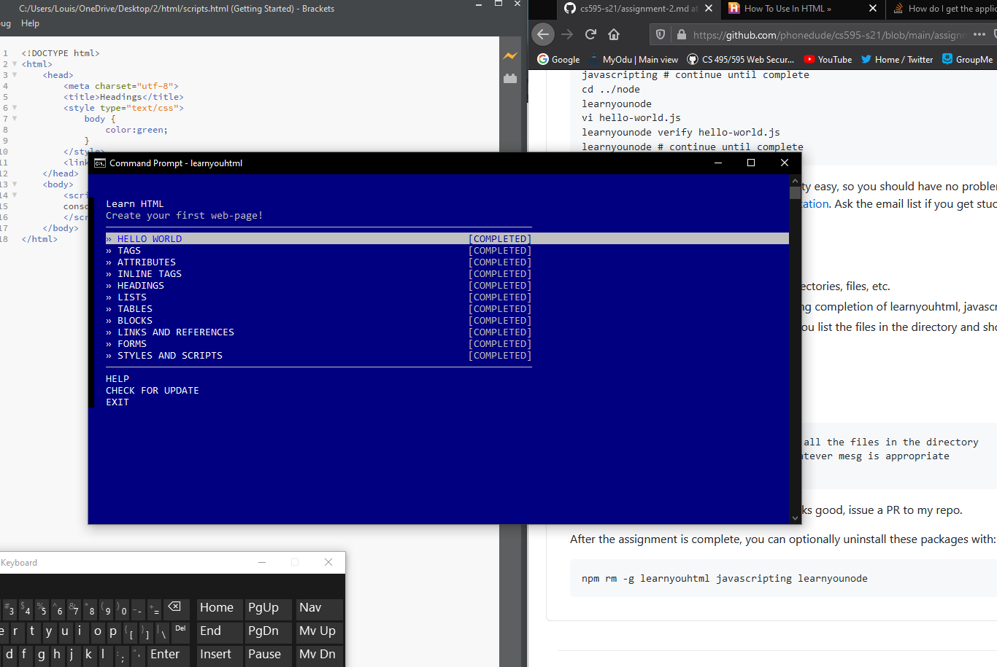

Javascripting

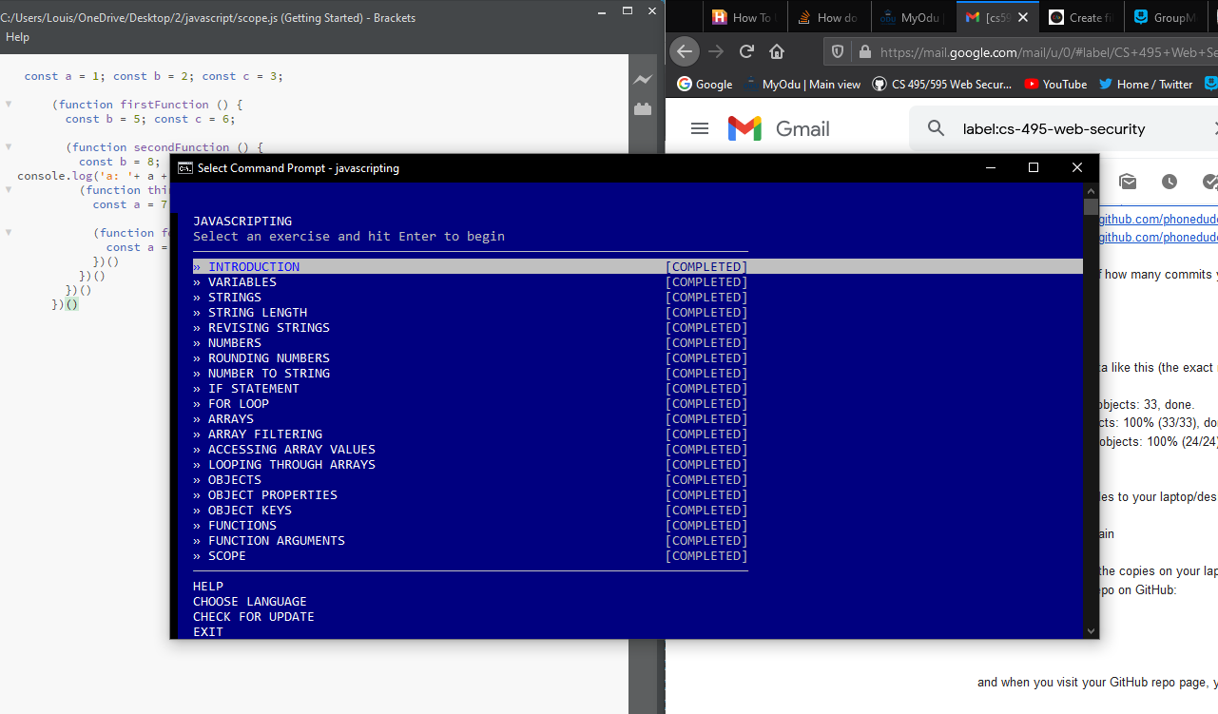

Learnyounode

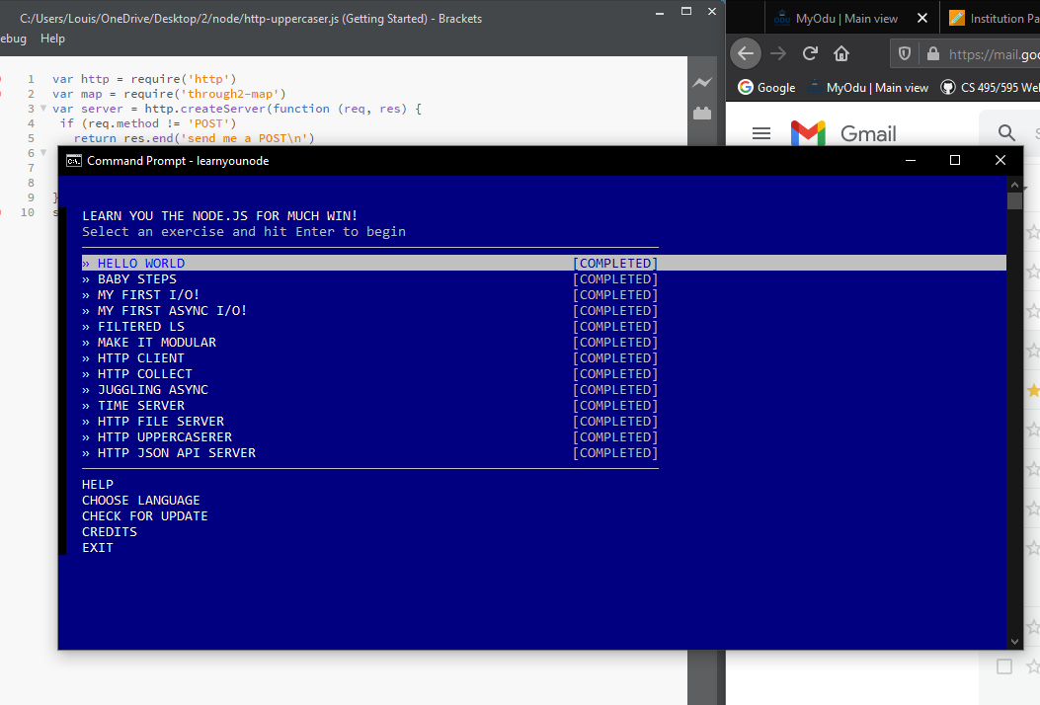

<https://www.youtube.com/watch?v=Gds8FK7g6yo>