**Lab5**

**Programming Fundamentals (CS-130) Total=100**

**Name:**

Open Eclipse IDE and create a new class for each of the following questions: Choose class name that most appropriately defining the problem. Take a print screen of the code with console output.

1. Answer the following multiple choice questions
2. Which of the following classes include the getCurrencyInstance() method?
3. String
4. NumberFormat
5. DecimalFormat
6. Math
7. None of the above
8. Consider the following snippet of code:

**Random generator = new Random();**

**int randNum = generator.nextInt(20) + 1;**

Which of the following will be true after these lines are executed?

1. randNum will hold a number between 1 and 20 inclusive.
2. randNum will hold a number between 0 and 20 inclusive.
3. randNum will hold a number between 1 and 21 inclusive.
4. these lines will not be executed because a compiler error will result.
5. none of the above
6. Which of the following expressions correctly computes the value of the mathematical expression 5 + 26?
7. Result = 5+Math.pow(2,6);
8. Result = 5+2*exponent (6);
9. Result = 5+2^6;
10. Result = 5 + 2*Math.exponent(6);
11. Suppose we have a String object referenced by a variable called listing. Create a new String object that consists of the first 5 characters in listing.

**listing = "3521 Parsons Avenue."**

1. String prefix = listing.substring(1,5);
2. String prefix = listing.front(5);
3. String prefix = listing. substring(0,5);
4. String prefix = listing.front(6);
5. What is the value of num?

**double num = Math.sqrt(49);**

A. 7

B. 7.0

What is the value of num?

1. double num = Math.floor(123.75);

A. 123.0

B. 124.0

1. What is the value of num?

double num = Math.ceil(45.17);

A. 45.0

B. 46.0

1. What is the value of num?

double num = Math.abs(-1.28);

A. 1.28

B. -1.28

C. 1.3

D. 1.2

1. What is the value of num?

double num = Math.max(100, 200);

A. 100.0

B. 200.0

C. 300.0

D. 150.0

1. What is the value of num?

double num = Math.min(100, 200);

A. 100.0

B. 200.0

C. 300.0

D. 150.0

1. int a = random.nextInt(7) + 4;

A. Random number between 4 to 7, including 4 and 7

B. Random number between 4 to 7, excluding 4 and 7

C. Random number between 4 to 10, excluding 4 and 10

D. Random number between 4 to 10, including 4 and 10

1. Print the following lines using NumberFormat : getCurrencyInstance(), getPercentInstance() method at eclipse.
2. Oil price of Kentucky is: 2.99$
3. The oil price increased by 10% than last year. Graphical user interface, text, application

   Description automatically generated
4. Assume that we have a Random object referenced by a variable called generator.  Generate a random number in the range 5-20 and store it in the int variable randNum.

1. Create an Enumerated type of object called Day and enter all the seven days of the week. Print all the days and its ordinal.

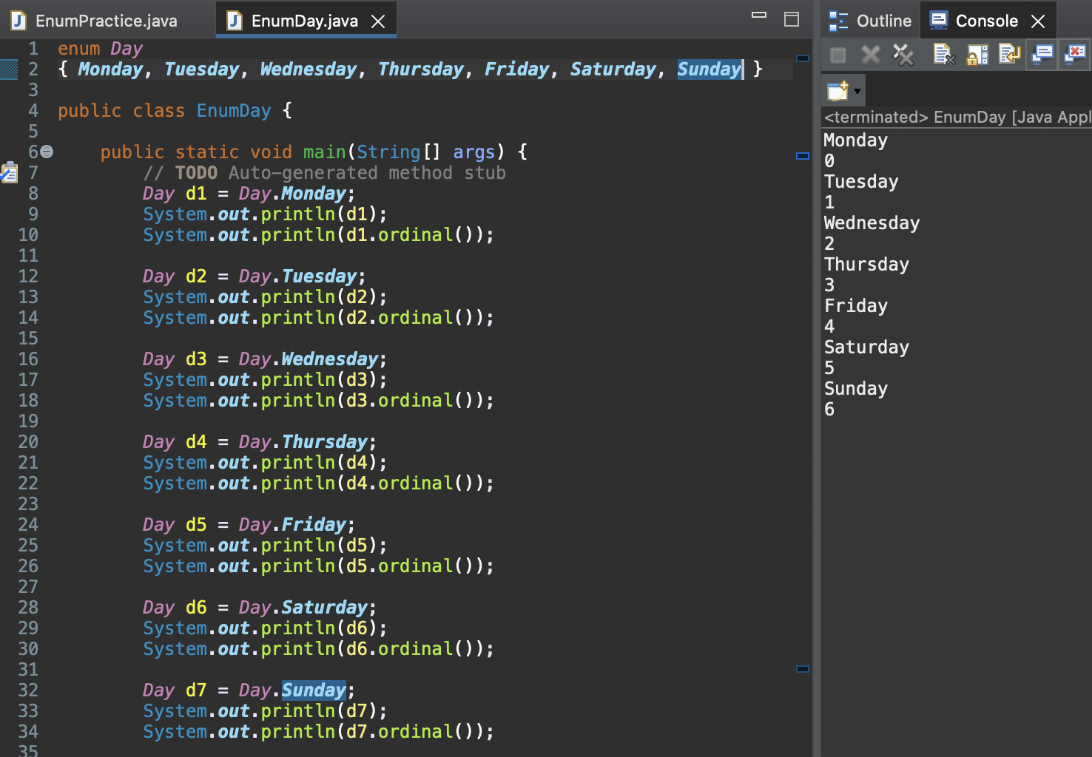

1. Write an application that reads the (x,y) coordinates for two points.  Compute the distance between the two points using the following formula:

A sample of what your output should look like appears below:

Enter the first x coordinate:12.0

Enter the first y coordinate:24.0

Enter the second x coordinate: 67.0

Enter the second y coordinate: 89.0

Write down formatted output about two decimal places using **DecimalFormat.**

The distance between points [12.0,24.0] and [67.0, 89.0] is 85.14.

1. Write an application that reads the lengths of the sides of a triangle from the user.  Compute the area of the triangle using Heron's formula in which s represents half of the perimeter of the triangle, and a, b, c, represent the lengths of the three sides.

Below is a sample of what your output should look like:

Enter the length of side A (integer):

Enter the length of side B (integer):

Enter the length of side C (integer):

The area is xyz.yz

The output will be formatted two decimal places using **DecimalFormat.**

The result is : 16.70

