**TranzVolt 2.0**

Interdisciplinary Group P06 (Capstone Team)

Primary Advisor: Dr. Tom Collins

Secondary Advisor: Dr. David MacNair

Georgia Institute of Technology

North Ave NW, Atlanta, GA 30332

Client: Tie Down Inc.

Team Members:

Juyeop Baek, Oliver Bunner, Su Yoon Jang, Raymond Jia, Dakota Survance, Sri Krishna Yerramilli

March 16, 2022

Table of Contents

Executive Summary 3

Nomenclature & Glossary 4

1. Introduction and Background 5

2. Existing Products, Prior Art, and Applicable Patents 5

3. Codes and Standards 8

4. Customer Requirements and Engineering Design Specifications 9

5. Market Research 13

6. Design Concept Ideation 15

7. Concept Selection and Justification 20

8. Industrial Design 23

9. Engineering Analyses and Experiments 24

10. Societal, Environmental and Sustainability Considerations 27

11. Team Member Contributions 27

12. Summary & Future Work / Project Deliverables 28

13. Citations 29

Appendix A 31

Appendix B 35

Appendix C 38

Appendix D 39

Appendix E 40

# Executive Summary

Although the current ladder hoists made by Tie Down are capable of carrying heavy and delicate equipment from ground level to roofs, we believe certain improvements can be implemented to enhance the customer’s experience with the product, while simultaneously decreasing costs in manufacturing. Because ladder hoist production is such a small market, dominance comes down to minute details, such as the speed of the carriage, or the customer setup time. The current major problems where TranzVolt requires assistance are the inefficient architecture, safety issues from rope reliance, and the difficult user interface. Our objective is to redesign the device to address all issues, by first separating the motor from the carriage for deadload weight reduction. We then plan to rearrange the wheel-to-ladder system, so that not only is TranzVolt compatible with multiple extendable ladders, but a safety apparatus would prevent injury if the rope were ever to be damaged. Finally, we hope to develop a new user interface for the remote control, to a more beginner-friendly layout. For the final prototype, we are estimating a 1.5 feet per second carriage speed with a 275-pound lift capacity. Thus far, we have worked separately from another team focusing on mechanical design, group 19 [Location Possessors] for our deliverables. However, due to the encouragement of Tie Down Inc. and our advisors, we have decided to collaborate for our final prototype. After a meeting with both teams presenting their own ideation reports, we have settled on a design of the device, with the ME team in control of the physical ladder and device design, and the ECE team in control of the motors, power, and the remote-control system. Our next steps are to separately engineer our individual portions, while staying in close contact with each other. We plan to integrate our devices into a single lift hoist before the expo.

# Nomenclature & Glossary

**Nomenclature**

1. lb. = pounds
2. Ft = feet
3. BMS = Battery Management System
4. RoHS = Restriction of Hazardous Substances in Electrical and Electronic Equipment

**Glossary**

1. AIEE: Assess Identify Exercise Educate
2. ECE: Electrical and Computer Engineering
3. GEDA: Georg Dechentreiter, Asbach
4. IEEE: Institute of Electrical and Electronics Engineers
5. ME: Mechanical Engineering
6. RGC: Reimann & Georger Corp.
7. UI: User Interface
8. RPM: Revolutions Per Minute
9. MCU: Microcontroller Unit
10. TI: Texas Instruments

# 1. Introduction and Background

In the industries related to roofing installations, there is often a need to transport construction materials from the ground level onto the rooftop. As construction workers rely on ladders to gain access to the rooftop, carrying heavy or bulky construction materials up and down these ladders are unsafe and not feasible. Construction workers often resort to boom lifts or scissor lifts to transport materials to the rooftop. However, these vehicles are expensive and difficult to transport, often excessive for simple roofing repair or solar panel installations.

Our sponsor, TranzVolt, specializes in building a portable ladder lift system for carrying construction materials onto rooftops in a fast and efficient manner. Our group is working in collaboration with group 19 [Location Possessors] to develop an improved system for TranzVolt, seeking to build a solution for extending ladder tracks as well as creating a new system with additional safety features. We will address the existing problems of high dead-load, freefall hazards, and a steep learning curve in our design. A faster, yet safer ladder hoist can most definitely increase the customer interest, while extendable ladder compatibility can enlarge Tie Down’s market. In this document, we discuss existing work regarding construction lifting systems and our planned approach to the completion of this project.

# 2. Existing Products, Prior Art, and Applicable Patents

Investigating existing patents for construction lifting devices, we find three existing patents.

Patent US2394148A from 1946 by Campbell is a design for a hoist attachment for ladders. The design incorporates a pulley system at the top and a cable design to pull a payload sled up the ladder. The attachment is attached to the top of a normal ladder and enables the payload sled to smoothly reach the rooftop. See Appendix A for a diagram of patent 2394148.

Patent US2626683A from 1953 by Eppink is a design for a material elevator attachment for ladders. The design also incorporates a pulley system at the top and uses a cable to pull a payload sled up the ladder. However, this design further specifies the existence of a hand-cranked winch at the base of the ladder, and the payload sled itself is much larger in comparison to Campbell’s patent. See Appendix B for a diagram of patent 262683.

Patent US10415309B2 from 2019 by Liu is a design that can hoist a platform onto heights with a ladder as a supporting device. It utilizes a sliding rail for the platform, so that the wheels are always attached to the ladder. It also includes a fall arrester in case of rope damage and contains a universal middle rail so that the product can be attached to any ladder that the customer owns. However, no methods are stated on how to get the platform down once it stops from free-falling. It also uses pedals at the bottom to control movement instead of a remote control, meaning the user would be vulnerable to any load that falls off the platform. See Appendix C for a diagram of patent US10415309B2.

Investigating current market competitors and active commercial designs, we found three existing designs.

The Safety Hoist CH200 is a steel-based ladder hoist that can lift a payload of 200 lb. and powered by a Honda gas engine. Although the weight able to be lifted is better than TranzVolt, the gas-powered engine can bring up environmental concerns, and Tie Down requires the use of brushless electric motors. The design also utilizes a cable-pulley system and is controlled by a pedal and lever attached physically to the base of the system. Again, this can lead to safety concerns as materials can fall from the platform, injuring anyone standing near the ladder. In addition, constant push or pull of the pedal is required by the user for full motion. See Figure 1 for a picture of the Safety Hoist system.

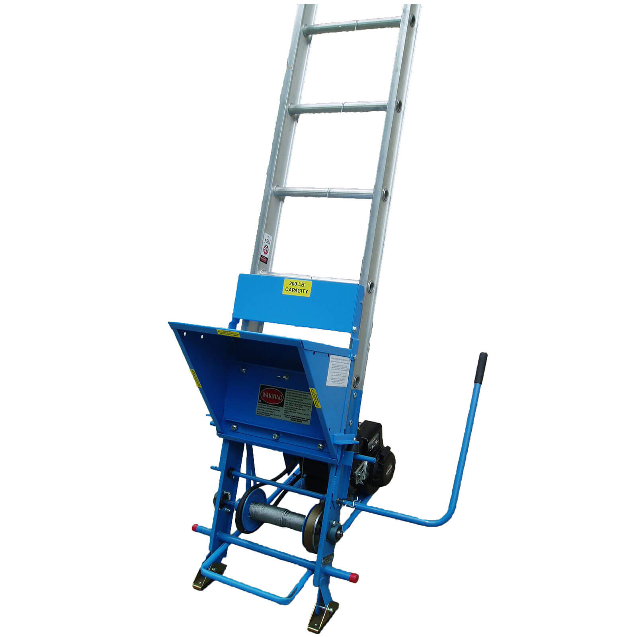

Figure 1. Safety Hoist System CH200

The RGC Pivoting Platform is another ladder hoist, but with the ability to lift a payload of 400 lb. The system is powered by a gas or electric engine and the ladder implements a unique design where the top of the ladder flattens out to ensure easy retrieval of the payload by the user. It also contains anchor points on the third and fifth rungs so that stability is not just relying on the friction of the ladder against the wall and the ground. Although the ladder supersedes TranzVolt in all requirements, it does have a much steeper price tag, more than double what the TranzVolt costs. The controls are attached to the ladder, again bringing the user in danger from falling payloads. See Figure 2 for a picture of the RGC Pivoting Platform.

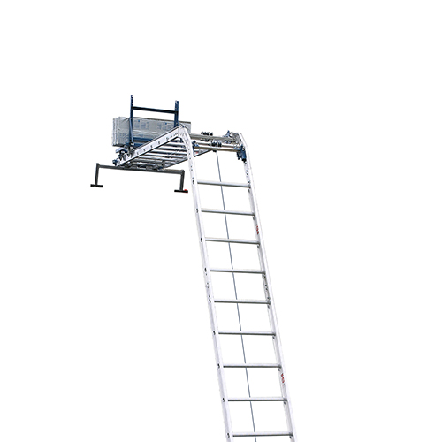

Figure 2. RGC Pivoting Platform

The GEDA ladder lift is the direct competitor of the TranzVolt systems. Like previously mentioned systems, GEDA uses a payload sled along with a cable-pulley system powered by an electric motor to transport the payload. It is known for being quiet during operation and requiring extensive training and setup for operation. See Figure 3 for a picture of the GEDA ladder lift system.

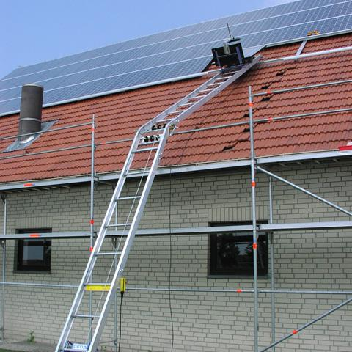

Figure 3. GEDA Ladder Hoist

After looking at previous patents and competitive products, we can easily detect what elements can be added to distinguish our design from others. A huge problem that all of these products bring to light is the lack of an emergency stop mechanism. Even if the platform were to stop midway to stop free fall, none of the previous devices contain a mechanism to safely bring down the payload for safety. Another surprising problem not addressed by competitive products is the lack of a remote control, to protect the user from being too close to the ladder. This is especially surprising, since wireless communication has been integrated into household equipment for a long time. If we were to create a beginner-friendly remote control that keeps the user away from dangerous falling payloads, we would most definitely differentiate ours from the market. On the other hand, some aspects can inspire ideas for our product, most notably the mechanisms to ensure safe unloading of the payload on rooftops as well as the single universal rail for ladder versatility.

# 3. Codes and Standards

Investigating related codes, we find two documents relevant to our work. The AIEE Test Code for Evaluation of Systems of Insulating Materials for Random-Wound Electric Machinery [1] may be used for the evaluation of insulation of our electrical equipment and determining their temperature classifications which further used to define the safe operating limits of our product. The 2017 National Electrical Safety Code [2] may be used for the safety evaluation of our systems used for generation, transmission, and distribution of electricity and communication signals.

Investigating related standards, we find two documents relevant to our work. The AIEE Switchgear Assemblies [3] standard covers the assembly of switchgear devices such as switches, interrupt devices, and controls which we may use to evaluate our choice of components. The IEEE Standard for High-Voltage Testing Techniques [4] covers basic standards and techniques for high-voltage testing of our equipment as well as special procedures for testing the equipment in dry, wet, or contaminated conditions.

# 4. Customer Requirements and Engineering Design Specifications

In order to identify the requirements and determine design specifications for the project, we first must identify the stakeholders in this project and their level of influence on the design. The main stakeholders in this project are Tie Down and Mohammed Aamir, the Tie Down representative, while the secondary stakeholders include Dr. Tom Collins, Dr. David MacNair, and the Georgia Institute of Technology. Their interests and influences can be seen in Table 1 and a diagram of their relative importance and influence can be found in Figure 1.

|  |
| --- |
|  |
| Table 1. Stakeholder Matrix |

After identifying our main stakeholders (Mohammed and Tie Down) and their influence on the system design, we held extensive discussions to receive and understand the necessary customer requirements. The requirements that were identified are as follows: 1) The design should have a substantial operating life. 2) The design should be easy to set up and require minimal training to operate. 3) The design should primarily minimize dead load while maximizing the lift capacity and lifting speed. 4) The design must also be able to reach standard roof heights while also portable for ease of transport of the system. 5) The design should be capable of transporting typical roofing materials safely. To ensure that this final design requirement is achieved, the design will be able to fasten materials to the lift to prevent horizontal movement of the payload. A braking system will also be in place to save the payload if an accident occurs, and the system ends up in a state of free-fall.

With the customer requirements identified, we began to investigate functional demands of the system. We recognized that functionally, the design needs to climb a ladder, secure a payload, carry a payload, and operate through remote control by a human user. We also determined that the design should be capable of 1) detecting overweight payloads and weight imbalances, 2) tracking angle irregularities, and 3) recording battery percentages. These functions are not as essential to the basic functionality of the system but are nevertheless prominent features that aid the operation and maintenance of the design. Beyond functional capabilities, several constraints were also identified relative to the design. Physically, our design will be constrained by the structural strength of the materials used, as well as the materials available for use. Because our client, Tie Down, requests that we use their custom aluminum track section, wheels, pulleys, sheet metal, and tube components, the design will be constrained by the strength and physical limitations of these components. Our design will also be constrained by the size of standard construction vehicles, as it must be capable of being transported to a wide variety of construction sites by these vehicles. Electronically, our design will be constrained by the limitations of the battery components provided by Tie Down, limiting the amount of power we may draw to maximize operating cycles in one battery life.

Upon defining requirements, functionalities, and constraints, engineering specifications were created and tabulated into a specification sheet seen in Appendix D. Below are detailed explanations of the items listed in the specification sheet in Appendix D.

1. *General Specifications*

In the general specifications, we address the requirements of a long operating life and setup requirements. After discussion with the client, it was agreed that the system must be able to transport a payload a minimum of 500 times, equivalent to a minimum of 500 operating cycles. It was also defined that ten minutes could be classified as the amount of time “minimal” training would be equivalent to. This same time threshold was applied to the setup time for the system.

1. *Physical Specifications*

In the physical specifications, we address the physical requirements of the entire system, lifting apparatus and track combined. To meet portability requirements, it was defined that the entire system should not weigh more than 50 lb. to be portable for construction workers.

1. *Electrical Specifications*

In the electrical specifications, we address the battery requirements of the system. We imposed electrical requirements for recording of battery life and a requirement for the battery capacity to last a minimum of 60 operating cycles. Beyond the battery, the client requested the ability to detect operation angles between 15 and 90 degrees and to prevent operation outside of these operating limits. We added this requirement by introducing the ability to detect payload weight imbalances more than 20 lb. per side as an added safety precaution.

1. *Mechanical Specifications*

In the mechanical specifications, we further addressed safety of the payload and safety relative to the operator. It was defined that the payload should not shift more than an inch during transport, any greater shift should be considered as dangerous operation.

1. *Performance Specifications*

In the performance specifications, we addressed the main client requests for minimizing the dead-load, maximizing lift capacity, and maximizing lifting speed. The client requested a maximum deadload weight of 20 lb., a minimum lifting capacity of 275 lb., and a minimum transport speed of 1.5 ft/sec. Requirements for system lift height were also addressed, with the client requesting a minimum lift height of 32 ft. Safety was once again addressed in this section, where we defined 0.05 seconds as a reasonable detection time of a cable failure and as the time within which a physical braking response must occur.

With the engineering specifications identified, we may use a House of Quality diagram to identify their relative importance, as seen in Figure 4.

|  |
| --- |
| Table  Description automatically generated with medium confidenceFigure 4. House of Quality |

# 5. Market Research

TranzVolt is a technologically advanced version of a standard roofing hoist. To alleviate the issues or hazards faced by roofers and construction workers daily, it is tailored to specific industries. The market for TranzVolt consists of roofing contractors, construction companies, scaffolding rental services as well as other companies that offer similar rooftop services (solar panel companies are a good example). However, since the TranzVolt roofing hoist is a product of Tie Down, the team’s initial customer is Tie Down itself. In addition, the scope of this project is limited to delivering a final product that meets the requirements and specifications of the project’s liaison, Mohammed Aamir. Tie Down will then extend the use of this product to various companies that rely on them to provide a more efficient and better powered platform hoist than currently available on the market.

Since the final product is closely tied to the needs and specifications of Tie Down, market research plans such as customer surveys and focus groups are difficult to conduct and inefficient in terms of overall results. Instead, the most effective form of market research involves directly collaborating with Mohammed Aamir, who determines if the product meets customer requirements, along with three main steps:

1. Identifying the most important requirements and specifications of the product
2. Identifying positives and negatives of various competitor’s products that are currently available on the market
3. Analyzing prior art as well as currently active patents.

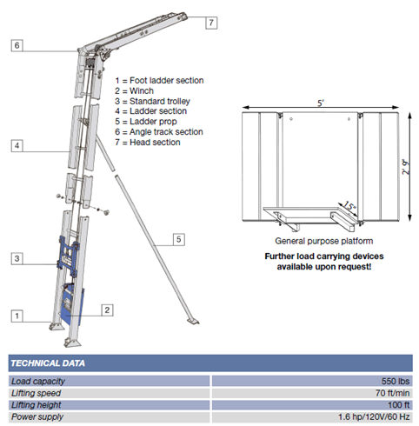

Figure 5. GEDA Ladder Hoist System

Research has established that the current TranzVolt Ladder Hoist is already one of the most advanced roofing hoist products available in the current market. Therefore, the focus is primarily on TranzVolt’s biggest competitor in this industry: GEDA. Details of this product are mentioned in Figure 5. Since the load capacity of this design is 550 lb at a power supply of 60 Hz and with a lifting speed of ~1.2 ft/sec, it has been established that the new TranzVolt design must be able to meet or exceed ~1.5 ft/sec average lifting speed along with a 275 lb lift capacity. However, there must also be improvements made in areas where the product from GEDA is found lacking. As of now, GEDA’s ladder lift comes with a steep learning curve for users. Set up often exceeds 15 minutes, and their design utilizes a cable that requires frequent maintenance due to fraying. Accordingly, the market strategy is to produce a design for the new TranzVolt that can improve on these drawbacks of GEDA’s ladder lift while reducing the overall cost of the product. Subsequently, market research indicates that a price of $2000 will prove to be extremely competitive, which is significantly less than the range at which GEDA sells their product ($3000-$4000). Furthermore, the design would have to be very intuitive and user friendly, taking no longer than 10 minutes to set up and incorporate better and more suitable material for the rope/cable.

Additionally, there are certain elements of the design that are tied to the needs of Tie Down or Mohammed Aamir. Extensive discussions about these requirements have allowed the team to produce two main requirements that are an absolute necessity for the product to prove competitive in the current market: total weight of the apparatus must be less than 50 lb and the deadload weight must not exceed 20 lb.

Moving forward, additional market information will be gathered through constant communication with the project’s primary stakeholders Dr. Collins and Mohammed Aamir to ensure that Tie Down as well as its customers will be satisfied with the final product.

# 6. Design Concept Ideation

Based on the customer requirements and specifications mentioned by Mohammed Aamir, five distinctive design ideations were brainstormed to account for different functional categories. The functional categories needed were determined using a function tree. Some of the key functions that are addressed in the ideation stage are efficiency, safety features, set-up time and lift rate. Although some of these functions have sub-functions, they were considered not as important towards the selection of the final design and therefore relegated to the morphological chart.

The first ideation incorporated the concept of dual motors. While this effectively doubled the existing lift speed by lifting more weight at a given time, the trade-off was there was no reduction in deadload weight, and the power consumption was doubled. This addressed one of the functional categories, that of safety. A second cable meant that the risk of one cable breaking and dropping the load could be mitigated. However, this came at the cost of increased set up time and having to maintain communication with two motors instead of just one.

Another ideation design featured a detachable carriage. This was specifically meant to tackle efficiency and throughput. Efficiency was significantly increased by separating the lifting carriage from the platform. This meant that unfolding could occur simultaneously while the carriage was descending. In addition, it also decreased the risk of system failure. However, the drawbacks of the design were that every TranzVolt would have to carry a lifting pad, a securing pad and two carriages. In addition, there was the possibility of increasing dead load, and material selection was crucial to ensure that the carriage could be secured on its own.

The counterweight design ideation was created to meet the requirements of increased lift rate and lift capacity. This design allows the load to ascend at a faster rate and descend at a slower rate, all while increasing usage cycle life. However, one issue with this design is that there is a longer setup time due to the pulley system for the counterweight. In addition, there is increased inherent system risk as the rope breaking would lead to 2 falling objects (both the counterweight and the TranzVolt platform).

Finally, one of the most innovative ideas involves the use of magnetics instead of tracks for the TranzVolt. In this, a strip of magnet cells is attached to the side of the ladder and electromagnetic forces are used. Lift force is generated by attraction/repulsion and there are no motors present in the system. Since there is no motor, the dead-load is significantly reduced, and this also leads to an increase in the lifting rate of the system. This revolutionary design can also significantly change the current market. However, there are certain tradeoffs to the design. The required magnets may be difficult to obtain, increasing cost as well as causing maintenance issues. In addition, this design is more prone to electrical failures.

A morphological chart (shown in Figures 6 – 11) was designed to analyze possible design solutions to the ideations and functional requirements of the project. The primary functions tackled are listed vertically in the morphological chart while the different ideas discussed and later quantitively evaluated are presented horizontally in the same chart.

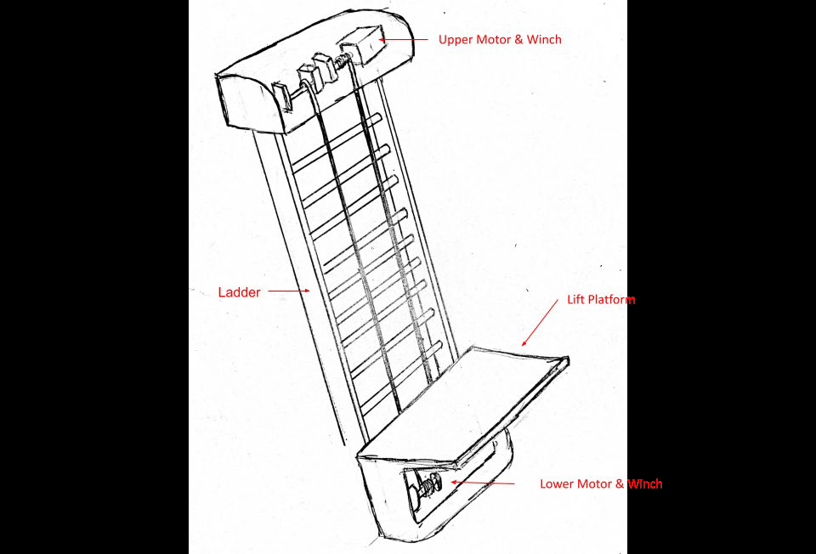

Figure 6. Design 1: Dual Motors

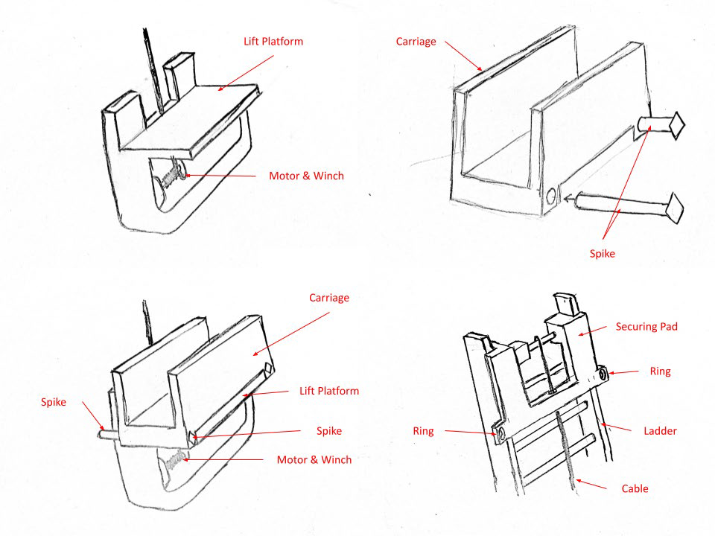

Figure 7. Design 2: Detachable Carriage

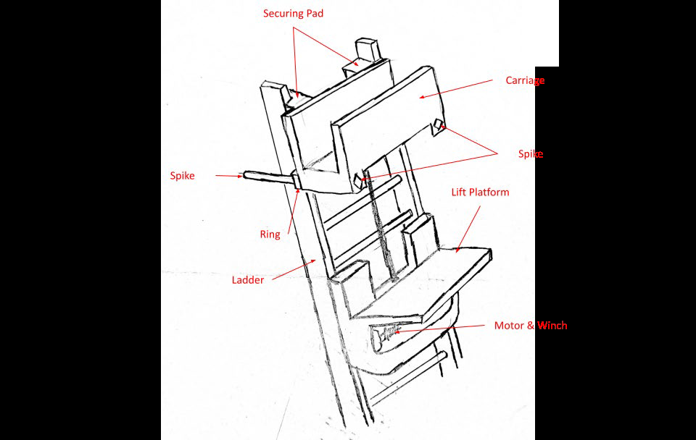

Figure 8. Design 2: Detachable Carriage

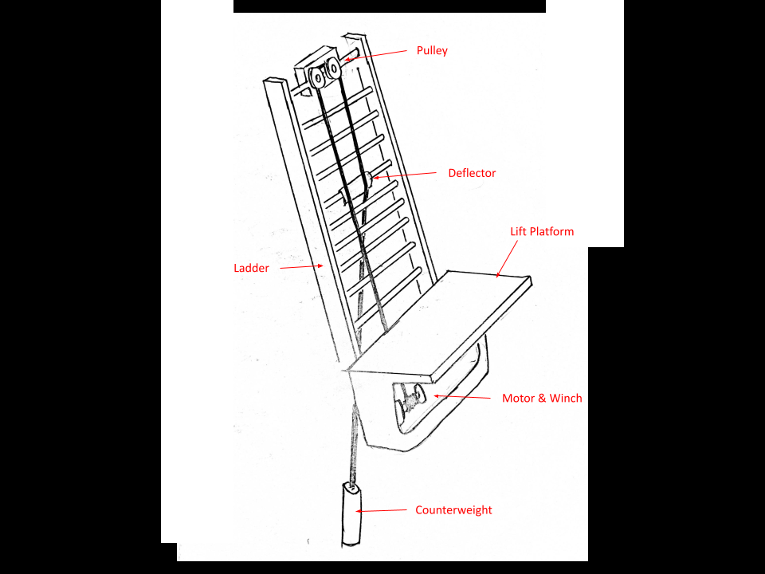

Figure 9. Design 3: Counterweight

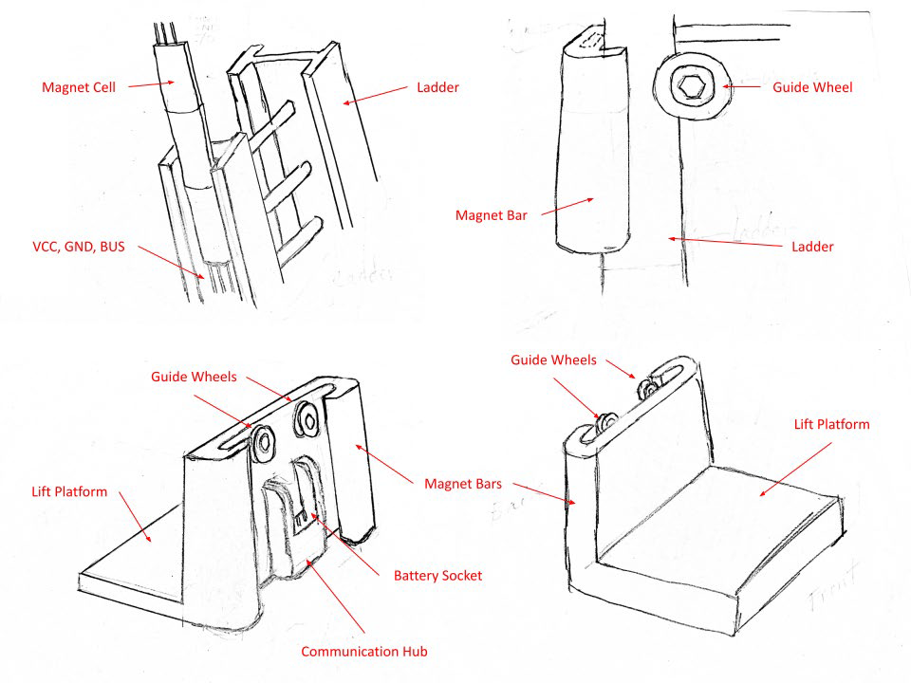

Figure 10. Design 4: Magnetics

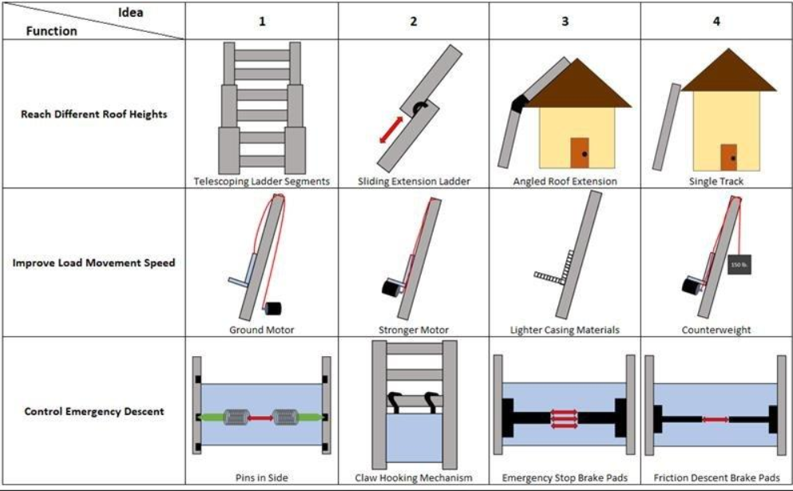Figure 11. Morphological Chart

A couple of the ideas talked about earlier include specific safety features that were deemed necessary in the final TranzVolt design. These include the idea of a detachable carriage as well as a braking system in the unlikely event of a rope/cable breaking.

# 7. Concept Selection and Justification

Since the final product incorporates both mechanical and electrical elements, there has been a mutual agreement between the two teams working on TranzVolt to collaborate. This has been according to the wishes of Mohammed Aamir and Tie Down, as it was deemed necessary in order to come up with a more well-designed and complete product.

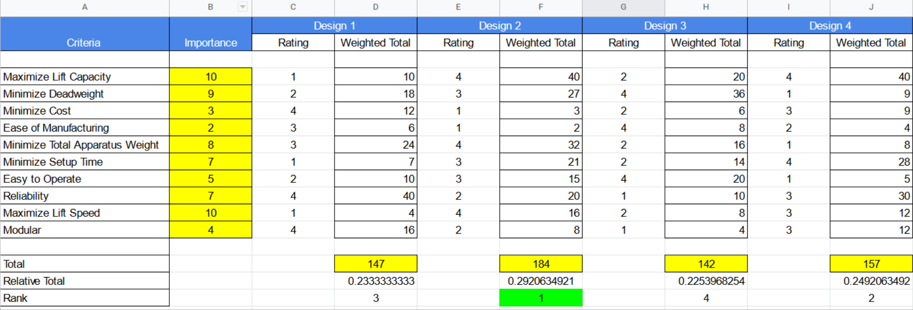

Figure 12. Evaluation Matrix

The generated concepts that were previously discussed in the Morphological Chart along with all the design ideations are combined in order to evaluate the completed design. These are then quantitatively analyzed using a 2nd level evaluation matrix (shown in Figure 12) to determine the best design. The evaluation matrix itself is designed to incorporate several requirements of Tie Down for the product. These criteria are then assigned a relative importance from 1-10, where 1 is the least important and 10 is the most important. Each design is then given individual ratings for all criteria present in the evaluation matrix. The ratings are assigned through extensive discussions with the team as well the representative from Tie Down, Mohammed Aamir. The rating is then multiplied by its importance in order to compute a relative weight for that criterion and design. These relative weights are then summed up to determine what design performs the best across all major criteria. This evaluation matrix is presented below.

In the evaluation matrix, it can be seen that ‘maximize lift speed’ and ‘maximize lift capacity’ are rated 10 in terms of importance. This is because market research, as well as prolonged discussions, have determined that these categories are the most important for TranzVolt to be a successful product in the current market. Since the currently available products in the market are already quite expensive, ‘minimize cost’ has been assigned a relatively low rating of 3. Similarly, since the product is going to be manufactured locally using Tie Down’s resources, ease of manufacturing is one of the least priorities. Accordingly, it has been given the lowest importance rating of 2.

As seen from the evaluation matrix, Design 2 is clearly the best. There are a few key elements present in Design 2 that make it significantly favorable over other designs that are being evaluated. Primarily, to reach different roof heights, this design incorporates a sliding extension track. This is a workable solution primarily because of the tradeoffs and impracticalities that other options will bring into the overall design. For example, one approach is to use a single track. However, this is clearly not a workable solution for the overall design as most roofs are ~ 32 ft high, and commercial vehicles that transport roofing tiles or solar panels do not have the capability to transport a 32-foot-long track. In fact, this would hurt Tie Down’s existing consumer base, because market research confirms that they do not have the vehicles necessary for this design to be successful. Another approach is to use telescoping ladder segments to minimize the space required for transportation. However, this creates an imbalance between the weights that different segments of the ladder can support. This trade-off is not ideal for TranzVolt. Finally, the last approach takes a considerably basic design and tries to create a universal one-for-all fit which would not work because of the wide variety of rooftop angles, edges, and shapes. Going back to the chosen solution, one of its most important benefits is the minimizing of set up time, since the two tracks can be pre-assembled. According to the evaluation matrix, set-up time is given a high importance rating of 8, therefore this design is ideal.

Another particularly important criterion is the load movement speed (lifting speed). Once again, the selected design had the best solution to this problem via the use of a ground motor, which optimizes speed in exchange for a slightly longer set-up time. Alternatives 2 and 4 run into the issue of having too much deadweight, which adversely affects lifting speed. In addition, the option that uses a counterweight also has problems regarding increased risk of failure and increased cost while presenting some engineering complexities. A potential solution could have been to use lighter casing materials while maintaining a similar design to the previous TranzVolt product. This also had the benefit of maintaining familiarity with current customers. However, most of the total apparatus weight present is taken up by deadweight such as the motor, batteries, and other electronics, none of which can be reduced in weight using material selection. Hence, the first choice is clearly the best because it significantly reduces deadweight as the motor and other electronic components are no longer in the carriage. This decreased weight means that the load can be lifted much faster with the same inherent power supply.

Once the final design was selected, the two teams decided to split the work as per their team’s expertise with one team handling the ladder and cart, and the other team handling the motor and control system. As in the chosen design, there are no electronics involved with either the cart or the ladder.

Finally, there are very few risks associated with the selected design. One of them is that in the unlikely event that the rope breaks, there is no mechanism to ease the load down at a slow pace. This sudden breakage could lead to the load on TranzVolt dropping or lead to other safety concerns. However, there is already a counter mechanism in the form of a jammer that stops the load from moving from its original position at the time of breakage.

# 8. Industrial Design

Some of the key Industrial Design considerations that influenced our TranzVolt controller design were Aesthetics, Ergonomics, Materials. Modularity and Protection. Our controller design consists of a much simpler UI interface with only 3 buttons instead of the 6 buttons that were present in the previous iteration of the controller. This eliminates the inconvenience of having to press a combination of buttons. However, the overall shape and aesthetics of the controller have been kept the same to maintain familiarity with the existing users of the tranzVolt controller. More importantly, the design does not overly focus on aesthetics to a point where it sacrifices functionality. In addition, the wired controller is also comfortable and intuitive to use. The emergency stop button is bigger than the other two buttons and is circular in shape so that it is easier to press. The up and down buttons are clearly labelled, and all 3 buttons only need to be pressed once to achieve their functionality.

The materials for the controller were carefully selected in order to find a balance between cost of production and expected lifecycle. Compatibility between these materials was ensured to avoid the controller failing before its expected lifecycle. Some of the key features we consider essential to our product include: an operating range of –20C to 60C, a thermoplastic enclosure, shock absorption and anti-slip features on the back of the controller. Furthermore, the controller was designed keeping modularity in mind. The main casing consists of 2 separate parts that can be taken apart quite easily (4 screws) to perform maintenance checks or make repairs to the device. The buttons are also all separately purchased for the same purpose. This makes further upgrades easy and greatly simplifies repairing of the TranzVolt controller.

Our design has clearly labeled up and down buttons with text and a universal red emergency stop button to keep the UI interface as intuitive as possible for TranzVolt customers. This also reduces the learning curve for new operators of the TranzVolt product.

Since our team is responsible for the motor. BMS, microcontroller unit and controller design of the TranzVolt, importance was not given to aspects like branding, concepts, logo, textures or colors. Nevertheless, the controller maintains a similar design to its predecessor.

# 9. Engineering Analyses and Experiments

After reading through multiple datasheets, we chose a chip for our Battery Management system that was both reasonably priced and capable of accomplishing our desired goals. We tried to simulate the system but was unable to find the component on any available software. When trying to manually enter the component on LTSpice, the simulation did not successfully finish. Thus, we will start with bread boarding our Battery Management System PCB to ensure that it will protect the battery before printing a test PCB as soon as we get our parts. Following the datasheet, we designed the BMS (Battery Management System) around a battery management IC, BQ7790400PW. The schematic of the BMS PCB is shown in Figure 13 which will be used as a guide for breadboarding as well. The BMS will be made to fit around the current PCB in the TranzVolt, shown in Figure 14.

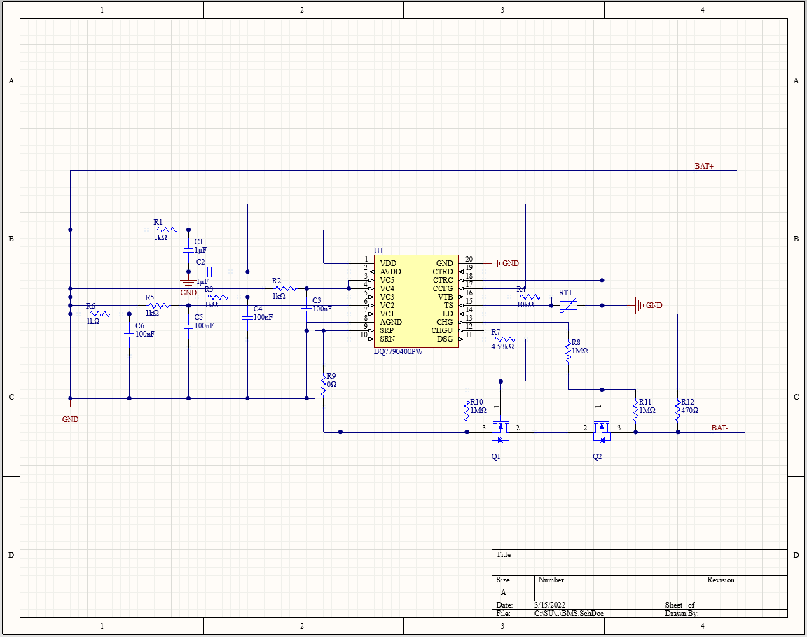

Figure 13. Altium Schematic of Battery Management System PCB

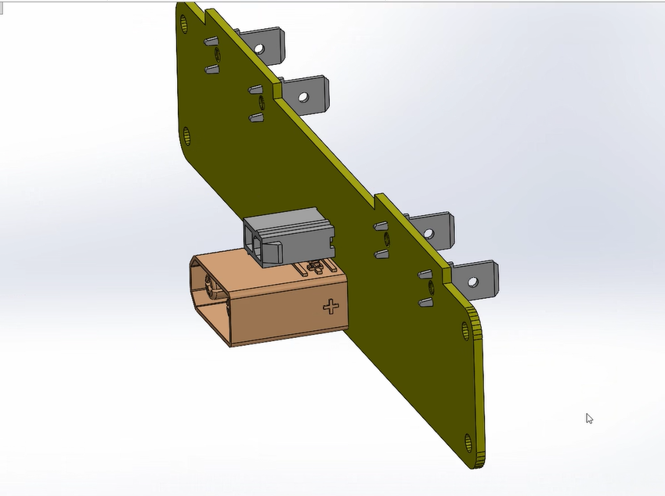

Figure 14. CAD model of current Battery PCB inside TranzVolt

For the UI subsystem, the software TinkerCAD proved especially useful. We were able to create a test circuit with an Arduino Uno (the programming of which will be the same as our Nano BLE), some switches, and some LEDs. With this simulation, pictured in Figure 15, testing our wiring and code became much easier. We connected all of the components and uploaded version one of our code. The simulation worked as we expected, and our code reached all the expected states as indicated by the two LEDs. TinkerCAD is also able to export a schematic of the simulated circuit (Figure 16). Once our parts arrive, we will physically build the circuit and verify again that our code and UI functions as we expect it to.

Figure 15. TinkerCAD circuit of UI subsystem with LED indicators

Figure 16. TinkerCAD schematic of UI subsystem

With regards to the motor subsystem, we currently have no way to simulate our code. Our chosen method of communicating with the Flipsky motor controller is over UART communication. This allows us to send commands to the motor controller, as well as receive data about the motor. This is vital as we need to access current and RPM values for our auto-homing algorithm. The drawback of this is that we cannot run a simulation of a basic DC motor that most simulation software supports. We were not able to find software that would support simulating custom UART signals. However, we have finished version one of our motor controls and are waiting for our parts to come in so we can verify functionality physically. The UI sub team has verified that the code enters the correct state (Up, Down, Stop, etc.) as expected, so once we have batteries and a motor, we can build a test circuit and verify the motor functionality as well. Our version 1 of both the UI and motor control code is included in appendix BLANK.

# 10. Societal, Environmental and Sustainability Considerations

Sustainability is extremely important as engineers we need to do our best to move forward with solutions that will not compromise the needs of future generations. One of the dimensions of sustainability is social. The goal is for our product to increase the quality of life by increasing the usability and efficiency of the current TranzVolt.

For environmental considerations on sustainability, we used RHoS Compliant components when choosing electrical parts of the Battery Management System. This means that all the components used in our BMS is lead-free directive. We also do not use any of the hazardous chemicals that require a Toxic Release Inventory filing. We are currently designing our BMS system to also cell-balance the batteries to extend their lifetime in consideration of waste. But because one of the requirements is to use the same motor, there is very little change we can make with power and energy consumption.

With regards to social impact, most of our design decisions were centered around the health and safety of those operating our TranzVolt. With our updated design, we have ensured that in an emergency situation, such as the rope snapping, the payload will not come crashing to the ground. We have also designed our UI such that if the operator were to drop the remote and walk away or not be able to operate the machine for whatever reason, the functionality of the machine will not be a risk to anyone’s safety. In addition, because our product is typically used by construction crews, we have designed the TranzVolt to operate quiet enough as to not disturb the local community, such as a residential area.

# 11. Team Member Contributions

Dakota Survance, the Team Lead, is responsible for submitting the weekly reports and communicating on behalf of the team with our advisor, Dr. Collins. Dakota has been taking charge of dividing up the workload among the team, scheduling meetings and meeting notes. He is on the Motor Control Subsystem Team as well as the BMS team.

Su Jang, the Sponsor Liaison, is responsible for communication on behalf of the team with our sponsor, Aamir Mohammad. Su has been meeting with the sponsor weekly and communicating their requirements to the rest of the team. She communicated with the collaborating team initially before the Team Liaison was appointed. She is leading the BMS Subsystem Team.

Raymond Jia, the Webmaster, is responsible for creating the team’s web page. He is leading the Motor Control Subsystem Team. Raymond was present at all the scheduled meetings and completed the tasks listed on the Gantt Chart located in Appendix E.

Sri Yerramilli, the Team Liaison, is responsible for communication between both sponsored teams. He is working with Juyeop Baek on the UI Subsystem.

Oliver Bunner, the Finance Manager, is responsible for managing the budget for the project. He is working with Sri and Dakota on the Motor Control Subsystem.

Juyeop Baek, the Project Manager, is responsible for the overall organization of the tasks and deliverables using a project management software known as Monday.com. He is working with Sri on the UI Subsystem.

All team members have completed their tasks on the Gannt Chart to date.

# 12. Summary & Future Work / Project Deliverables

Our teams toured Tie Down’s facility and interacted with the current TranzVolt seen in the market. After lengthy discussions with the collaborating team, group 19 [Location Possessors], which is composed of mechanical engineers, we concluded that it would be best to split the project into two parts: mechanical engineering and electrical engineering. The mechanical team is responsible for all the mechanical aspects of the project, which includes but is not limited to implementing the emergency braking system and designing the track and cart. The electrical team is responsible for the motors and the control system. We have chosen a battery management integrated chip and will start testing when parts come in.

Our team has come up with a new BMS system (TI BQ 77904 IC) that adds voltage protection and overcurrent protection to the previously existing thermal sensor safety mechanism. The MCU design was upgraded from the Icarus Control Unit (ICU) to the Arduino Nano 33 BLE which has Bluetooth capabilities. Furthermore, our team changed the UI controls to be more intuitive. The new controller design is much simpler and only consists of 3 buttons, while still removing the necessity to press a combination of buttons. This new wired design also eliminated receiver redundancy and battery dependency, two key issues with the previous controller design.

In the future, we plan on designing an auto-homing feature for the TranzVolt. As soon as parts come in, we plan on assembling our subsystems. We will continue to collaborate with group 19 to ensure our components are compatible with their mechanical design.

Juyeop oversees the organization of our project management software, Monday.com; this includes handling tasks and deliverables. A detailed Gantt Chart is provided in Appendix E that shows the current project plan. Once we choose the microcontroller we wish to use, the Gantt Chart will be updated with more details. Dakota, our team lead, has been communicating with our advisor via email and will continue to do so. Su, our sponsor liaison, has been communicating with our sponsor via Microsoft Teams and will continue to do so. Sri, our team liaison, will be communicating with the collaborating team via Microsoft Teams. He is also the lead for the mechanical aspects of our project, specifically the CAD designs and manufacturing of the TranzVolt controller. Raymond is our webmaster and is responsible for maintaining our team’s website. Oliver is our Finance Manager and is responsible for maintaining the budget of the project.

# 13. Citations

[1] "AIEE Test Code for Evaluation of Systems of Insulating Materials for Random-Wound Electric

Machinery," in AIEE No.1C-1954 , vol., no., pp.1-12, 12 Jan. 1954, doi:  
 10.1109/IEEESTD.1954.7369899.

[2] "2017 National Electrical Safety Code(R) (NESC(R))," in 2017 National Electrical Safety Code(R)

(NESC(R)) , vol., no., pp.1-405, 1 Aug. 2016, doi: 10.1109/IEEESTD.2016.7526279.

[3] "AIEE Switchgear Assemblies," in AIEE No 27A-1941 (Proposed Revision of AIEE No-27) , vol.,

no., pp.1-12, 28 Feb. 1941, doi: 10.1109/IEEESTD.1941.7393408.

[4] "IEEE Standard for High-Voltage Testing Techniques," in IEEE Std 4-2013 (Revision of IEEE Std 4-

1995) , vol., no., pp.1-213, 10 May 2013, doi: 10.1109/IEEESTD.2013.6515981.

[5] Hoist Attachment for Ladders, by H.L. Campbell. (February 5, 1946). US2394148A. [Online].

Available: https://patents.google.com/patent/US2394148A/en

[6] Material Elevator Attachement for Ladders, by E. George. (January 27, 1953). US2626683A.

[Online]. Available: https://patents.google.com/patent/US2626683#patentCitations

# Appendix A

**Patent ID:** US2394148A

**Patent Author:** Harry L. Campbell

**Patent Date:** 02/05/1946

**Attached Figures on Following Pages:**

Figure 1 - Side elevational view of the conventional form of a two section extension ladder having the improved material elevating and conveying mechanism mounted thereon.

Figure 2 – Enlarged fragmentary view showing the upper part of the improved attachment and illustrating the manner in which the carriage comes to a stop upon reaching the upper end of its travel.

Figure 3 – Substantially planned view-taken on the line 33 in Figure 1.

Figure 4 – Enlarged top plan view taken on line 44 in Figure 2.

Figure 5 – Enlarged cross sectional view taken on line 55 in Figure 1.

Figure 6 – Enlarged fragmentary and side elevational view showing the form of bridge which permits the carriage to pass over the bracket between the two ladder sections.

Figure 7 – A cross-sectional view taken on the line 11 in Figure 6.

|  |
| --- |
|  |
|  |
|  |

# Appendix B

**Patent ID:** US2626683A

**Patent Author:** George Eppink

**Patent Date:** 01/27/1953

**Attached Figures on Following Pages:**

Figure 1 – Front elevation view of a ladder equipped with the improved materials elevator.

Figure 2 – Oblique view of the winch assembly for the improved materials elevator.

Figure 3 – Oblique view of the pulley assembly for the improved materials elevator.

Figure 4 – Fragmentary, oblique view of the carriage for the improved materials elevator.

Figure 5 – Enlarged, fragmentary, side elevation view of the upper end of a ladder equipped with the materials elevator.

Figure 6 – Enlarged, fragmentary, partially sectional view of the handle mounting for the winch of the improved materials elevator.

Figure 7 – Sectional view taken along the plane VII-VII of Figure 6.

Figure 8 – Sectional view of the ratchet mechanism for the winch of the improved materials elevator taken along the plane VIII-VIII of Figure 1.

Figure 9 – Enlarged, fragmentary, sectional view of the mounting for one end of the pulley assembly of the improved materials elevator.

Figure 10 – Fragmentary, sectional, elevation view of the carriage which is used with a multisectoral ladder.

|  |
| --- |
|  |
|  |

# Appendix C

**Patent ID:** US10415309B2

**Patent Author:** Zhixin Liu

**Patent Date:** 09/17/2019

|  |
| --- |
|  |

# Appendix D

**Specifications Sheet**



# Appendix E

**Gantt Chart of Project Plan**

