Data Processing and Cleaning — Walkthrough
An Evaluation of Multi-Agent Reinforcement Learning for Dynamic Bus Scheduling Under Non-Ideal Conditions
Group B3 · University of Santo Tomas · CapMetro Rapid Route 801 (Direction 6) · Mid-Stage Assessment 1

This document records exactly how the CapMetro Automatic Passenger Counter (APC) dataset was processed into the per-stop inputs that parameterise the simulation. Each step gives the operation performed, the code that performs it, the reason it is done that way, and the figure that evidences it. It is a standalone reference: every number is reproducible from the raw dataset, and the complete script appears in the appendix.

1 Source and Scope
The empirical basis is the CapMetro APC dataset for July–December 2021, published on the Texas open-data portal. The study restricts attention to Route 801 — a high-frequency CapMetro Rapid corridor on which bunching is an operating concern — in direction code 6. The raw asset is ~3.7 GB and is never loaded whole; it is streamed in one million-row chunks, and only the thirteen required fields are read. Route 801 records ≈810,309 boardings over 184 service days in the window, and direction 6 contributes the 229,421 clean stop-events analysed here.
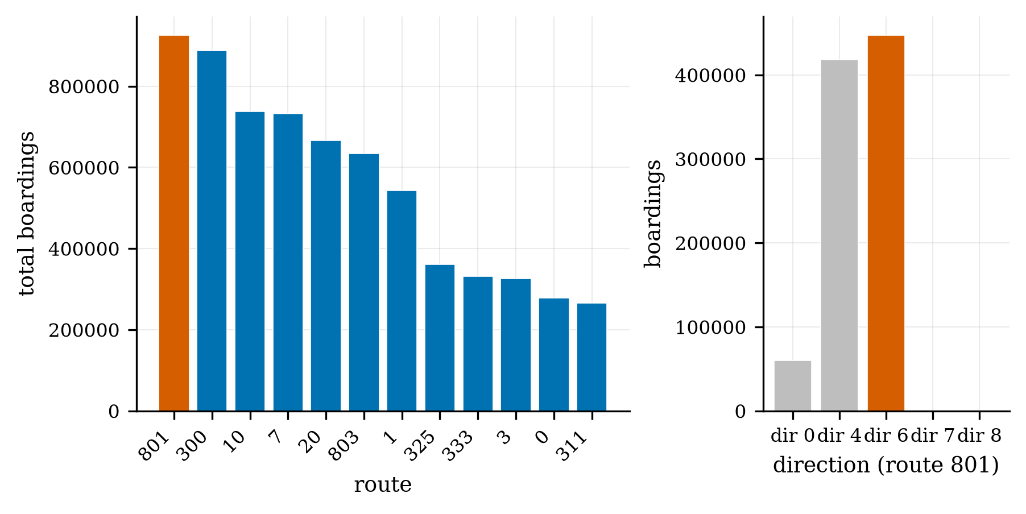
Figure 1. Route 801 is the highest-boarding route (left); direction 6 is the study direction (right).

2 Column Selection
Thirteen of the forty-seven APC fields are retained, each for a defined purpose. Two identify the route and screen for mid-service reassignment; two are data-quality gates; two locate the event; and the remainder carry stop order, demand, dwell, and segment time and distance, with the timestamp retained for scoping.
Field kept | Reason
route_id | Selects Route 801.
current_route_id | Must equal route_id — excludes trips reassigned to another route mid-service.
import_error | Kept only where 0 (record imported without error).
import_trip_error | Kept only where 0 (trip imported without error).
bs_id | Bus-stop identifier; bs_id = 0 (unknown) is excluded.
direction_code_id | Restricts to direction code 6, the study direction.
actual_sequence | Orders the stops along the corridor.
ons | Boardings (APC count) — the demand signal.
offs | Alightings (APC count).
dwell_time | Time stopped; the dwell parameter, and removed from rev_seconds to get running time.
rev_seconds | Revenue open-to-open time; the source of segment running time.
rev_distance | Inter-stop distance (miles; units flagged as unresolved).
transit_date_time | Timestamp; scopes records to July–December 2021.

3 The Six Cleaning Rules
A stop-event is retained only if it passes all six checks: it is on Route 801; the operating route equals the scheduled route (which drops trips reassigned mid-service); both import-error flags are clear; the stop identifier is valid (not zero); and the direction code is 6. Applied together, these reduce the ~9.2 million raw records to 229,421. The filter is expressed as a single boolean mask evaluated per chunk.
Excerpt — scripts/extract_sim_inputs.py: the streamed read and the six-rule mask.
for ch in pd.read_csv(RAW, usecols=need, dtype=str, chunksize=1_000_000, na_filter=False):
n_raw += len(ch)
m = ((ch["route_id"]=="801") & (ch["route_id"]==ch["current_route_id"]) &
(ch["import_error"]=="0") & (ch["import_trip_error"]=="0") &
(ch["bs_id"]!="0") & (ch["direction_code_id"]=="6"))
parts.append(ch[m])
df = pd.concat(parts, ignore_index=True)
print(f"raw {n_raw:,} -> dir-6 clean {len(df):,} (expect 229,421)")
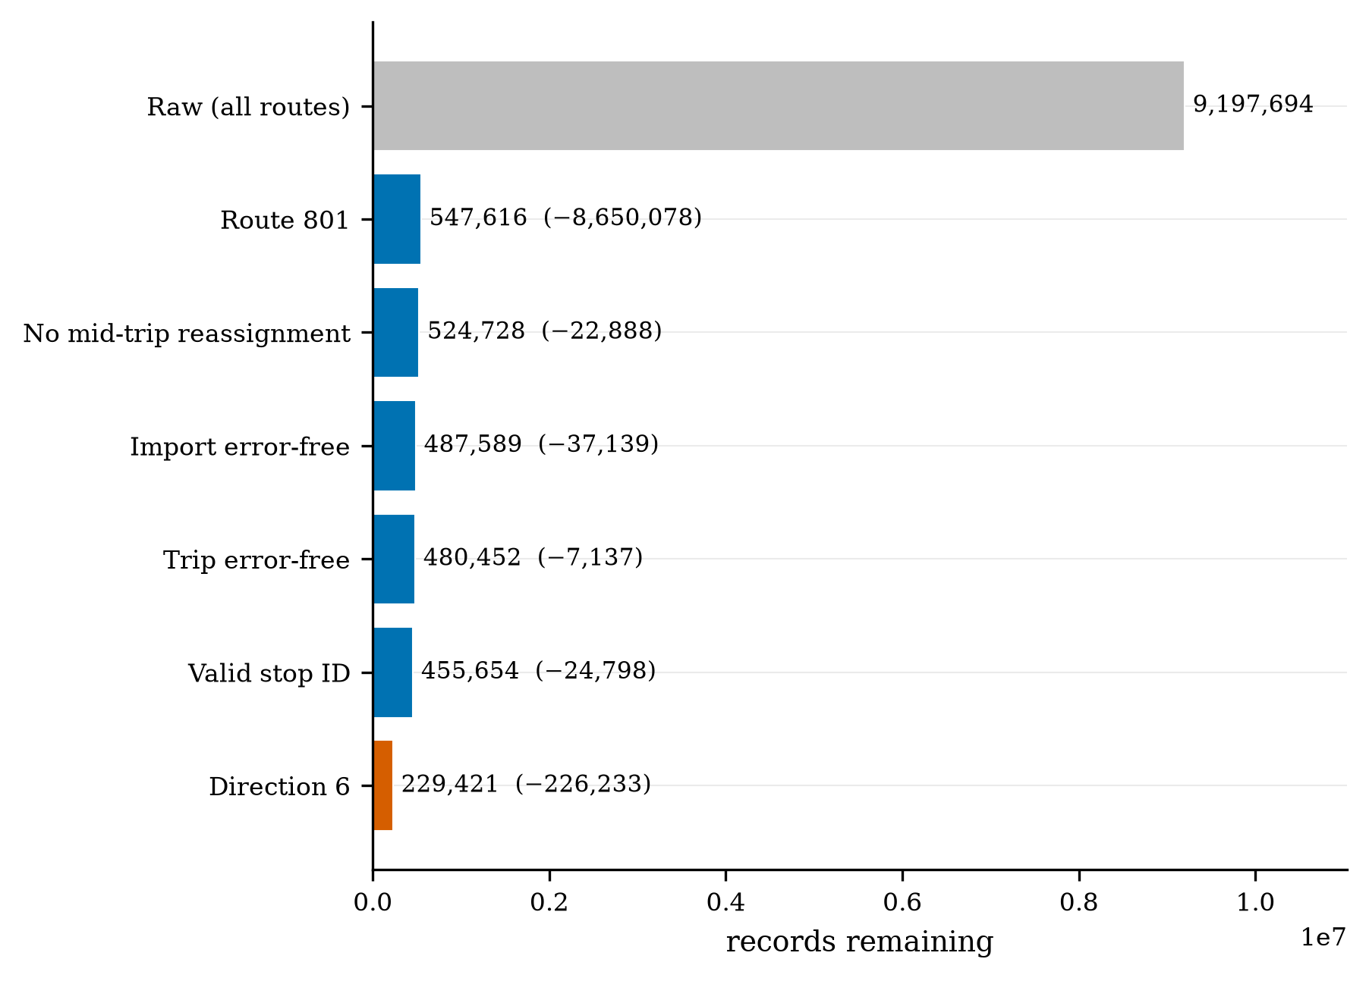
Figure 2. Cleaning funnel: 9,197,694 raw records reduce to 229,421 direction-6 stop-events through the six rules.
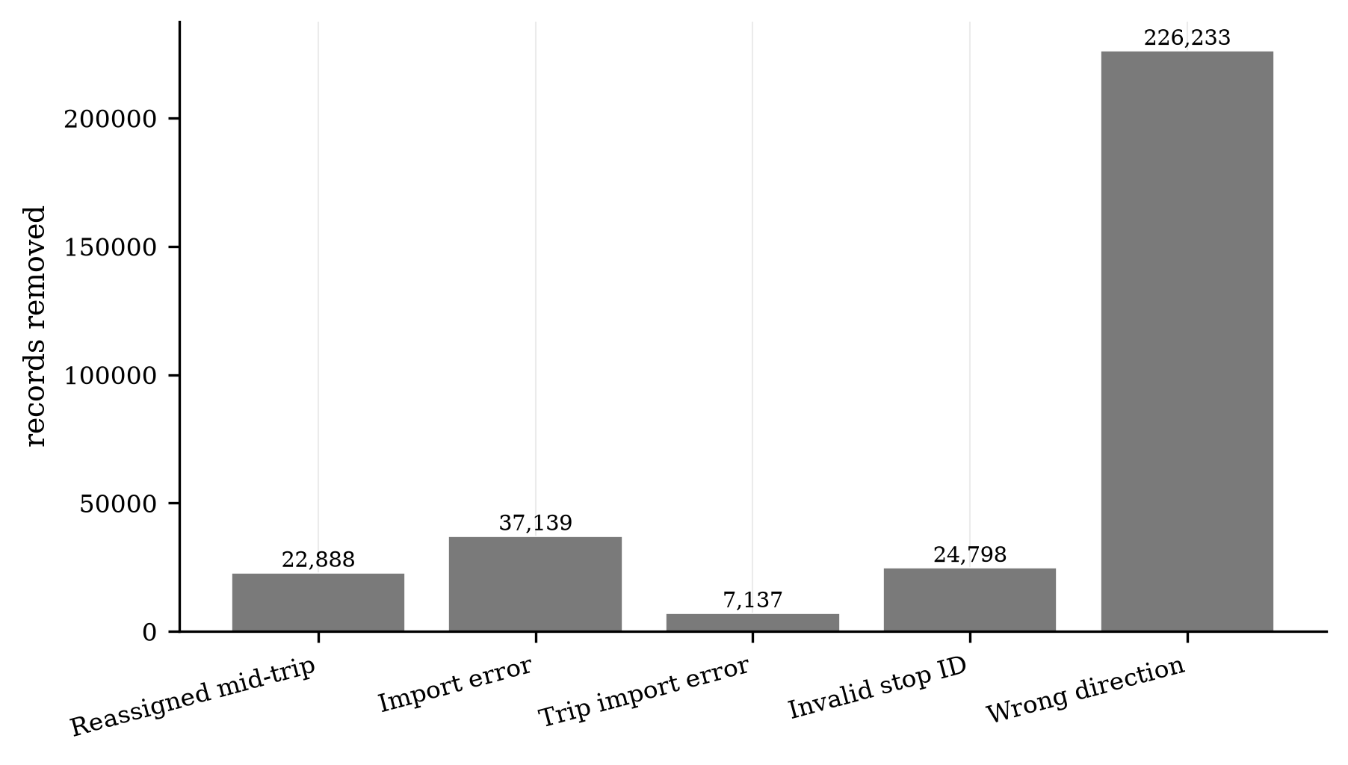
Figure 3. Composition of the records removed within Route 801, by rule.

4 Derivation and Aggregation
Two derived quantities are then formed. The segment running time is defined as rev_seconds − dwell_time, so that the originating stop's dwell is not counted twice. Per-stop parameters are reduced from the cleaned subset using the median for dwell, running time, and distance — which is robust to the long-tailed layover and outlier records a mean would distort — and the mean for boardings and alightings, which are the demand rates the simulator samples.
Excerpt — scripts/extract_sim_inputs.py: the derivation and the per-stop reduction.
df["run_seconds"] = (df["rev_seconds"] - df["dwell_time"]).clip(lower=0) # segment running time
stops = (df.groupby("bs_id")
.agg(seq=("actual_sequence","median"), mean_boardings=("ons","mean"),
mean_alightings=("offs","mean"), dwell_s=("dwell_time","median"),
run_s=("run_seconds","median"), dist_mi=("rev_distance","median")) # NOTE: rev_distance is MILES
.sort_values("seq").round(2))
stops.to_csv(f"{OUT}/stops.csv"); print("wrote sim_inputs/stops.csv", len(stops), "stops")
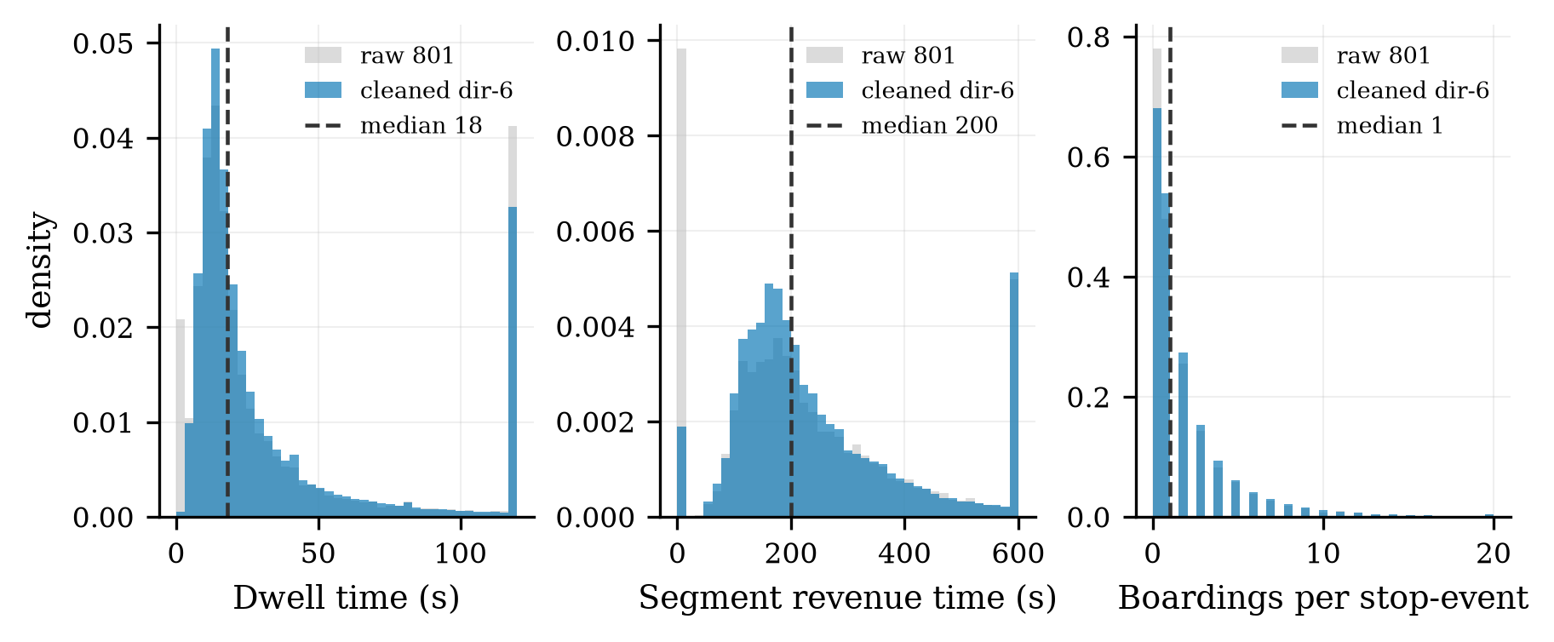
Figure 4. Raw vs cleaned distributions; the long right tails motivate the filters and the median aggregation (dashed = median).
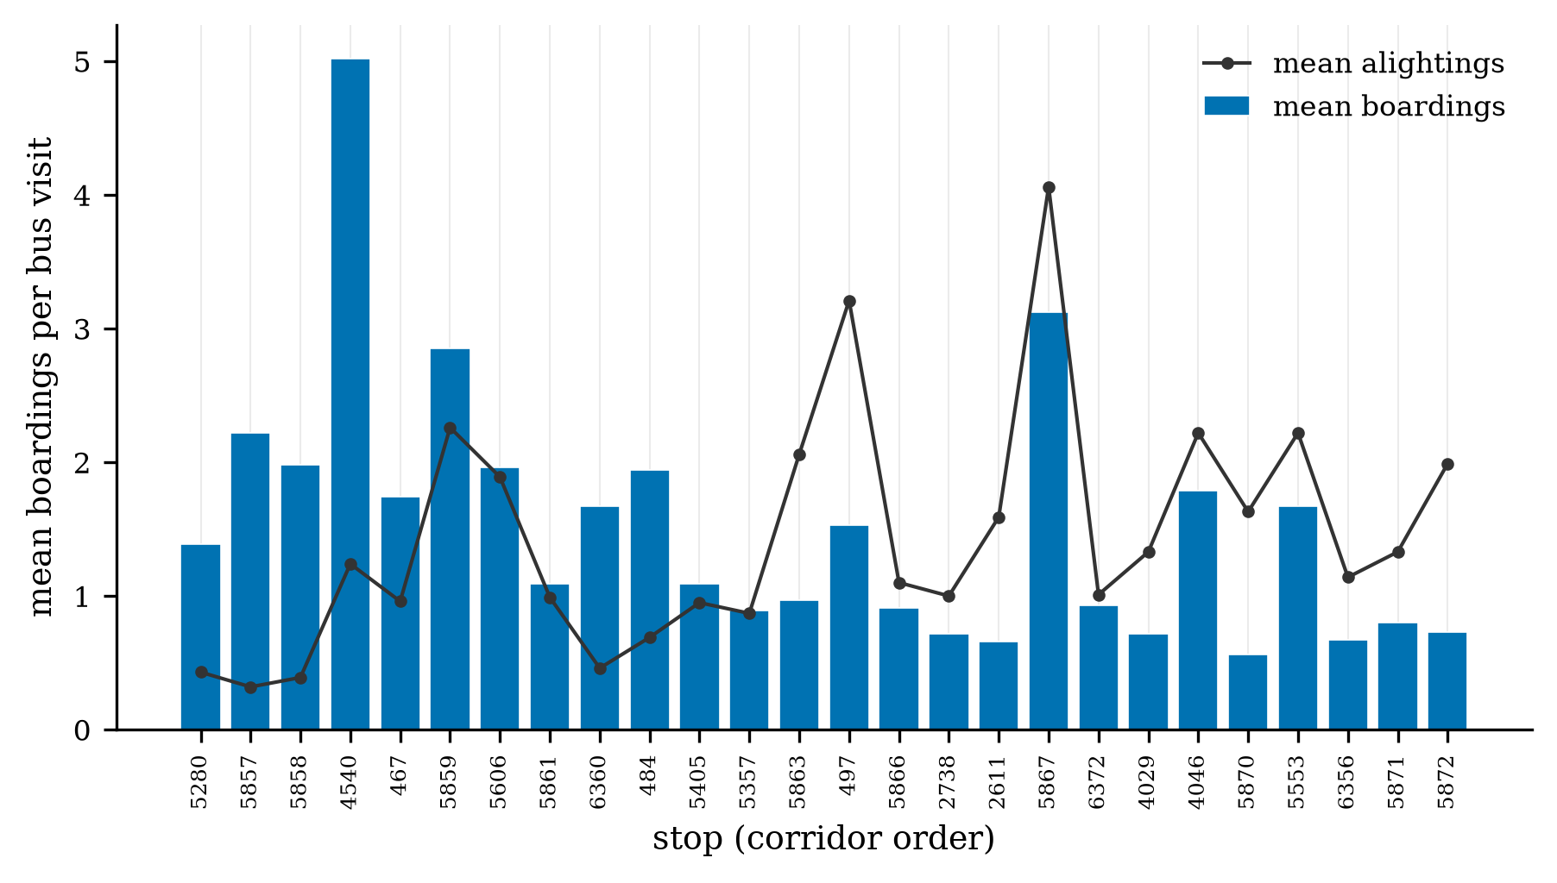
Figure 5. Per-stop mean boardings per bus visit along the 26-stop corridor; the five control stops are highlighted.

5 Provenance, Reproducibility, and Output
The cleaned subset is written to disk and a SHA-256 checksum is recorded, so the derived inputs are reproducible and auditable — a property requested in review. The output is sim_inputs/stops.csv, twenty-six rows of per-stop dwell, running time, distance, and demand, which parameterise the SUMO corridor and its calibration. No passenger-arrival times are used at any point; demand enters only as a rate, consistent with the manuscript's treatment of arrivals as unobserved. The dataset does not provide vehicle capacity, breakdowns, or an authoritative schedule; these are supplied as simulated or synthetic layers and are labelled as such.
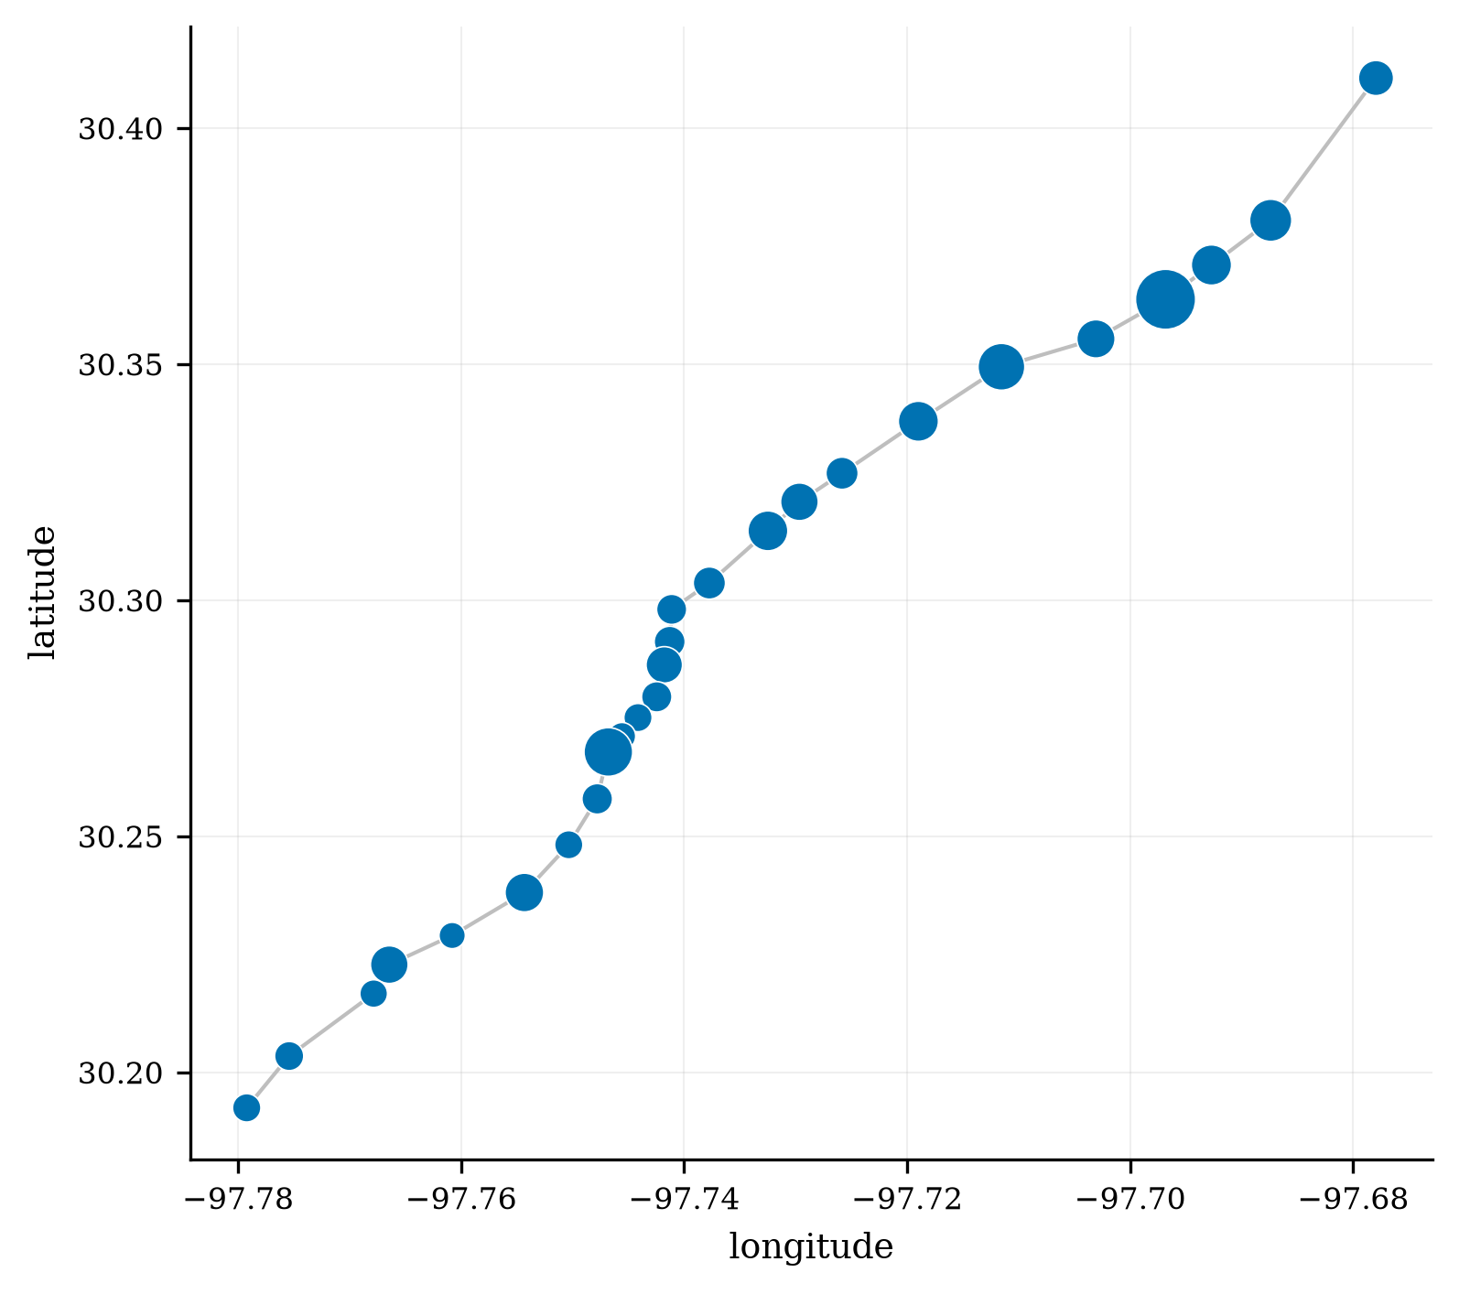
Figure 6. The resulting 26-stop direction-6 corridor (marker size = demand); the five control stops in orange.

Appendix — Full Cleaning Script
The complete implementation, read directly from the working tree.

scripts/extract_sim_inputs.py
"""Stream the 3.5 GB raw APC CSV -> dir-6 clean subset (229,421 rows) -> sim_inputs/stops.csv.
Reproduces the pipeline's six cleaning filters. Point values only (no distributions)."""
import pandas as pd, os
RAW = r"C:\Users\jared\Desktop\THESIS\APC_Raw_July_2021_-_December_2021_20260824.csv" # <-- set path
OUT = "sim_inputs"; os.makedirs(OUT, exist_ok=True); os.makedirs("data", exist_ok=True)
need = ["route_id","current_route_id","import_error","import_trip_error","bs_id","direction_code_id",
"actual_sequence","ons","offs","dwell_time","rev_seconds","rev_distance","transit_date_time"]
parts, n_raw = [], 0
for ch in pd.read_csv(RAW, usecols=need, dtype=str, chunksize=1_000_000, na_filter=False):
n_raw += len(ch)
m = ((ch["route_id"]=="801") & (ch["route_id"]==ch["current_route_id"]) &
(ch["import_error"]=="0") & (ch["import_trip_error"]=="0") &
(ch["bs_id"]!="0") & (ch["direction_code_id"]=="6"))
parts.append(ch[m])
df = pd.concat(parts, ignore_index=True)
print(f"raw {n_raw:,} -> dir-6 clean {len(df):,} (expect 229,421)")
df.to_csv("data/route_801_direction_6_clean.csv", index=False) # cache the subset
for c in ["actual_sequence","ons","offs","dwell_time","rev_seconds","rev_distance"]:
df[c] = pd.to_numeric(df[c], errors="coerce")
df["run_seconds"] = (df["rev_seconds"] - df["dwell_time"]).clip(lower=0) # segment running time
stops = (df.groupby("bs_id")
.agg(seq=("actual_sequence","median"), mean_boardings=("ons","mean"),
mean_alightings=("offs","mean"), dwell_s=("dwell_time","median"),
run_s=("run_seconds","median"), dist_mi=("rev_distance","median")) # NOTE: rev_distance is MILES
.sort_values("seq").round(2))
stops.to_csv(f"{OUT}/stops.csv"); print("wrote sim_inputs/stops.csv", len(stops), "stops")

